Department for Environment, Food and Rural Affairs  Scottish Government  Welsh Government |  |  |  |  | 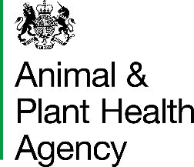  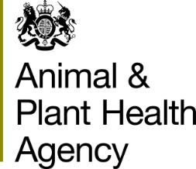
Breeds at Risk - Registration Form
This form may be completed on-screen. If you prefer to complete in manuscript please use BLOCK letters or TICK boxes as appropriate.
1. Owner (Legal owner of Breeds at Risk Animals)
- Name
- Address |  |  |  | (iv) Telephone No. (incl. nat. dialling code)
 |  |  |  | (v) Mobile No.
 | Postcode:
 |  |  |  | (vi) Email
- CPH of home premises
2. Keeper and Premises where animals are kept (Details of the premises and contact details for the keeper of the Breeds at Risk Animals)
(i) Name
(ii) Address |  |  |  | (iv) Telephone No. (incl. nat. dialling code)
(if different)
 |  |  |  | (v) Mobile No.
 | Postcode
 |  |  |  | (vi) Email
(iii) CPH of premises where animals are located

3. Details of Breeds at Risk Animals
Species/Breed (enter each different breed at risk species on a new line) | Official UK Herd/Flock Number | Breed Society Herd/Flock Number | No. of Pedigree Animals of this species on premises

The completion and submission of this form confirms that:
All animals detailed on this form are pedigree animals and are registered with the appropriate Breed Society
I have read the Data Protection statement below
I understand that APHA may contact the Breed Society to verify the information on this application
Once completed, this form should be returned to:
- APHA, Business Support and Resilience, Lutra House, Dodd Way, Preston, Lancashire, PR5 8BX
- emailed to: BreedsatRiskRegister@apha.gov.uk

DATA PROTECTION
For information on how we handle personal data please go to www.gov.uk and search Animal and Plant Health Agency Personal Information Charter.

APHA is an Executive Agency of the Department for Environment, Food and Rural Affairs and also works on behalf of the Scottish Government, Welsh Government and Food Standards Agency to safeguard animal and plant health for the benefit of people, the environment and the economy.

