MINISTRY OF DEFENCE – DEFENCE EQUIPMENT SALES AUTHORITY
FORMER RFA DILIGENCE – STATEMENT OF UNDERSTANDING
JANUARY 2019
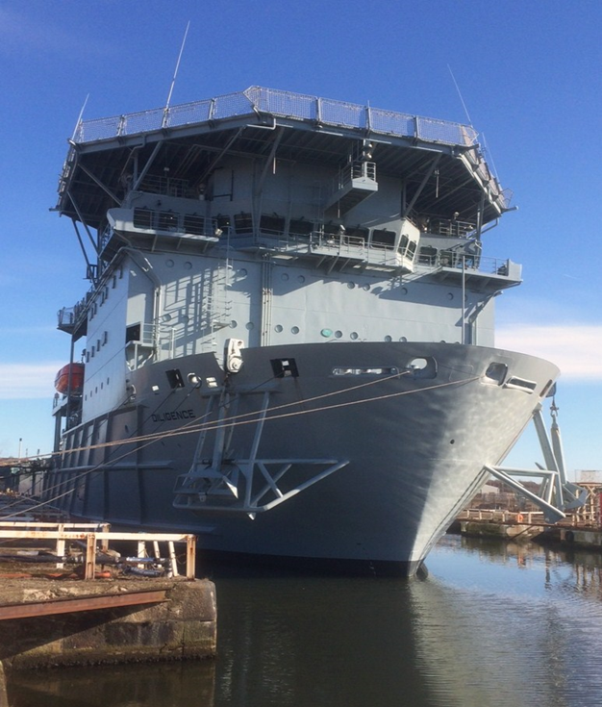

Organisation and Contact Details
Important notice:
All sections in this form must be completed in full; failure to do so may result in its rejection and the organisation not invited. (MOD reserves the right to invite only those which it considers put forward viable proposals, based on the information provided)

ORGANISATION AND CONTACT DETAILS
Full name of organisation:

Registered office address |  | Company or Organisation registration number
 |  | VAT registration number
 |  | Name of immediate parent company
 |  | Name of ultimate parent company
Company website
Contact details FOR ENQUIRIES RELATING TO THIS Statement
Name
Position in the organisation
Full Address
Telephone number
Mobile number
E-mail address

Where did you first view the Diligence advertisement?
Platform | (x)
Apollo Duck
DESA.Gov.uk website Advert
Defence Online
Defence Contracts Online
Defence Contracts Bulletin

Information required

1. Please provide a basic summary of the proposed use for the Vessel and an idea for its final location
2. Please provide details of who you may approach to undertake the conversion work
3. Please provide an indication of how this project will be funded, understanding that it will not just be the purchase costs as per the advert, but towing costs, insurance, refurbishment and bond that will be required for the life of the project.
4. Other than technical information that will be provided at the next stage is there any other information that you would like to receive before purchasing the vessel
5. Confirmation you are aware of the following estimated timescales noting dates may change but the process cannot be deviated from:
- Advert closed Thursday 28th March
- Quick look around of the vessel 8th/9th Apr (note this will only be a quick escorted walk around a more in- depth viewing will take place once you have been invited to tender)
- Invitation to Tender (ITT)sent out to interested parties Apr/May
- In-depth viewing of the vessel with Q&A May/June
- Closing date for the ITT to be returned to the DESA July/Aug
- Evaluation of all ITT’s Sept/Oct
- Contract award to the winning Bidders Nov/Dec

5. Details required if you wish to be invited to the walk around on the 8th or 9th April: (dates will be confirmed Friday 29th March not before.)
- Full name of representatives (2 per Organisation) and their role. (no persons under 18 will be allowed on the vessel).
- Contact details for the day
- Telephone numbers (land line)
- Mobile telephone numbers for the day of the viewing
- Nationality (any foreign nationals will need to provide a passport number)
- Photo ID
- Confirmation that the correct safety clothing i.e. steel toecap boots and appropriate Personal Protective Equipment (PPE) will be worn on arrival.

SIGNATURE

8 | I declare I understand the information provided will be used to assess the suitability to be invited to view the vessel and the Authority has the right to refuse my request to view the vessel or to be invited to tender the vessel.
8 | FORM COMPLETED BY
8.1 | Name:
8.2 | Date:
10.3 | Signature:

Please return the completed statement of understanding electronically to:
DESLD-DESA-Commercial@mod.gov.uk &
DESLD-DESANavy@mod.gov.uk by 17:00 hrs (GMT) Thursday 28th March 2019

