SIN Canada secures jobs, exports and investment in Artificial Intelligence (AI) in the UK

In 2018, SIN Canada team was instrumental in securing almost £2 million investment from Canada’s most successful AI start-up, Element AI, nearly £4 million from Canadian Venture Capitals to BIOS a Cambridge-based to export their expertise to Canada, while also organising a UK-Canada AI Innovation Challenge set by Bombardier.

SIN Secures Business Wins
Element AI launched its first international office In London with an initial investment of almost £2 million and rapid job creation. This was a direct result of interactions with SIN and DIT local teams and followed the SIN inward AI mission to the UK. Montreal-based Element AI grew from 7 people in October 2016 to over 500 employees in late 2018 with offices now in Toronto, Seoul and Singapore and has already raised over £400 million in funding to date, aiming for unicorn status. This investment builds upon the UK’s historic expertise in AI and the ongoing, pioneering work that the UK continues to promote.
SIN Canada in collaboration with the UK’s Knowledge Transfer Network (KTN) facilitated BIOS with access to nearly £4 million in seed funding from Canadian investors. BIOS has recently opened an R&D office in Montreal. The company is developing a “neural interface” using AI, which can be used to develop new cutting-edge treatments on organs and nerve systems throughout the body. BIOS will use the funding to double its technical team and further develop its core neural interface technologies and readily commercialise its products.
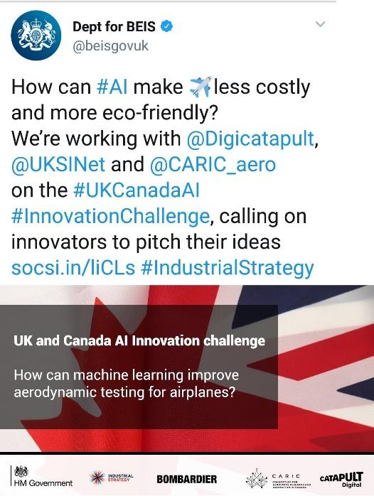
SIN organised 1st UK-Canada AI Innovation Challenge

SIN Canada, Digital Catapult and the consortium in Aersospace Research and Innovation in Canada delivered a UK-Canada AI Innovation Challenge set by Bombardier. Launched by Baroness Fairhead in September 2018, this activity responds to the Industrial Strategy, AI Sector Deal, AI Grand Challenge. The challenge called on innovators to use AI to make aircraft less costly and more eco-friendly by burning less fuel. UK and Canadian start-ups and researchers pitched ideas for AI to help improve the systems used to prevent ice build-up on wings and help aircraft reach their optimum performance. The winners, London-based start-up DecisionLab and Canadian start-up BI Expertise, had the opportunity to visit Bombardier and explore a potential multimillion future collaboration and also a bespoke visit to the UK and Canada.
The success of this bilateral activity and positive impact of the UK-Canada AI challenge on UK exports and innovation has been highlighted in the Industrial Strategy One Year report. In addition, DIT and SIN colleagues in Germany, Singapore, Malaysia and UAE are considering organising similar bilateral activities in post.

SIN Canada (Montreal): mario.rivero-huguet@fco.gov.uk

