

Iraqis Call on the New Government for Jobs, Services, and Reconstruction

August – October 2018 Survey Findings

PUBLIC REPORT

Working for Democracy and Making Democracy Work 1


This material has been funded by the UK government; however the views and opinions expressed do not necessarily reflect the UK government’s official policies.

Working for Democracy and Making Democracy Work 2

Methodology Overview

– 17 August – 1 October 2018

– 3804 face-to-face interviews (14,582 unweighted)

– National, covering 18 governorates; including 102 interviews from IDP camp

– Avg. MOE +/-: 1.6% national; 4.8% Baghdad; 1.8% South (Babil, Basra, Kerbala, Missan, Najaf, Qadisiyah, Wassit); 2.4% West (Anbar, Diyala, Kirkuk, Ninewa, Salahaddin); 3.1% Kurdish Region of Iraq (KRI)

– Representative by gender, age, education, urban/rural

– Multi-stage cluster sampling; probability proportional to size sampling down to block level in urban areas; simple random sampling at rural village selection and house/individual level

– Half and quarter split samples were used on select questions for testing purposes or to reduce the survey length
– Implementation team: NDI, JPM Strategic Solutions, GQR, IIACSS

– 14th national survey in Iraq conducted by team dating back to 2010; 2nd national survey conducted by team this year

Working for Democracy and Making Democracy Work 3
Key findings

1. Country mood more pessimistic, driven by increasing frustration in services and lingering job concerns in West and South.

2. Smaller majority perceive security is improving, as concerns toward ISIS or terrorism-related violence increase.

3. Low trust in government institutions and low confidence in elections drive perceptions that Iraq is more divided and drive support for protests.

4. Most see Shia-Sunni relations as improving.

5. Role of women in Iraq at pivot point. Strong demand for equal rights that are not being delivered. Some differences in views by gender.

6. High expectations on government to create jobs, while most see bribes and connections are necessary to get a government job.

Working for Democracy and Making Democracy Work 4


Country mood worsens, especially in West

Working for Democracy and Making Democracy Work 5
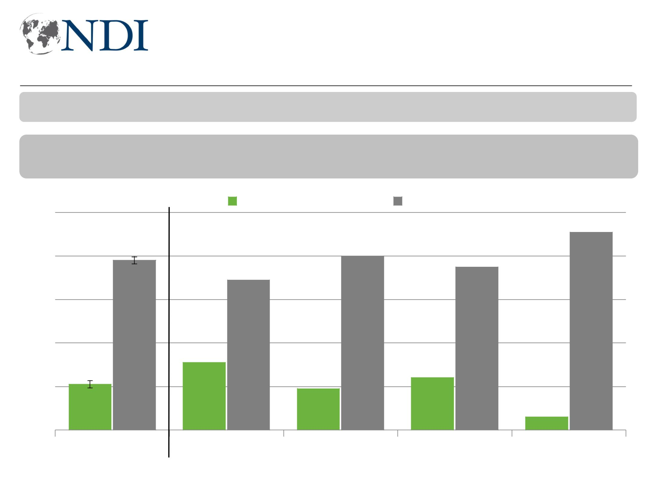
Country mood worsening especially in West

Generally speaking, do you think that things in Iraq are going in the right direction, or do you think things are going in the wrong direction?

- April ‘18

-10 +12

100

80

78

60

40

+3 -1 |  | -8 +10 |  | -26 +28 |  |  | -2 +3
 | Right direction |  |  | Wrong direction
 |  |  |  |  |  |  | 91
 |  | 80
 |  |  |  | 75
69

20
21

0

31
19 24 6

Total

Baghdad South West KRI
Working for Democracy and Making Democracy Work 6
Most say country not going in right direction
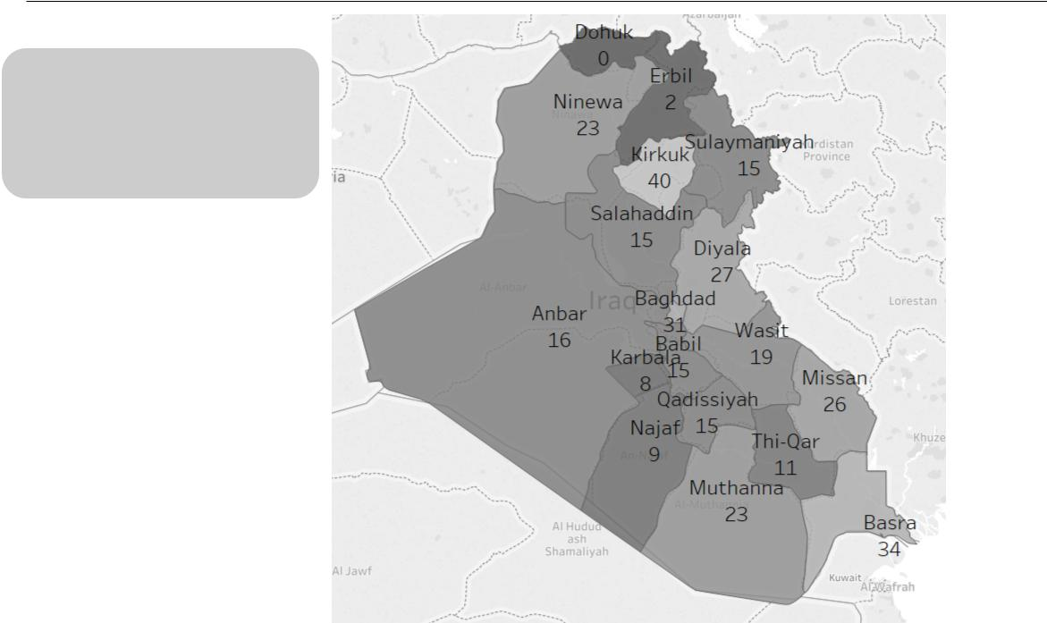

Generally speaking, do
you think that things in
Iraq are going in the right
direction, or do you think
things are going in the

wrong direction?

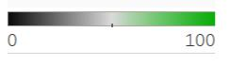

% saying right direction

Working for Democracy and Making Democracy Work 7
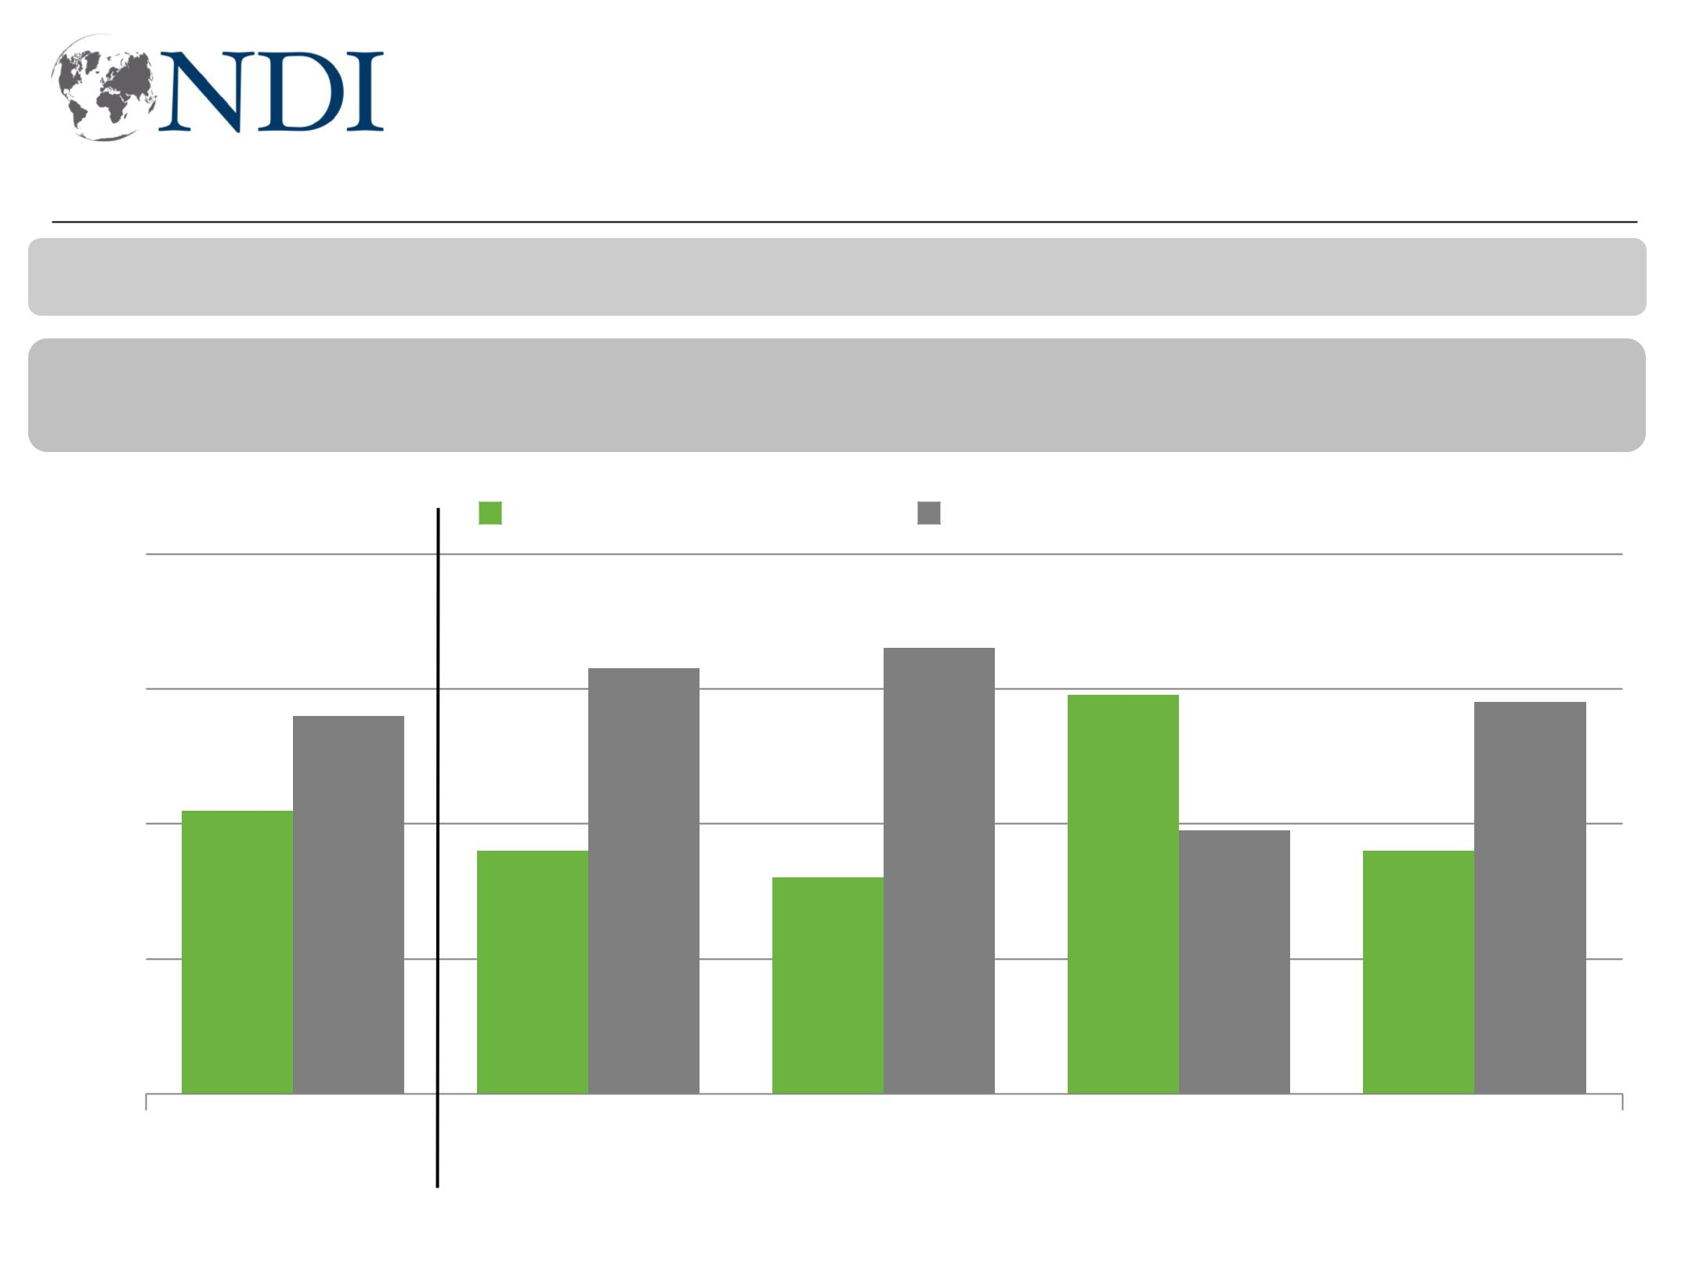
But views toward governorates in West more positive

And generally speaking, do you think that things in (Province/KRI) are going in the right direction, or do you think things are going in the wrong direction?

- April ‘18

-3 +4 +0 +1 -3 +5 -5 +6 +4 -6

80

60

40

20

0

Right direction | Wrong direction

 |  |  |  |  |  |  |  |  |  |  |  |  |  |  | 66
 |  |  |  |  |  |  |  |  |  |  | 63 |  |  |  | 66
 |  |  |  |  |  |  |  |  |  |  | 63 |  |  |  | 66 |  |  | 59 |  |  |  |  | 58
 |  |  |  | 56 |  |  |  |  |  |  | 63 |  |  |  |  |  |  | 59 |  |  |  |  | 58
42 |  |  |  |  |  |  |  |  |  |  |  |  |  |  |  |  |  |  | 39
 |  |  |  |  |  |  |  |  |  | 36 |  |  |  |  |  |  |  |  | 39 |  |  | 36
 |  |  |  |  |  |  |  |  |  | 36 |  |  |  | 32 |  |  |  |  | 39 |  |  | 36

Total Baghdad South West KRI

Working for Democracy and Making Democracy Work 8
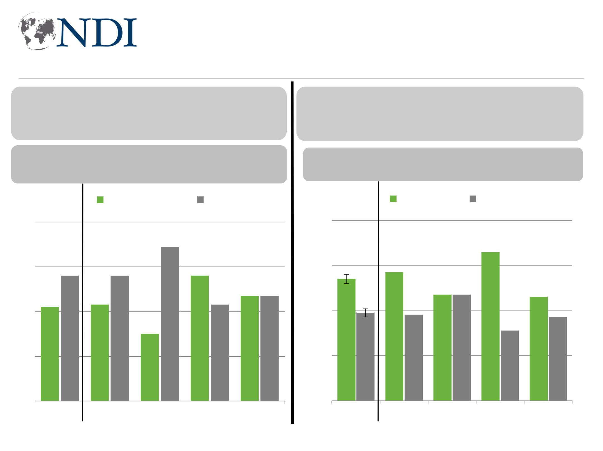
Satisfaction and expectations down outside KRI

Thinking specifically about your life now compared to 6 months ago, would you say you are more or less satisfied now

than compared to 6 months ago?

- April ’18

 | -9 +9 |  |  |  |  |  |  |  |  |  |  | -10 +10 |  |  |  |  |  |  | -13 +14 |  |  |  |  |  | -15 +15 |  |  |  |  |  |  |  | +17 -21
 |  |  |  |  |  |  |  |  |  |  |  |  |  |  | More satisfied |  |  |  |  |  |  |  |  |  |  |  | Less satisfied
80
60 |  |  |  |  |  |  |  |  |  |  |  |  |  |  |  |  |  |  |  |  |  |  | 69
 |  |  |  |  |  |  |  | 56 |  |  |  |  |  |  |  |  | 56 |  |  |  |  |  |  |  |  |  | 56
40 |  |  |  |  |  |  |  |  |  |  |  |  |  |  |  |  |  |  |  |  |  |  |  |  |  |  | 56 |  |  |  |  |  | 47 |  | 47
40 |  |  |  |  |  |  |  |  |  |  |  |  |  |  | 43 |  |  |  |  |  |  |  |  |  |  |  |  |  | 43 |  |  |  | 47 |  | 47
40 |  |  | 42 |  |  |  |  |  |  |  |  |  |  |  | 43 |  |  |  |  |  |  |  |  |  |  |  |  |  | 43 |  |  |  | 47 |  | 47
20 |  |  |  |  |  |  |  |  |  |  |  |  |  |  |  |  |  |  |  |  | 30
0
0 |  |  |  | Total |  |  |  |  |  |  |  |  |  | Baghdad |  |  |  |  |  |  | South |  |  |  |  |  | West |  |  |  |  |  | KRI

Thinking specifically about your life, do you expect things to get better for you or worse for you over the next 6 months.

∆ April ’18 |  | -11 +14 +3 -10
-7 +9 -4 +7 -10 +13 |  | -11 +14 +3 -10
 | Better | Worse

80

60 | 57 |  | 66
54 | 57 | 47 47
54 |  | 47 47 | 46
40 |  | 47 47 | 46
39 | 38 |  | 37
20 |  |  | 31
0
Total | Baghdad | South | WestKRI
Working for Democracy and Making Democracy Work 9
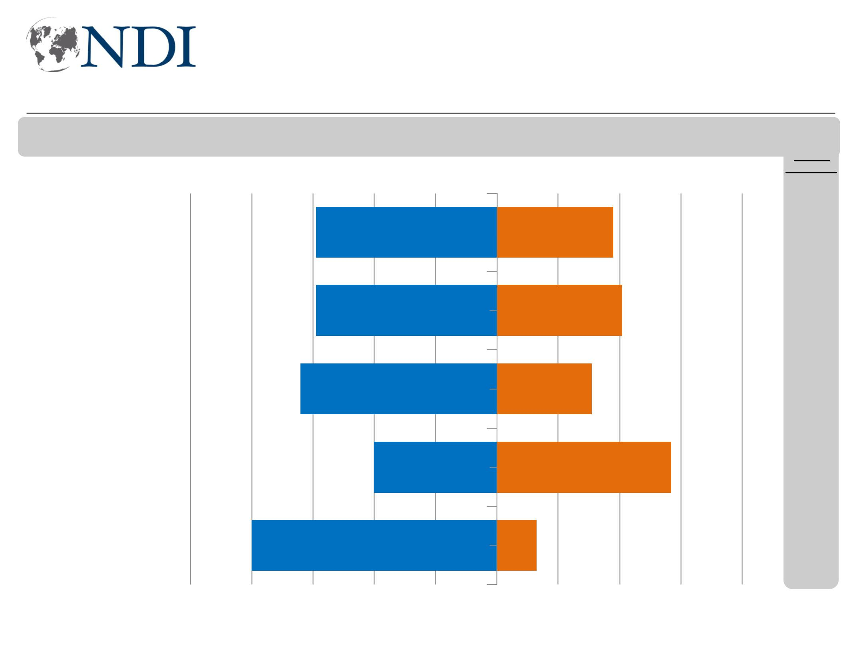
Access to basic services worsening, especially in South

Now, I will read you a list of issues. Please tell me if you think this issue is getting better or worse in Iraq. (Access to services like electricity)

Worse Better

Total

Baghdad

South

West

KRI

59 38

59 41

64 31

40 57

80 13

-9

-4

-13

-8

-4

-100 -80 -60 -40 -20 0 20 40 60 80 100

Working for Democracy and Making Democracy Work 10
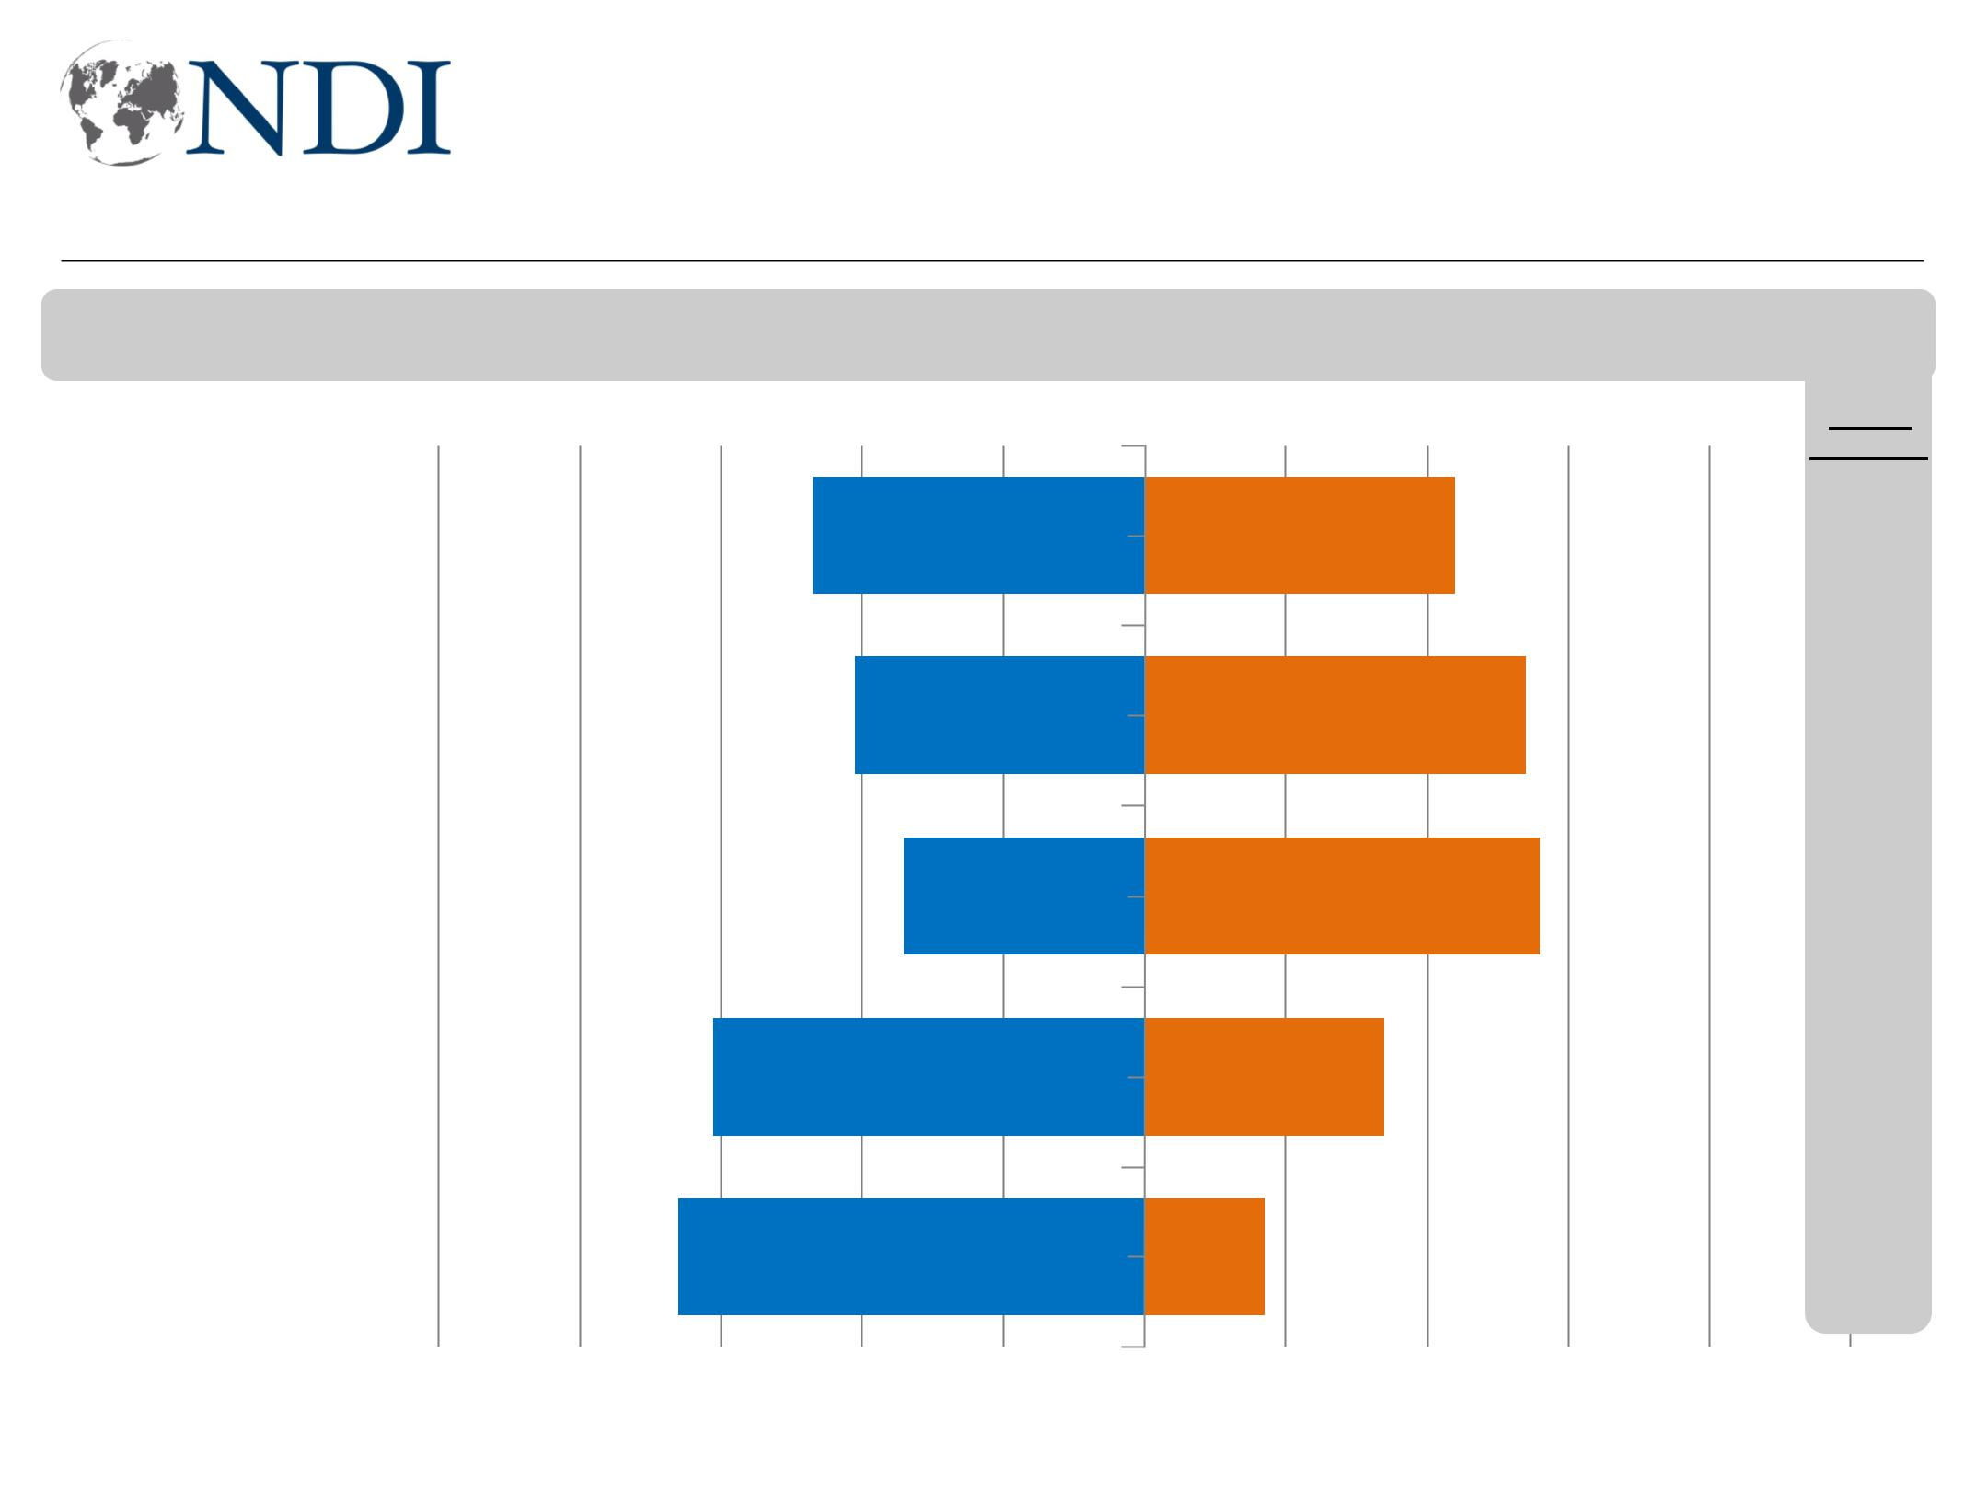
Growing majority in West say reconstruction efforts worse

Now, I will read you a list of issues. Please tell me if you think this issue is getting better or worse in Iraq. (Government’s response to reconstruct areas once occupied by ISIS)

Total

Baghdad

South

West

KRI

Worse Better

47 44

41 54

34 56

61 34

66 17

-9

-10

-5

-10

-16

-100 -80 -60 -40 -20 0 20 40 60 80 100

Working for Democracy and Making Democracy Work 11
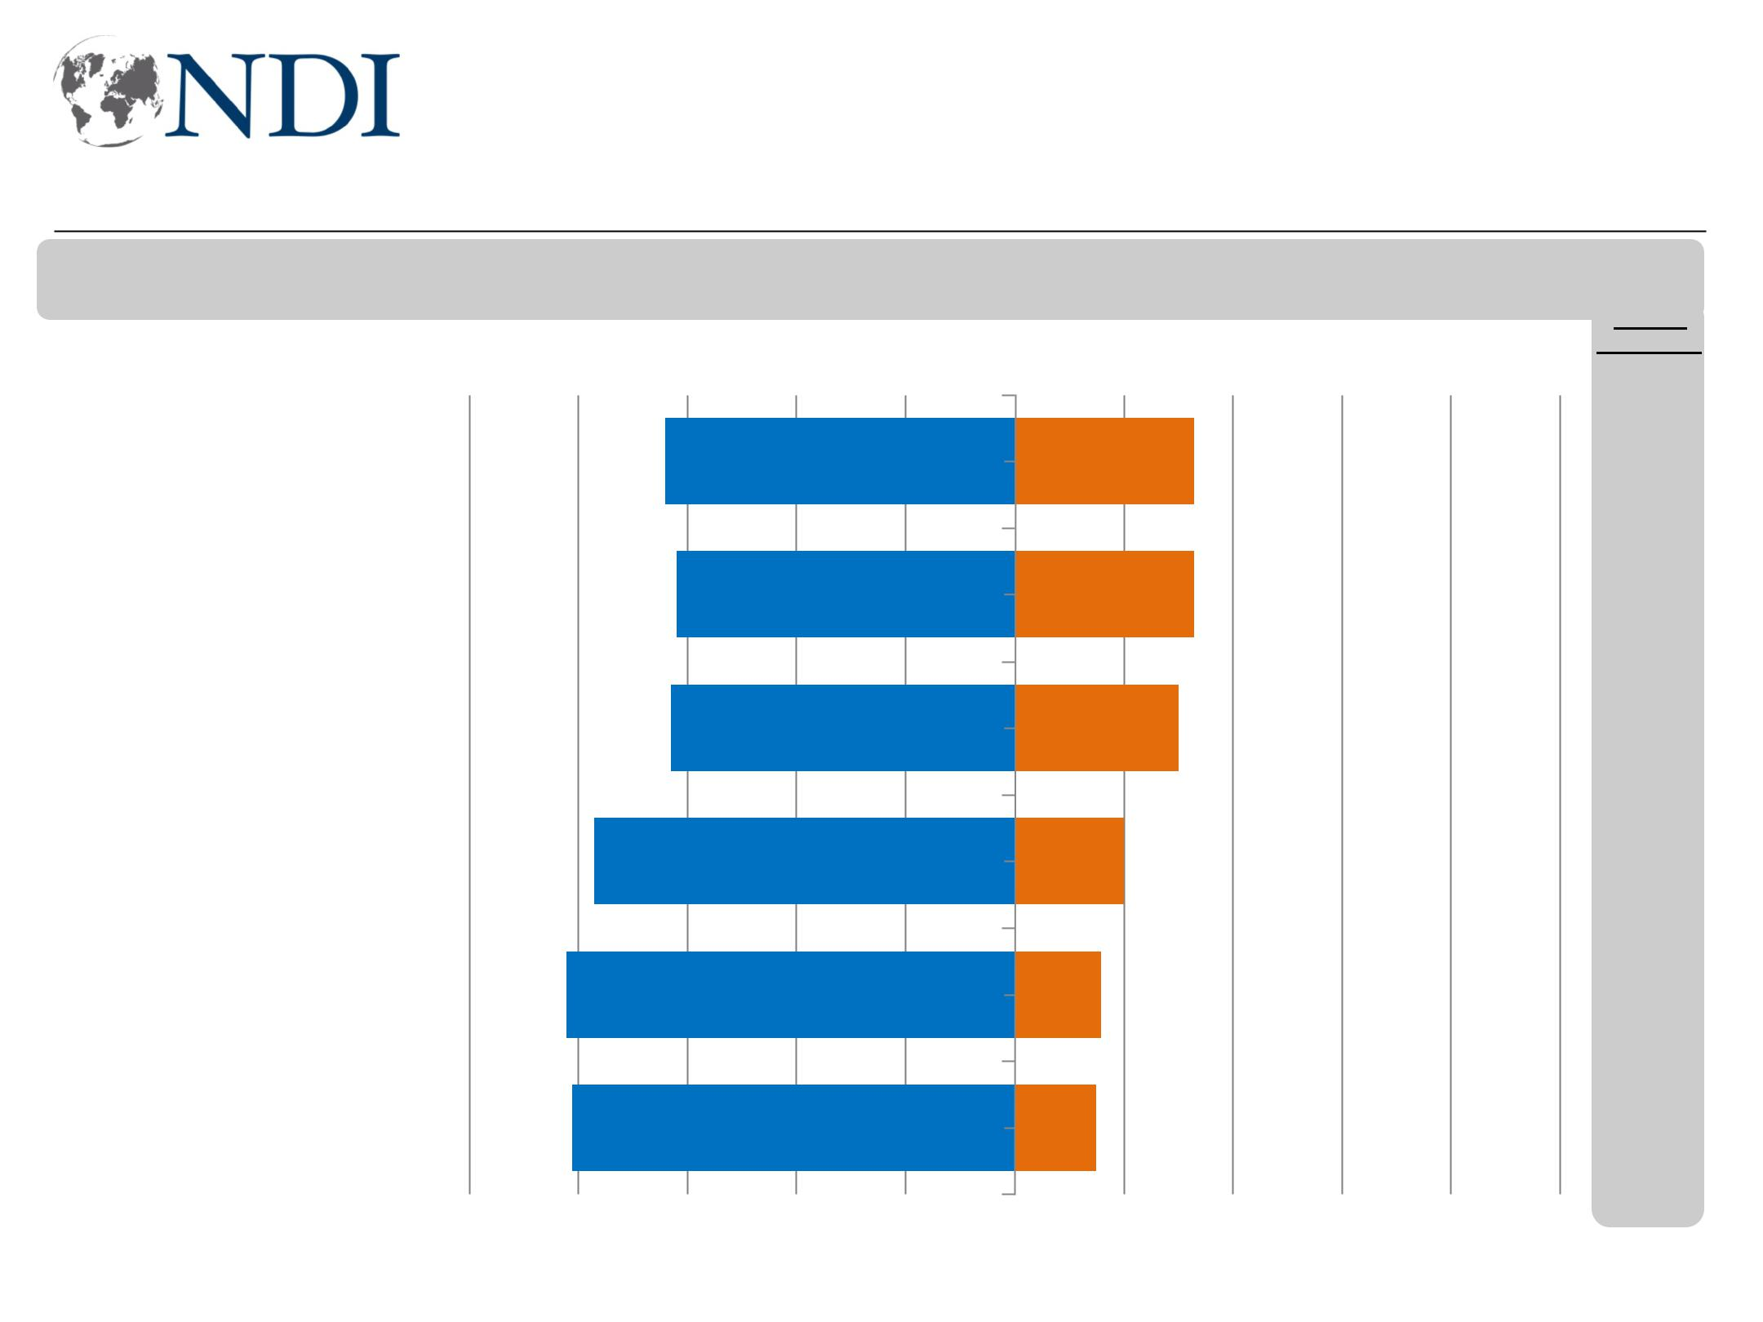
Views on other issues, economy reflect worsening mood

Now, I will read you a list of issues. Please tell me if you think this issue is getting better or worse in Iraq.

Worse Better

Education

The justice system

Housing

Cost of living

Job opportunities

Corruption

64 33

62 33

63 30

77 20

82 16

81 15

-2

-6

-3

-2

+3

+0

-100 -80 -60 -40 -20 0 20 40 60 80 100

Working for Democracy and Making Democracy Work 12
Top priorities for the next Iraqi government

Now, I am going to read you a list of concerns that some people may have. Please tell me which TWO of these are the most important for the Iraqi government to address.


Jobs and unemployment

Basic services—electricity, water

Corruption

Security

Education and schools

Infrastructure

Health care services

Sectarianism

Fairness of, access to justice

High prices

39
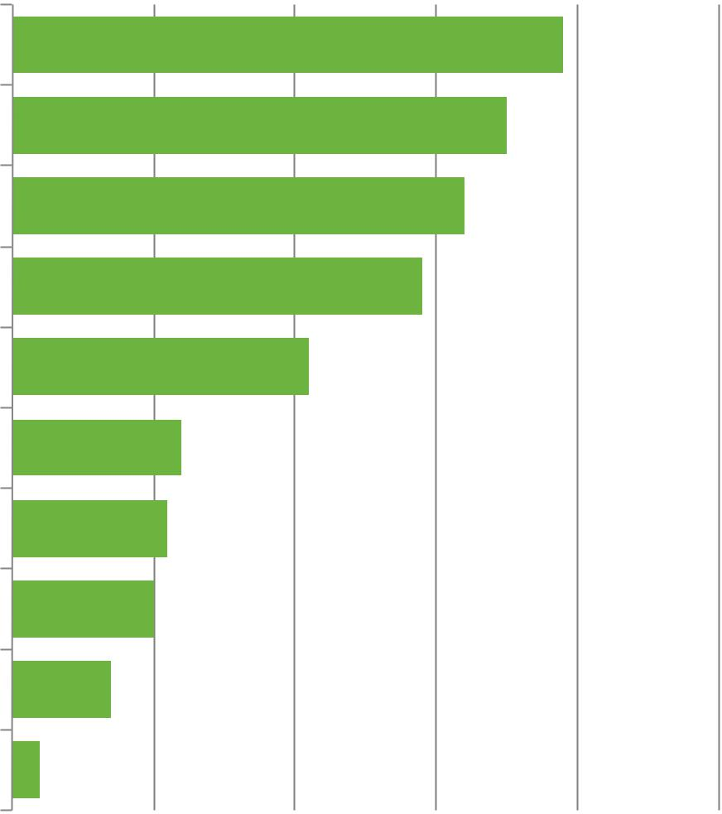

35

32

29

21

12

11

10

7

2

- April 18

-3

+16

-4

-2

+1

-4

+2

+0

-2

-3

0 10 20 30 40 50

Working for Democracy and Making Democracy Work 13
Electricity and water top demand of local government

Please tell me which TWO of these are the most important for your governorate’s government to address.
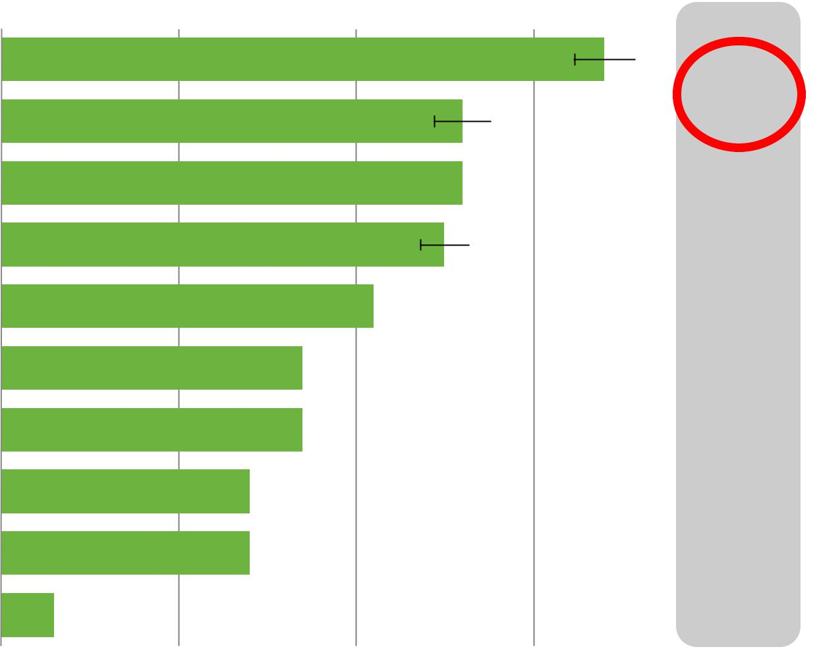

 |  |  |  |  |  |  |  |  |  |  |  |  |  |  |  |  |  |  |  |  |  |  |  |  |  |  | 34 |  |  |  |  | ∆ April 18
Electricity |  |  |  |  |  |  |  |  |  |  | 26 |  |  |  |  |  |  |  |  |  |  |  |  |  |  |  |  |  |  |  |  |  | +9
Potable water |  |  |  |  |  |  |  |  |  |  |  |  |  |  |  |  |  |  |  |  |  |  |  |  |  |  |  |  |  |  |  | +10
Corruption |  |  |  |  |  |  |  |  |  |  | 26 |  |  |  |  |  |  |  |  |  |  |  |  |  |  |  |  |  |  |  |  | -5
Schools and education |  |  |  |  |  |  |  |  |  |  | 25 |  |  |  |  |  |  |  |  |  |  |  |  |  |  |  |  |  |  |  |  | +0
The economy |  |  |  |  |  |  |  |  |  |  | 21 |  |  |  |  |  |  |  |  |  |  |  |  |  |  |  |  |  |  |  |  | -2
Infrastructure |  |  |  |  |  |  |  |  |  |  | 17 |  |  |  |  |  |  |  |  |  |  |  |  |  |  |  |  |  |  |  |  | -5
Personal safety |  |  | 14 |  |  |  |  |  |  |  | 17 |  |  |  |  |  |  |  |  |  |  |  |  |  |  |  |  |  |  |  |  | +1
Healthcare facilities |  |  |  |  |  |  |  |  |  |  |  |  |  |  |  |  |  |  |  |  |  |  |  |  |  |  |  |  |  |  |  | -2
Garbage/environment |  |  | 14 |  |  |  |  |  |  |  |  |  |  |  |  |  |  |  |  |  |  |  |  |  |  |  |  |  |  |  |  | -3
Property/land grabbing |  |  | 3 |  |  |  |  |  |  |  |  |  |  |  |  |  |  |  |  |  |  |  |  |  |  |  |  |  |  |  |  | -1
0 |  |  | 10 |  |  |  |  |  |  |  | 20 |  |  |  |  |  |  |  |  |  |  |  |  |  |  |  | 30 |  |  |  |  | 40
Working for Democracy and Making Democracy Work |  |  |  |  |  |  |  |  |  |  |  |  |  |  |  |  |  |  |  |  |  |  |  |  |  |  |  |  |  |  |  | 14

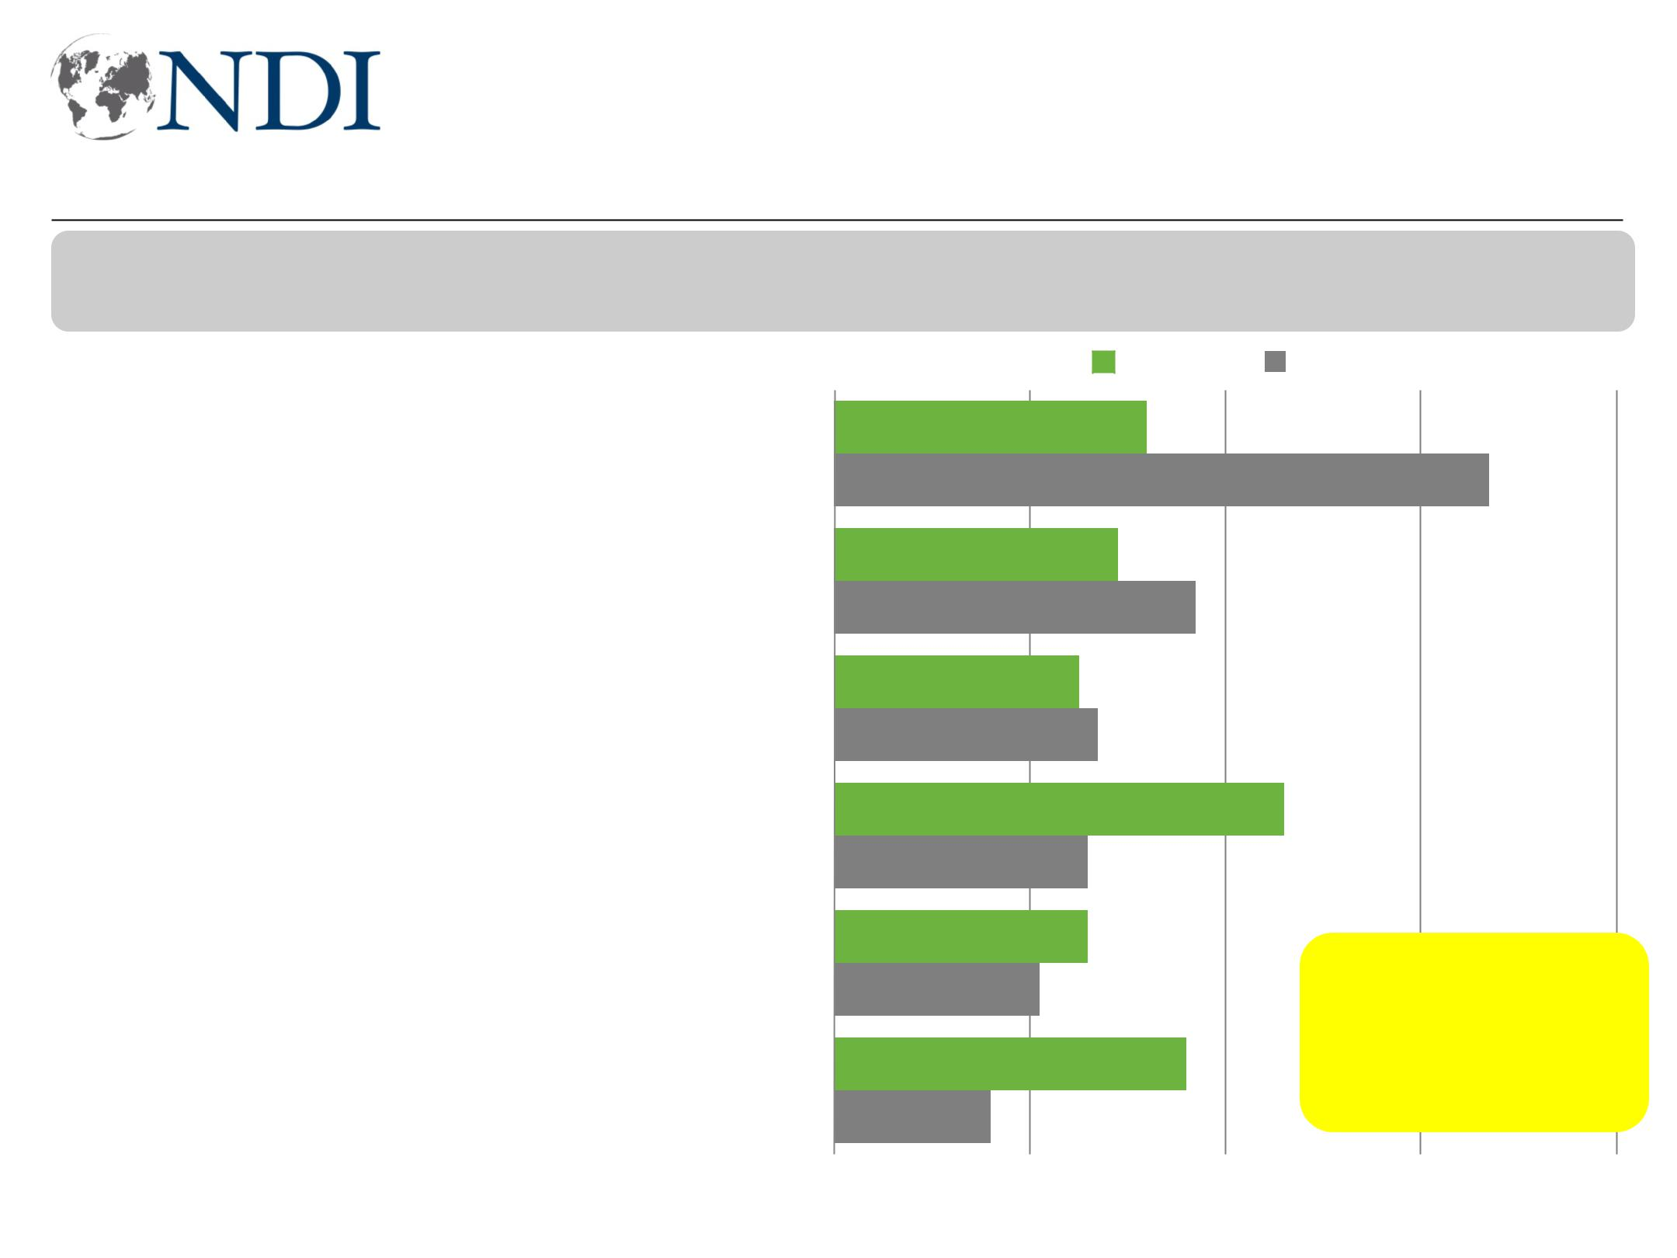
Outside of KRI, majority concerned about drinking water

Now, I am going to read you a list of environmental concerns that some people may have. Please tell me which two concern you the most?

Lack of clean drinking water

Lack of sanitation and open sewage

Lack of water for farming

Industry-related air pollution

Extreme weather, like heat and sand storms

Pollution resulting from conflict

 |  |  |  |  | KRI |  |  |  | Non-KRI
 |  | 32 |  |  |  |  |  |  | 67
 |  | 29 |  |  | 37
 |  | 25
 |  | 27
 |  |  |  |  |  |  |  | 46
 |  | 26
 |  | 26 |  |  |  |  |  |  | 90% in Basra
 |  | 21 |  |  |  |  |  |  | 90% in Basra
 |  | 21 |  |  |  |  |  |  | concerned most
 |  |  |  |  |  |  |  |  | about clean
 |  | 36 |  |  |  |  |  |  | about clean
 |  |  |  |  |  |  |  |  | drinking water
 |  | 16
0 |  | 20 |  |  |  |  |  | 40 | 60 | 80

Working for Democracy and Making Democracy Work 15

Government Institutions and Elections Viewed More Negatively

Working for Democracy and Making Democracy Work 16
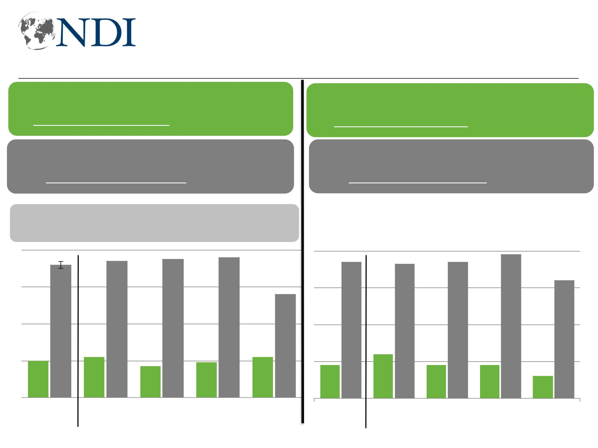
Awareness of government priorities remains low

I generally have a good idea what my local government's priorities are.

I do not have a good sense of what my local government's priorities are.

- April ’18

-1 +5 +0 +4 -3 +9 -6 +8 +9 -6

80
60 72 74 75 76

56
40

20
0 |  |  | 20 |  |  |  |  |  |  |  |  |  | 22 |  |  |  |  |  | 17 |  |  |  |  |  | 19 |  |  |  |  |  | 22
0 |  |  |  | Total |  |  |  |  |  |  |  | Baghdad |  |  |  |  |  |  | South |  |  |  |  |  | West |  |  |  |  |  | KRI

I generally have a good idea what the Iraqi government's priorities are.

I do not have a good sense of what the Iraqi government's priorities are.

 |  |  |  |  |  |  |  | 78
74 |  |  |  | 73 |  |  | 74 | 78
64

 |  |  |  |  |  |  |  |  | 24
18 |  |  |  |  |  |  |  |  | 24 |  |  |  |  | 18 |  |  |  |  | 18 |  |  |  | 12
Total |  |  |  |  |  |  |  | Baghdad South |  |  |  |  |  |  |  |  |  |  | West |  |  |  | KRI

Working for Democracy and Making Democracy Work 17
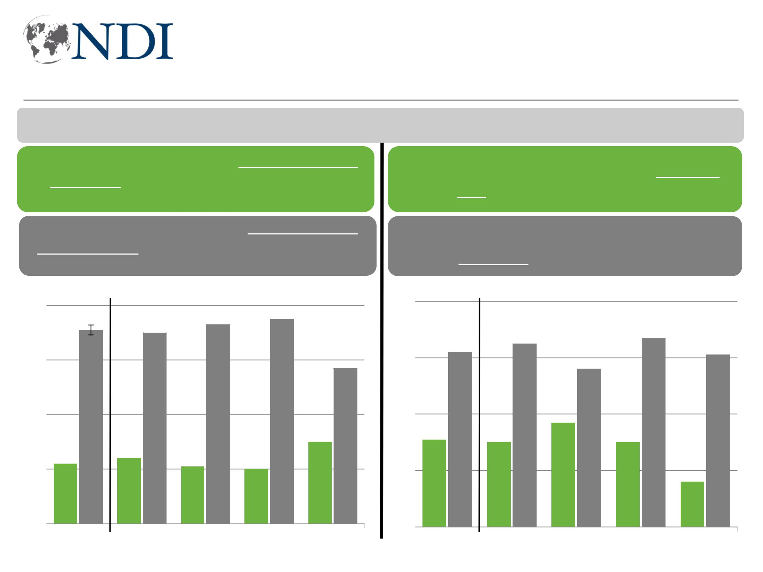
Dissatisfaction with election results, voice to make change

I'm going to read you some pairs of statements and, for each one, I want you to tell me which statement comes closer to your point of view.

Generally speaking, I am happy with the outcome of last May's parliamentary elections.

Generally speaking, I am unhappy with

the outcome of last May's parliamentary

 |  | elections.
80
60 | 71 | 70 | 73 | 75

57

40
 |  |  |  |  |  |  |  |  |  |  |  |  |  |  |  |  |  |  |  |  |  |  |  |  |  |  |  | 30
20 |  |  |  |  |  |  |  |  |  | 24 |  |  |  |  |  |  |  |  |  |  |  |  |  |  |  |  |  | 30
20 |  |  | 22 |  |  |  |  |  |  | 24 |  |  |  |  |  | 21 |  |  |  |  |  | 20 |  |  |  |  |  | 30
0
0 |  |  | Total |  |  |  |  | Baghdad South |  |  |  |  |  |  |  |  |  |  |  |  |  | WestKRI

The May 2018 election affirms I have a

say in the direction of Iraq.

The May 2018 election makes me feel I have little say in the direction of Iraq.

80

 |  |  |  |  |  |  |  |  |  |  |  |  |  |  |  |  |  |  |  |  |  |  |  |  | 67
60 |  |  |  |  |  |  |  |  |  |  |  |  | 65 |  |  |  |  |  |  |  |  |  |  |  | 67
60 |  |  |  |  |  | 62 |  |  |  |  |  |  |  |  |  |  |  |  |  |  |  |  |  |  |  |  |  |  |  |  | 61
 |  |  |  |  |  |  |  |  |  |  |  |  |  |  |  |  |  |  | 56
40
 |  |  |  |  |  |  |  |  |  |  |  |  |  |  |  |  | 37
20 |  |  | 31 |  |  |  |  |  |  |  | 30 |  |  |  |  |  | 37 |  |  |  |  |  | 30
 |  |  |  |  |  |  |  |  |  |  |  |  |  |  |  |  |  |  |  |  |  |  |  |  |  |  |  |  | 16
0
0 |  |  | Total |  |  |  |  |  |  | Baghdad South |  |  |  |  |  |  |  |  |  |  |  |  | WestKRI
Working for Democracy and Making Democracy Work 18
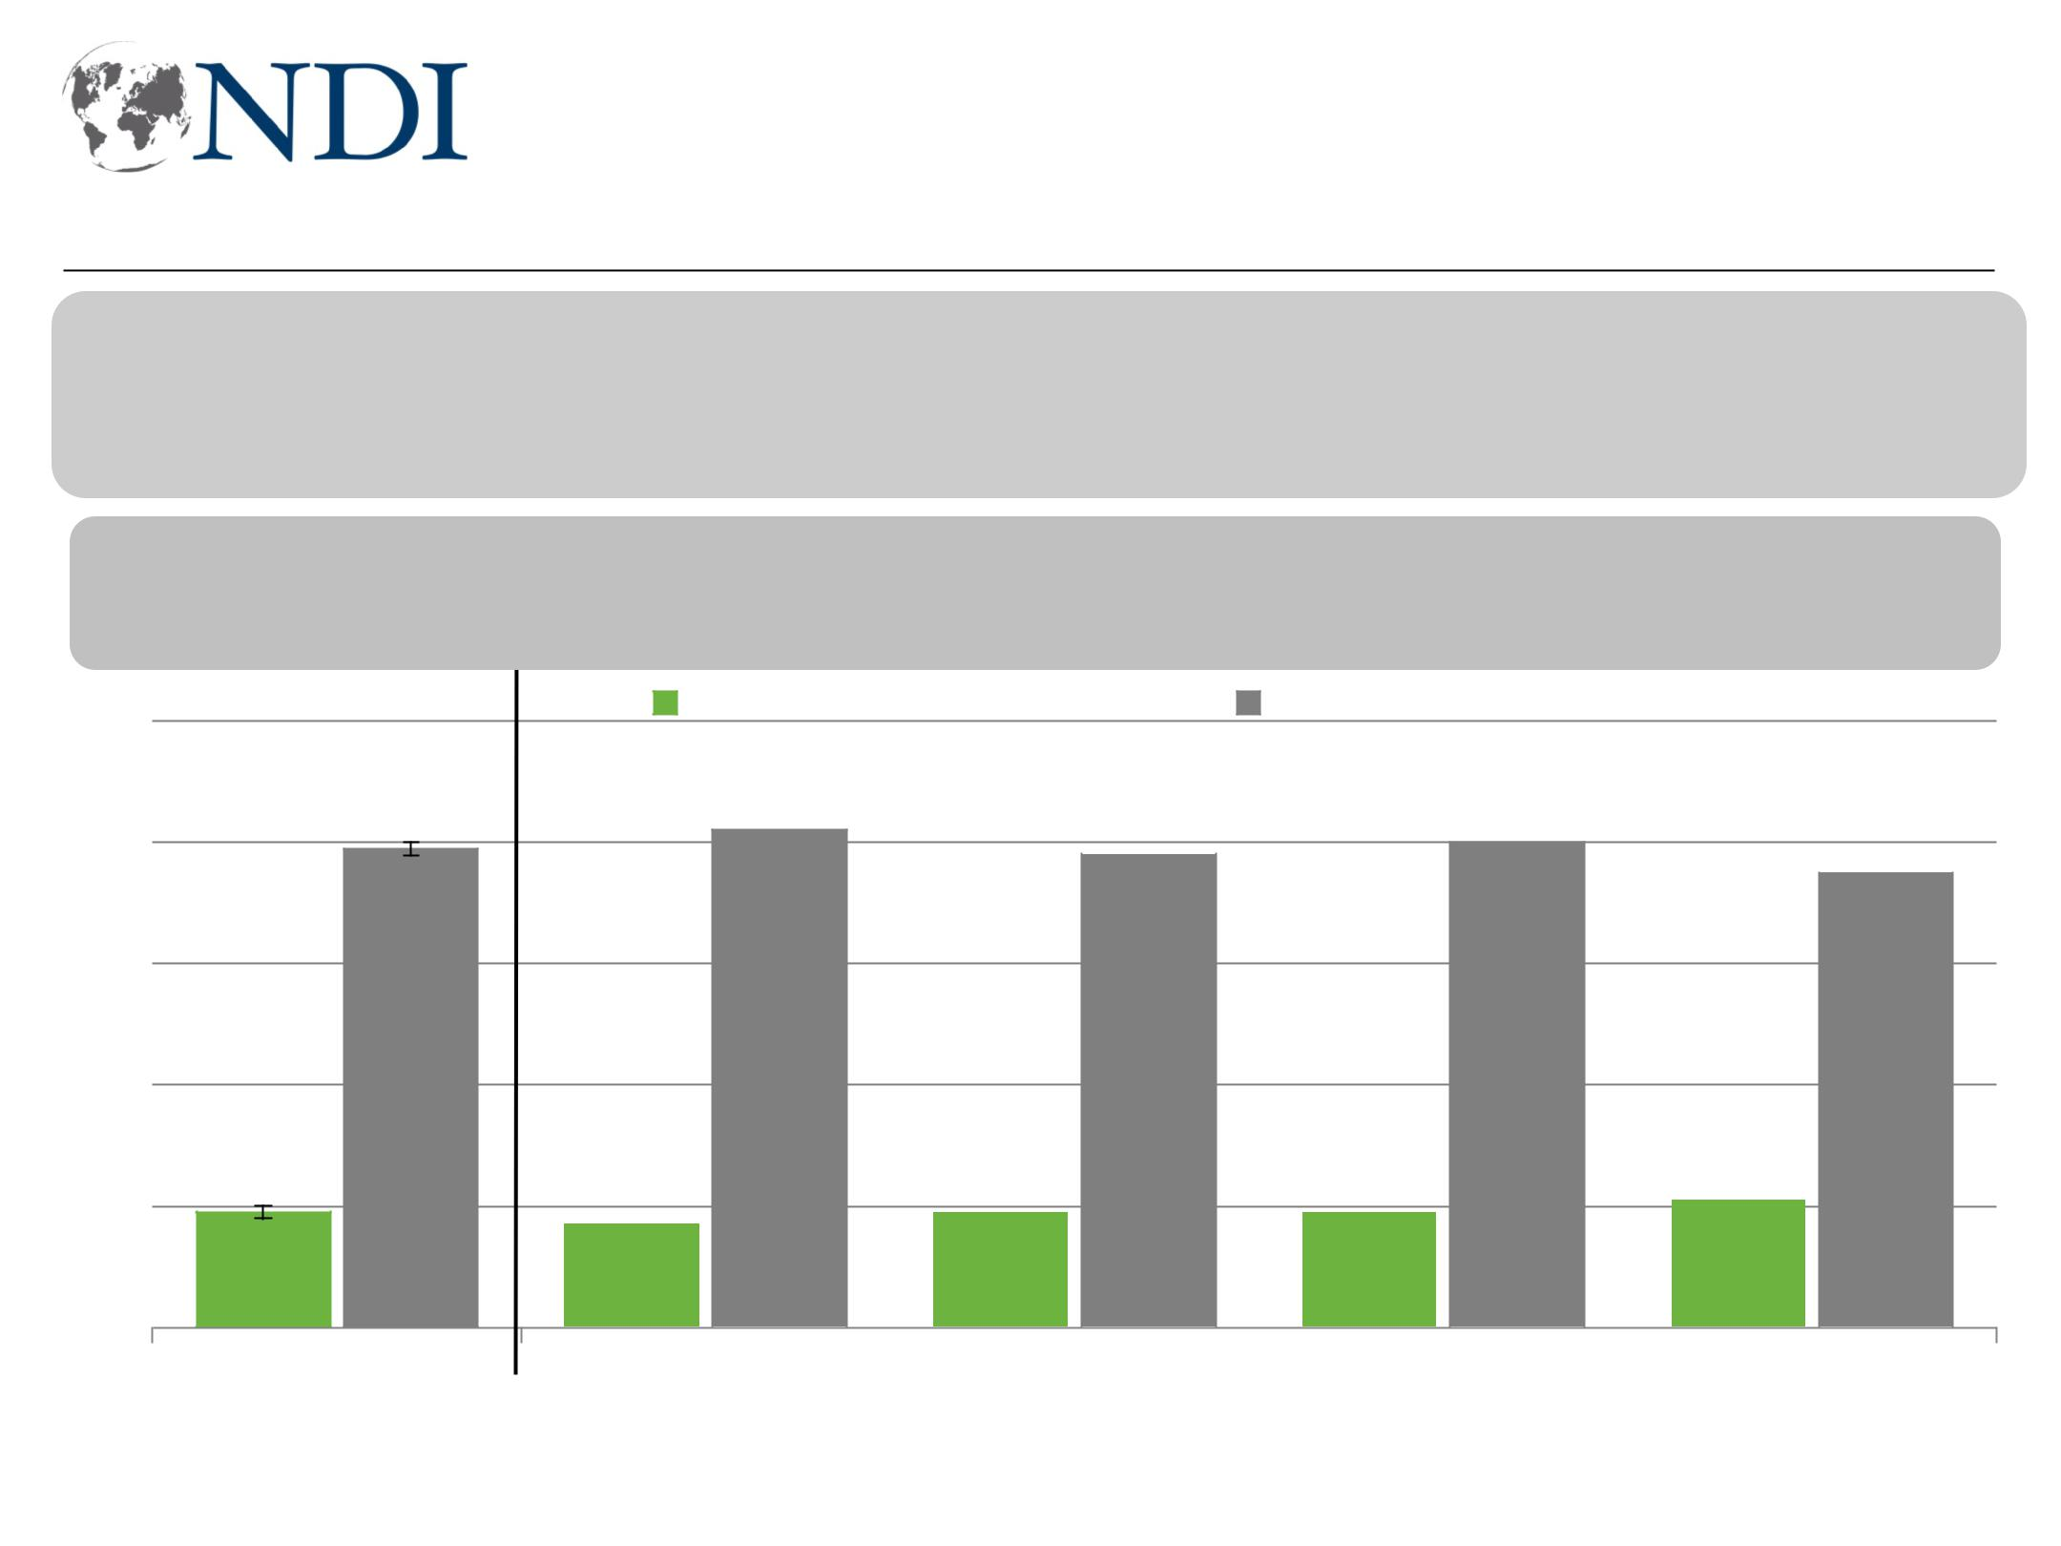
Less than 1 in 5 think elections were free and fair

This wave: Do you think the May 2018 Iraqi parliamentary elections were mostly free and fair or mostly NOT free and fair?

April question was: Based on what you know, will the anticipated May 2018 Iraqi elections be mostly free and fair or not mostly free and fair?

- April ‘18

-19 +23

100

80

79
60

40

20

19
0

Total

-20 +21 | -18 +22 | -25 +29 | -12 +17
Free and fair |  | Not free and fair

82 | 78 | 80
82 | 78 | 80 | 75

 |  |  |  |  |  |  |  |  |  |  |  |  |  |  | 21
 |  |  |  |  | 19 |  |  |  |  | 19 |  |  |  |  | 21
17 |  |  |  |  | 19 |  |  |  |  | 19 |  |  |  |  | 21
Baghdad |  |  |  |  | South |  |  |  |  | West |  |  |  |  | KRI

Working for Democracy and Making Democracy Work 19
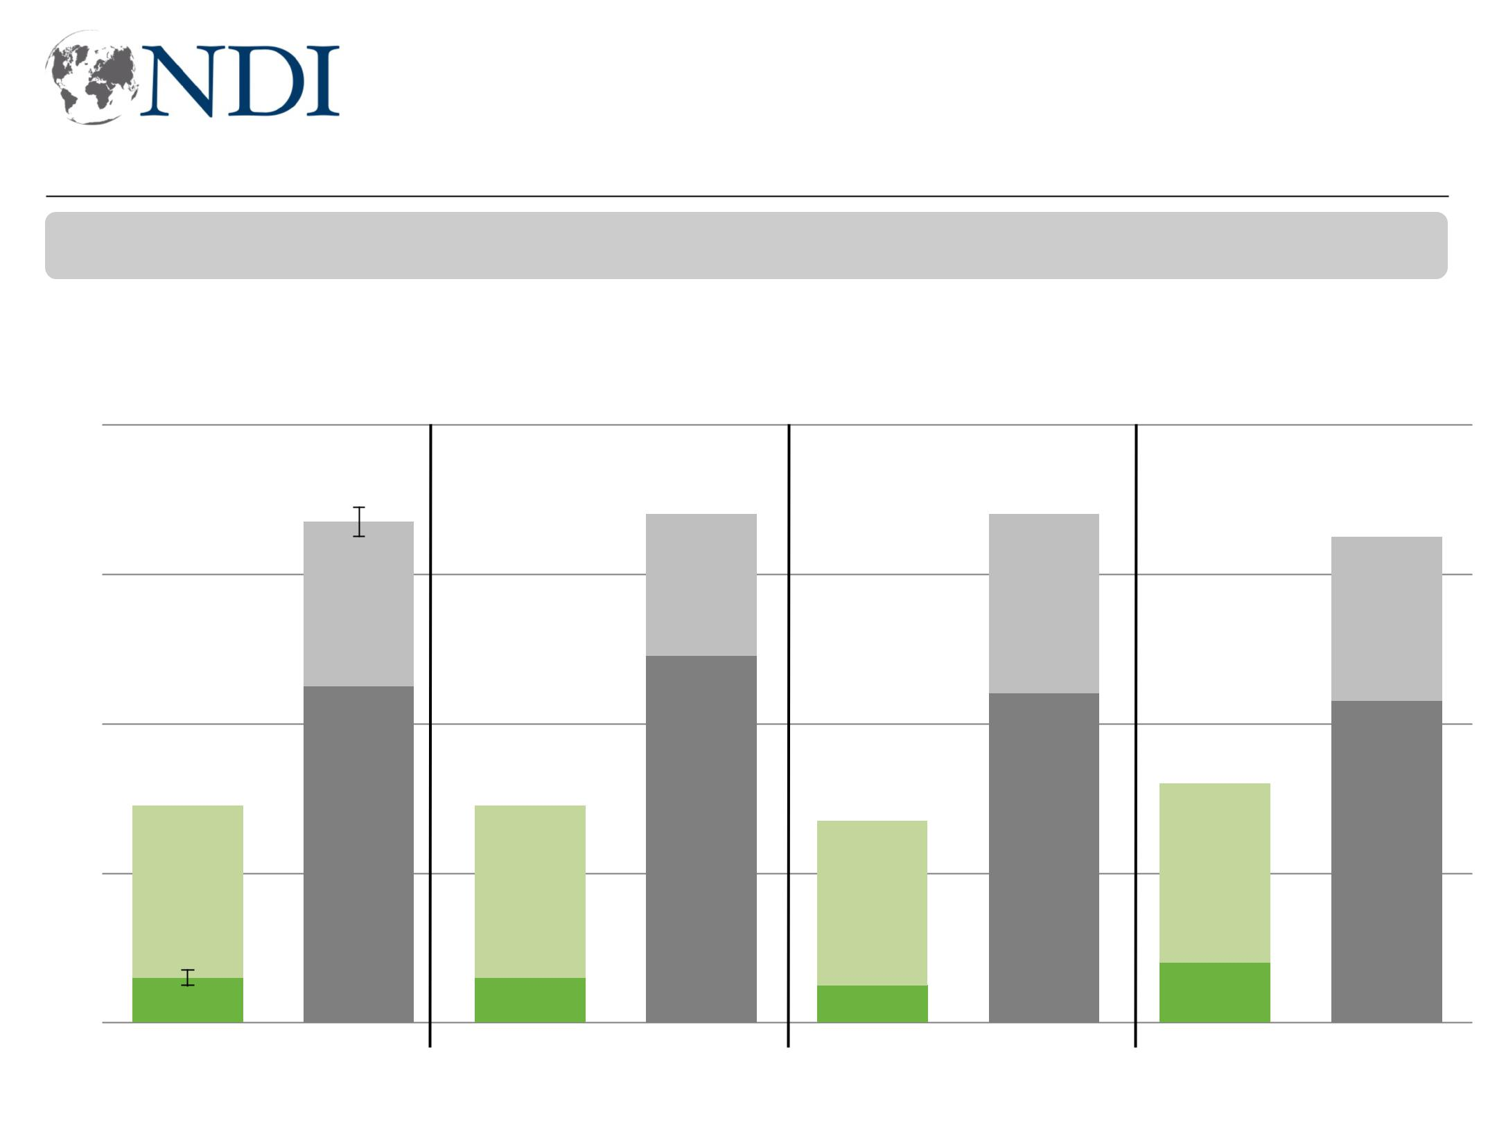
Views of fairness of upcoming provincial elections just as poor

Based on what you know, will the upcoming provincial elections be mostly free and fair or not mostly free and fair?

80

60

 Free and fair, strongly  Not free and fair, strongly

67 68

 Free and fair, somewhat  Not free and fair, somewhat
68 65

40

20

 |  |  |  |  |  |  |  | 49
 |  |  |  | 45 |  |  |  | 49
29 |  |  |  |  |  |  |  | 29

27

44 33 43

0

6 6

Non-KRI Baghdad

5 8
South West

Working for Democracy and Making Democracy Work 20
Election reforms focused on counting increases trust

Now I will read you a list of things that could be done to improve confidence in the results for the upcoming provincial elections. For each, please indicate if that action would increase your trust a great deal, somewhat, just a little, or not at all?

Video record the counting of every ballot

Continue electronic counting, but use int'l audit company to evaluate the technology

Form official committee to review fraud, prosecute those found guilty of manipulating results

Have the United Nations co-manage IHEC

Revert to manually counting each ballot

Permanently replace IHEC with judges appointed by the Supreme Judicial Council

Parliament establishes a new independent IHEC and commissioners

Reinstate suspended IHEC commissioners so they can resume their roles

A great deal |  |  |  |  |  |  |  |  |  |  |  |  |  |  |  |  |  |  |  |  |  |  |  |  |  |  |  | Somewhat
 |  |  |  |  |  |  |  |  |  |  |  |  |  |  |  |  |  |  |  |  | 38 |  |  |  |  |  |  |  |  |  |  |  |  |  |  |  |  |  |  |  |  |  |  |  |  |  |  |  |  |  |  |  |  |  |  |  |  |  |  |  |  |  |  | 65
 |  |  |  |  |  |  |  |  |  |  |  |  |  |  |  |  |  |  |  |  | 36 |  |  |  |  |  |  |  |  |  |  |  |  |  |  |  |  |  |  |  |  |  |  |  |  |  |  |  |  |  |  |  |  |  |  |  |  |  |  |  |  | 63
30 |  |  |  |  |  |  |  |  |  |  |  |  |  |  |  |  |  |  |  |  |  |  |  |  |  |  |  |  |  |  |  |  |  |  |  |  |  |  |  |  |  |  |  |  |  |  |  |  |  |  |  |  |  |  |  | 58
28 |  |  |  |  |  |  |  |  |  |  |  |  |  |  |  |  |  |  |  |  |  |  |  |  |  |  |  |  |  |  |  |  |  |  |  |  |  |  |  |  |  |  |  |  |  |  |  |  |  |  |  |  |  | 54
26 |  |  |  |  |  |  |  |  |  |  |  |  |  |  |  |  |  |  |  |  |  |  |  |  |  |  |  |  |  |  |  |  |  |  |  |  |  |  |  |  |  |  |  |  |  |  |  | 51
21 |  |  |  |  |  |  |  |  |  |  |  |  |  |  |  |  |  |  |  |  |  |  |  |  |  |  |  |  |  |  |  |  |  |  |  |  |  |  |  |  |  |  |  |  |  |  |  |  |  | 51
20 |  |  |  |  |  |  |  |  |  |  |  |  |  |  |  |  |  |  |  |  |  |  |  |  |  |  |  |  |  |  |  | 35 |  |  |  |  |  |  |  |  |  |  |  |  |  | 50
12
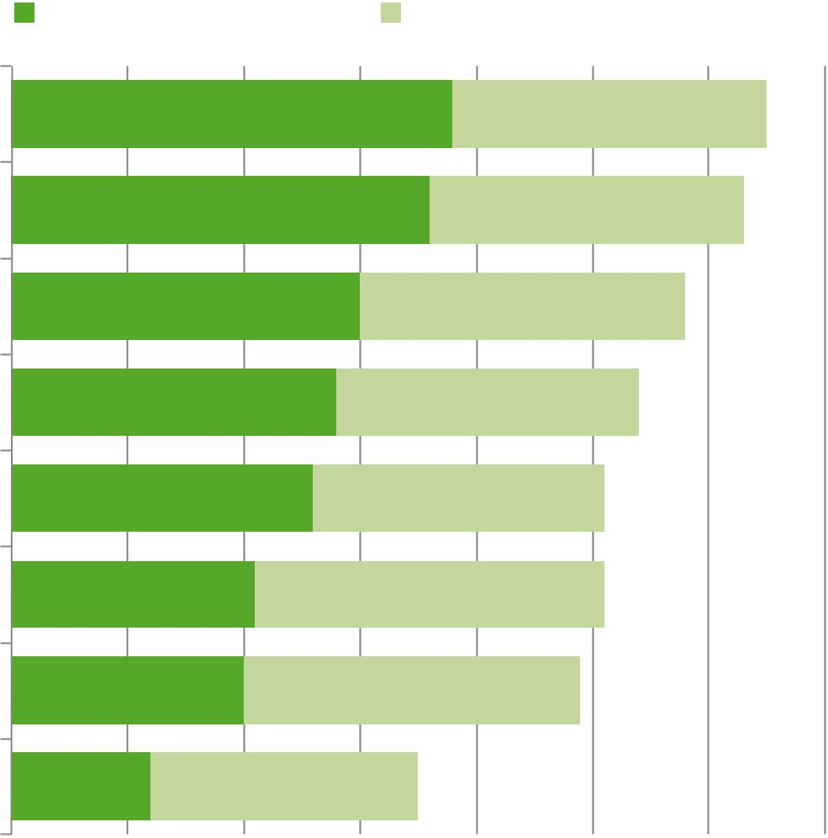

0 | 10 | 20 | 30 | 40 | 50 | 60 | 21 | 70
Working for Democracy and Making Democracy Work

Low trust in government institutions

I will now give you a list of institutions. For each, please tell me how much you trust that institution. Do you trust that institution a lot, somewhat, just a little, or not at all?


Trust a lot Trust somewhat
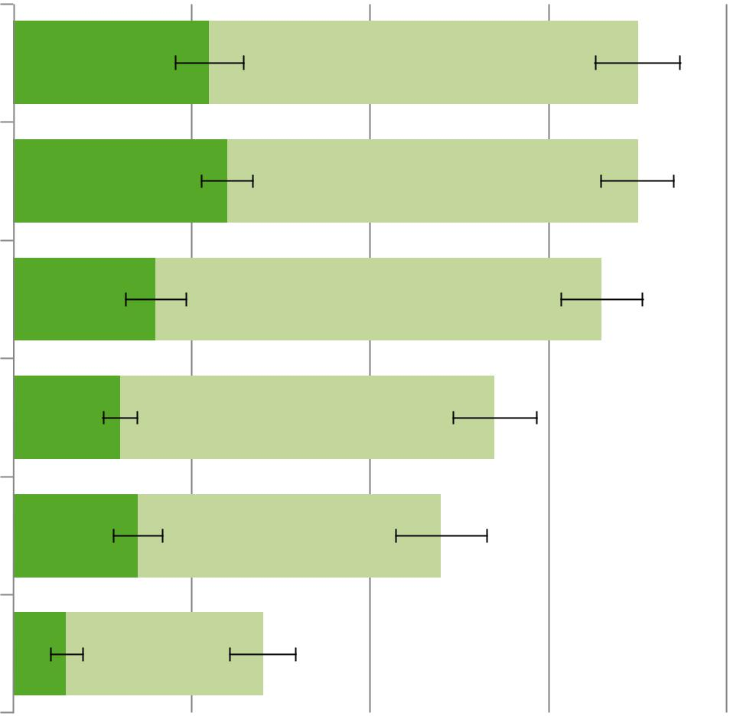

- April ’18

The justice system

The Human Rights Commission

The district council

The provincial council

The Iraqi government

The Council of Representatives

11 | 35
12 | 35
8 | 33
6 | 27
7 | 24
3 | 14

-7

N/A

-1

-7

-11

-2

0 10 20 30 40
Working for Democracy and Making Democracy Work 22
Trust in Iraqi government drops in West and South
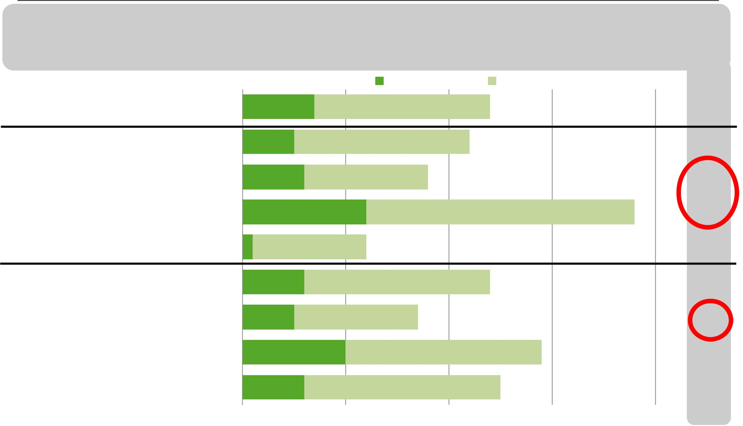

I will now give you a list of institutions. For each, please tell me how much you trust that institution. Do you trust that institution a lot, somewhat, just a little, or not at all? (Iraqi government)
 |  |  |  |  |  |  |  | Trust a lot |  |  | Trust somewhat |  |  | ∆ April
 |  |  |  |  |  |  |  |  |  |  |  |  |  |  |  | ’18
 |  |  |  |  |  |  |  |  |  |  |  |  |  | -11
Total |  |  | 7 |  |  |  |  |  |  |  |  |  | 24
Baghdad |  |  | 5 |  |  |  |  |  |  |  | 22 |  |  | +0
South |  |  | 6 |  |  |  |  | 18 |  |  |  |  |  | -15
West |  |  | 12 |  |  |  |  |  |  |  |  |  |  | 38 -20
KRI 1 |  |  |  |  |  |  |  | 12 |  |  |  |  |  | -1
Young women |  |  | 6 |  |  |  |  |  |  |  | 24 |  |  | -9
Young men |  |  | 5 |  |  |  |  | 17 |  |  |  |  |  | -16
Older women |  |  | 10 |  |  |  |  |  |  |  | 29 |  |  | -8
Older men |  |  | 6 |  |  |  |  |  |  |  | 25 |  |  | -10
0 |  |  | 10 |  |  |  |  | 20 |  |  | 30 |  |  | 40
Working for Democracy and Making Democracy Work 23
Strong support for protests

Generally speaking, do you approve or disapprove of the most recent public protests throughout Iraq?

Approve | Disapprove


100

80

60

40

20

0

 |  |  |  |  | 82 | 80 |  |  |  |  |  | 80 |  |  | 79
76 |  |  |  |  | 82 | 80 |  |  |  |  |  | 80 |  |  | 79
 |  |  |  |  |  | 73 |  |  | 73 |  |  |  | 71
 |  |  |  |  |  |  |  |  | 57
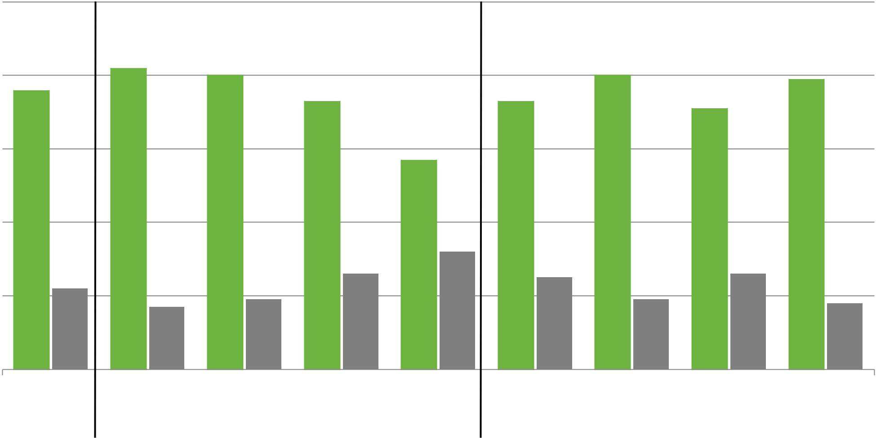

 |  |  |  |  |  |  |  |  |  |  |  |  |  |  |  | 32
 |  |  |  |  |  |  |  |  |  |  |  |  | 26 |  |  | 32 |  |  | 25 |  |  |  |  |  | 26
22 |  |  |  |  |  |  |  |  |  |  |  |  | 26 |  |  |  |  |  | 25 |  |  |  |  |  | 26
 |  |  |  |  |  |  | 17 |  |  | 19 |  |  | 26 |  |  |  |  |  | 25 |  |  | 19 |  |  | 26 |  |  | 18

Total Baghdad South West KRI Young Young Older Older men

women men women

Working for Democracy and Making Democracy Work 24
Mixed views on effectiveness of protests
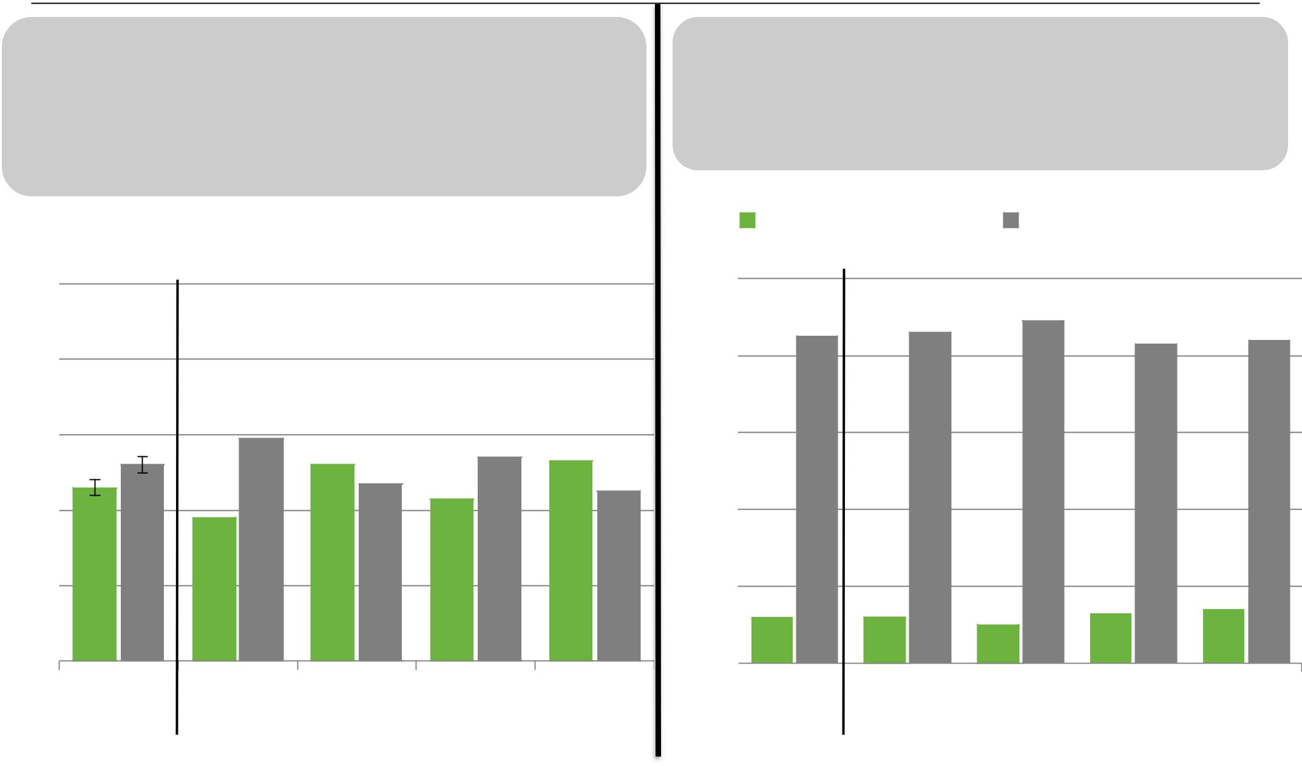

Regardless of whether you approve or disapprove of the protests and demonstrations, do you think

these protests and demonstrations are a very effective means to influencing the government's
actions, somewhat effective, a little effective, or not
at all effective in influencing the government's actions?

Very/somewhat effective A little/not effective

100

80

60
40 465238 59 524743545345
20

0

Total Young Young Older Older women men women men

Regardless of whether you approve or disapprove of the protests and demonstrations,

do you think the politicians in Baghdad have done enough to respond to the demands of the

protestors or have not done enough to respond to the demand of the protestors?

Done enough | Not done enough

100

80 |  |  |  |  | 86 | 89
80 | 85 |  |  |  | 86 | 89 | 83 | 84
60

40

20

0 |  | 12 |  |  |  |  |  |  | 12 |  |  |  | 10 |  |  |  | 13 |  |  |  |  | 14
0 |  | Total |  |  |  |  |  |  |  | Young |  |  | Young |  |  |  | Older |  |  |  |  | Older
 |  |  |  |  |  |  |  |  |  | women |  |  | men |  |  | women |  |  |  |  |  | men

Working for Democracy and Making Democracy Work 25

Some weakening in security perceptions

Working for Democracy and Making Democracy Work 26
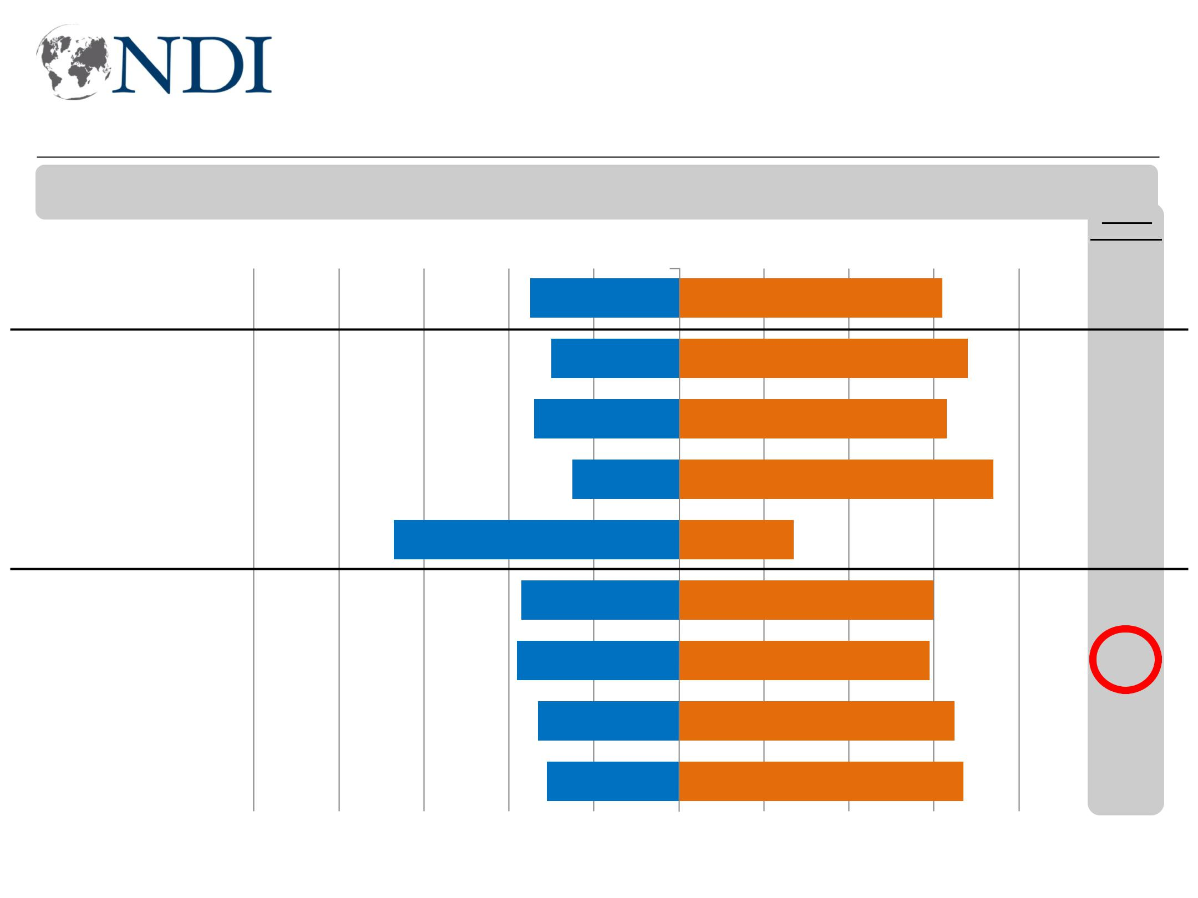
Fewer Iraqis view security as getting better

Now, I will read you a list of issues. Please tell me if you think this issue is getting better or worse in Iraq . (Security)

Worse Better

Total |  |  |  |  | 35 |  |  | 62
Baghdad |  | 30 |  |  |  |  |  | 68
South |  | 34 |  |  |  |  |  | 63
West | 67 | 25 |  |  |  |  |  | 74
KRI | 67 | 37 |  |  |  |  |  | 27
Young women |  |  |  |  |  |  |  | 60
Young men |  | 38 |  |  |  |  |  | 59
Older women |  | 33 |  |  |  |  |  | 65
Older men |  | 31 |  |  |  |  |  | 67

-16

-14

-16

-13

-23

-16

-20

-13

-12

-100 -80 -60 -40 -20 0 20 40 60 80 100

Working for Democracy and Making Democracy Work 27
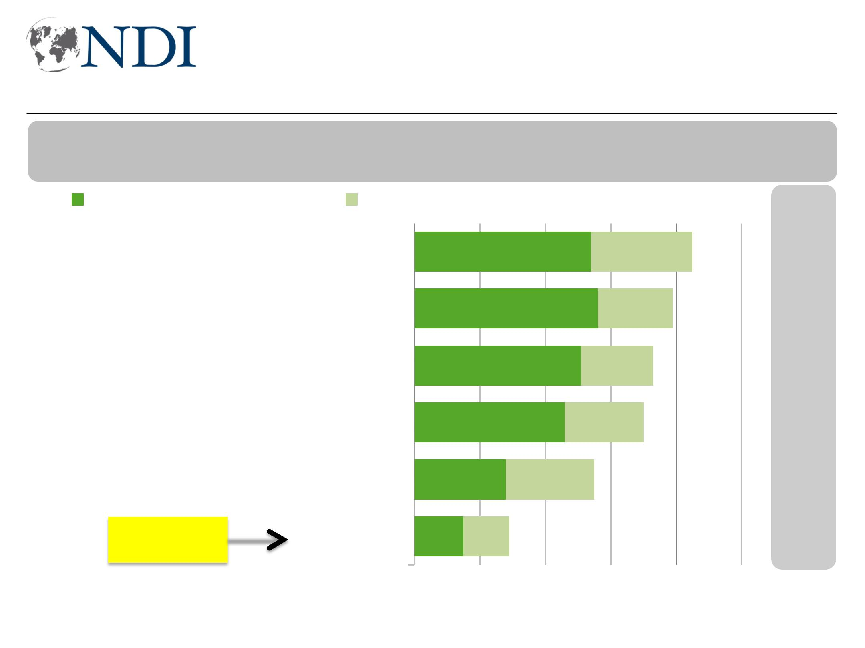
But security forces continue to be seen as responsive

Now I am going to ask about different groups in Iraq. For each one, please tell me how responsive they would be to you if you need help.

Very responsive |  | Somewhat responsive
 |  |  |  |  |  |  |  |  |  | 54 |  |  |  |  |  |  |  |  |  |  |  |  |  |  |  |  |  |  |  |  |  |  |  |  |  |  |  |  |  |  |  |  |  |  |  |  |  |  |  | 85
 |  | Local police |  |  |  |  |  |  |  |  |  |  |  |  |  |  |  |  |  |  |  |  |  |  |  |  |  |  |  |  |  |  |  |  |  |  |  |  |  |  |  |  |  |  |  |  |  |  |  | 85
 |  |  |  |  |  |  |  |  |  | 56 |  |  |  |  |  |  |  |  |  |  |  |  |  |  |  |  |  |  |  |  |  |  |  |  |  |  |  |  |  |  |  |  |  |  |  | 79
 | The Iraqi army
 |  |  |  |  |  |  |  |  |  | 51 |  |  |  |  |  |  |  |  |  |  |  |  |  |  |  |  |  |  |  |  |  |  |  |  |  |  |  |  |  |  |  | 73
PMUs only from your governorate
 |  |  |  |  |  |  |  |  |  | 46 |  |  |  |  |  |  |  |  |  |  |  |  |  |  |  |  |  |  |  |  |  |  |  |  |  |  |  |  |  | 70
PMUs from other governorates |  |  |  |  | 28
 |  |  |  |  |  |  |  |  |  | 55
 | Federal police
KRI—90% |  | Peshmerga 15 |  |  |  |  |  |  |  |  |  |  |  |  |  | 29

- April 18

+2

-2

+1

+6

+8

+7

0 20 40 60 80 100

Working for Democracy and Making Democracy Work 28
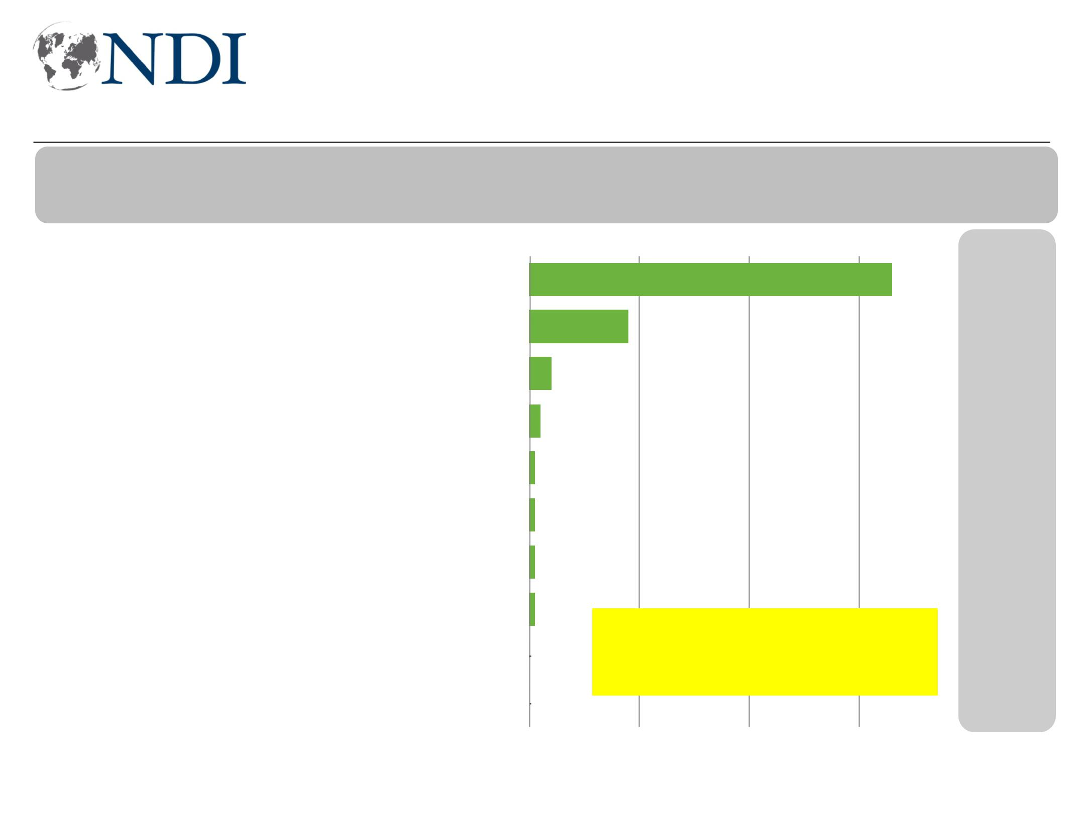
ISIS continues to be biggest security concern

Based on what you know, which ONE of the following do you feel is the biggest threat to your day to day security?

 |  |  |  |  |  |  |  |  |  |  |  |  |  |  |  |  |  |  |  |  |  |  |  | 66 |  |  |  |  |  | ∆ April 18
ISIS and other terrorist organizations |  |  |  |  |  |  |  |  |  |  |  |  |  |  |  | 18 |  |  |  |  |  |  |  | 66 |  |  |  |  | +8
Local criminals |  |  |  |  |  |  |  |  |  |  |  |  |  |  |  | 18 |  |  |  |  |  |  |  |  |  |  |  |  | -2
Other clans |  |  |  |  |  |  |  |  |  |  |  |  |  |  |  | 4 |  |  |  |  |  |  |  |  |  |  |  |  | +2
PMUs only from your governorate |  |  |  |  |  |  |  |  |  |  | 2 |  |  |  |  |  |  |  |  |  |  |  |  |  |  |  |  |  | +0
 |  |  |  |  |  |  |  |  |  |  |  |  |  |  |  |  |  |  |  |  |  |  |  |  |  |  |  |  | +0
The Iraqi army |  |  |  |  |  |  | 1
 |  |  |  |  |  |  |  |  |  |  |  |  |  |  |  |  |  |  |  |  |  |  |  |  |  |  |  |  | -1
Peshmerga |  |  |  |  |  |  | 1
PMUs from other governorates |  |  |  |  |  |  |  | 1 |  |  |  |  |  |  |  |  |  |  |  |  |  |  |  |  |  |  |  |  | -4
My family or clan members |  |  |  |  |  |  | 1 |  |  |  |  |  |  |  |  |  |  |  |  |  |  | KRI Concerns: |  |  |  |  |  |  | +0
 |  |  |  |  |  |  | 0
The local police |  |  |  |  |  |  |  |  |  |  |  |  |  |  |  |  |  |  |  |  | Local criminals: |  | 44% |  |  |  |  |  | -1
The local police |  |  |  |  |  |  |  |  |  |  |  |  |  |  |  | ISIS, other terrorist orgs.: 42%
The federal police |  |  |  |  |  |  | 0 |  |  |  |  |  |  |  |  |  |  |  |  |  |  |  |  |  |  |  |  |  | +0
0 |  |  |  |  |  |  |  |  |  |  |  |  |  |  |  | 20 |  |  |  |  | 40 |  |  | 60 |  |  |  |  | 80
Working for Democracy and Making Democracy Work 29
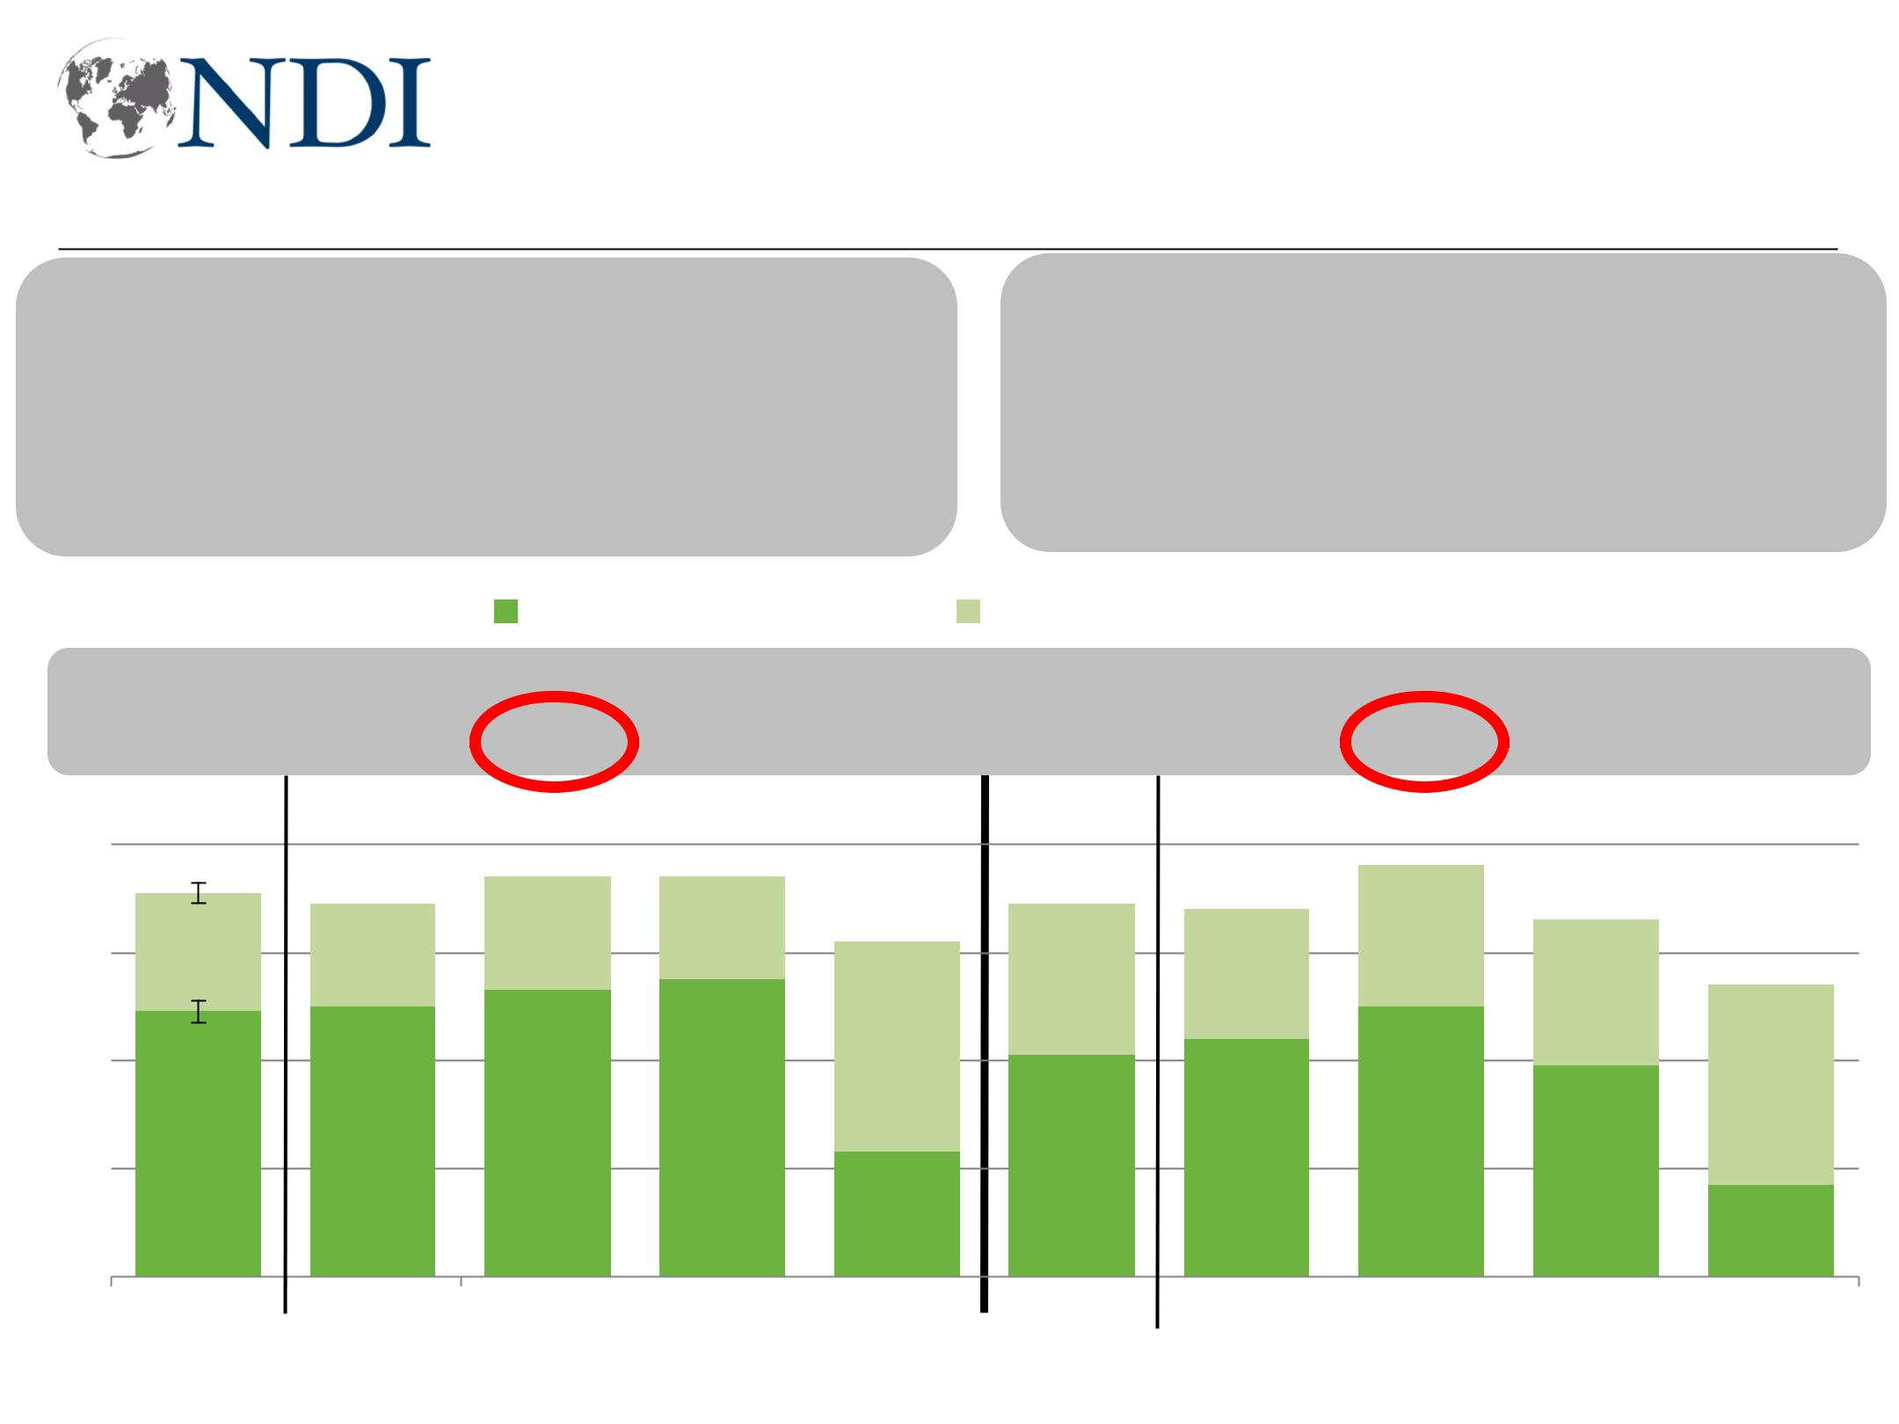
High and growing violence concerns, especially in South

Would you say you are very concerned about ISIS and other extremist groups re-emerging in your area, somewhat concerned, just a little concerned, or not at all concerned about ISIS and other extremist groups re-emerging in your area?

Would you say you are very concerned about violence in your community getting worse over the next 6 months, somewhat concerned, just a little concerned, or not at all concerned about violence in your community getting worse over the next 6 months?

- Very/somewhat, April’18

+10 +13

80 71 70

60

40 49 50

20

0

Total Baghdad

Very Concerned |  |  |  |  |  | Somewhat Concerned
+20 | +8 |  | -12 |  | +13 |  |  |  |  | +9 |  | +22 |  | +13 |  | -10
74 | 74 |  | 62 |  | 69 |  |  |  |  | 69 |  | 76 |  | 66
 |  |  |  |  |  |  |  |  |  |  |  |  |  |  |  | 54
53 | 55 |  |  |  |  |  |  |  |  | 44 |  | 50
53 |  |  | 23 |  | 41 |  |  |  |  |  |  |  |  | 39
 |  |  |  |  |  |  |  |  |  |  |  |  |  |  |  | 17
South |  | West |  | KRI |  | Total |  |  |  |  | Baghdad |  | South |  | West |  | KRI

Working for Democracy and Making Democracy Work 30
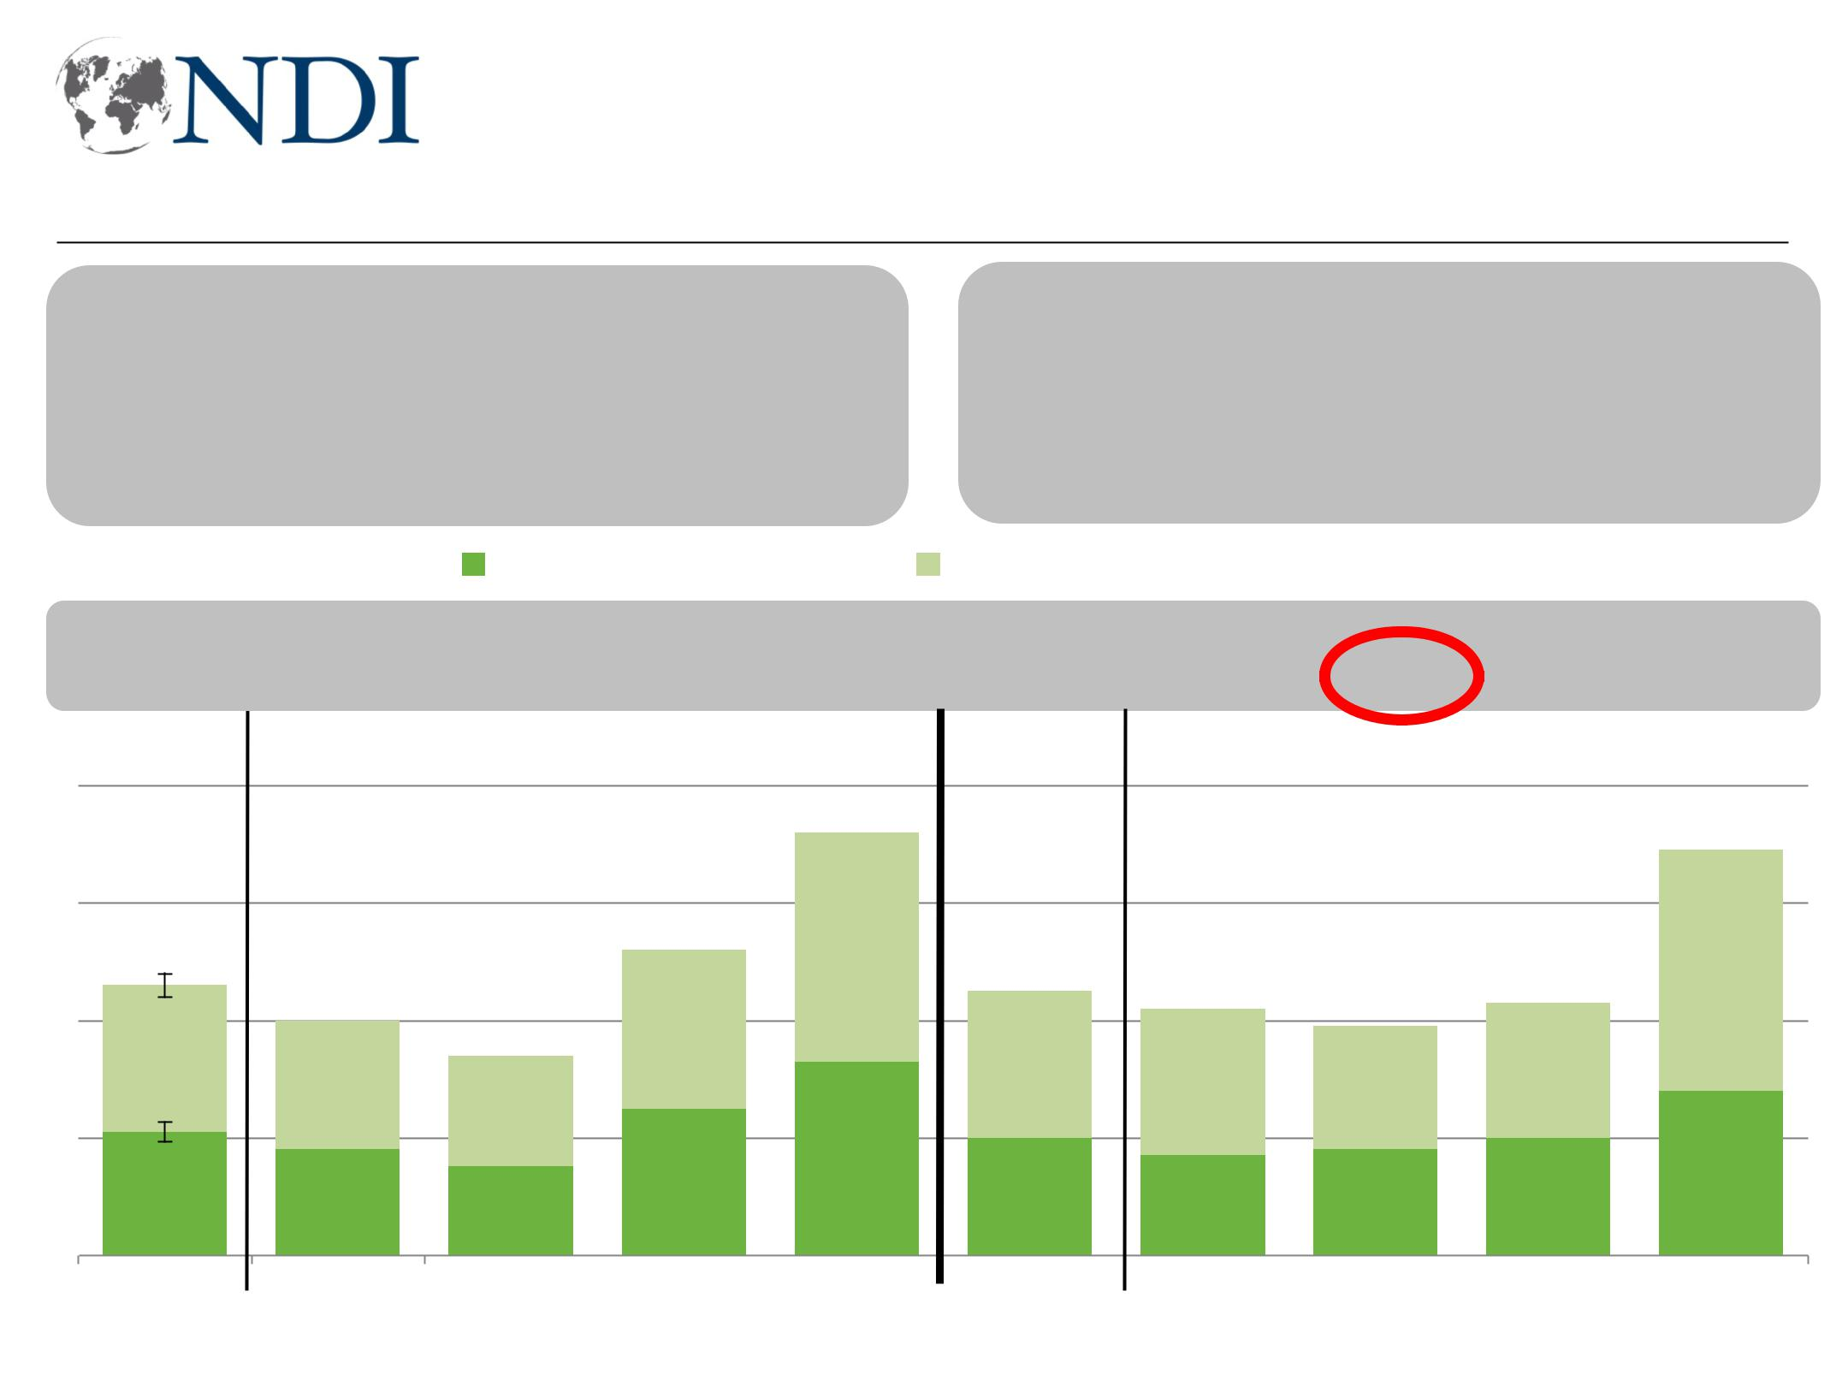
Concerns also increase for PMUs and Army violence

As you know, many people have differing opinions about the PMUs. We want to gain a better understanding of these views. Based on what you know, how concerned are you about members of the PMUs committing violence?

How concerned are you about members of the Iraqi Army and Security Forces committing violence? Would you say you are very concerned, somewhat concerned, just a little concerned, or not at all concerned?

- Very/somewhat, April’18

+4 +5

80

60
45 40

40

20
21 18
0
Total Baghdad

Very Concerned |  |  |  |  |  | Somewhat Concerned
+12 | +4 |  | -19 |  | +10 |  |  |  |  | +10 |  | +20 |  | +6 |  | -14
 |  |  | 71 |  |  |  |  |  |  |  |  |  |  |  |  | 69
 | 52 |  |  |  | 45 |  |  |  |  | 42 |  | 39 |  | 43
34
34 | 25 |  | 33 |  |  |  |  |  |  |  |  |  |  |  |  | 28
15 |  |  |  |  | 20 |  |  |  |  | 17 |  | 18 |  | 20
South |  | West |  | KRI |  | Total |  |  |  |  | Baghdad |  | South |  | West |  | KRI
Working for Democracy and Making Democracy Work 31
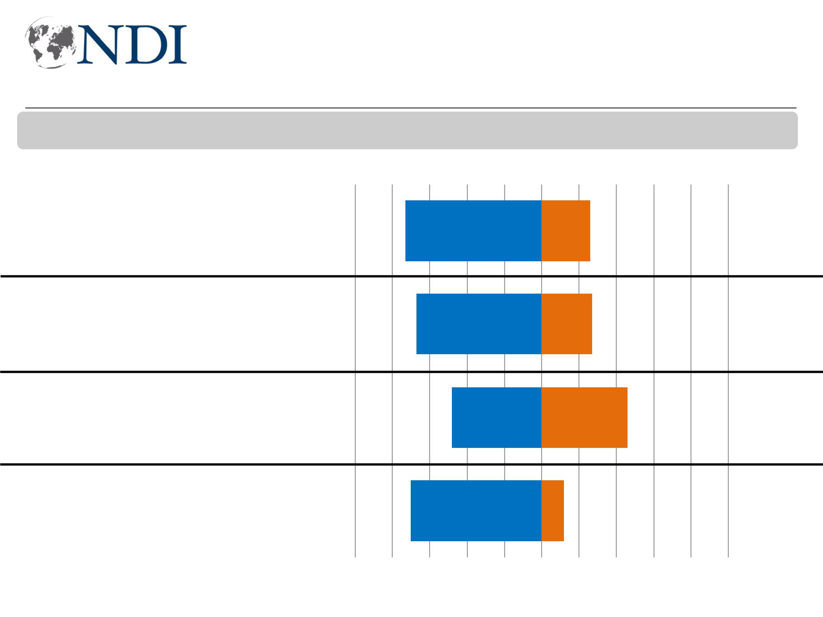
More say tribal violence getting worse

Now, I will read you a list of issues. Please tell me if you think this issue is getting better or worse in Iraq. (Violence between tribes)

Worse Better

Baghdad

South

West

KRI

73 26

67 27

48 46

70 12

-100 -80 -60 -40 -20 0 20 40 60 80 100

Working for Democracy and Making Democracy Work 32
Unemployment, access to weapons cause tribal violence

Now, to something else. Some say that tension among tribes in some parts of Iraq has increased lately. I am going to read you a list of potential causes of violence between tribes in Iraq. Please tell me which ONE of these do you think is the biggest cause of
violence between tribes in Iraq.
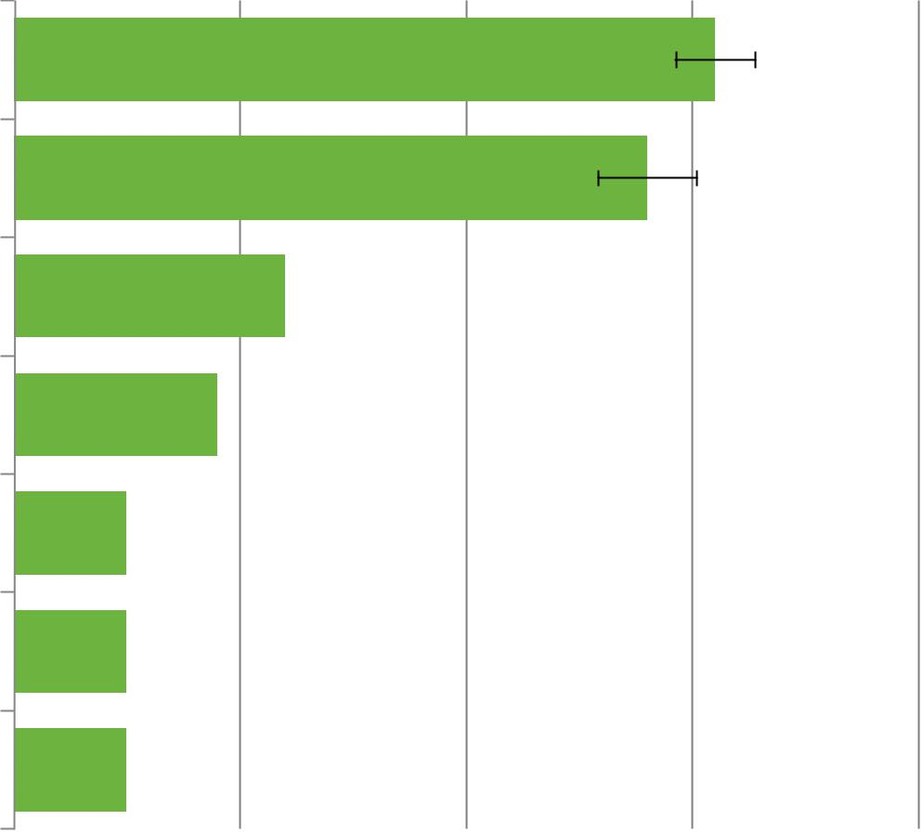

Too many jobless youth

Easy access to weapons

Manipulation by political parties

Manipulation by armed groups

Competition over resources, such as water

Involvement in illegal activities, such as smuggling

Retribution for ISIS fighters and families

31

28

12

9

5

5

5

0 10 20 30 40

Working for Democracy and Making Democracy Work 33

Iraq divided, but not specifically sectarian

Working for Democracy and Making Democracy Work 34
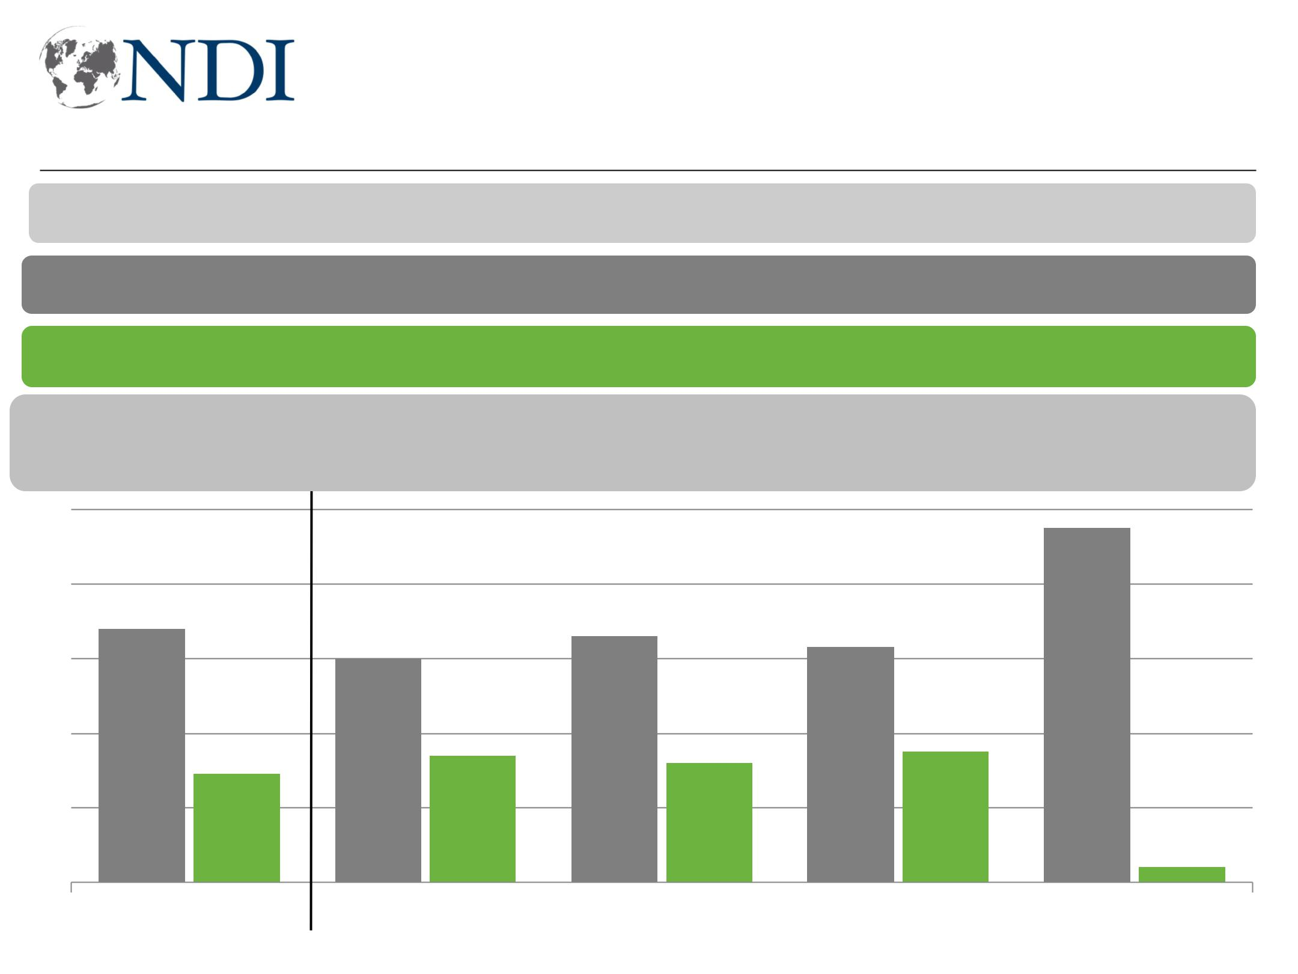
Large majority see Iraq more divided than unified

I'm going to read you some pairs of statements and, for each one, I want you to tell me which statement comes closer to your point of view.

Iraq is mostly a divided country.

Iraq is mostly a unified country.

- Apr’18

100

80

60

40

20

0

+18 -18 +17 -20 +21 -20 +19 -19 +4 -3

 |  |  |  |  |  |  |  |  |  |  |  |  |  |  |  |  |  |  |  |  |  |  |  |  |  |  |  | 95
68 |  |  |  |  |  |  |  |  |  |  |  |  |  |  |  |  |  | 66
 |  |  |  |  |  |  |  |  |  |  |  |  |  |  |  |  |  | 66 |  |  |  |  | 63
 |  |  |  |  |  |  |  |  |  |  |  |  | 60 |  |  |  |  | 66 |  |  |  |  | 63
 |  |  |  |  |  | 29 |  |  |  |  |  |  |  |  | 34 |  |  |  |  | 32 |  |  |  |  | 35 |  |  |  | 4
 |  |  |  | Total |  |  |  |  |  |  |  |  | Baghdad |  |  |  |  | South |  |  |  |  | West |  |  |  |  | KRI
Working for Democracy and Making Democracy Work 35
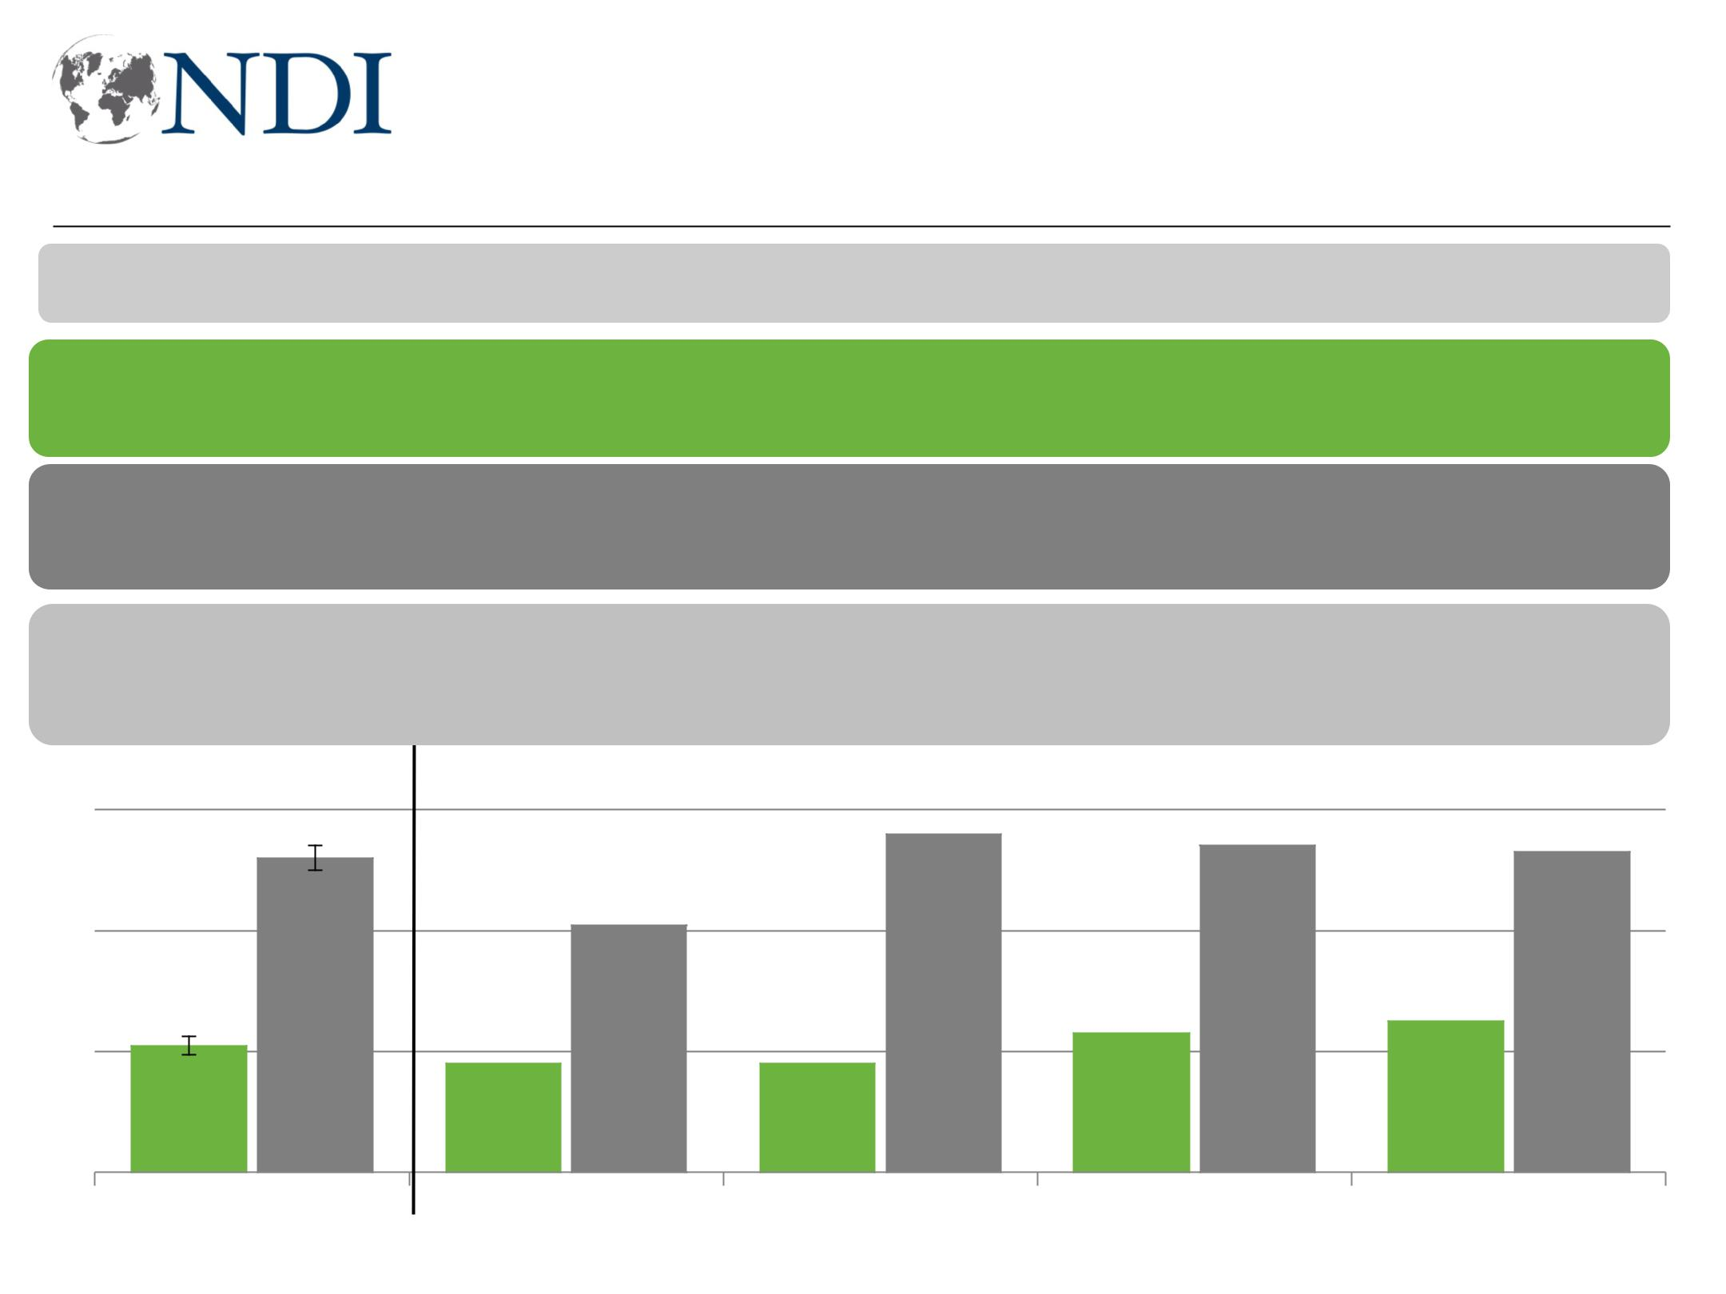
Majority feel other components get more services

I'm going to read you some pairs of statements and, for each one, I want you to tell me which statement comes closer to your point of view.

I generally feel that my component gets its fair share of services.

I feel that other components get more services than they should.

- April ’18

80 -3 +1

60

40 52

20

21

0

Total

-4 -4 -5 +10 -7 -1 +6 -11

56 54 53

41
18 18 23 25

Baghdad South West KRI
Working for Democracy and Making Democracy Work 36
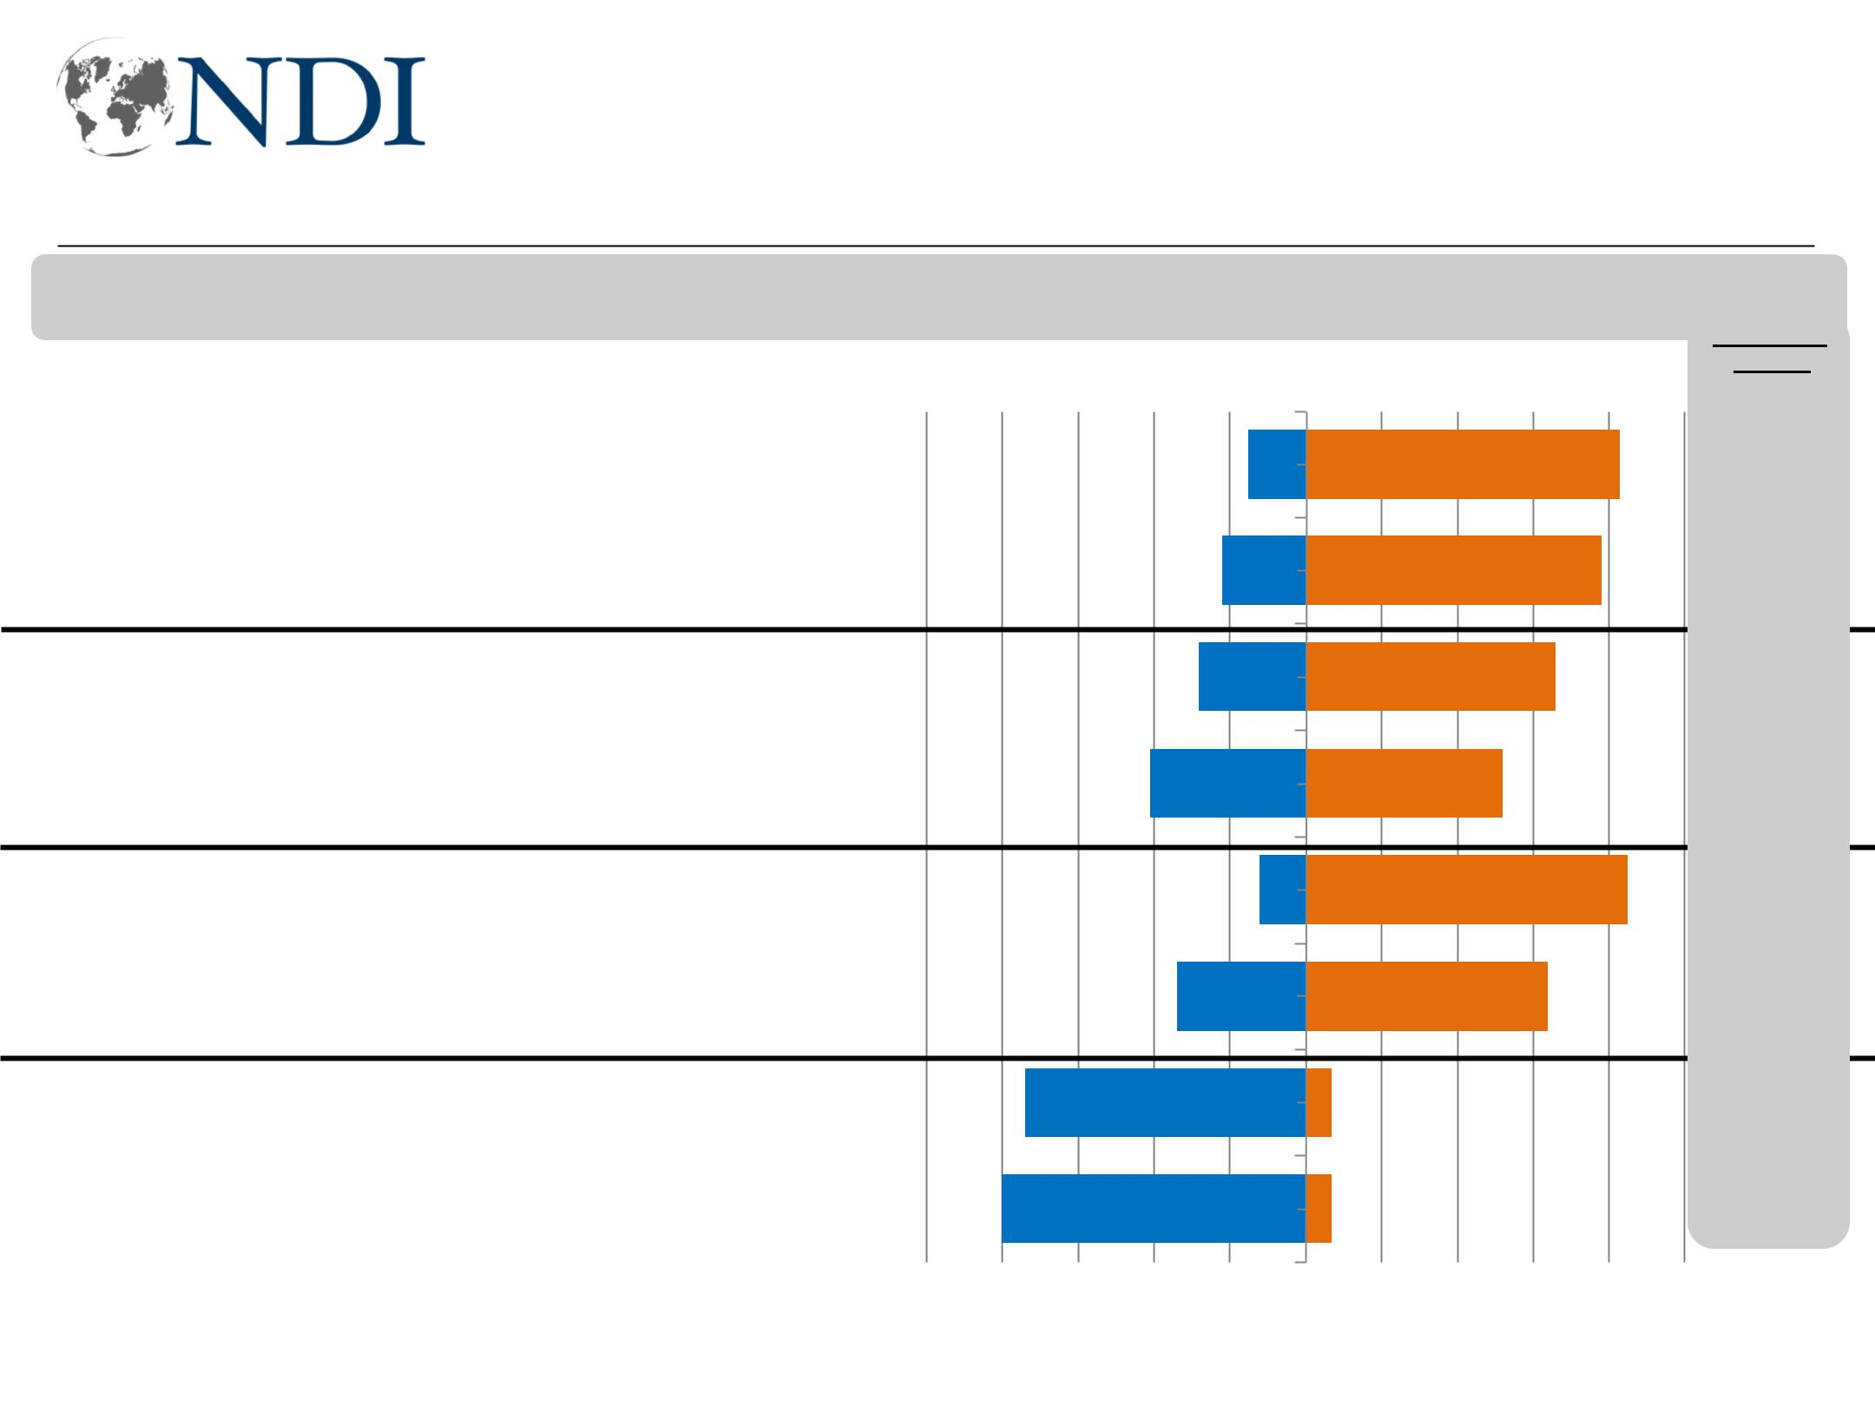
Division not on sectarian lines; Sunni-Shia relations seen as improving

Now, I will read you a list of issues. Please tell me if you think this issue is getting better or worse in Iraq.

Relations between Sunni and Shia

Baghdad

Sectarianism

Relations between Sunni and Shia

South

Sectarianism

Relations between Sunni and Shia

West

Sectarianism

Relations between Sunni and Shia

KRI

Sectarianism

74

80

Worse Better

15 83

22 78

28 66

41 52

12 85

34 64

7

7

-7

-8

-5

-13

+0

-10

+2

-2

-100 -80 -60 -40 -20 0 20 40 60 80 100

Working for Democracy and Making Democracy Work 37
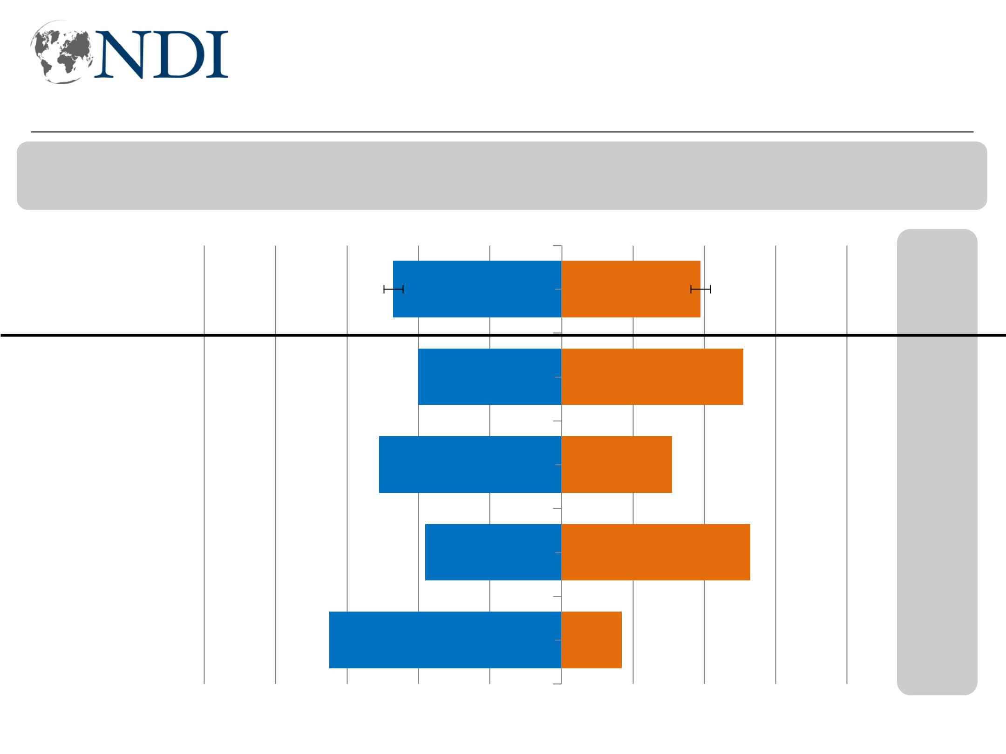
Perceptions of relations with KRG slightly improving

Now, I will read you a list of issues. Please tell me if you think this issue is getting better or worse in Iraq. (Relations between the Kurdistan Regional Government and the central government.)

Worse Better

Total | 47 | 39

Baghdad | 40 | 51

South | 51 | 31

West | 38 | 53

KRI 65 17

- April ‘18 Better
+6

+12

+1

+8

+8

-100 -80 -60 -40 -20 0 20 40 60 80 100
Working for Democracy and Making Democracy Work 38

Iraqis and job creation

Working for Democracy and Making Democracy Work 39
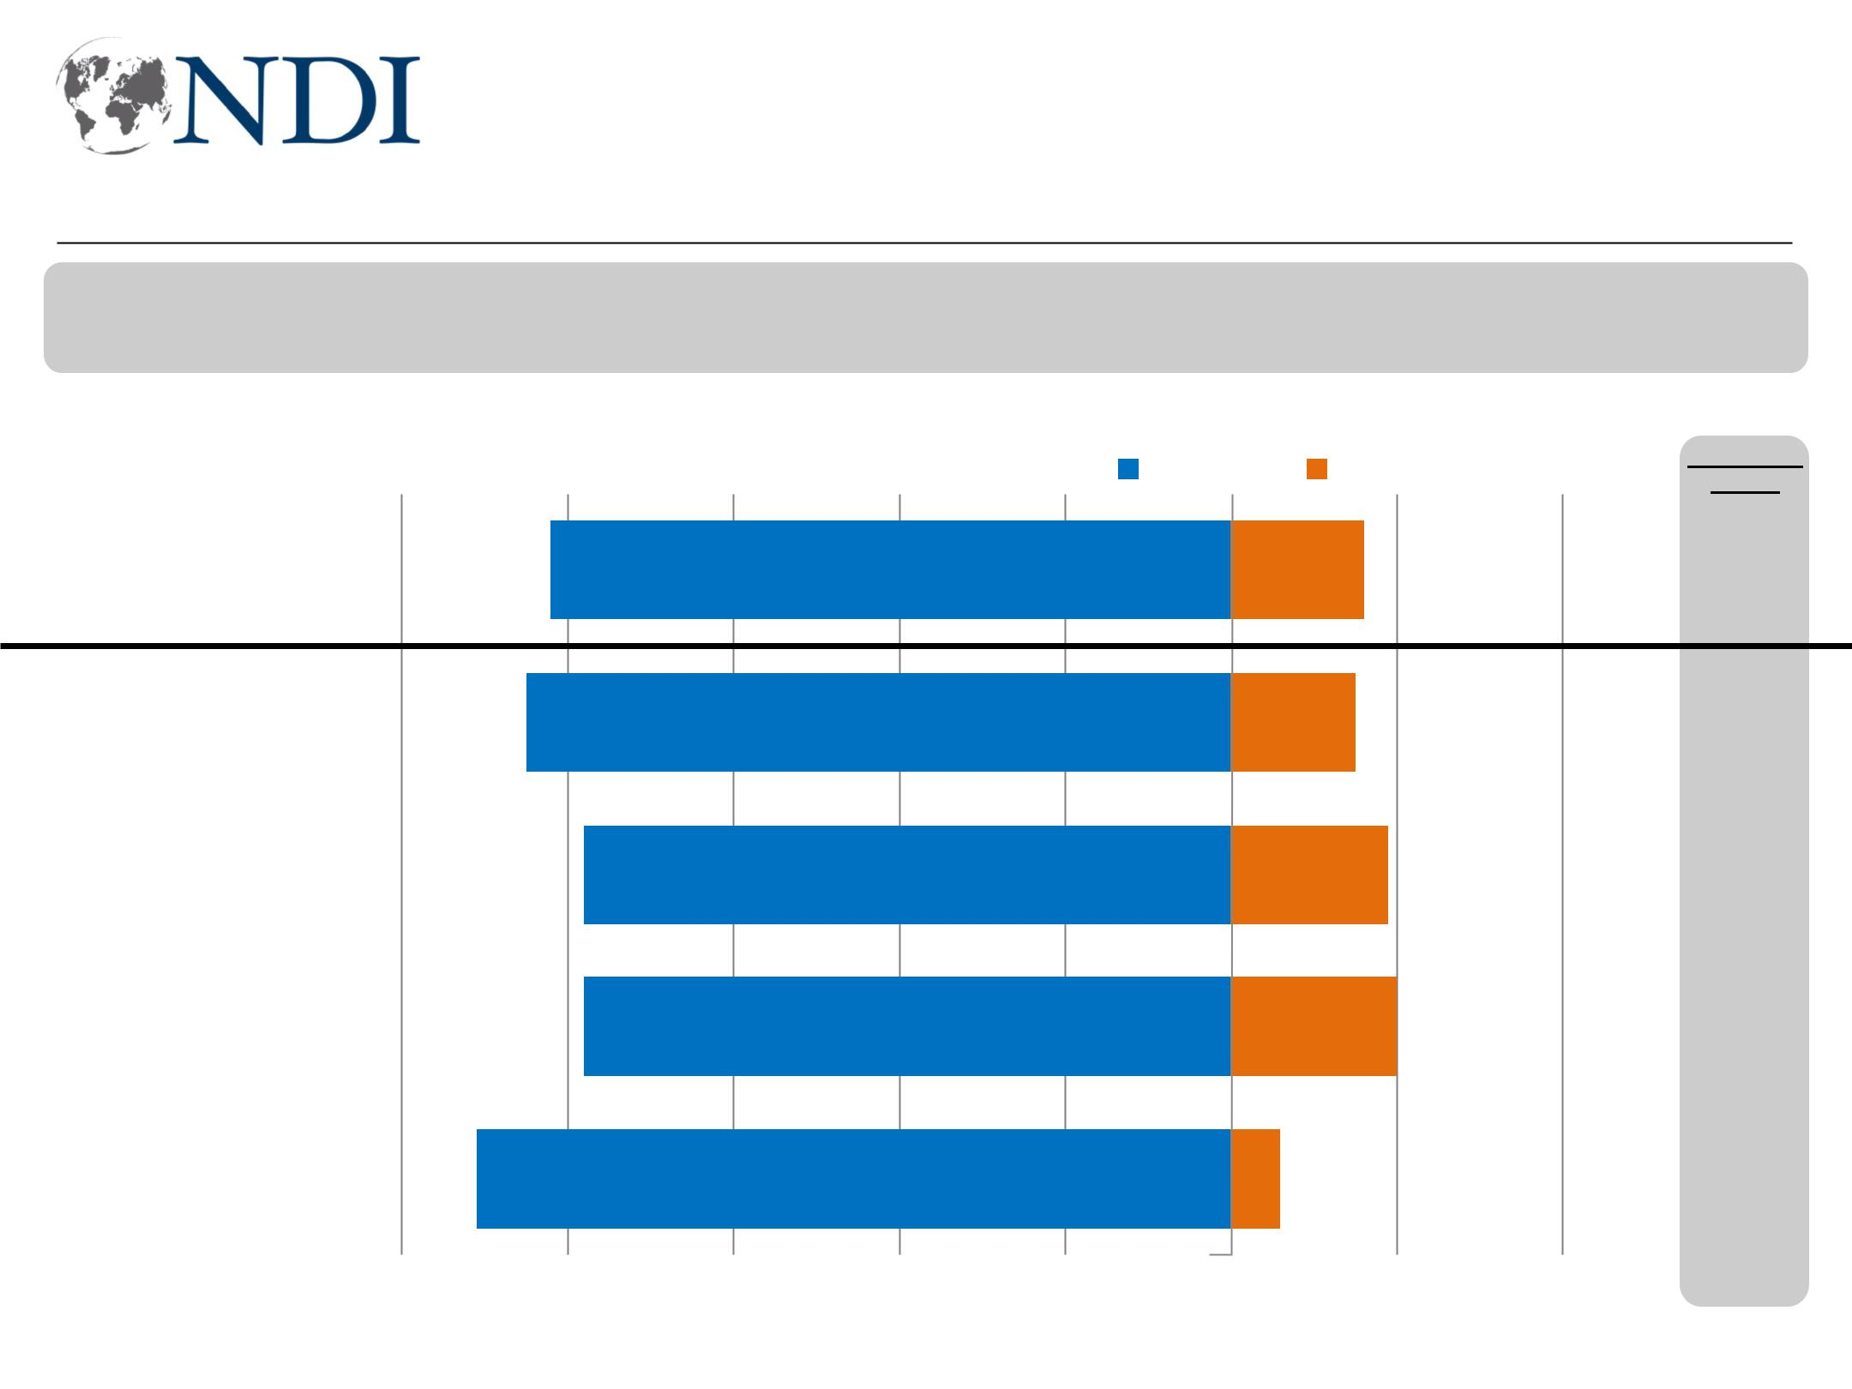
Job opportunities continue to be viewed as worsening

Now, I will read you a list of issues. Please tell me if you think this issue is getting better or worse in Iraq. (Job opportunities)

 |  |  |  |  |  | Worse Better
Total |  |  |  |  | 82 |  |  |  | 16
Baghdad | 85
Baghdad |  |  |  |  |  |  |  |  | 15
South | 78
South |  |  |  |  |  |  |  |  | 19
West | 78
West |  |  |  |  |  |  |  |  | 20
KRI | 91
KRI |  |  |  |  |  |  |  |  | 6

+3

+4

+8

+0

+6

-100 -80 -60 -40 -20 0 20 40 60

Working for Democracy and Making Democracy Work 40
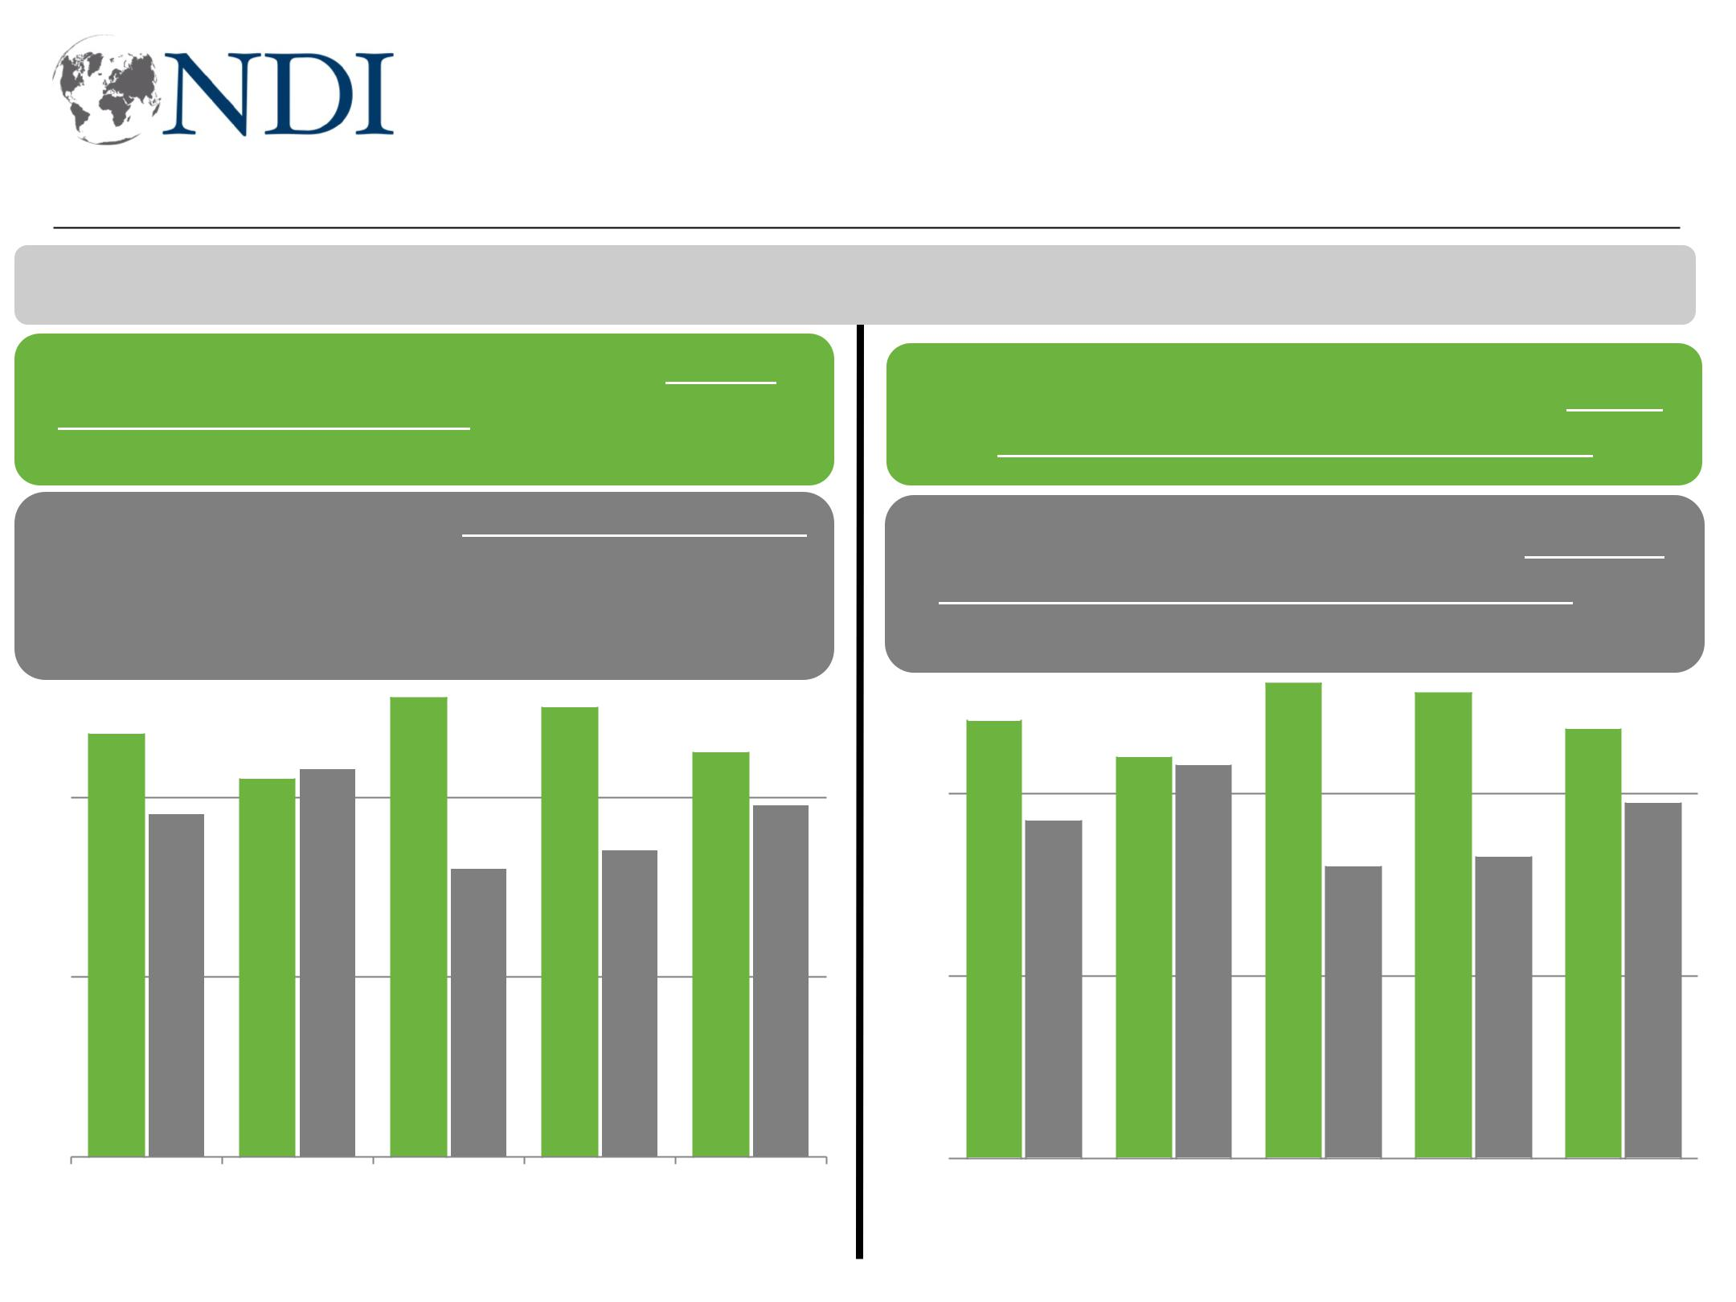
Pluralities want government jobs over private jobs

I'm going to read you some pairs of statements and, for each one, I want you to tell me which statement comes closer to your point of view.

The government should play an active role in increasing jobs in the country by increasing government jobs.

The govt's role should help private sector by creating a coherent legal framework,

- eliminating corruption, & boosting

spending on infrastructure.

What Iraq needs most right now is more jobs created by the government.

What Iraq needs most right now is more
- jobs created by private companies and

businesses.

 |  |  |  |  |  |  |  |  |  | 51 | 50 |  |  |  |  |  |  |  |  |  |  |  |  | 52 |  |  |  | 51
 |  |  |  |  |  |  |  |  |  | 51 | 50 |  |  |  | 48 |  |  |  |  |  |  |  |  |  |  |  |  | 51 | 47
40 | 47 |  |  |  |  |  |  |  |  | 51 | 50 |  |  | 40
40 |  |  |  |  |  |  |  |  | 42 | 43 | 45 |  |  | 40 |  |  |  |  |  |  |  | 44 43
 |  |  |  |  |  |  |  |  | 42 | 43 |  |  |  | 39 |  |  |  |  |  |  |  |  |  |  |  |  |  |  |  | 39
 | 38 |  |  |  |  |  |  |  |  |  |  |  |  | 39
 |  |  |  |  |  |  |  |  |  |  | 34 |  |  | 39 |  |  | 37
 |  |  |  |  |  |  |  |  |  | 32 |  |  |  | 39 |  |  |  |  |  |  |  |  |  |  |  |  |  |  | 33
 |  |  |  |  |  |  |  |  |  | 32 |  |  |  |  |  |  | 32 |  |  |  |  |  |  |  |  |  |  |  | 33
20 |  |  |  |  |  |  |  |  |  |  |  |  |  | 20

0 |  |  |  |  |  |  |  |  |  |  |  |  | 0
0 | Total |  | Men |  | Women |  |  | Less than |  | Intermediate |  |  | 0 |  |  | Total |  |  |  |  |  | Men |  |  |  |  |  | Women |  |  |  |  |  | Less than |  |  |  |  | Intermediate
 |  |  |  |  |  |  | intermediate |  |  | + |  |  |  |  |  |  |  |  |  |  |  |  |  |  |  |  |  |  |  |  |  |  | intermediate |  |  |  |  | +
 |  |  |  |  |  |  |  | educ. |  |  |  |  |  |  |  |  |  |  |  |  |  |  |  |  |  |  |  |  |  |  |  |  |  | educ.
Working for Democracy and Making Democracy Work 41
Focus on government jobs to reduce unemployment

Now I am going to read you a list of things the next government of Iraq could do to improve the country's employment situation. Please tell me which TWO of these would be most important to improve the country's employment situation?
Non-KRI | KRI
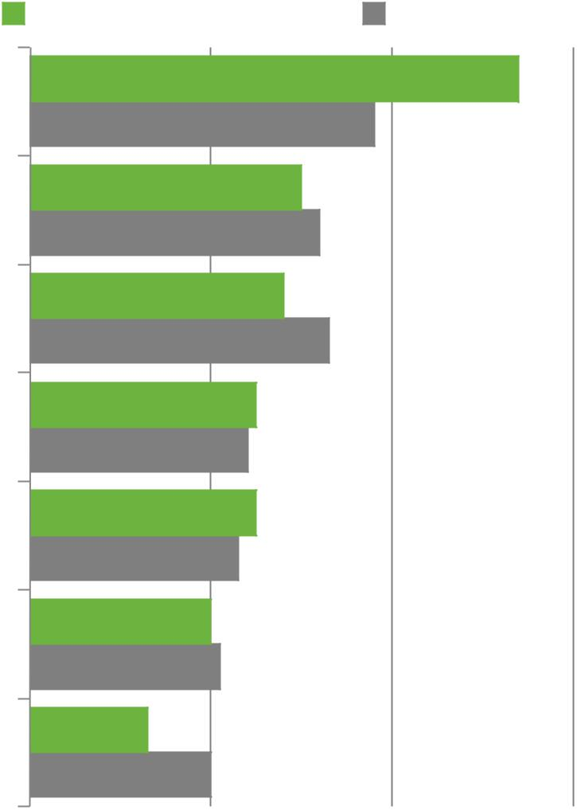

Create more government jobs

Ensure positions are filled on merit, not quota/connections

Provide incentives to businesses that hire new employees

Establish vocational training centers throughout Iraq

Focus on creating jobs outside the oil sector

Incentivize employers to hire more women

Reduce the paperwork needed to create new companies
54
38
30

32
28

33
25

24
25

23
20

21
13

20

0 | 20 | 40 | 42 | 60
Working for Democracy and Making Democracy Work |  |  | 42

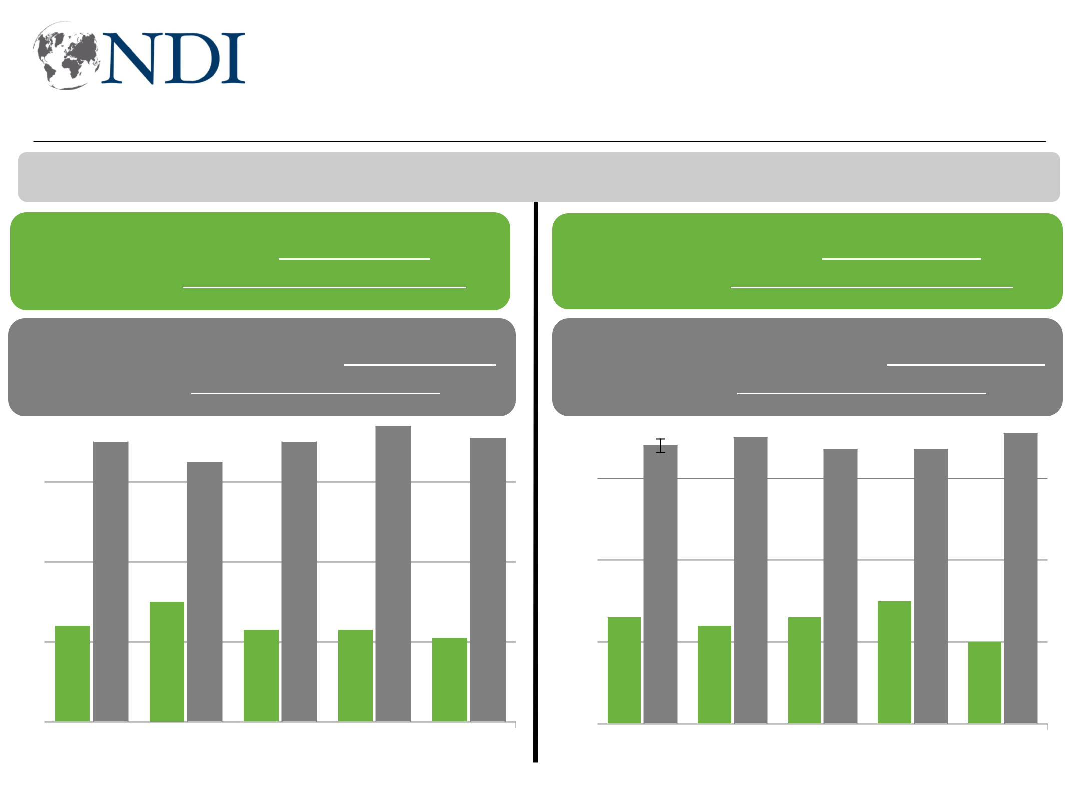
In public and private sector, you need to know right people

I'm going to read you some pairs of statements and, for each one, I want you to tell me which statement comes closer to your point of view.

You are likely to get a public sector job if | You are likely to get a private sector job if
you are the most qualified candidate. |  | you are the most qualified candidate.
You are most likely to get a public sector | You are most likely to get a private sector
job if you know the right people. | 80 | job if you know the right people.
80 | 80

 |  |  |  |  |  |  |  |  | 74
 |  |  |  |  |  |  |  |  | 74 | 71
 | 70 |  |  |  |  |  |  | 70 | 74 | 71
60 |  |  |  |  | 65 |  |  | 70 | 74 | 71

40

20 |  |  |  |  |  |  |  |  |  | 30
20 |  |  | 24 |  |  |  |  |  |  | 30 |  |  |  |  |  | 23 |  |  |  |  |  | 23
 |  |  |  |  |  |  |  |  |  | 30 |  |  |  |  |  | 23 |  |  |  |  |  | 23 |  |  |  |  |  | 21
0
0 |  |  | Total |  |  |  |  |  | Baghdad |  |  |  |  |  |  | South |  |  |  |  |  | West |  |  |  |  |  | KRI

60 | 68 | 70 | 67 | 67 | 71

40

 |  |  |  |  |  |  |  |  |  |  |  |  |  |  |  |  |  |  |  |  |  |  |  | 30
20 |  |  | 26 |  |  |  |  |  |  |  |  | 24 |  |  |  |  |  | 26 |  |  |  |  |  | 30
20 |  |  |  |  |  |  |  |  |  |  |  | 24 |  |  |  |  |  | 26 |  |  |  |  |  |  |  |  |  |  |  | 20
0
0 |  |  | Total |  |  |  |  |  |  | Baghdad |  |  |  |  |  |  |  | SouthWestKRI

Working for Democracy and Making Democracy Work 43
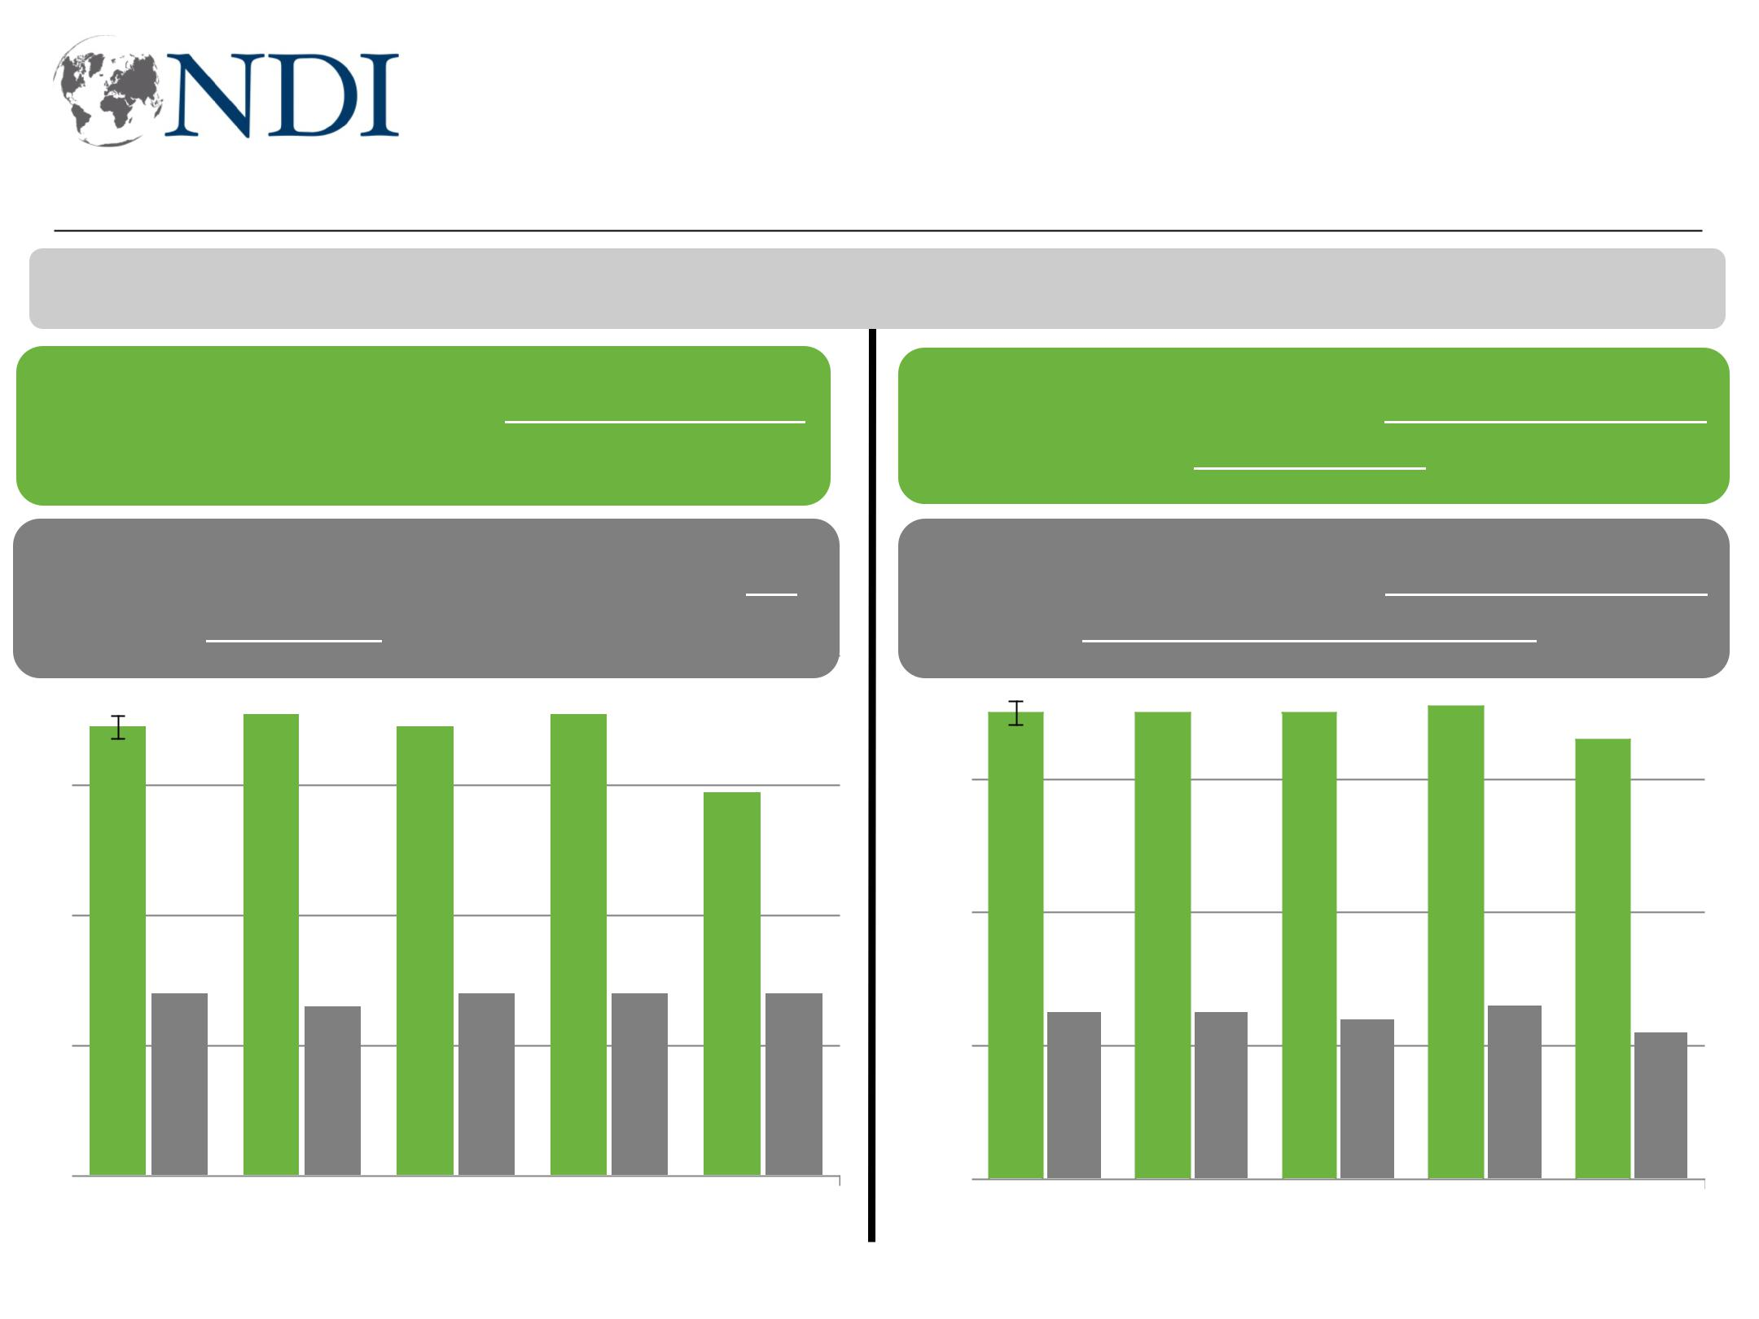
Bribes and connections for government jobs

I'm going to read you some pairs of statements and, for each one, I want you to tell me which statement comes closer to your point of view.

To get a government job you need to pay a bribe.

To get a government job you usually do

To get a government job you need to have connections.

To get a government job you usually need

not need to pay a bribe.
80

80

to have a strong resume.

60 69 71 69 71

59

40

20 |  |  | 28 |  |  |  |  |  | 26 |  |  |  | 28 |  |  | 28 |  |  | 28
0
0 |  | Total |  |  |  |  |  | Baghdad |  |  |  | South |  |  | West |  |  | KRI

60 | 70 | 70 | 70 | 71 | 66

40

 |  |  |  |  |  |  |  |  |  |  |  |  |  |  |  |  |  |  |  |  |  |  |  | 26
20 |  |  |  |  | 25 |  |  |  |  |  |  | 25 |  |  |  |  |  | 24 |  |  |  |  |  | 26
20 |  |  |  |  |  |  |  |  |  |  |  | 25 |  |  |  |  |  | 24 |  |  |  |  |  | 26 |  |  |  |  |  | 22
0
0 |  |  | Total |  |  |  |  | Baghdad |  |  |  |  |  |  |  | South |  |  |  |  |  | West |  |  |  |  |  | KRI

Working for Democracy and Making Democracy Work 44

Some openness to women rights, but with limits

Working for Democracy and Making Democracy Work 45
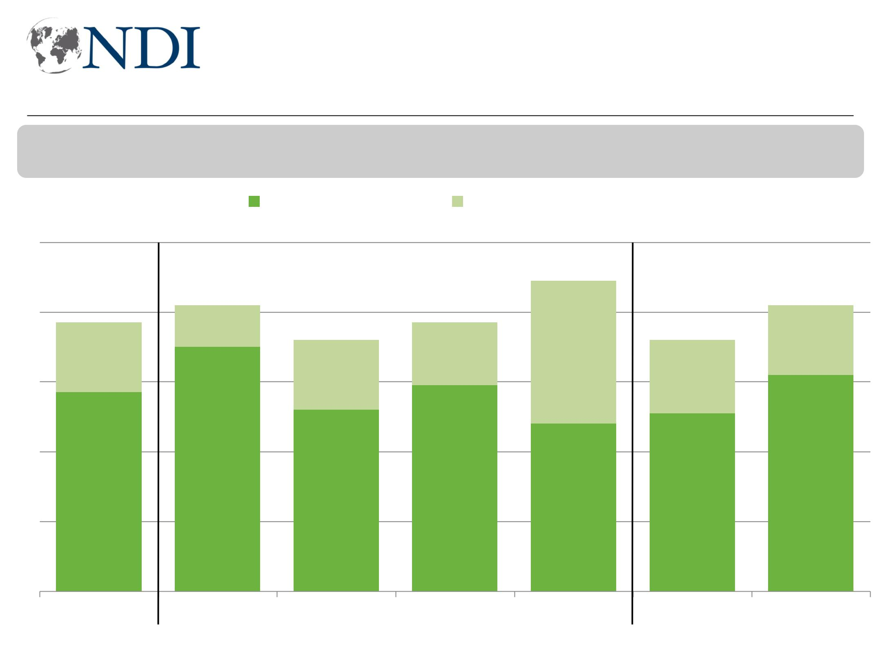
Strong support for “equal rights” for women as a concept

Generally speaking, do you think that men and women should have equal rights in Iraq?
Yes or no?

100

80

60

40

20

0

 |  |  |  | Yes, strongly | Yes, somewhat
 |  |  |  | 81 | 89
77 |  |  |  | 81 | 77
 |  |  |  | 71 | 77 | 72
 |  |  |  | 70 | 59
57 |  |  |  | 52 | 59 | 51
 |  |  |  | 52 | 48 | 51

Total Baghdad South West KRI Men

Working for Democracy and Making Democracy Work

82

62

Women
46
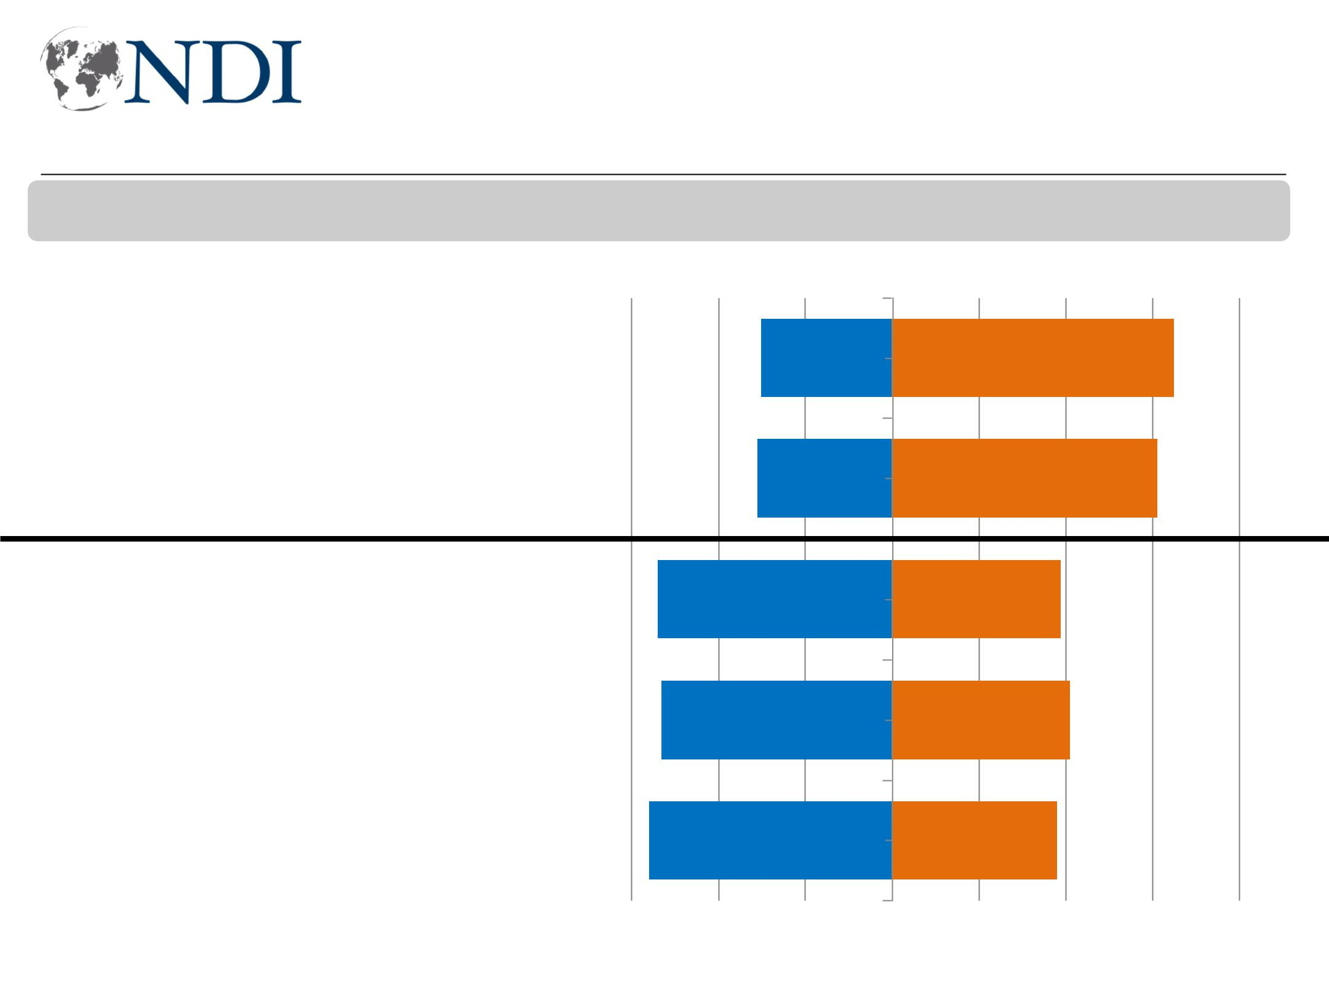
Majority perceive women’s rights as getting worse

Now, I will read you a list of issues. Please tell me if you think this issue is getting better or worse in Iraq.

Worse Better

Participation of women in public life

Participation of women in politics

Women's rights (total)

Women's rights (men)

Women's rights (women)

30 65

31 61

54 39

53 41

56 38

-60 -40 -20 0 20 40 60 80

Working for Democracy and Making Democracy Work 47
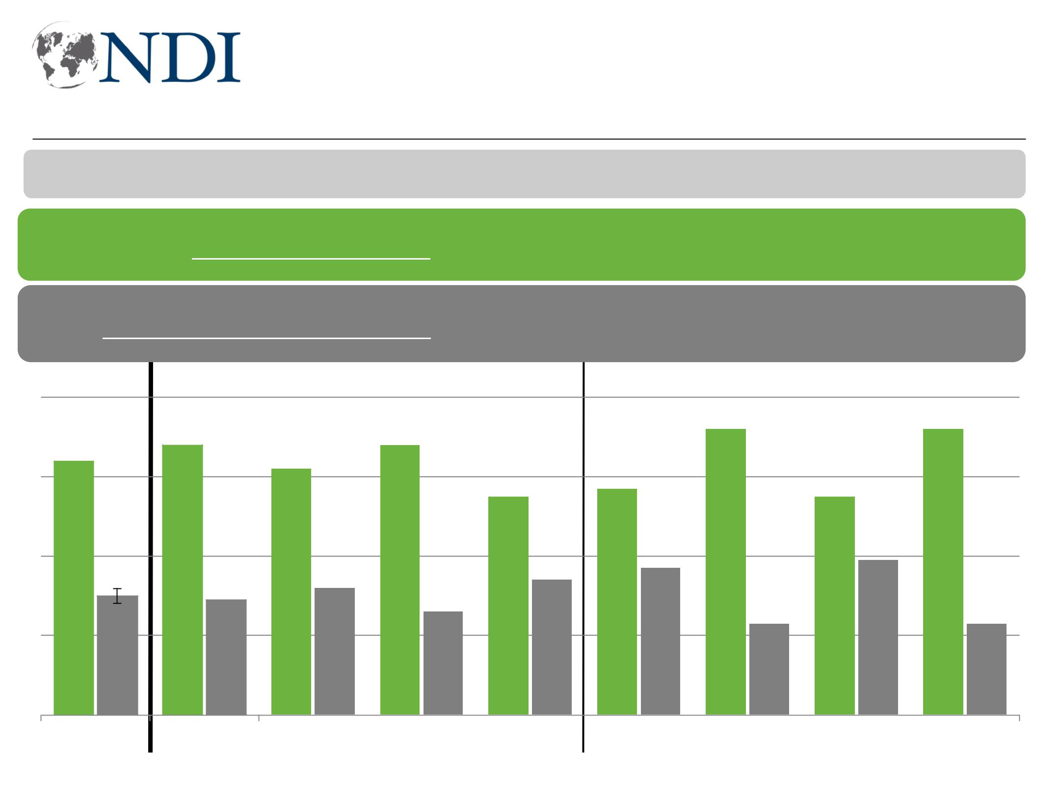
Majority think Iraq stronger with women in workforce

Now for something different. I'm going to read you some pairs of statements and, for each one, I want you to tell me which statement comes closer to your point of view.

Iraq would be stronger if more women entered the workforce.

It is not culturally appropriate for women to pursue jobs outside the house.

80

60 |  |  |  |  | 68
60 | 64

40

20 30 29

0

Total Baghdad

 |  |  |  |  |  |  |  |  |  |  |  |  |  |  |  |  |  |  |  | 72 |  |  |  |  |  |  |  |  |  | 72
 |  |  |  |  | 68
62 |  |  |  |  | 68
62 |  |  |  |  |  |  |  |  |  |  |  |  |  |  | 57
62 |  |  |  |  |  |  |  |  |  | 55 |  |  |  |  | 57 |  |  |  |  |  |  |  |  |  | 55
 |  |  |  |  |  |  |  |  |  |  |  |  |  |  |  |  |  |  |  |  |  |  |  |  |  |  | 39
 |  |  |  |  |  |  |  |  |  |  |  |  |  |  |  |  | 37 |  |  |  |  |  |  |  |  |  | 39
 |  |  |  |  |  |  |  |  |  |  |  | 34 |  |  |  |  | 37
 |  | 32 |  |  |  |  |  |  |  |  |  | 34 |  |  |  |  | 37
 |  | 32 |  |  |  |  | 26 |  |  |  |  | 34 |  |  |  |  | 37
 |  | 32 |  |  |  |  | 26 |  |  |  |  | 34 |  |  |  |  | 37 |  |  |  |  | 23 |  |  |  |  |  |  |  |  |  | 23

South West KRI Urban men Urban Rural men Rural
women women
Working for Democracy and Making Democracy Work 48
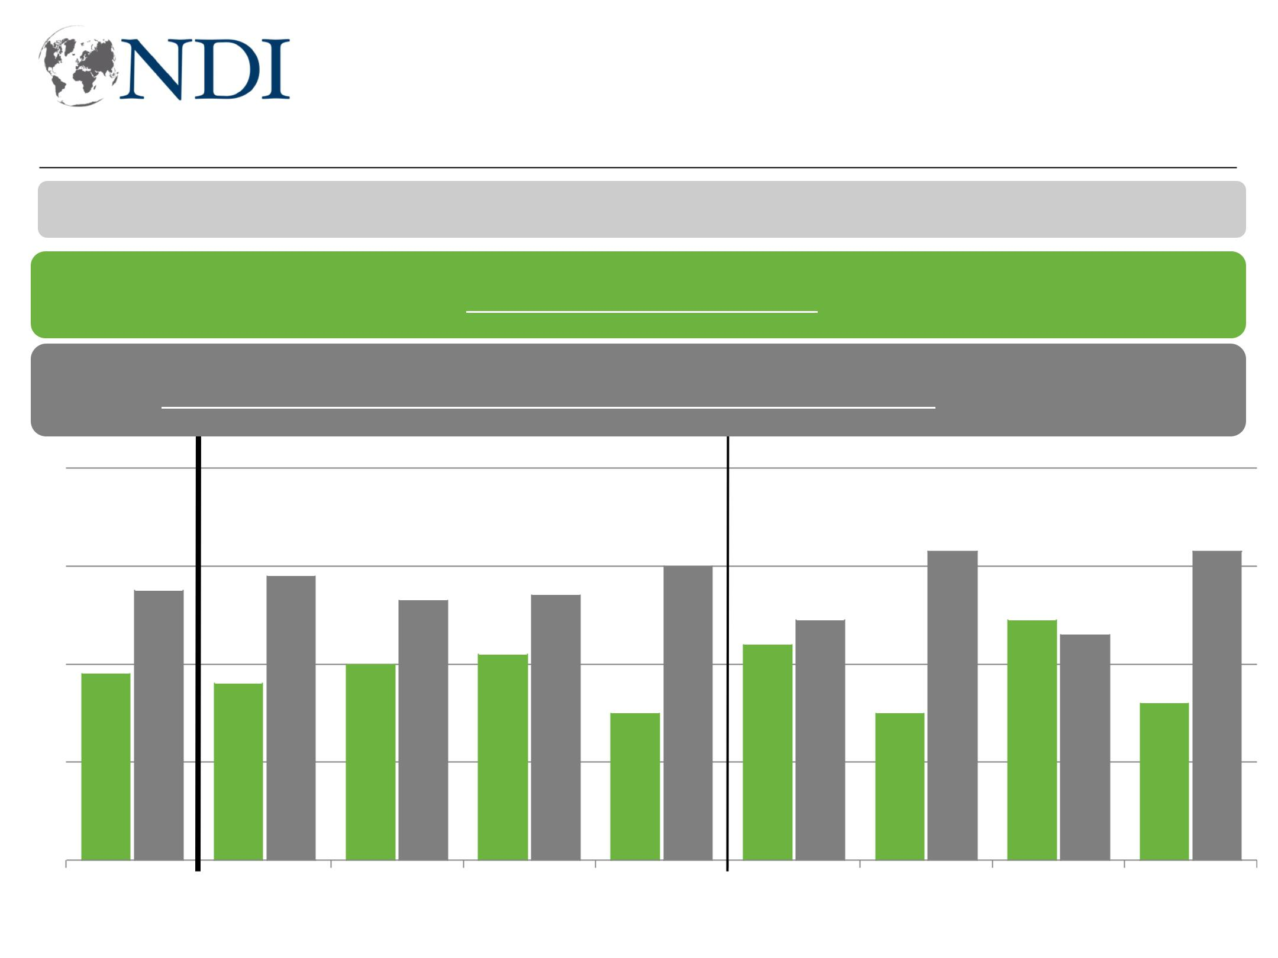
Men more resistant to women working when jobs limited

Now for something different. I'm going to read you some pairs of statements and for each one, I want you to tell me which statement comes closer to your point of view.

If jobs are limited, men should have more of a right to a job.

Both men and women should have an equal opportunity to get most jobs.

80

60 |  |  |  |  |  |  |  |  |  |  |  |  |  |  |  |  |  |  |  |  |  |  |  |  |  |  |  | 63 |  |  |  |  | 63
60 |  |  |  |  |  |  |  |  |  |  |  |  |  |  |  |  |  |  |  |  |  |  | 60
 |  |  |  |  |  |  |  |  |  |  | 58
55 |  |  |  |  |  |  |  |  |  |  |  |  |  |  | 53 |  |  |  |  | 54
 |  |  |  |  |  |  |  |  |  |  |  |  |  |  |  |  |  |  |  |  |  |  |  |  |  |  |  | 49 |  |  |  |  | 49 46
40 |  |  |  |  |  |  |  |  |  |  |  |  |  |  |  |  |  |  | 42 |  |  |  | 44
40 |  |  |  |  |  |  |  |  |  |  |  |  |  |  | 40 |  |  |  | 42
38 |  |  |  |  |  |  |  |  |  |  | 36 |  |  |  | 40 |  |  |  | 42
 |  |  |  |  |  |  |  |  |  |  | 36 |  |  |  | 40 |  |  |  | 42 |  |  |  |  |  |  |  |  |  |  |  |  |  | 32
 |  |  |  |  |  |  |  |  |  |  |  |  |  |  |  |  |  |  |  |  |  |  | 30 |  |  |  |  | 30
20 |  |  |  |  |  |  |  |  |  |  |  |  |  |  |  |  |  |  |  |  |  |  | 30

0

TotalBaghdadSouth | West | KRIUrban men Urban Rural men | Rural
Working for Democracy and Making Democracy Work women |  |  | women | 49

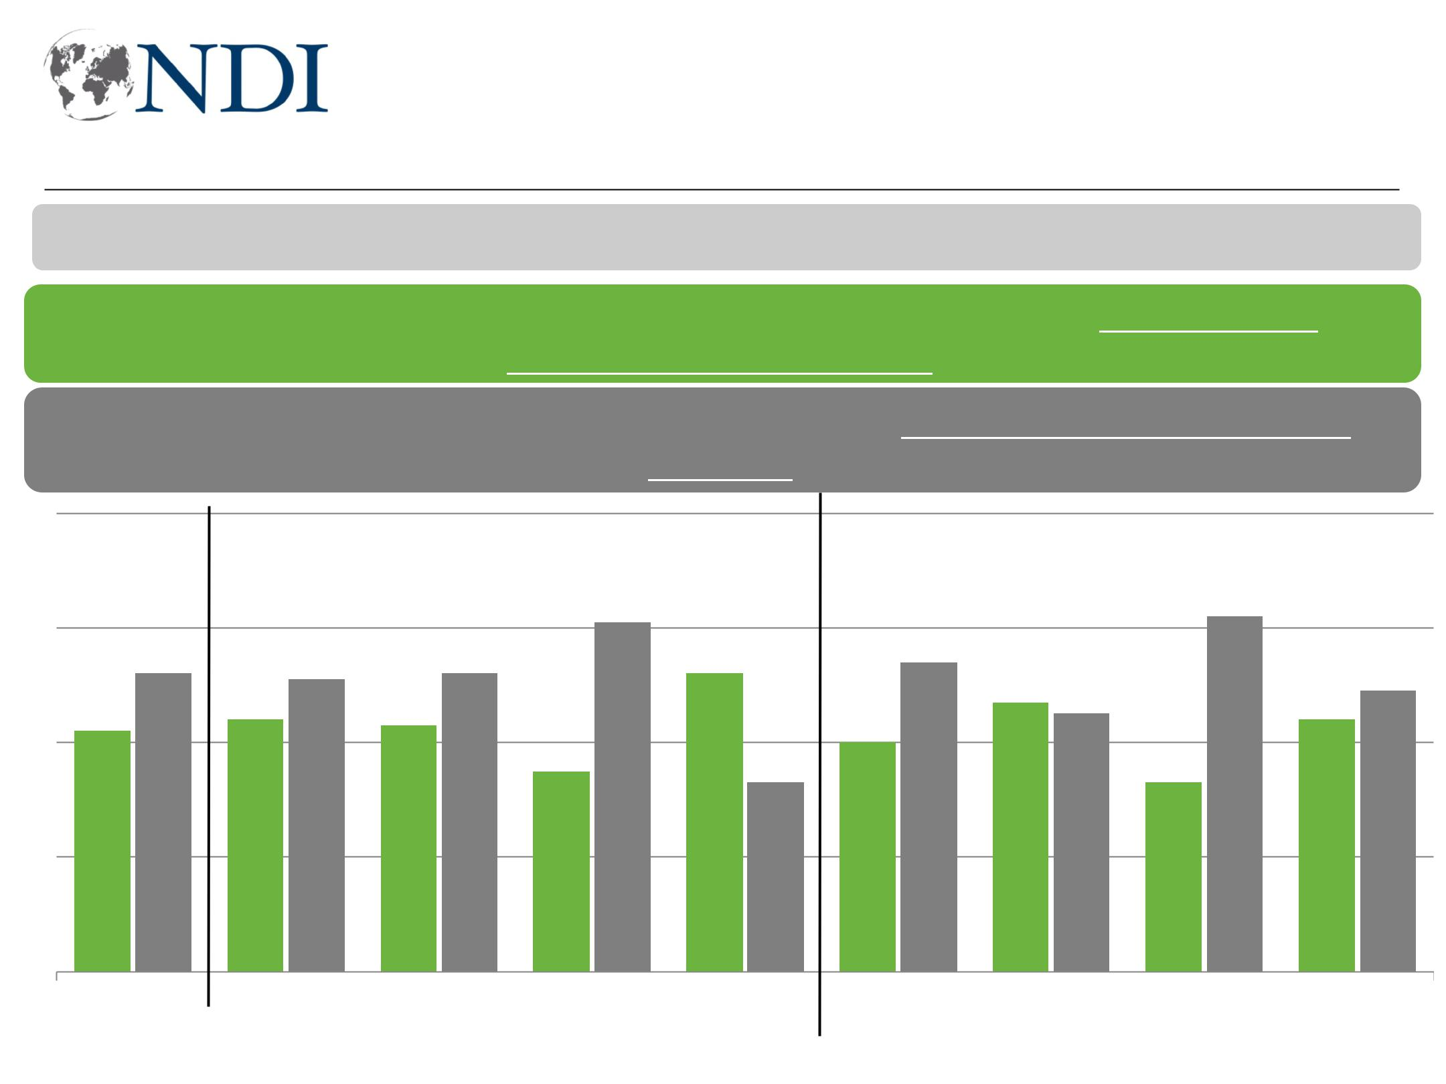
Majority prefer a lesser role for women in government, business

I'm going to read you some pairs of statements and, for each one, I want you to tell me which statement comes closer to your point of view.

Women and men should have equal roles in running the government/ businesses and industry.

Men should have a greater role in running the government/business and industry.

80

60

40

20

0

 |  |  |  |  |  |  |  |  |  |  |  |  |  |  |  |  |  |  |  |  |  |  |  |  |  |  |  |  |  |  |  |  |  |  |  |  |  |  |  |  | 62
 |  |  |  |  |  |  |  |  |  |  |  |  |  |  |  |  |  |  |  |  | 61 |  |  |  |  |  |  |  |  |  |  |  |  |  |  |  |  |  |  |  | 62
 |  |  |  |  |  |  |  |  |  |  |  |  |  |  |  |  |  |  |  |  | 61 |  |  |  |  |  |  |  |  |  | 54 |  |  |  |  |  |  |  |  |  | 62
 |  |  |  |  | 52 |  |  |  |  |  | 51 |  |  |  |  | 52 |  |  |  |  |  |  |  | 52 |  |  |  |  |  |  | 54
 |  |  |  |  |  |  |  |  |  |  | 51 |  |  |  |  | 52 |  |  |  |  |  |  |  | 52 |  |  |  |  |  |  | 54 |  |  |  |  |  |  |  |  |  |  |  |  |  |  | 49
 |  |  |  |  |  |  |  |  |  |  | 51 |  |  |  |  |  |  |  |  |  |  |  |  | 52 |  |  |  |  |  |  |  |  |  | 47 |  |  |  |  |  |  |  |  |  |  |  | 49
 |  |  |  |  |  |  |  |  | 44 |  | 51 |  |  | 43 |  | 52 |  |  |  |  |  |  |  | 52 |  |  |  |  |  |  | 54 |  |  | 47 |  | 45 |  |  |  |  |  |  |  | 44 |  | 49
42 |  |  |  |  |  |  |  |  | 44 |  |  |  |  | 43 |  |  |  |  |  |  |  |  |  |  |  |  |  |  | 40 |  |  |  |  | 47 |  | 45 |  |  |  |  |  |  |  | 44 |  | 49
 |  |  |  |  |  |  |  |  | 44 |  |  |  |  | 43 |  |  |  |  | 35 |  |  |  |  |  |  |  |  |  | 40 |  |  |  |  |  |  |  |  |  |  |  |  |  |  | 44
 |  |  |  |  |  |  |  |  |  |  |  |  |  |  |  |  |  |  | 35 |  |  |  |  |  |  | 33 |  |  | 40 |  |  |  |  |  |  |  |  |  | 33

Total Baghdad South West KRI Urban men Urban Rural men Rural
women women
Working for Democracy and Making Democracy Work 50
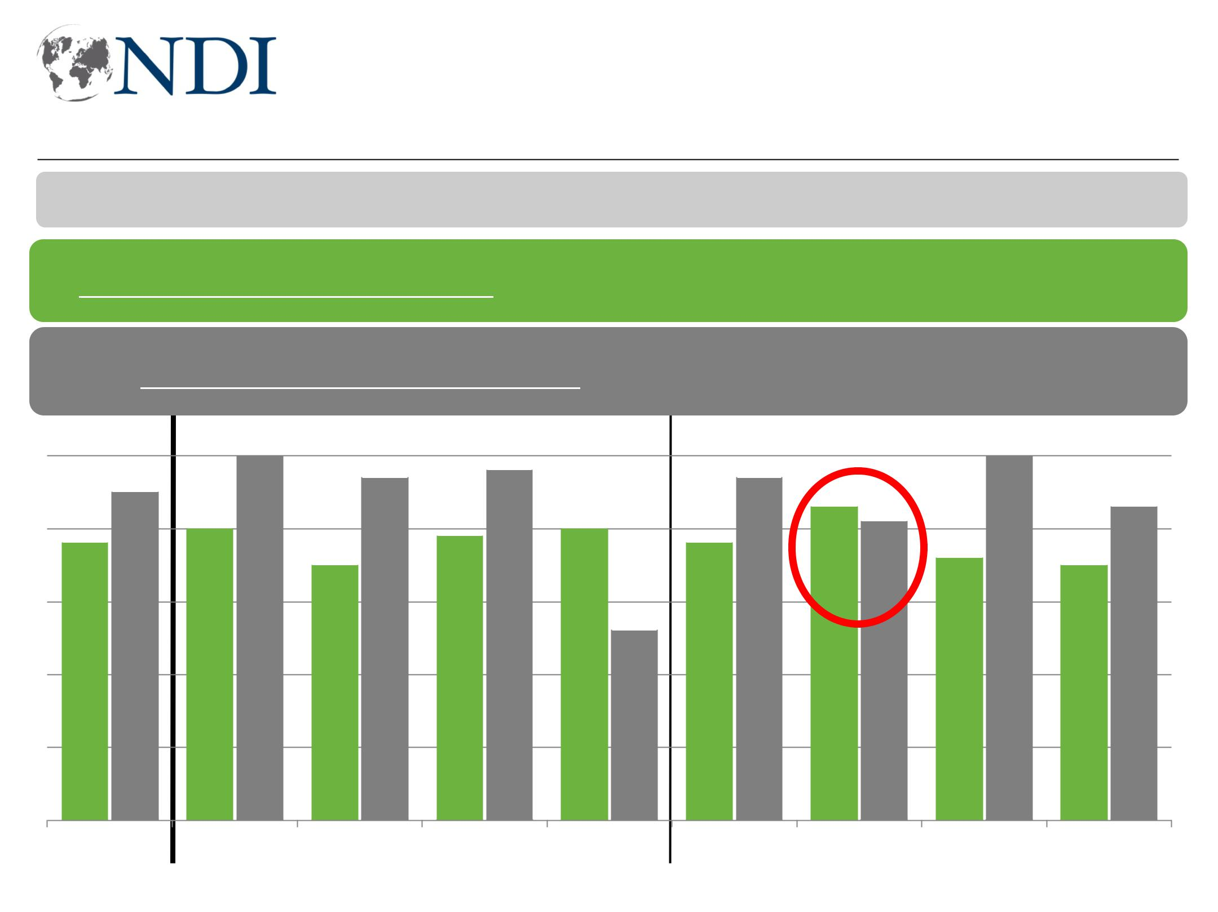
Only young women more likely to say they can represent themselves

Now for something different. I'm going to read you some pairs of statements and, for each one, I want you to tell me which statement comes closer to your point of view.

Only women can sufficiently represent the interests of women in politics.

Men can sufficiently represent the interests of women in politics.

50
50 |  |  |  |  |  |  |  |  |  |  |  | 50 |  |  |  |  |  |  |  |  |  |  |  |  |  |  |  |  |  |  |  |  |  |  |  | 50
 |  |  |  |  |  |  |  |  |  |  |  |  |  |  |  |  |  |  |  | 48
 |  |  |  |  |  |  |  |  |  |  |  |  |  |  |  | 47 |  |  |  |  |  |  |  | 47
40 |  |  |  |  | 45 |  |  |  |  |  |  |  |  |  |  |  |  |  |  |  |  |  |  |  |  |  |  |  |  |  | 43 |  |  |  |  |  |  |  |  | 43
40 |  |  |  |  |  |  |  |  |  |  |  |  |  |  |  |  |  |  |  |  |  |  |  |  |  |  |  |  |  |  | 43 | 41
 |  |  |  |  | 40 |  |  |  |  |  |  |  |  |  |  | 39 |  |  |  | 40 |  |  |  |  |  |  |  |  |  |  | 43
 | 38 |  |  |  |  |  |  |  |  |  |  |  |  |  |  |  |  |  |  |  |  |  |  |  |  | 38 |  |  |  |  | 43
 |  |  |  |  |  |  |  |  |  |  |  |  |  |  | 35 |  |  |  |  |  |  |  |  |  |  |  |  |  |  |  |  |  |  |  |  | 35
30 |  |  |  |  |  |  |  |  |  |  |  |  |  |  | 35 |  |  |  |  |  |  |  |  |  |  |  |  |  |  |  |  | 36
20 |  |  |  |  |  |  |  |  |  |  |  |  |  |  |  |  |  |  |  |  |  |  |  | 26

10

0

Total

Baghdad

South West KRI Young Young
men women

Working for Democracy and Making Democracy Work

Older men

Older

women

51
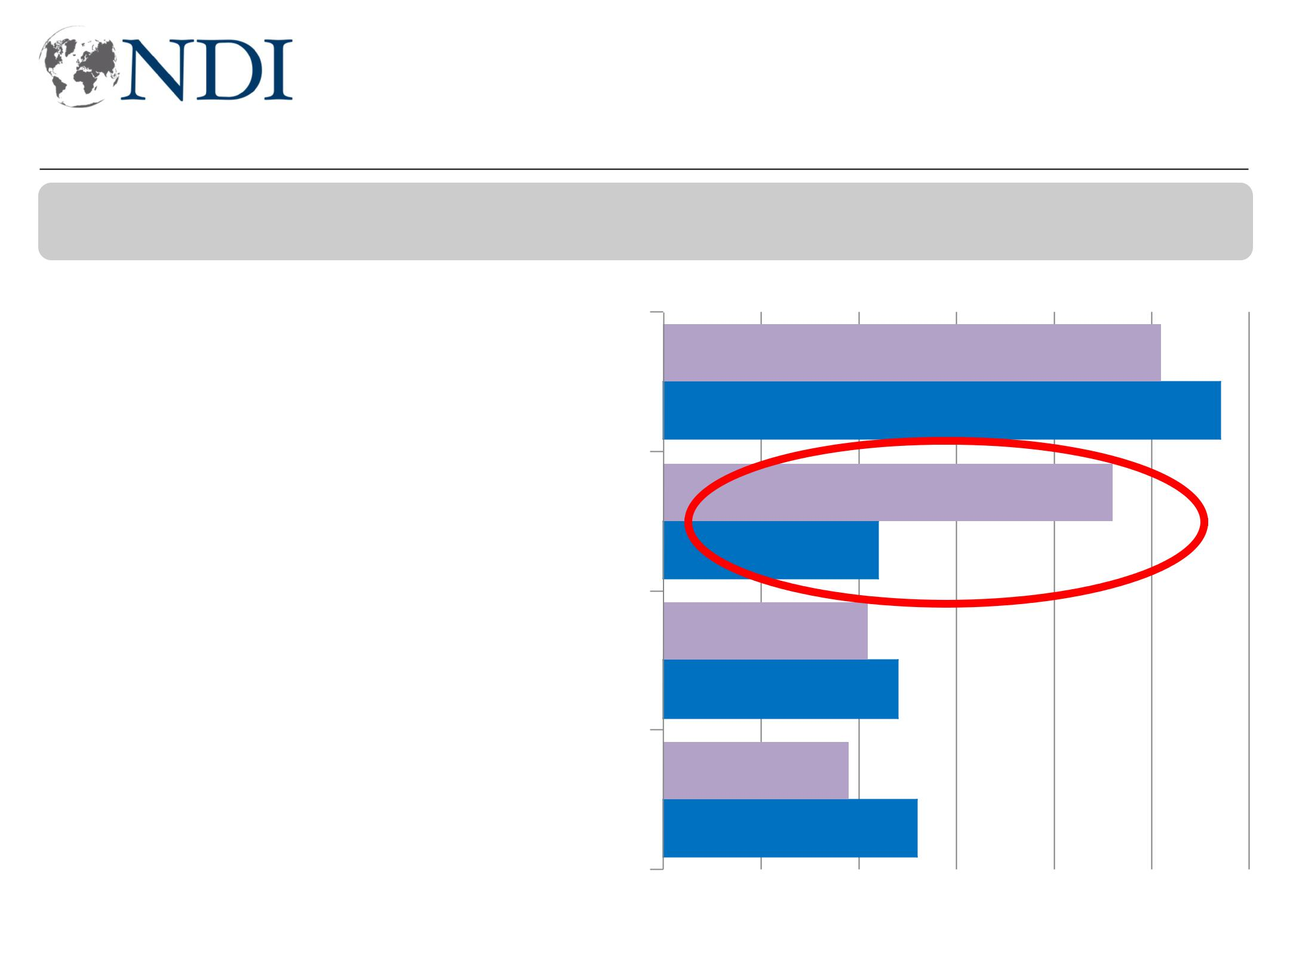
Women twice as likely to vote based on family suggestions

When it came time to vote in the May 2018 election, which of the following were the TWO main factors that determined how you voted?

 Women  Men

51
The individual candidate
57

46
Suggestions from family
22

21
Party's accomplishments
24

19
The party leader
26

0 10 20 30 40 50 60

Working for Democracy and Making Democracy Work 52
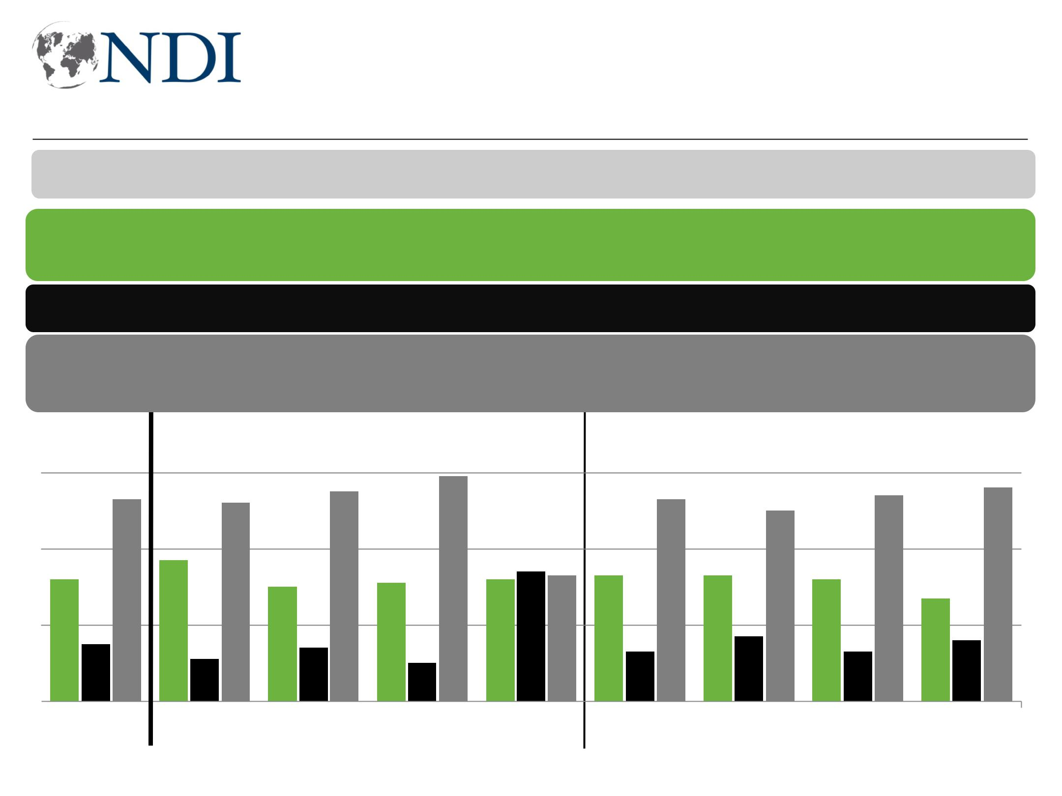
More blame families than society for holding women back

Now for something different. I'm going to read you some pairs of statements and, for each one, I want you to tell me which statement comes closer to your point of view.

Society as a whole does more to prevent women from achieving more.

Both/Neither

Individual families do more to prevent women from achieving more.

60

 |  |  |  |  |  |  |  |  |  |  |  |  |  |  |  |  |  |  |  |  |  | 55 |  |  |  | 59 |  |  |  |  |  |  |  |  |  |  |  |  |  |  |  |  |  | 54 |  |  |  |  | 56
53 |  |  |  |  |  |  |  |  |  |  |  |  |  |  |  |  | 52 |  |  |  |  |  |  |  |  |  |  |  |  |  |  |  |  |  | 53 |  |  |  |  | 50
40
 |  |  |  |  |  |  |  |  |  |  |  |  |  |  |  |  |  | 37
 |  | 32 |  |  |  |  |  |  |  |  |  |  |  |  |  |  |  | 37 |  |  |  | 30 |  |  |  | 31 |  |  |  |  | 32 |  | 34 | 33 |  | 33 |  |  |  |  | 33 |  |  |  | 32
20 |  |  |  |  |  |  |  |  |  |  |  |  |  |  |  |  |  |  |  |  |  | 30 |  |  |  | 31 |  |  |  |  | 32 |  | 34 | 33 |  | 33 |  |  |  |  | 33 |  |  |  | 32 |  |  |  | 27
 |  |  |  |  |  |  |  | 15 |  |  |  |  |  |  |  |  |  |  |  |  |  |  | 14 |  |  |  |  |  |  |  |  |  |  |  |  |  |  | 13 |  |  |  | 17 |  |  |  | 13 |  |  |  | 16
0 |  |  |  |  |  |  |  |  |  |  |  |  |  |  |  |  |  |  | 11 |  |  |  | 14 |  |  |  |  | 10 |  |  |  |  |  |  |  |  |  | 13 |  |  |  | 17 |  |  |  | 13 |  |  |  | 16
0 |  |  |  |  |  | Total |  |  |  |  |  |  |  |  |  |  |  | Baghdad |  |  |  | South |  |  |  | West |  |  |  |  | KRI |  |  |  | Urban men |  |  |  |  |  | Urban |  |  | Rural men |  |  |  |  | Rural
 |  |  |  |  |  |  |  |  |  |  |  |  |  |  |  |  |  |  |  |  |  |  |  |  |  |  |  |  |  |  |  |  |  |  |  |  |  |  |  |  | women |  |  |  |  |  |  |  | women

Working for Democracy and Making Democracy Work 53
Most resistance to women traveling, in police, as PM

Now I am going to ask you about various things that women in Iraq could do in society and politics. For each one, please tell me if think a woman should be able to do that activity or should a woman not be able to do that activity?
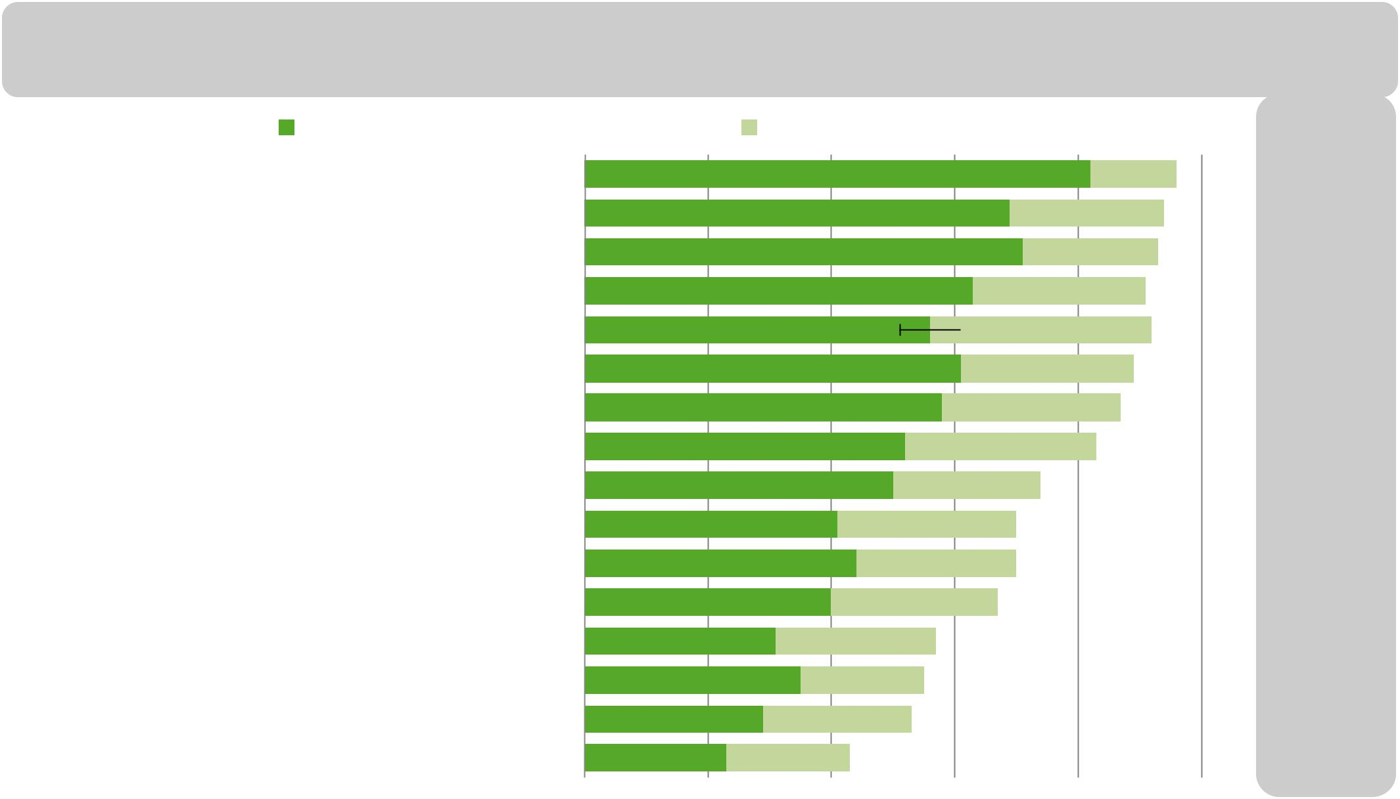
Should be able, strongly |  |  |  |  |  |  |  |  |  |  |  | Should be able, somewhat |  |  |  |  |  |  |  |  |  |  |  |  |  |  |  |  |  |  |  |  |  |  |  |  |  |  |  |  |  |  |  |  |  |  |  |  |  |  |  |  |  |  |  |  |  |  |  |  |  |  |  |  |  |  |  |  |  |  |  |  |  |  |  | Difference
 |  |  |  |  |  |  |  |  |  |  |  |  |  |  |  |  |  |  |  |  |  |  |  |  |  |  |  |  |  |  |  |  |  |  |  |  |  |  |  |  |  |  |  |  |  |  |  |  |  |  |  |  |  |  |  |  |  |  |  |  |  |  |  |  |  |  |  |  |  |  |  |  |  |  |  | women –men,
 |  |  |  |  |  |  |  |  |  |  |  |  |  |  |  |  |  |  |  |  |  |  |  |  |  |  |  |  |  |  |  |  |  |  |  |  |  |  |  |  |  |  |  |  |  |  |  |  |  |  |  |  |  |  |  |  |  |  |  |  |  |  |  |  |  |  |  |  |  |  |  |  |  |  | Able, strongly
Get a university degree |  |  |  |  |  |  |  |  |  |  |  |  |  |  |  |  |  |  |  |  |  |  |  |  |  |  |  |  |  |  |  |  |  |  |  |  |  |  |  |  |  |  |  |  |  |  |  |  |  |  |  |  |  |  |  |  |  | 82 |  |  |  |  |  |  |  |  |  |  |  |  |  |  |  |  |  |  |  |  |  |  |  |  |  |  |  |  |  |  |  |  |  |  |  |  |  |  |  |  |  | 96
Get a university degree |  |  |  |  |  |  |  |  |  |  |  |  |  |  |  |  |  |  |  |  |  |  |  |  |  |  |  |  |  |  |  |  |  |  |  |  |  |  |  |  |  |  |  |  |  |  |  |  |  |  |  |  |  |  |  |  |  |  |  |  |  |  |  |  |  |  |  |  |  |  |  |  |  |  |  |  |  |  |  |  |  |  |  |  |  |  |  |  |  |  |  |  |  |  |  |  |  |  |  | 96 | +9
Get a university degree |  |  |  |  |  |  |  |  |  |  |  |  |  |  |  |  |  |  |  |  |  | 69 |  |  |  |  |  |  |  |  |  |  |  |  |  |  |  |  |  |  |  |  |  |  |  |  |  |  |  |  |  |  |  |  |  |  |  |  |  |  |  |  |  |  |  |  |  |  |  |  |  |  |  |  |  |  |  |  |  |  |  |  |  |  |  |  |  |  |  |  |  |  |  |  |  |  |  | 94
Become an advocate for women's rights |  |  |  |  |  |  |  |  |  |  |  |  |  |  |  |  |  |  |  |  |  |  |  |  |  |  |  |  |  |  |  |  |  |  |  |  |  |  |  |  |  |  |  |  |  |  |  |  |  |  |  |  |  |  |  |  |  |  |  |  |  |  |  |  |  |  |  |  |  |  |  |  |  |  |  |  |  |  |  |  |  |  |  |  |  |  |  |  |  |  |  |  |  |  |  |  |  |  |  |  | +3
Have a government job |  |  |  |  |  |  |  |  |  |  |  |  |  |  |  |  |  |  |  |  |  | 71 |  |  |  |  |  |  |  |  |  |  |  |  |  |  |  |  |  |  |  |  |  |  |  |  |  |  |  |  |  |  |  |  |  |  |  |  |  |  |  |  |  |  |  |  |  |  |  |  |  |  |  |  |  |  |  |  |  |  |  |  |  |  |  |  |  |  |  |  |  |  |  |  |  | 92 |  |  |  |  | +9
Become a community activist implementing local |  |  |  |  |  |  |  |  |  |  |  |  |  |  |  |  |  |  |  |  |  | 63 |  |  |  |  |  |  |  |  |  |  |  |  |  |  |  |  |  |  |  |  |  |  |  |  |  |  |  |  |  |  |  |  |  |  |  |  |  |  |  |  |  |  |  |  |  |  |  |  |  |  |  |  |  |  |  |  |  |  |  |  |  |  |  |  |  |  |  | 92 |  |  |  |  |  |  |  |  |  |  | +13
(KRI) Run for office in KRI |  |  |  |  |  |  |  |  |  |  |  |  |  |  |  |  |  |  |  |  |  | 56 |  |  |  |  |  |  |  |  |  |  |  |  |  |  |  |  |  |  |  |  |  |  |  |  |  |  |  |  |  |  |  |  |  |  |  |  |  |  |  |  |  |  |  |  |  |  |  |  |  |  |  |  |  |  |  |  |  |  |  |  |  |  |  |  |  |  |  |  |  |  |  |  | 92 |  |  |  |  |  | +11
Run their own business |  |  |  |  |  |  |  |  |  |  |  |  |  |  |  |  |  |  |  |  |  | 61 |  |  |  |  |  |  |  |  |  |  |  |  |  |  |  |  |  |  |  |  |  |  |  |  |  |  |  |  |  |  |  |  |  |  |  |  |  |  |  |  |  |  |  |  |  |  |  |  |  |  |  |  |  |  |  |  |  |  |  |  |  |  |  | 89 |  |  |  |  |  |  |  |  |  |  |  |  |  |  | +13
Run own large business with men & women employees |  |  |  |  |  |  |  |  |  |  |  |  |  |  |  |  |  |  |  |  |  | 58 |  |  |  |  |  |  |  |  |  |  |  |  |  |  |  |  |  |  |  |  |  |  |  |  |  |  |  |  |  |  |  |  |  |  |  |  |  |  |  |  |  |  |  |  |  |  |  |  |  |  |  |  |  |  |  |  |  | 87 |  |  |  |  |  |  |  |  |  |  |  |  |  |  |  |  |  |  |  |  | +11
(non-KRI) Run for office in the provincial elections |  |  |  |  |  |  |  |  |  |  |  |  |  |  |  |  |  |  |  |  |  | 52 |  |  |  |  |  |  |  |  |  |  |  |  |  |  |  |  |  |  |  |  |  |  |  |  |  |  |  |  |  |  |  |  |  |  |  |  |  |  |  |  |  |  |  |  |  |  |  |  |  |  |  |  | 82 |  |  |  |  |  |  |  |  |  |  |  |  |  |  |  |  |  |  |  |  |  |  |  |  |  | +3
(non-KRI) Run for office in the provincial elections |  |  |  |  |  |  |  |  |  |  |  |  |  |  |  |  |  |  |  |  |  |  |  |  |  |  |  |  |  |  |  |  |  |  |  |  |  |  |  |  |  |  |  |  |  |  |  |  |  |  |  |  |  |  |  |  |  |  |  |  |  |  |  |  |  |  |  | 75
Make a higher salary than their husbands |  |  |  |  |  | 50 |  |  |  |  |  |  |  |  |  |  |  |  |  |  |  |  |  |  |  |  |  |  |  |  |  |  |  |  |  |  |  |  |  |  |  |  |  |  |  |  |  |  |  |  |  |  |  |  |  |  |  |  |  |  |  |  |  |  |  |  |  |  |  |  |  |  |  |  |  |  |  |  |  |  |  |  |  |  |  |  |  |  |  |  |  |  |  |  |  |  |  |  |  |  | +15
 |  |  |  |  |  | 41 |  |  |  |  |  |  |  |  |  |  |  |  |  |  |  |  |  |  |  |  |  |  |  |  |  |  |  |  |  |  |  |  |  |  |  |  |  |  |  |  |  |  |  |  |  |  |  |  |  |  |  |  |  |  |  |  |  | 71 |  |  |  |  |  |  |  |  |  |  |  |  |  |  |  |  |  |  |  |  |  |  |  |  |  |  |  |  |  |  |  |  |  |  |  |  | +8
Work as many hours as they want
Marry whomever they want |  |  |  |  |  | 44 |  |  |  |  |  |  |  |  |  |  |  |  |  |  |  |  |  |  |  |  |  |  |  |  |  |  |  |  |  |  |  |  |  |  |  |  |  |  |  |  |  |  |  |  |  |  |  |  |  |  |  |  |  |  |  |  |  |  | 70 |  |  |  |  |  |  |  |  |  |  |  |  |  |  |  |  |  |  |  |  |  |  |  |  |  |  |  |  |  |  |  |  |  |  |  | +8
Be a minister in the federal government |  |  |  |  |  | 40 |  |  |  |  |  |  |  |  |  |  |  |  |  |  |  |  |  |  |  |  |  |  |  |  |  |  |  |  |  |  |  |  |  |  |  |  |  |  |  |  |  |  |  |  |  |  |  |  |  |  |  | 66 |  |  |  |  |  |  |  |  |  |  |  |  |  |  |  |  |  |  |  |  |  |  |  |  |  |  |  |  |  |  |  |  |  |  |  |  |  |  |  |  |  |  | +1
 |  |  |  |  |  |  |  |  |  |  |  |  |  |  |  |  |  |  |  |  |  |  |  |  |  |  |  |  |  |  |  |  |  |  |  |  |  |  |  |  |  |  | 57
 |  |  |  |  |  | 31 |  |  |  |  |  |  |  |  |  |  |  |  |  |  |  |  |  |  |  |  |  |  |  |  |  |  |  |  |  |  |  |  |  |  |  |  |  |  |  |  |  |  |  |  |  |  |  |  |  |  |  |  |  |  |  |  |  |  |  |  |  |  |  |  |  |  |  |  |  |  |  |  |  |  |  |  |  |  |  |  |  |  |  |  |  |  |  |  |  |  |  |  |  |  | +8
Join a political party
Be a prime minister |  |  |  |  |  | 35 |  |  |  |  |  |  |  |  |  |  |  |  |  |  |  |  |  |  |  |  |  |  |  |  |  |  |  |  |  |  |  |  | 55 |  |  |  |  |  |  |  |  |  |  |  |  |  |  |  |  |  |  |  |  |  |  |  |  |  |  |  |  |  |  |  |  |  |  |  |  |  |  |  |  |  |  |  |  |  |  |  |  |  |  |  |  |  |  |  |  |  |  |  |  |  | +7
 |  |  | 29 |  |  |  |  |  |  |  |  |  |  |  |  |  |  |  |  |  |  |  |  |  |  |  |  |  |  |  |  |  |  |  |  |  | 54 |  |  |  |  |  |  |  |  |  |  |  |  |  |  |  |  |  |  |  |  |  |  |  |  |  |  |  |  |  |  |  |  |  |  |  |  |  |  |  |  |  |  |  |  |  |  |  |  |  |  |  |  |  |  |  |  |  |  |  |  |  |  |  | +3
Be part of the Iraqi police
 |  |  | 23 |  |  |  |  |  |  |  |  |  |  |  |  |  |  |  |  |  |  |  |  | 42 |  |  |  |  |  |  |  |  |  |  |  |  |  |  |  |  |  |  |  |  |  |  |  |  |  |  |  |  |  |  |  |  |  |  |  |  |  |  |  |  |  |  |  |  |  |  |  |  |  |  |  |  |  |  |  |  |  |  |  |  |  |  |  |  |  |  |  | +11
Travel alone wherever and whenever they want |  |  | 23
0 |  |  | 20 |  |  | 40 |  |  |  |  |  |  |  |  |  |  |  |  |  |  |  | 60 |  |  |  |  |  |  |  |  |  |  |  |  |  |  |  |  |  |  |  |  |  |  |  |  |  |  |  |  |  |  |  |  |  |  |  | 80 |  |  |  |  |  |  |  |  |  |  |  |  |  |  |  |  | 100 |  |  |  |  |  |  |  |  |  |  |  |  |  |  |  |  |  |  |  |  |  |  |  |  |  | 54
Working for Democracy and Making Democracy Work

Gender divides on salary, work hours, political activities

Now I am going to ask you about various things that women in Iraq could do in society and politics. For each one, please tell me if think a woman should be able to do that activity or should a woman not be able to do that activity?

Should be able, strongly Should be able, somewhat 0
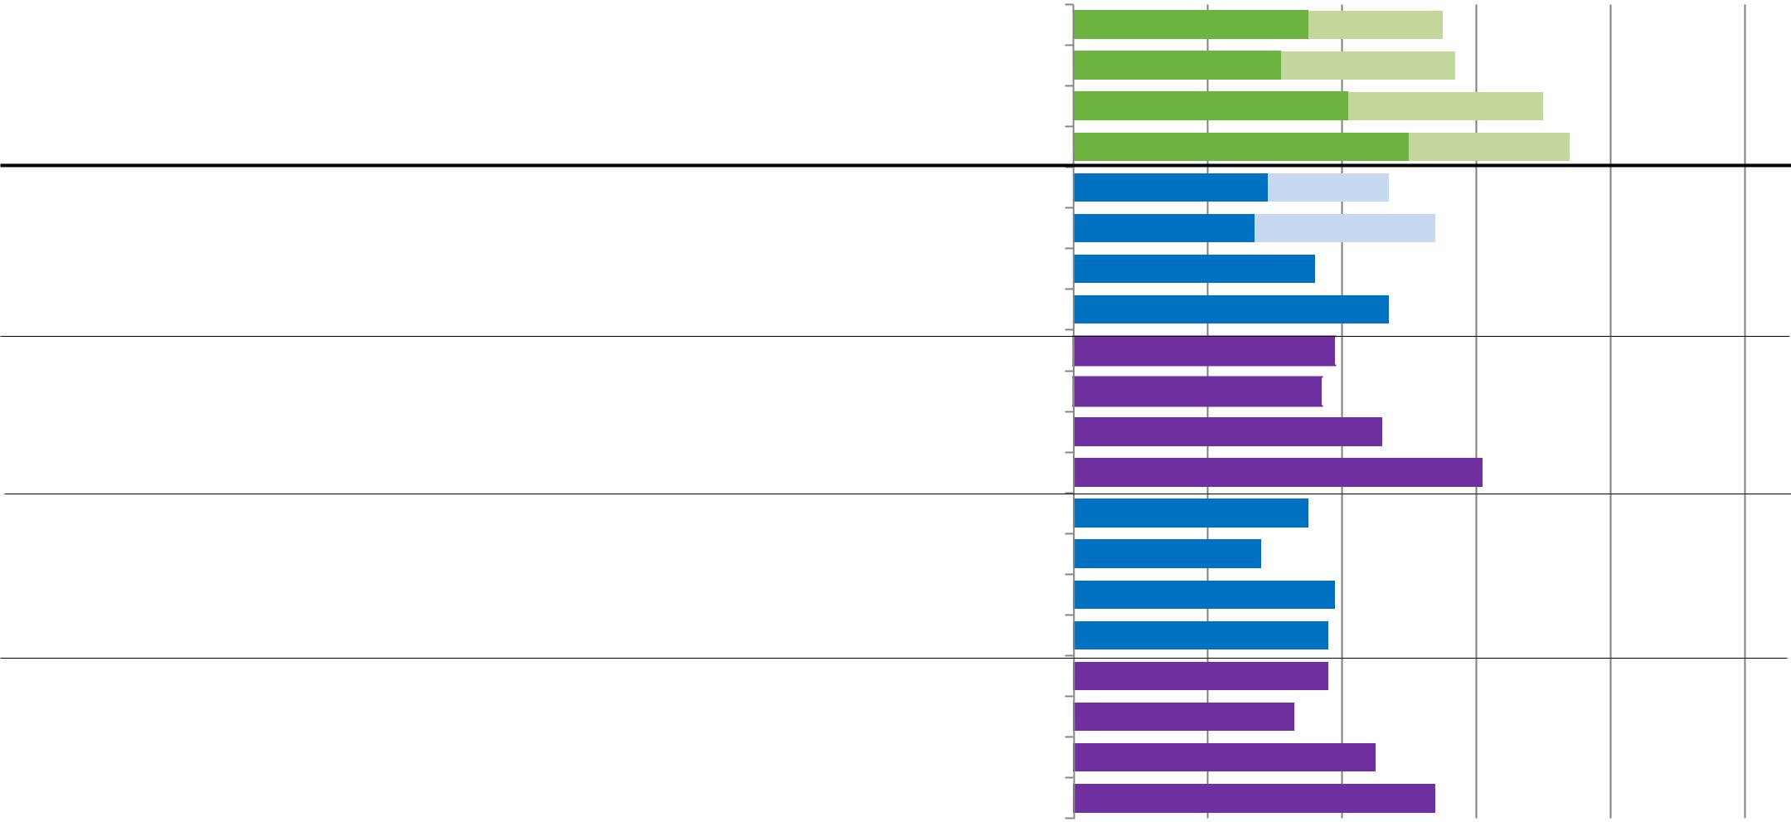
Total | Be a prime minister
Total | Work as many hours as they want
 | Join a political party
 | Make a higher salary than their husbands
 | Be a prime minister
Young men | Join a political party
Young men | Work as many hours as they want
 | Make a higher salary than their husbands
Young women | Be a prime minister
Young women | Work as many hours as they want
 | Join a political party
 | Make a higher salary than their husbands
Older men | Be a prime minister
Older men | Work as many hours as they want
 | Join a political party
 | Make a higher salary than their husbands
Older women | Be a prime minister
Older women | Work as many hours as they want
 | Join a political party
 | Make a higher salary than their husbands

20 | 40 |  |  |  |  |  |  |  |  |  |  |  | 60 |  |  |  |  |  |  |  |  |  |  |  |  |  | 80 |  |  | 100
35 |  |  |  |  |  |  |  |  |  |  |  |  |  |  |  |  |  |  |  | 55
31 |  |  |  |  |  |  |  |  |  |  |  |  |  |  |  |  |  |  |  |  |  | 57 |  |  |  |  | 71
31 | 41
 | 50 |  |  |  |  |  |  |  |  |  |  |  |  |  |  |  |  |  |  |  |  |  |  |  |  |  |  |  | 75
29 |  |  |  |  |  |  |  |  |  |  |  |  | 47 |  |  |  |  |  |  |  |  |  |  |  |  |  |  |  | 75
27 |  |  |  |  |  |  |  |  |  |  |  |  | 54
36 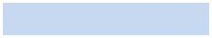 63
47 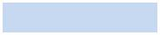 69
39  61
37  62
46  80
61  84
35 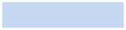 55
28 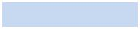 51
39 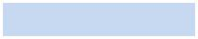 64
38 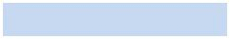 67
38  59
33  61
45  76

54  78

Working for Democracy and Making Democracy Work

55
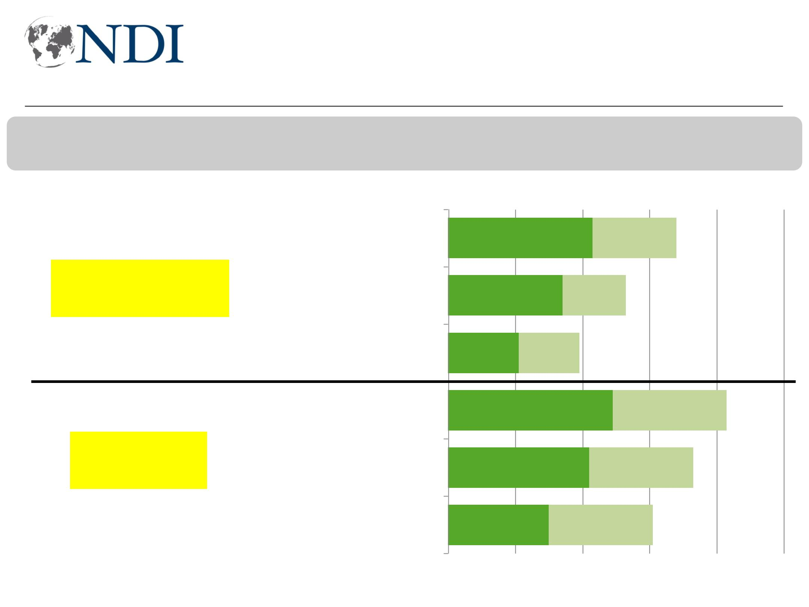
Kurds more liberal on women travel, marriage, PM

Now I am going to ask you about various things that women in Iraq could do in society and politics. For each one, please tell me if think a woman should be able to do that activity or should a woman not be able to do that activity?

Should be able, strongly

Marry whomever they want

Non-KRI | Be a prime minister

Travel alone whereever and whenever they want

Marry whomever they want

KRI | Be a prime minister

Travel alone whereever and whenever they want

Should be able, somewhat

43 68

34 53

21 39

49 83

42 73

30 61

0 | 20 | 40 | 60 | 80 | 56 | 100
Working for Democracy and Making Democracy Work

