BRITISH ANTARCTIC TERRITORY

THIS LICENSE is granted by the Commissioner pursuant to section 2(1)(b) of the Currency Ordinance 1990.

1. Pobjoy Mint Limited of Millennia House, Kingswood Park, Bonsor Drive, Kingswood, Surrey is hereby authorised by this licence to-

- make during a period of eighteen months from the date of the grant
of this licence and

- issue during a period of two years from the date of the release agreed
to between the Government and Mint

coins in the quantities and of the design and specification set out in the schedule.

2. It is a condition of this licence that every such coin issued must fully comply with the design and specification set out in the schedule.

3. Each such coin made in accordance with the conditions of this licence shall be legal tender in the Territory for its face value from the first date on which that coin was minted.

THE SCHEDULE
(Design, specification, authorised quantity and authorised mint of coins)
Design:
The obverse of every coin shall consist of the uncouped portrait of Her Majesty Queen Elizabeth II by Pobjoy Mint Ltd surrounded by the inscription "BRITISH ANTARCTIC TERRITORY" and the year of the minting of the coin.

The reverse design of every coin is adapted from the Polar Medal and shows the RRS Discovery surrounded by ice floes with a sledging party in the foreground. The wording ‘1868 – ROBERT FALCON SCOTT – 1912’ appears in the surround and the £2, £4 and £20 denomination of the coin respectively at the base as shown in the annex to this schedule.
Specification, authorised quantity and authorised mint of coins:

Type Silver Proof Cupro Nickel Gold Proof Gold Proof Gold Proof

Denomination £2 £2 £2 £4 £20

Weight 28.28 28.28 0.50 1.24 6.22
(grams)

Diameter 38.60 38.60 11.00 13.92 22.00
(millimetres)

Fineness 925 75% Cu 0.999 0.999 0.999
25% NI

Quality Proof Uncirculated Proof Proof Proof

Shape Round Round Round Round Round

Edge Milled Milled Milled Milled Milled

Quantity 2,000 10,000 10,000 10,000 2,500

ANNEX TO THE SCHEDULE

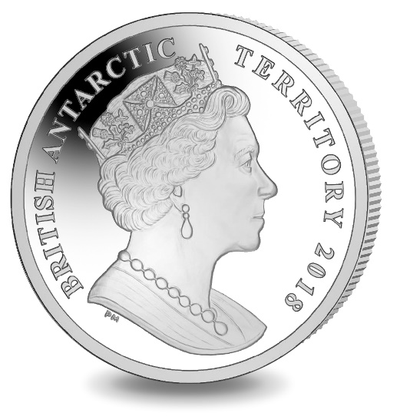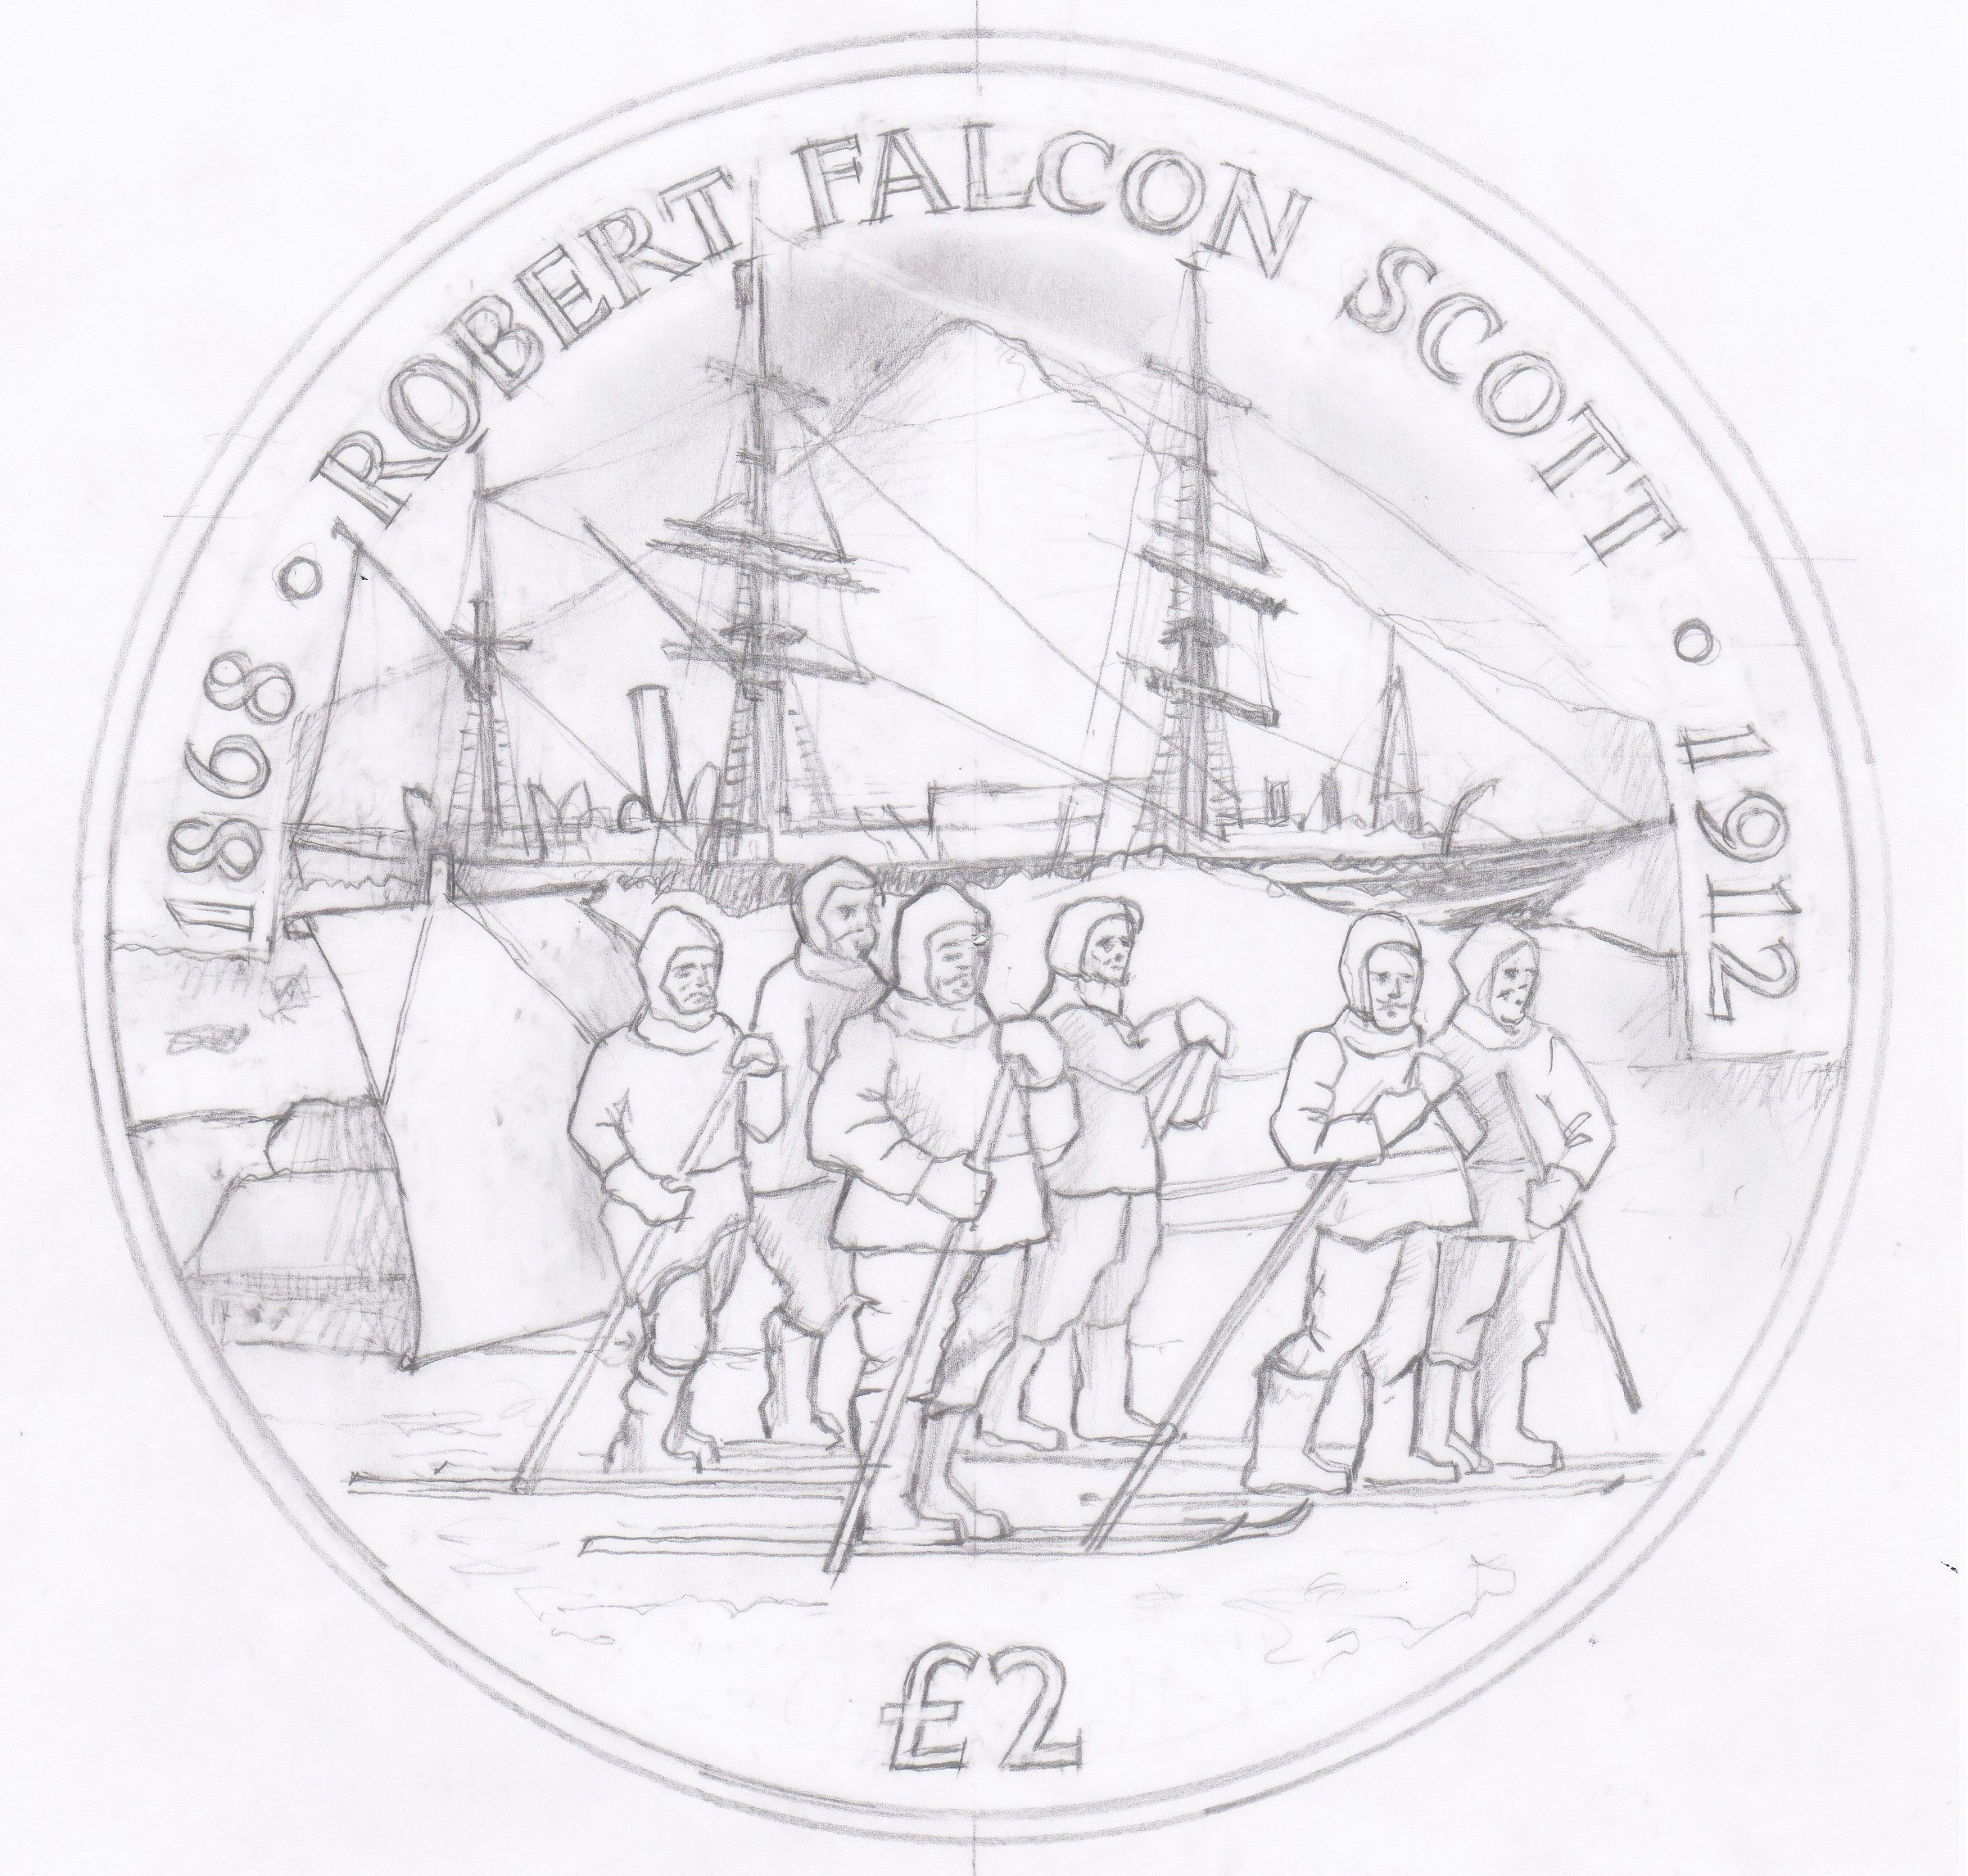

IN WITNESS whereof the Commissioner has hereto set his hand and the Seal of the Territory this 12th day of December 2017.

Ben Merrick
[Signed by Commissioner]
[Sealed]

