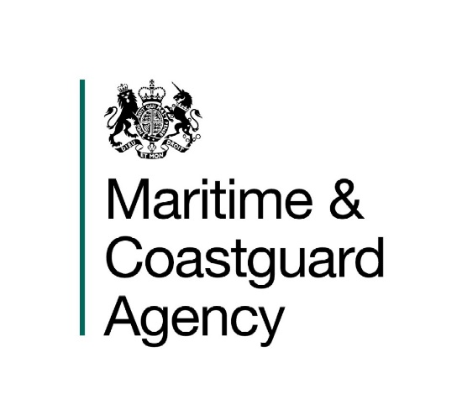
Maritime and Coastguard Agency Log

1892()

The Workboat Code Edition 2

Notice to all designers, builders, owners, operators, employers, crews, masters of small commercial workboats, and Certifying Authorities.

This notice replaces previous Codes and Notices concerning newbuild small workboats, and pilot boats

Summary
This Merchant Shipping Notice (MSN) announces the latest revision of the MCA publication, the Workboat Code Edition 2 which is a revision of “The Safety of Small Workboats and Pilot Boats – A Code of Practice” (also known as the “Brown Code”). The Workboat Code Edition 2 is still underpinned by the Merchant Shipping (Small Workboats and Pilot Boats) Regulations 1998, as amended.
The changes arising from Workboat Code Edition 2 apply to new vessels, constructed on or after [#/## 2018]..

- Introduction

  - In 1998, the Agency published its “The Safety of Small Workboats and Pilot Boats – A Code of Practice” (also known as the Brown Code and now also referred to as Edition 1 (1998)), under the provisions of regulation 3(1) of the Merchant Shipping (Small Workboats and Pilot Boats) Regulations 1998.

  - The latest edition of the Workboat Code has now been published as The Safety of Small Workboats and Pilot Boats – A Code of Practice Edition 2), and replaces Edition 1 (1998). "Workboat" means a small vessel (of under 24 metres length) in commercial use for purposes other than sport or pleasure, including a dedicated pilot boat.

  - In practice, for new vessels, Workboat Code Edition 2 replaces:-

    - The Safety of Small Workboats and Pilot Boats – A Code of Practice (the “Brown Code”);
    - its equivalent standard published in the technical Annex to Marine Guidance Note MGN 280 (M), as far as it applies to small workboats and pilot boats.

  - Please note that the Workboat Code Industry Working Group Technical Standard which was published in 2014 is no longer recognised for new vessels, and after the end of the phase in period (see below) will not be recognised for existing vessels either.
- The Workboat Code Edition 2

2.1 The changes contained in Workboat Code Edition 2 apply to new vessels, and are not retrospective for existing vessels under Workboat Code Edition 1 (1998) or MGN 280, holding valid certification.
a. "New vessel" means a vessel to which this Code applies, the keel of which was laid, or the construction or lay-up was started, on or after the first day on which this Workboat Code Edition 2 came into force, or any vessel where there has not been a valid certificate for the previous five years.
b. “Existing vessel” means a vessel which is not a new vessel.

2.2 This Code came into force on [## ## 2018].
2.3 Workboat Code Edition 2, like its predecessor, has been developed by an industry working group. It has incorporated current best industry practice, includes updates necessary as a response to accidents relevant to the industry, and incorporates amendments which have taken place in the relevant international conventions. In regard to those international conventions and where appropriate, the Workboat Code Edition 2 offers guidance on appropriate means of achieving compliance, including those more suited to small workboats and their modes of operation.

2.4 The Workboat Code Edition 2 replaces The Safety of Small Workboats and Pilot Boats – A Code of Practice (Edition 1 1998), in the context of United Kingdom law, with effect from [insert date]; the date on which Workboat Code Edition 2 came into force.

2.5 Other flag states, who wish to apply Workboat Code Edition 2 according to their own requirements and laws, may take full advantage of its availability.

Existing Vessels

  - The changes in Workboat Code Edition 2 are not retrospective for existing vessels certificated under the Safety of Small Workboats and Pilot Boats – A Code of Practice (Edition 1 1998) or MGN 280. Owners / operators of such vessels may voluntarily phase them in to comply fully with Workboat Code Edition 2 requirements.
  - Alternatively, they may continue to operate these vessels, and have them surveyed and certificated under the earlier standards, until such time that certain aspects of these vessels may be brought into line with current, Workboat Code Edition 2 standards. These revisions, when agreed, will be published as amendments to the earlier standards referred to in 1.3 above. Appendix 16 of Workboat Code Edition 2 provides for saving and transitional arrangements to allow this to occur.

  - Vessels certificated under the Workboat Code Industry Working Group Technical Standard, introduced in 2014, must comply with the changes in the Workboat Code Edition 2 by the next due renewal examination after entry in to force of the Workboat Code Edition 2, or three (3) years after the entry in to force date of the Workboat Code Edition 2, whichever date falls later. Paragraph 1.4 refers.

  - Please note that, where any existing vessel upgrades, and phases-in, to the Workboat Code Edition 2 regime, it must do so fully. A vessel cannot meet a combination of the Workboat Code Edition 2 standards and those of earlier codes or standards.

  - For legal reasons, the previous Codes and Standards are incorporated into this Code by reference, but this is only so that the saving and transitional provisions can work properly. New vessels cannot use these previous Codes and Standards, and existing vessels can only use them to the extent spelt out in Workboat Code Edition 2 Appendix 16.

- Further Information on the Code
3.1 Further information on the contents of this Notice can be obtained from the address at the end of this Notice. The text of Workboat Code Edition 2 can be found at:
[insert link once published]

More Information

Coded Vessel Safety Unit, Vessel Policy Branch
Maritime and Coastguard Agency,
Bay 2/23
Spring Place,
105 Commercial Road,
Southampton,
SO15 1EG.

Tel : +44 (0) 203 817 2000.
e-mail: codes@mcga.gov.uk .

Website Address: www.gov.uk/government/organisations/maritime-and-coastguard-agency .

General Enquiries: infoline@mcga.gov.uk

File Ref: MS 183/002/0004

Published: Printers to Insert
Please note that all addresses and
telephone numbers are correct at time of publishing.

© Crown Copyright 2018

Safer Lives, Safer Ships, Cleaner Seas.

SI 1998 No. 1609, as amended by SI 2006 No. 2055, SI 2013 No. 1785, SI 2015 No. 0782 and SI 2016 No. 0354
MGN 280 Small Vessels in Commercial Use for Sport or Pleasure, Workboats and Pilot Boats – Alternative Construction Standards
Relevant international conventions include the International Convention for the Safety Of Life At Sea (SOLAS), which incorporates the International Maritime Dangerous Goods (IMDG) Code; the Maritime Labour Convention (MLC); The International Convention on Load Lines; and, The International Convention for the Prevention of Pollution from Ships (MARPOL).

