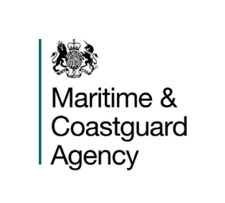 |  |  | Small Commercial Vessel Codes Safety Unit  Vessel Standards Branch  Bay 2/23  Spring Place  105 Commercial Road  Southampton  SO15 1EG
 |  |  | United Kingdom
 |  |  | Tel:  Email: | +44 (0)20381 72496  codes@mcga.gov.uk
 |  |  | Your ref:  Our ref: |  | WBCode2MSN-Stakeholder Engagement Exercise
 |  |  | 18 October 2018

Dear Stakeholder,

Stakeholder Engagement Exercise on the draft Merchant Shipping Notice Relating to The Workboat Code Edition 2

The Maritime and Coastguard Agency would appreciate your input on the attached draft Merchant Shipping Notice (MSN) which has been developed to provide a brief explanation and overview of The Workboat Code Edition 2.

Your effort and input into the development of Edition 2 over the past few years has been greatly valued, and the MCA believes that this Code represents a positive and successful outcome of what has been a joint, collaborative effort between the Agency and the small workboat and pilot boat industry.

We would therefore be grateful if you can consider draft MSN 1892 attached as Annex 1 of this letter, and let me have your answers to the two questions overleaf.

Please note that a copy of the Workboat Code Edition 2 is included for information and ease of reference only, and is not part of this Stakeholder Engagement Exercise, No comments on the Code can be accepted as it has already been subject to a formal consultation process, and further justified subsequently by a Gap Analysis which upheld the legality and process of the proposed changes .
Question 1 | Does the draft MSN adequately explain the general purpose and application of The Workboat Code Edition 2?
Answer 1
Question 2 | Do you consider that the draft MSN reflects the provisions of the Code, as agreed by the Workboat Code Working Group and subsequent Small Commercial Vessel Technical Working Group Meetings?
Answer 2

This stakeholder engagement exercise will run for six weeks, from 17 October 2018. If you wish to contribute, we would appreciate your responses by 28 November 2018. All responses should be made in writing (email or post) to:-

Email: codes@mcga.gov.uk

Post: Small Commercial Vessel Codes Safety Unit
Vessel Standards Branch
Bay 2/23, Spring Place
105 Commercial Road
Southampton
SO15 1EG

Thank you, and if you have any questions about participation please do not hesitate to contact us by telephone or email.

Yours Faithfully

Mrs Jenny Vines
Small Commercial Vessel Codes Policy Manager

