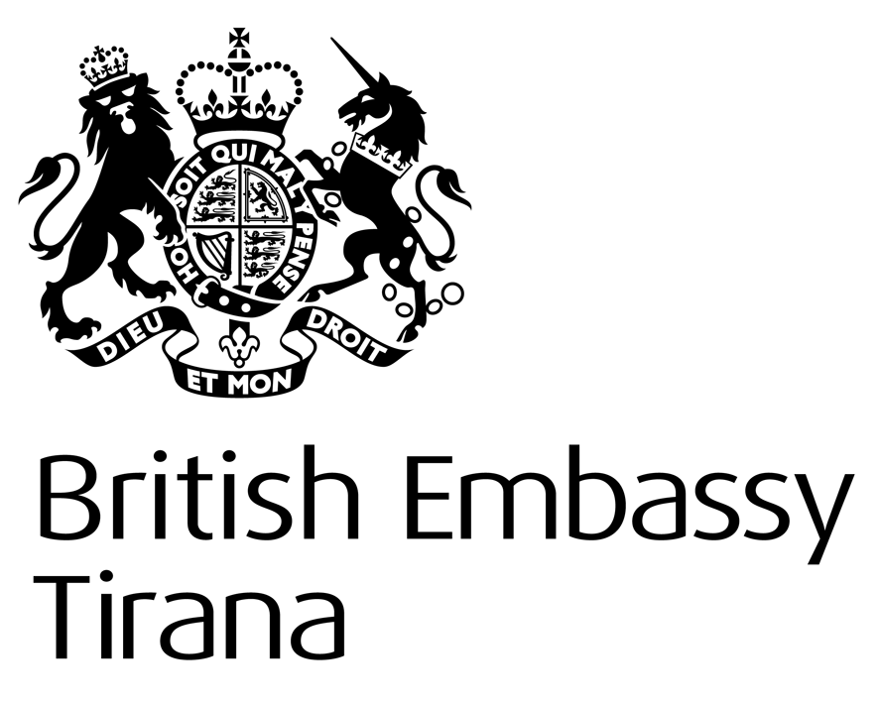

LOST PROPERTY NOTICE

With the exception of passports (which are cancelled and returned to Her Majesty’s Passport Office) and driving licences (which are returned to DVLA) we do not accept or hold items of lost property.
Thank you

Consular Section

2018

