This good practice example has been withdrawn as it is older than 3 years and may no longer reflect current policy.
Creating a culture to sustain high apprenticeship performance: Ministry of Defence (RAF)

URN: 54191
Region: South East
Remit: Further education and skills

Provider background
The Royal Air Force (RAF) provides a broad range of apprenticeships to meet the strategic defence needs of the UK. Apprenticeships within the RAF are delivered at 14 ground training schools located across the UK to around 2,500 apprentices each year. On completion of their training, apprentices are deployed across 38 operational support units worldwide.

Brief description
This good practice example shows how the RAF has successfully created an ambitious and highly aspirational culture within its apprenticeship programme.
Senior commanders have achieved this by embedding a shared set of core institutional values known as RISE (respect, integrity, service and excellence) that cover every aspect of the RAF’s day-to-day activities. The culture embedded through RISE successfully prepares younger staff and recent recruits for their working life, helping them to excel in their training and equipping them well to secure promotion.
As a result, apprenticeships are highly valued by leaders at all levels in the RAF as a means of ensuring that staff are well trained and that training meets the needs of both the apprentices and the Service.

The good practice in detail
At its inspection in December 2014, inspectors judged the overall effectiveness of the Ministry of Defence (RAF) to be outstanding. Inspectors recognised that the Service was able to demonstrate exceptionally high standards in the quality of training received by apprentices, with virtually all achieving their apprenticeship qualification within the planned time.

Establishing a career ladder through apprenticeships
The RAF aims to develop its current and future non-commissioned workforce through apprenticeships. The success of the apprenticeship programme is clear. Within the non-commissioned ranks, over 80% of corporals are ex-apprentices, who in turn provide strong and visible role models for newer recruits and those just embarking on their apprenticeship career.
The ‘All of one company’ policy offers all those in non-commissioned ranks who are attached to a trade group, irrespective of their age, the opportunity to do an apprenticeship. As a result of this policy, the uptake for apprenticeships is very high, with over 2,500 apprentices in training each year and virtually all achieving their qualifications.
Leaders use a formal career and promotion framework based on apprenticeship skills and competencies to recognise and reward vocational excellence. For example:
- apprentices in the engineering trade group are rewarded with a pay rise on graduation from the ‘intermediate apprenticeship in engineering’ – they also achieve the status of Senior Aircraftman/Aircraftwoman (SAC) and are eligible to wear a rank badge denoting their newly gained status
- engineering apprentices who graduate at an ‘advanced’ level also receive an automatic pay rise and are awarded the promoted status of senior aircraftsman/woman (SAC) and the accompanying trade badge, which denotes both their rank and ‘technician’ status.
Apprentices highly covet trade badges to show their progression within the Service and increasing level of skill and competency.
The success of the apprenticeship scheme in building a highly skilled and competent workforce is shown by the fact that virtually all of the LAC/SACs within the Service are either apprentices or ex-apprentices.

High expectations for performance and capability
The ‘Defence train the trainer’ programme gives training instructors the instructional and facilitative skills to embed an aspirational culture that engages, motivates and rapidly develops apprentices’ performance and capability.
Through a clear strategy of focusing on developing the moral character and personal effectiveness of apprentices during their initial recruitment and induction training (Phase One), RAF commanders can reliably count on all apprentices to do ‘what is right and what is expected of them’.

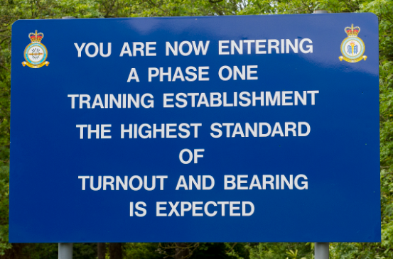

These values are further reinforced and promoted during subsequent training phases. Phase Two of the apprenticeship programme focuses on developing recruits’ specialist vocational trade-specific skills, aligned to one of 16 nationally recognised apprenticeship frameworks.
When they graduate from their apprenticeship, recruits are eligible for selection to take advanced-level post-trade Phase Three training. For example, apprentices who graduate as Aircraft Maintenance Mechanics and who show aptitude can on the recommendation of their commanding officer be selected to undertake an Advanced Apprenticeship in Aeronautical Engineering, leading to qualification as an Aircraft Technicians (Mechanical), Aircraft Technician (Avionics) followed by a further opportunity to undertake more specialist training in areas such non-destructive testing, metallurgy (the scientific and technical study of metals) and aircraft airworthiness.

Building skills within the culture
Well-structured and carefully planned training enables apprentices to quickly develop good levels of technical skills and conduct themselves to the high standards expected in the military, particularly when responding to operational commands and instructions.
Apprentices rapidly:
- gain self-confidence and confidence in others due to the clear focus that leaders place on commonly understood and shared values such as courage, honesty and integrity
- demonstrate an exceptionally clear understanding of the importance of institutional pride, loyalty and teamwork and how these aspects underpin and build trust in friends, colleagues, mentors and supervisors
- gain a high standard of respect for both themselves and for others that equips them well for a career within the Service
- develop strong determination to do well in all aspects of their training, personal conduct and career within the Service
- develop resilience and trust in both their own technical and leadership abilities and those of comrades, particularly when on operational attachment at airbases and other locations – this is due to the precise guidance and detailed instructions provided by leaders and training instructors
- become confident in their ability to embed and replicate the RAF values of respect and responsibility in their relationships with others, within the workplace and beyond. They are respected and ‘counted on to do what is right’ even when they face hardship and danger such as while on deployment to combat zones or when undertaking humanitarian work overseas.

Using organisational values, beliefs and traditions from the start
RAF commanders give great attention to detail in carefully selecting, retaining and promoting apprentices within the Service.
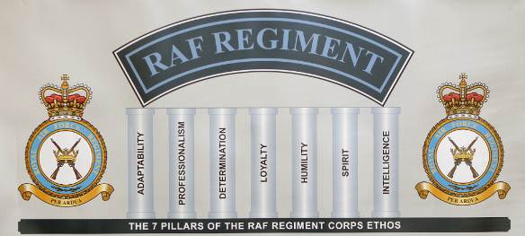
For those seeking entry on to the RAF apprenticeship scheme, the criteria for selection focus strongly on their ability to demonstrate a commitment to the RAF’s values and behaviours including teamwork, respect and adaptability.
Leaders also give appropriate weighting to applicants’ academic ability, as well their overall level of fitness and health assessed during a multi-stage fitness test conducted during Phase One of the programme.
All new recruits selected for apprenticeship training receive a comprehensive and thorough induction into the values, beliefs and traditions of the RAF and life within the military. The early integration of these values helps foster a strong sense of ‘belonging to an extended family’ and motivates them to think and act in ways that are consistent with the ethos.

The importance of leadership
Leaders and training instructors closely monitor the development of apprentices’ technical and social skills, particularly their ability to demonstrate the values and behaviours embedded in RISE.
Recognition and reward systems are used very effectively, both to motivate and successfully sustain recruits’ interest in and commitment to achieving and sustaining high levels of performance. Apprentices regularly receive positive challenge, encouragement and support from their training instructors, who make effective use of daily ‘parade musters’ and ‘assemblies’ to recognise and celebrate those recruits who are performing to a good standard and making good progress in their training.
Leaders and training instructors also encourage and reward apprentices who display desired attributes and behaviours through:
- awarding ‘letters of commendation’ for those apprentices who demonstrate high standards of conduct and performance – known in the RAF as ‘a good show’. Commendations are attached to the recruits’ training and development record and can be used to inform potential selection at promotion boards. Consequently they are highly sought after and valued by all apprentices
- embedding high status to the right to wear cap and trade insignia badges as part of the uniform – denoting to themselves, their comrades and squadron commanders their increasing levels of competence and technical skills
- the very effective use of station newsletters, notice boards and wall displays to reinforce and celebrate the importance of RAF values, beliefs and traditions such as camaraderie, professionalism, organisational pride and loyalty
- the prestige that senior RAF commanders and graduating apprentices attach to passing-out parades, both formally conferring a ‘rite of passage’ for successful apprentices as qualified aircraftsmen/women and their subsequent deployment to operational squadrons.

