BUSINESS IMPACT TARGET:
SUMMARY TEMPLATE
Non-qualifying Regulatory Provisions (NQRP) summary reporting template

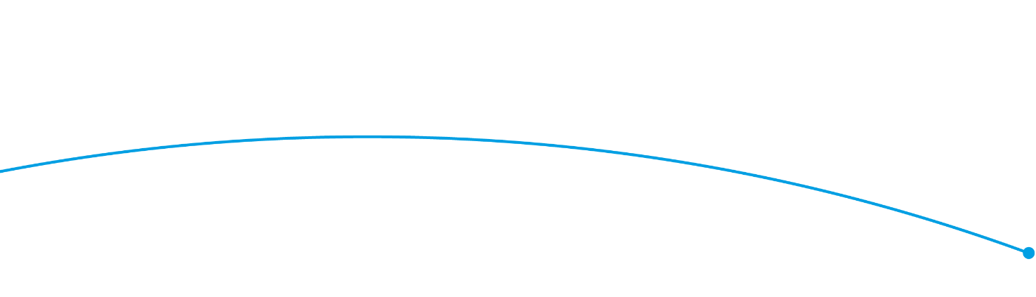

Regulator: Fish Health Inspectorate
Business Impact Target Reporting Period Covered: 9th June 2017 to 20th June 2018
Excluded Category* | Summary of measure(s), including any impact data where available**
Measures certified as being below de minimis (measures with an EANDCB below +/- £5 million) | Following consideration of the exclusion category there are no measures for the reporting period that qualify for the exclusion.
EU Regulations, Decisions and Directives and other international obligations, including the implementation of the EU Withdrawal Bill and EU Withdrawal Agreement | Following consideration of the exclusion category there are no measures for the reporting period that qualify for the exclusion.
Measures certified as concerning EU Withdrawal Bill operability measures | Following consideration of the exclusion category there are no measures for the reporting period that qualify for the exclusion.
Pro-competition | Following consideration of the exclusion category there are no measures for the reporting period that qualify for the exclusion.
Systemic Financial Risk | Following consideration of the exclusion category there are no measures for the reporting period that qualify for the exclusion.
Civil Emergencies | The Fish Health Inspectorate applied statutory controls on 33 fisheries, 1 farm and 1 fish trader to control the listed (notifiable) condition koi herpesvirus (KHV) disease. Following the detection of the listed disease spring viraemia of carp (SVC) statutory controls were placed on 1 fishery on confirmation of infection. In addition, statutory controls were placed on another fishery on suspicion of infection with SVC.  In addition, following the detection of oyster herpesvirus (Os-HV1 µvar) in the Thames estuary the confirmed designations in North Kent and Essex were amalgamated into a single disease control area. This will assist in facilitating the continuity of business in the shellfish farming and harvesting sectors in the area.
Fines and Penalties | Following consideration of the exclusion category there are no measures for the reporting period that qualify for the exclusion.
Misuse of Drugs | Following consideration of the exclusion category there are no measures for the reporting period that qualify for the exclusion.
Measures certified as relating to the safety of tenants, residents and occupants in response to the Grenfell tragedy | Following consideration of the exclusion category there are no measures for the reporting period that qualify for the exclusion.
Casework | The Fish Health Inspectorate served 14 enforcement notices, issued 23 official warning letters, and undertook 61 enforcement visits during the reporting period. This casework relates to non-compliant businesses. The increase in enforcement activities as compared with the previous year is related to the higher number of outbreaks of listed diseases, primarily on managed fisheries, requiring investigation and compliance inspections. We are also involved in several multi-agency investigations with other regulatory bodies including UK Border Force (UKBF), the Environment Agency (EA), the Marine Management Organisation (MMO) and Southern Inshore Fisheries Conservation Authority (IFCA). One of these investigations resulted in a prosecution of a business for multiple offences. None of the activities listed in this section represent a change in the burden of regulation on business, and the potential offences investigated relate to existing longstanding regulatory requirements.
Education, communications and promotion | The FHI continued to engage with businesses through attendance at trade body events such as those held by the Ornamental Aquatic Trade Association (OATA), the British Trout Association (BTA), and the Coarse Fish Conference. The FHI also attends scientific conferences and meetings. Information on regulation is published on the Gov.UK website, the Marine Science blog, and for events such as disease outbreaks, on the FHI Facebook page. Businesses in proximity to disease outbreak events are contacted directly by letter or email to ensure that they are aware of the increased biosecurity risk in their area. Attendance by businesses at promotional or educational events is not compulsory, and none of the material produced creates a new regulatory standard that businesses would be expected to follow.
Activity related to policy development | The Fish Health Inspectorate provides advice to Defra on policy related issues in several areas including aquatic animal health, non-native species, trade in live aquatic animals, and aquaculture development. However, the FHI has no responsibilities in relation the development of government policy, review of policy or the undertaking of consultations.
Changes to management of regulator | Following consideration of the exclusion category there are no measures for the reporting period that qualify for the exclusion.
All other excluded categories | Following consideration of the other exclusion category there are no measures for the reporting period that qualify for the exclusion.

* For full, legal definitions of these exclusion categories, please see https://www.parliament.uk/business/publications/written-questions-answers-statements/written-statement/Commons/2018-06-20/HCWS776/
** Complete the summary box as ‘Following consideration of the exclusion category there are no measures for the reporting period that qualify for the exclusion.’ where this is appropriate.

