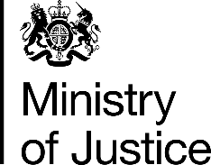 | December 2017

Freedom of Information Act (FOIA) Request – 171120009

You asked for the following information from the Ministry of Justice (MoJ):

Can I please amend this request: - Ethnicity of those sentenced and issued with a Sexual Offence Prevention Order in the past 12 months. Please let me know if this request is more suitable.

Your request has been handled under the FOIA.

I can confirm that the MoJ holds the information that you have requested and I have provided it in the attached annex. Please note that these figures only include cases recorded as Sexual Offence Prevention Orders as requested and do not include Sexual Harm Prevention Orders.

