**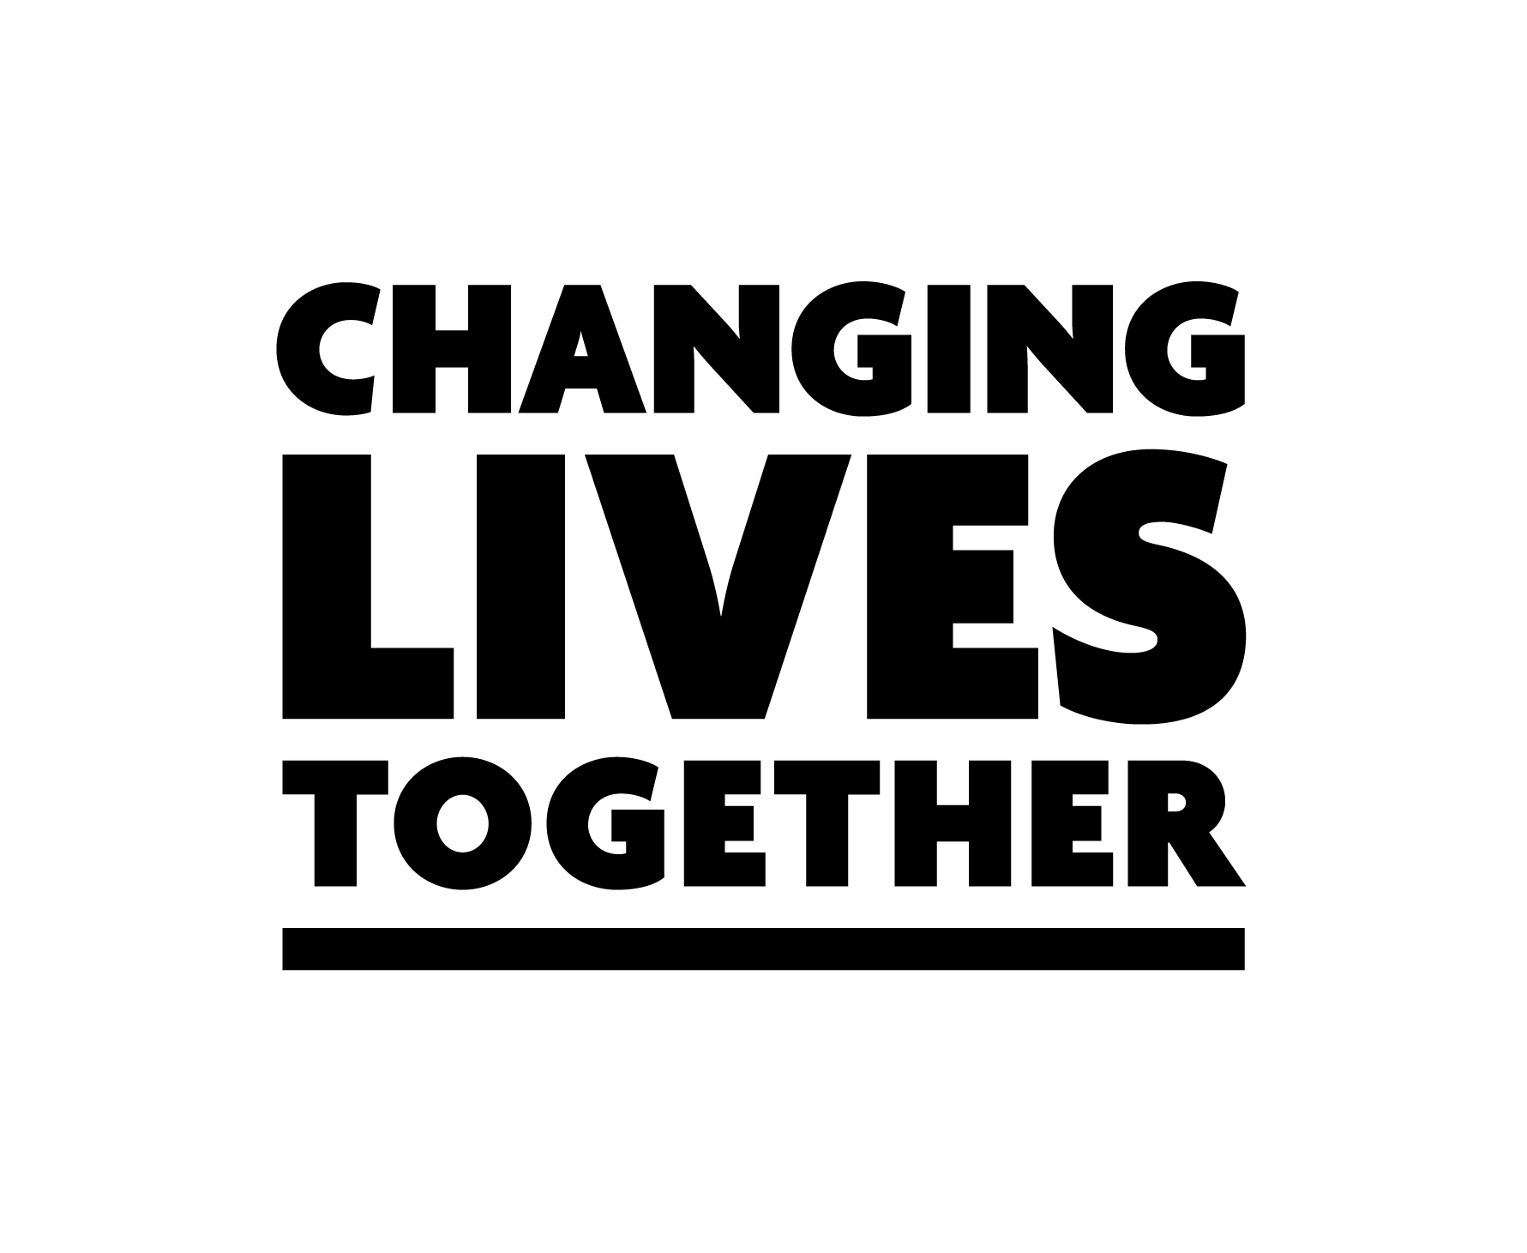Macintosh HD:Users:Binit:Documents:Library:HMPPS branding:Her Majesty's Prison and Probation Service:SMALL AW:HMPPS_BLK_SML_AW.eps**

**Share your story**

**You are changing lives every day – we want to hear about it.**

Every day you are working to change lives for the better - whether that is the people in your care, their families who see a difference, or the victims you are preventing by helping someone onto the right path.

You might not realise, but even the small things you do every day make a difference. It might be making extra time for an individual in your care or supervision who needs help filling out a form, or simply greeting everyone with a smile in the morning.

So we think it’s time to share those stories and we’ve launched Changing Lives Together to do just that.

Please fill out the below form for yourself or a colleague so we can show staff the good we do. Even better, click the ‘use externally’ box and we can tell the world.

**Your details**

**Name**

**Email**

**Role**

**Organisation**

**Your nomination**

If you are filing this out to recognise a colleague, please put their details here

**What small thing did you / this person do today to make a difference in someone’s life?**

**What motivates you / this person?**

**How do you / this person change lives?**

**Privacy**

Can be used within HMPPS only

Can be used publicly on social media

**Submitting your entry**

Submit your completed form to [changinglivestogether@noms.gsi.gov.uk](mailto:changinglivestogether@noms.gsi.gov.uk)