# SIN China facilitates £2m export win for award-winning UK toothpaste technology

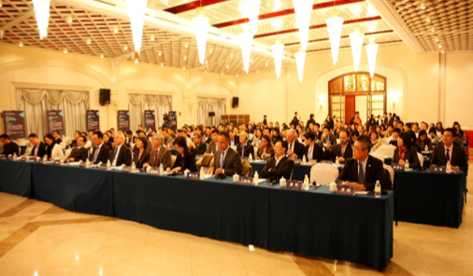A UK spinout company has secured a £2m agreement to export an award-winning toothpaste ingredient to China as a result of participating in a SIN mission, as well as securing investment from the Chinese partner company.

With ICUK (Innovation China UK), SIN China ran a technology partnering mission in Smart Materials in November 2015, with the aim of generating new innovation partnerships and commercial opportunities for UK companies and research institutes in this high-growth sector. One of the participants was UK company BioMin Technologies Ltd, a spinout from Queen Mary University of London and Imperial College London set up to commercialise a new technology: a bioactive glass material which contains particles that can repair tooth enamel and relieve tooth pain.

During the visit they met Guangdong KanWan Cosmetics Co. Ltd, a large Chinese toothpaste manufacturer, and over subsequent meetings also supported by SIN established a manufacturing and distribution license agreement, under which the bioactive glass, manufactured in the UK, is exported to China for use in a toothpaste formulation developed by KanWan. The export agreement is estimated to be worth £2m over the next four years.

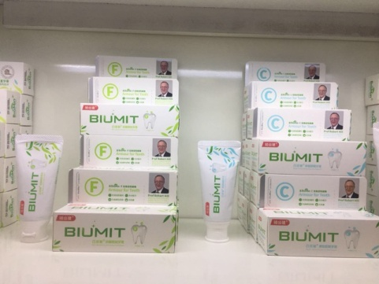

KanWan also became a shareholder in BioMin, investing £45,000 as part of a recent fund raising round which enabled BioMin to commercialise the technology and establish their manufacturing infrastructure, as well as contracting further research.

The retail product Biumit was introduced onto the Chinese market in January 2018. Supported along the way by both SIN and DIT (Department for International Trade), this is a success story that not only delivers economic benefit to the UK, but also relief for the millions of Chinese consumers who suffer from tooth sensitivity and pain.

Richard Whatley, CEO of BioMin Technologies, said:

“The support provided by ICUK and SIN has been central to establishing a Chinese licence partner for our innovative technology. China has the largest demand for toothpaste in the world and hence this partnership with Guangdong Kanwan Cosmetics Co opens up enormous potential for our start-up enterprise.”

SIN China Contact: [morag.brown@fco.gov.uk](mailto:morag.brown@fco.gov.uk)