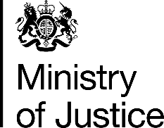 | November 2017

Freedom of Information Act (FOIA) Request – 171103005

You asked for the following information from the Ministry of Justice (MoJ):

I am seeking information on the number of convictions in 2015/16 under the Animal Welfare Act 2006, broken down by police force area or county, data which I believe may have been published by yourselves.

I have seen local media reports citing statistics for individual areas (for example, this article from Cambridge News) which describe the source of the information as a freedom of information request to the MoJ. However, the information does not yet appear to be listed in the FOI log on the gov.uk website. There have also been several recent written answers to parliamentary questions which have provided the data for other areas, with the source listed as Justice Statistics Analytical Services.

If the information is available for all police force areas, counties or similar, I would be most grateful if you would be able to point me in the right direction. Many thanks in advance for your help.

Your request has been handled under the FOIA.

I can confirm that the MoJ holds the information that you have requested and I have provided it in the attached annex.

