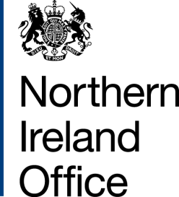

Northern Ireland Office:
Business appointment rules advice

This page summarises advice given under the business appointment rules to applicants at SCS2 and SCS1 level and equivalents.

During the period October - December 2017, the Northern Ireland Office did not issue any decisions on applications submitted under the Business Appointment Rules.

