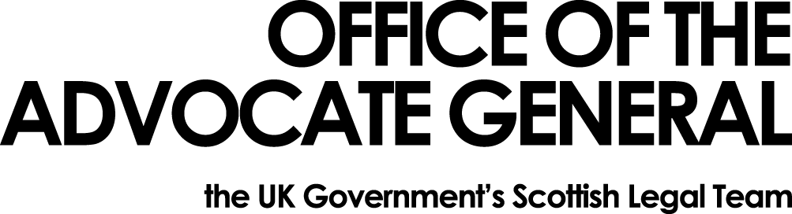
[REDACTED] | Area GG South  OAG  Victoria Quay  Edinburgh EH6 6QQ  7 February 2018

Dear [REDACTED]

Freedom of Information Request

Thank you for your email of 16 January 2018 requesting information under the Freedom of Information Act 2000 (FOIA). You asked:

I am interested in finding figures of how much has been spent on ministerial boxes across the various government departments, such as the one famously used to deliver the budget on November 22nd 2017.

1). How much in British pounds sterling, for each calendar year since 2013 up to the present date (2013, 2014, 2015, 2016 and data for 2017) has been spent on new ministerial boxes, and repairs to ministerial boxes by your department.

Having completed our search for information I can tell you that there has been no spend since 2013 on new ministerial boxes or repairs to ministerial boxes from the Office of the Advocate General.

You may, if dissatisfied with the treatment of your request, ask the Office of the Advocate General to conduct an internal review of its decision. The internal review will be conducted by someone other than the person who took the initial decision. Requests for internal review should be addressed to the Information Officer, Office the Advocate General, Victoria Quay, Edinburgh, EH6 6QQ.

If following the internal review you remain dissatisfied with the treatment of your request by OAG then you may take your complaint to the Information Commissioner, whose address is Wycliffe House, Water Lane, Wilmslow, Cheshire, SK9 5AF. Details of the complaints procedure can be found here:
https://ico.org.uk/concerns

Yours sincerely

[REDACTED]

