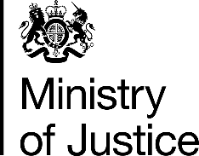 | April 2017

Freedom of Information Act (FOIA) Request – 111477

You asked for the following information from the Ministry of Justice (MoJ):

I have been conducting some research looking at the Annual Criminal Statistics reports. However, I would like some more detailed data relating prosecutions and convictions.

Please could you provide statistics for:
(1) The number of prosecutions for publishing an obscene publication or possessing an obscene article for publication for gain (Obscene Publications Act, 1959, s.2) between 2005 and 2015.
(2) The number of convictions for publishing an obscene publication or possessing an obscene article for publication for gain (Obscene Publications Act, 1959, s.2) between 2005 and 2015.

If you do not have statistics for all of these years, please could you send me statistics for those years that you do hold.

Your request has been handled under the FOIA.

I can confirm that the MoJ holds the information that you have requested and I have provided it in the attached table, which provides the number of defendants proceeded against at magistrates courts and found guilty at all courts of publishing an obscene publication or possessing an obscene article for publication for gain, in England and Wales, from 2005 to 2015

