Prescription Only to Pharmacy Reclassification

Maloff Protect 250mg/100mg Film-Coated Tablets

Atovaquone 250mg/Proguanil hydrochloride 100mg

PL 25258/0166 - 0014

Glenmark Pharmaceuticals Europe Ltd

Approval date: 3 July 2017

TABLE OF CONTENTS

Introduction Page 2

Background Page 2
Proposed terms of reclassification Page 2

Criteria for P classification Page 2

Assessment of suitability for Pharmacy availability Page 3

Advice from the Commission on Human Medicines Page 5

Consultation on Pharmacy Availability of Maloff Protect Page 5

Responses to consultation ARM 93 Page 5

Conclusion Page 9

1. Introduction

Maloff Protect 250mg/100mg Film Coated Tablets (hereafter referred to as Maloff Protect) is a medicine to be taken by mouth to prevent malaria infection in adults travelling to areas where malaria is widespread.

The active ingredients are atovaquone and proguanil hydrochloride. Both are in a class of drugs called biguanides used to prevent and treat malaria.

Malaria is a serious disease caused by a parasite passed to humans by the bite of an infected mosquito which passes the malaria parasite into the bloodstream. Maloff Protect prevents malaria by killing these parasites in the blood.

The Licence holder, Glenmark Pharmaceuticals Europe Ltd applied to make this product available as a Pharmacy (P) medicine for sale in pharmacies, by or under the supervision of a pharmacist.

The Medicines and Healthcare Products Regulatory Agency (MHRA) considers this product is safe enough to be sold in pharmacies.

2. Background

Atovaquone and proguanil hydrochloride belong to a group of medicines called antimalarials. They act in different ways to kill the malaria parasite. When used together to prevent malaria they are more effective than when each substance is used alone. They are also used to treat malaria infection but Maloff Protect will only be available as a Pharmacy (P) medicine for malaria prevention. It is considered that anyone infected with malaria should be treated under the supervision of a doctor or other healthcare professional qualified to prescribe medicines.

Maloff Protect containing atovaquone and proguanil hydrochloride was first authorised to Glenmark as a prescription only medicine (POM) in 2015. A tablet containing 250mg atovaquone and 100mg proguanil hydrochloride has been licensed in Europe for the prevention and treatment of malaria since 1996.

This was the first application for pharmacy availability for this product in the UK.

3. Proposed Terms of Reclassification

The applicant proposed the following conditions for the P availability of Maloff Protect:

• Tablets for oral use
• For prevention of malaria in adults weighing more than 40 kg
• Dose: 1 tablet to be taken daily commencing one to two days prior to entering a
malaria-endemic area, continuing during the period of stay, continuing for 7 days after leaving the area
• Maximum dose: 250mg/100mg
• Maximum daily dose: 250mg/100mg
• Maximum pack size: 36 tablets (total number of tablets dispensed dependent on duration of travel with maximum of 93 tablets for 12 weeks’ travel).

4. Criteria for P classification

To be reclassified from POM to P, a medicine must:

• Be unlikely to be a direct or indirect danger to human health when used without the supervision of a doctor, even if used correctly
• Be generally used correctly (i.e. not frequently or to a wide extent used incorrectly)
• Not contain substances or preparations of substances where the activity of the product or its side effects require further investigation
• Not normally be prescribed by a doctor for injection (parenteral administration)

These criteria are set out in the Human Medicines Regulations 2012, Regulation 62(3).

5. Assessment of suitability for pharmacy availability

5.1 Prescription Only Criteria

The MHRA assessed the application against the criteria for classification as a Prescription Only Medicine, as stated in section 4.

5.1.1 Direct danger
Direct danger means that a danger may be present if the product causes adverse reactions that are important. The most frequently reported side effects for Maloff Protect are generally mild to moderate in intensity and stop when the medicine is stopped; these include abdominal pain, headache, loss of appetite, nausea, vomiting, diarrhoea, and coughing.

Individuals who are considered to be at risk of serious adverse reactions with atovaquone and proguanil hydrochloride will not receive Maloff Protect unless advised by a doctor or other qualified prescriber. These individuals include those weighing less than 40kg, people known to have kidney or liver disease and people with a history of depression or seizures. Maloff Protect will also not be made available to women who are pregnant, planning to become pregnant or breastfeeding. They will be advised to consult their doctor. Children will also not receive this product through pharmacies because they are at risk of more severe complications of malaria and need advice from a doctor or other qualified prescriber.

Although drug-drug interactions (interactions between atovaquone or proguanil hydrochloride and other drugs taken at the same time) have been identified, people who are known to be using any of the drugs known to interact with atovaquone or proguanil would also not receive Maloff Protect. Therefore, the danger of drug-drug interactions leading to adverse reactions is low for this product.

5.1.2 Indirect danger
Indirect danger to human health, even when the product is used correctly, could occur where treatment might mask or hide an underlying condition requiring medical attention and supervision. Use of the medicine might delay diagnosis and definitive treatment and jeopardise the chance of more successful therapy. Therefore, it is important that the condition or symptoms, for which a medicinal product not subject to a medical prescription is indicated, can be correctly assessed by the patient and that the product can be used without medical supervision.

Maloff Protect will be used to prevent and not treat malaria, so no diagnosis of a condition is needed. However, it is important that travellers can decide if Maloff Protect is a correct product to take depending on the part of the world they will be visiting. The label and the patient leaflet advises patients to get advice from a healthcare professional about which antimalarial to take. And training material will be made available for pharmacists and their staff to enable them to identify the correct choice of products for an individual. There is always a risk that people can still catch malaria even if they take medicines to protect themselves. Maloff Protect does not mask the symptoms of malarial infection.

Malaria is a medical emergency, with a potential for life threatening or fatal disease if not treated within 24 hours. Pharmacists will have the opportunity to make patients aware of the symptoms of malaria at the time of supplying Maloff Protect in case they catch the disease. The leaflet will also instruct patients to seek medical advice immediately if they experience any of the symptoms of malaria infection.

As with antibiotics there is a risk that overuse and misuse can lead to resistance (the ability of the malaria parasite to resist the effects of Maloff Protect). The risk that use of Maloff Protect to prevent malaria will lead to the development of resistance is very low. Resistance development is associated with use of antimalarials in treatment rather than prevention of malaria. Patients will be instructed on how to take the medicine correctly, which will also reduce the risk of development of resistance.

Maloff Protect is considered to be safe in long term use provided there are no serious side effects experienced.

5.1.3 Incorrect use – frequently and to a very wide extent
Although patients may be supplied a large number of tablets at once especially for longer trips, the risks of misuse including use for self- treatment are low and no different from that of the prescription medicine. As Maloff Protect has a simple dosing schedule the risk of medication error (mistakes made when using the medicine) is low. The effects of overdose are known to be non-serious and reversible. Atovaquone and proguanil hydrochloride are not known to have abuse potential.
There is no evidence that similar products already available via pharmacies for prevention of malaria are used incorrectly.

5.1.4 Activity and/or adverse reactions require further investigation
Products containing atovaquone and proguanil hydrochloride have been used as prescription products since 1997 and the activity and adverse reactions are well established therefore this criterion does not apply.

5.1.5 Is normally prescribed as an injection
This product is for oral use only, so this does not apply.

5.2 Risk Management Plan

The application contained a risk management plan (RMP). RMPs are documents that contain information on a medicine’s safety profile and one or more of the following:

• How any risks identified in the safety profile will be prevented or minimised in patients
• Plans for studies and other activities to gain more knowledge about the safety and efficacy of the medicine
• Risk factors for side effects
• Measuring the effectiveness of measures taken to prevent or minimise risks.

The RMP for this product identified the main risks associated with the product and proposed how these will be managed in the product information (Summary of Product Characteristics, labelling and patient information leaflet) and by the provision of training material for pharmacists and their staff.

5.2.1 Training resources
Additional resources will be provided for pharmacists, which cover the following areas:

• Pharmacy Guide
- The Pharmacy Guide will provide information to pharmacists on the choice of medicines available to prevent malaria and how to use Maloff Protect safely.
- The Pharmacy Guide includes information on malaria and how it is spread, advice to avoid getting bitten by mosquitoes, the choice of products available to prevent malaria, recommended online resources to
seek information from, advice on patients who should not receive Maloff Protect, symptoms of malaria, what to do if patients think they are infected and the importance of reminding patients to take the drug correctly to reduce the risk of resistance.

• Screening Questionnaire
- The Screening Questionnaire contains a list of Yes/No questions which the pharmacist should ask the patient.
- This will help the pharmacist identify if the patient has any risk factors which means they should not be given Maloff Protect.

• Pack Calculator
- This will help the pharmacist calculate the number of tablets to supply depending on how long the patient is going to be travelling for.

• Pharmacist Checklist
- The Pharmacist Checklist will remind the pharmacist of actions to take when supplying Maloff Protect.

The following additional resources will also be provided for patients:

• User Reminder Card
- The User Reminder Card displays a daily calendar to help patients track or record whether they have taken their dose for that day.
- The other side of the card has a space for the pharmacist to provide the address or directions to the nearest place to receive full travel advice (including advice other than on prevention of malaria).

• User Reminder App
- The User Reminder App will allow patients to program a daily reminder on their phone to remind them to take Maloff Protect at a set time each day. The User Reminder App will be accessible through a QR code on the label.

6. Advice from the Commission on Human Medicines

The Commission on Human Medicines advised in favour of Pharmacy availability of Maloff Protect 250mg/100mg Film Coated Tablets for prevention of malaria in adults weighing more than 40 kg, with a maximum dose and daily dose of 250mg/100mg and a maximum pack size of 35.

7. Consultation on Pharmacy Availability of Maloff Protect

Consultation ARM 93 proposing pharmacy availability of Maloff Protect 250mg/100mg Film Coated Tablets was issued on 16 March 2017 with a deadline for comments of 6 April 2017. A copy of the consultation document and details of the responses are available on the MHRA website.

8. Responses to consultation ARM 93

8 responses were received: 4 were in favour of the reclassification, 3 were not in favour, and 1 was unsure.

Of these 8 responses received, 3 were from specified organisations. The Royal Pharmaceutical Society and the Royal College of Physicians were in favour of the reclassification. The Dispensing Doctors’ Association were not in favour. Of the 5 remaining responses, 3 were from individual pharmacists. Two pharmacists were not in favour of the reclassification and the other pharmacist was unsure. The final two respondents requested that their response remain confidential.

The respondents had concerns as follows:
• Maloff Protect may not be the appropriate antimalarial for the region of travel, including if travel plans change.
• The traveller may not receive a complete risk or travel health assessment; it may be more appropriate to receive travel advice from a single source.
• The number of tablets dispensed for duration of travel may not be appropriate, which may lead to inappropriate use.
• The maximum number of tablets to be dispensed at any one time should be stated.
• Travellers may share medicines between them.
• There may be issues with antimicrobial resistance.
• Additional information is required on the label in case travellers do not read the leaflet.

All issues raised had already been considered by CHM when they advised on the product’s suitability for Pharmacy classification. No concerns were raised in relation to the suitability of this product for supply without prescription that had not already been addressed during previous assessment of this product.

The following sections detail the key issues raised by respondents and how they have been addressed.

The appropriateness of antimalarial chemoprophylaxis for the region of travel including if travel plans change
The patient leaflet advises that the traveller should seek advice on whether Maloff Protect is suitable for the part of the world they will be visiting.

The Pharmacy Guide advises dispensing pharmacists that selecting the right antimalarial depends on the region or regions that the customer intends to travel to and the prevalence of resistance to antimalarial drugs in those regions. The guide directs pharmacists to check the latest recommendations about malaria chemoprophylaxis before providing advice to patients on the following websites:
• www.travelhealthpro.org.uk/countries
• www.travax.nhs.uk (for Scottish healthcare professionals)
These two online resources are those recommended by Public Health England’s Advisory Committee for Malaria Prevention for UK Travellers (ACMP) for travel advice (which includes malaria advice) for travellers from the UK.

The Pharmacy Checklist contains a reminder of the actions that the pharmacist should take in sequence. The first step of the consultation with the traveller is to check which malaria chemoprophylaxis is recommended for the country/countries the customer will be visiting.

It is acknowledged that changes in travel plans may result in atovaquone/proguanil no longer being the appropriate antimalarial chemoprophylaxis for the region of travel. However, this circumstance is relevant to all travel advice and may occur regardless of whether the antimalarial is provided via the POM or P route. Nevertheless, to address this concern, the following statement asking the traveller to seek updated travel advice should travel plans change was added to the Pharmacy Guide:
“Advise the customer that if their travel plans change, they will need to seek updated travel advice”.

Travel health assessments including the need to receive advice from more than one source
The importance of a full travel health assessment is reiterated in several of the product materials.

The Patient Leaflet states:
“Getting advice for malaria is only one of the aspects to protect your health before your travel. Remember to seek a full travel consultation.”

The Pharmacy Guide advises Pharmacists to:
“Ensure the customer has had a full travel consultation. If they have not, remind them of the need to undertake an overall risk assessment-based package of travel health advice including advice on vaccinations. Provide the address to the nearest facility they can receive this in the space provided on the patient reminder card. Malaria prophylaxis is only one of the aspects of pre-travel advice.”

One side of the Patient Reminder Card is dedicated exclusively to the need to obtain travel advice, with similar advice to the Pharmacy Guide, as follows:
“Your pharmacist should provide the address of the nearest facility to receive a full travel consultation including advice on vaccinations if you have not already done so”. There is also a clearly marked space for the pharmacist to provide the address of the nearest travel advice facility.

To be consistent with the tone of the advice provided in the other materials, advice in the Pharmacy Checklist was made more robust by the following amendment:
“Direct the customer to a facility to receive a full travel consultation including advice on vaccinations.”

Although it may be less convenient for travellers to receive advice from more than one source, if travellers were not previously aware that they required a full consultation, contact with the community pharmacist will be an opportunity to direct them to receive this. The traveller can still choose to receive their malaria chemoprophylaxis from the same source as the remainder of their travel advice if they wish to do so.

The number of tablets dispensed
Respondents felt that the inability to dispense the precise number of tablets required and the availability only of pack sizes of 24 and 36 may result in inappropriate use of excess tablets after travel, or in travellers purchasing fewer tablets than needed to complete the course.

The respondents did not specify the concern relating to how the tablets may be inappropriately used, but at the time of the assessment it was recognised that this may include providing medicines for use by other travellers or keeping excess tablets for use at another date. This may also lead to Maloff Protect being shared with other travellers for whom Maloff Protect may not be appropriate, for example, groups in which use is contraindicated or use in regions where Maloff Protect may not be effective.

The recommended pack sizes were selected to provide the minimum required tablets for a complete course (including tablets needed before and after travel) while minimising the number of excess tablets available

Days in malaria area | Total number of tablets * | Recommended pack size | Number of excess tablets
7 (1 week) | 16 | 1 x 24 | Eight extra tablets
14 (2 weeks) | 23 | 1 x24 | One extra tablet
21 (3 weeks) | 30 | 1 x 36 | Six extra tablets
28 (4 weeks) | 37 | 2 x 24 | Eleven extra tablets
42 (6 weeks) | 51 | 1x36; 1x24 | Nine extra tablets
56 (8 weeks) | 65 | 2 x 36 | Seven extra tablet
84 (12 weeks) | 93 | 2x36; 1x 24 | Three extra tablets

The largest number of excess tablets that may be encountered is therefore 11. This is insufficient for a full course of malaria chemoprophylaxis unless the number of days travelled is 2 days, which is less likely for long distance travel and so would be insufficient to provide to other travellers or to retain for personal use at a later date.

The Pharmacy Guide advises pharmacists to remind customers to return any remaining Maloff Protect tablets to the pharmacy for destruction once the course has been completed.

Of note, the POM criteria alone do not always act as a deterrent to issues with inappropriate use of excess medicines, including sharing medicines with other individuals. Sharing can and does also occur with POM medications, including those used for other indications. Patients may not complete their recommended courses of POM treatment regimens and this may also lead to inappropriate use of the unused medication, including supply to others. Therefore, the risk of inappropriate use of excess medicines is no greater with this product classified as a P than as a POM.

The maximum number of tablets should be stated
A separate issue raised by the Royal Pharmaceutical Society relating to the number of tablets dispensed was that the maximum quantity of tablets (93 for 12 weeks of travel) should be communicated in the SmPC and if a larger quantity of tablets is needed for a longer duration of travel, the patient should be signposted to a prescriber who is able to do this. The SmPC was amended, as follows:

Section 4.4:
“The maximum duration of travel for which Maloff Protect can be supplied without prescription is 12 weeks (93 tablets). For longer durations of travel, advice should be sought from a doctor or other qualified prescriber.”

This statement was also added to the relevant sections in the Pharmacy Guide, Pharmacy Checklist, and the Pack Size calculator.

A question was added to the Screening questionnaire to check that the duration for which Maloff Protect is required is no longer than 12 weeks.

Antimicrobial resistance
Advice was sought specifically from Commission on Human Medicines (CHM) Infection Expert Advisory Group (EAG) regarding the potential for increasing the incidence of parasitic resistance to atovaquone/proguanil.

The EAG considered the risk of resistance to be low because atovaquone/proguanil was not widely used as treatment in endemic areas. The Group noted that resistance that emerged with other antimalarials had arisen not from use of the drugs for prophylaxis but rather from treatment pressure and suboptimal treatment in malaria endemic regions.

The risk of resistance with use of atovaquone/proguanil as prophylaxis was therefore considered a small, theoretical risk. This risk was considered to be minimised by advice provided in the product information and the relevant additional risk minimisation material.

The risk minimisation material (including the product information) addresses the modifiable human factors that may contribute to the selection of resistant malaria parasites. For example, by: prompting reference to the most up-to-date material on resistance development; providing clear advice about dosing and supporting adherence; providing direction in situations where malabsorption is likely; and advising not only on recognition of symptoms of malarial infection but also on actions to take in the event of infection.

Advice on patients who are known to be taking medications that are known to interact with atovaquone/proguanil is also provided in the product information and risk minimisation material. Therefore, these groups can be excluded from receiving Maloff Protect.

Label wording
The Royal Pharmaceutical Society suggested that the label should be amended as follows:

Current wording:
How to take: Adults: Take one tablet once a day with food or a milky drink where possible.
Proposed wording:
How to take: Adults: Take one tablet once a day at the same time each day with food or a milky drink where possible.

The Society made the point that although the need to take the medicine at the same time each day was reflected in the PIL, some patients may not read the PIL and will only refer to the dosage on the outer label. This suggestion was accepted and the label was amended accordingly

9. Conclusion

Assessment of the responses to consultation on the application for Maloff Protect has revealed no new issues of concern in addition to those considered by CHM and on which CHM were reassured. Considering the advice from CHM, the MHRA has taken the decision to approve Pharmacy legal status for Maloff Protect.

Summary of Product Characteristics (SmPC), Patient Information Leaflet (PIL) and labelling
In accordance with Directive 2010/84/EU the Summary of Product Characteristics (SmPC) and package leaflet for the product granted a Marketing Authorisation at a national level is available on the MHRA website.

The approved labelling for Maloff Protect is presented below:

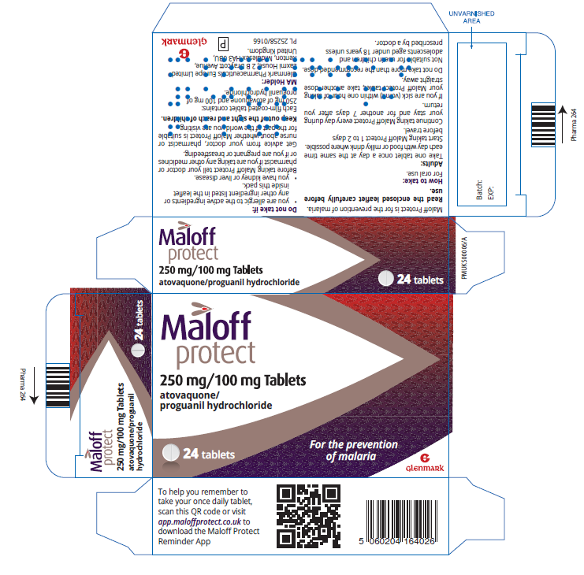
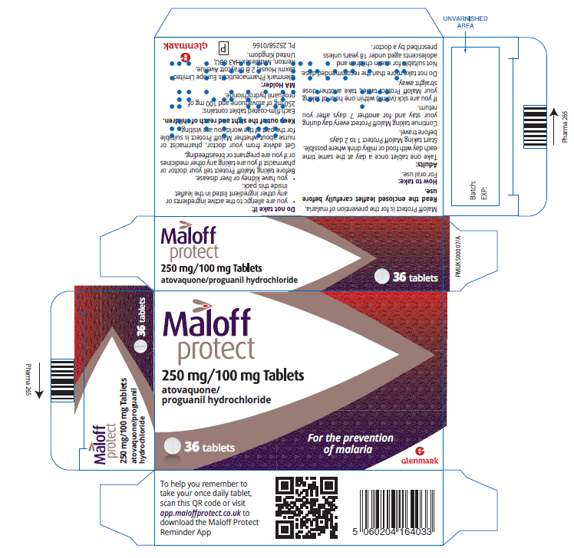

ARM Stands for Application to Reclassify a Medicine. An ARM consultation is a public consultation inviting views from all stakeholders on a proposal to reclassify a medicine from POM to P or from P to GSL.
Preventing infectious disease with chemical agents in the form of medicines.
SmPC stands for Summary of Product Characteristics. The SmPC is a legal document describing a medicine’s properties and how it can be used. SmPCs are available online via the MHRA.

