Changes to Ofsted’s statistical reporting of inspection outcomes for local authority maintained schools and academies
Consultation document
This is a consultation on our proposals for revisions to how we report statistics relating to maintained schools and academies inspection outcomes.

We are seeking the widest possible range of views to ensure that the revised publications take into account the needs of all those who have expertise or an interest in maintained schools and academies. We are particularly keen to hear from people who are directly involved with schools, including children, parents and carers and those who run and commission services.

The closing date for this consultation is 18 January 2018.

If you would like a version of this document in a different format, such as large print or Braille, please telephone 0300 123 1231 or email enquiries@ofsted.gov.uk.

Contents
About Ofsted 3
Purpose and background to the consultation 3
The aim of the consultation 4
Proposals 4
Making the data more comprehensive and accessible (question 1) 4
Changing the presentation of some of the aggregated analysis (question 2) 6
Minor changes to releases to improve naming and usability (questions 3 and 4) 8
The consultation process 8
Questionnaire for changes to Ofsted’s statistical reporting of inspection outcomes for maintained schools and academies 10
Additional questions about you 18

About Ofsted
- The Office for Standards in Education, Children’s Services and Skills (Ofsted) regulates and inspects to achieve excellence in the care of children and young people and in education and skills for learners of all ages.

Purpose and background to the consultation
- This consultation seeks your views on the new arrangements we propose for reporting the outcomes of inspections of local authority maintained schools and academies. Your contribution will help to refine and develop these statistics to meet users’ needs.
- Two regular Ofsted publications will be affected by these changes:
- ‘Maintained schools and academies inspections and outcomes – official statistics’, published three times a year at: www.gov.uk/government/collections/maintained-schools-and-academies-inspections-and-outcomes-official-statistics. This reports on the most recent inspection outcomes of all open schools and the outcomes of inspections in the academic year to date. In addition to tables, charts and underlying school level data, it includes a written commentary on the main findings from the data.
‘Management information – schools’, published monthly at: www.gov.uk/government/statistics/monthly-management-information-ofsteds-school-inspections-outcomes. This also reports on the most recent inspection outcomes of all open schools and the outcomes of inspections in the academic year to date. However it is a smaller release and does not include a written commentary.
- The data affected by these proposals may also be quoted in a variety of our communications. This includes speeches, blogs, conferences, surveys, letters, and HMCI’s Annual Report 2017/18.
- These proposals only affect how we report on the outcomes of inspections in our statistical datasets. They do not affect the timing of a school’s inspection, the data that is used in the inspection, or the way that school inspection reports are displayed on our website.

The aim of the consultation
- This consultation aims to investigate how we can make the content of the official statistics releases more transparent and user-friendly.
- The responses will inform the review of the publications. The consultation closes on 18 January 2018. Results will be published in March 2018.

Proposals
- We are proposing three changes to the maintained schools and academies releases, namely:
- making the data more comprehensive and accessible
- changing the presentation of some of the aggregated analysis
minor changes to releases to improve naming and usability.

Making the data more comprehensive and accessible (question 1)
- Our statistics report on all schools that are currently open across the country. If the school has had an inspection, then the outcomes are included in the aggregated analysis and in the underlying school-level data.
- Some schools are open but do not yet have an inspection outcome. This is either because they are an entirely new school (for instance a new free school) or because they have not yet been inspected in their current form. The vast majority of schools that do not have an inspection outcome are academies.
- Whether or not a new school keeps its inspection history in our statistical dataset depends on whether the Department for Education (DfE) classifies the school as a new school. This decision determines whether the DfE assigns new reference numbers to the school. Every school has two reference numbers – a local authority establishment number (LAESTAB) and a unique reference number (URN). In some cases, the school will be assigned a new URN, but keep the same LAESTAB. In other cases, the school will have a new LAESTAB and a new URN.
- For instance, in general:
- If a local authority maintained school becomes an academy converter, it usually keeps its LAESTAB but is assigned a new URN. These schools remain in our statistical datasets. These schools were usually good or outstanding at their last inspection.
- If a local authority maintained school becomes a sponsor-led academy, the DfE usually assigns both a new LAESTAB and a new URN. These schools lose their inspection history in our statistical datasets. These schools were usually inadequate or required improvement at their last inspection.
- If an academy is ‘brokered’ into a multi-academy trust (MAT) or re-brokered from one MAT to another, the DfE will sometimes but not always assign a new LAESTAB and URN. This depends on the specific circumstances of the school and the reasons for the brokering. The regional schools commissioner, multi-academy trust and sponsor decide on the best approach. If the school receives a new LAESTAB it will lose its inspection history in our statistical datasets. These schools were usually inadequate or required improvement at their last inspection.
If a local authority maintained school changes substantially, for instance it merges with another school or registers a change of religious character, then it may also receive a new LAESTAB and URN. If the school receives a new LAESTAB, it will lose its inspection history in our statistical datasets.
- As these examples illustrate, there is a range of different scenarios that make the data less comprehensive and that can make it less accessible to our users.
- The number of schools that are operating but for which we have no inspection grade in the dataset has grown over time. In 2013, the number stood at 549. In our official statistics at August 2017, it was 916. If more schools become academies and more academies are re-brokered, then this number is likely to continue to grow. This is why we propose the changes outlined in this consultation.
- The vast majority of schools without a current inspection outcome are new sponsor-led academies. These schools usually have an inspection history from the school’s ‘predecessor’ school; the local authority maintained school that closed to become the new academy. These predecessor schools tend to be weaker schools: around 85% were judged requires improvement or inadequate. Not including these schools in the statistics affects the national grade profile because, in effect, the stronger schools tend to remain in the dataset when they become an academy while the weaker ones drop out.
- Our proposal is to include the grade of the predecessor for new schools that have not yet been inspected, wherever possible. In cases where multiple schools have merged, no grade would be included.
- Including the grades of predecessor schools will make the data:
- more comprehensive: of the 916 schools currently without an inspection outcome, 578 have a clear, single, predecessor school with an inspection grade, and these grades would be added in to the analysis
- more equitable: inspection history would be included for both converter and sponsor-led academies
- more accurately representative of school standards: weaker grades would not disappear from the data when a school became a sponsor-led academy or moved to a different multi-academy trust
more transparent and useful: in the underlying data it will be clearer whether a grade relates to an inspection of the new school or the predecessor school. Users will also be able to track changes over a longer period of time.
- The impact of these changes on our statistics, based on our August 2017 figures for all schools in England at their most recent inspection, would be:
- a two percentage point decrease in the percentage of good or outstanding primary schools nationally
- a three percentage point decrease in the percentage of good or outstanding secondary schools
a two percentage point decrease for all phases combined.

Changing the presentation of some of the aggregated analysis (question 2)
- In the aggregated data and analysis we would make it clear where an inspection outcome related to a predecessor school rather than the current academy. We would do this by adding a new group of schools in to chart 6 of the official statistics, which shows the grade profile for different types of schools.
- When presenting the grade profile by school type we currently use six categories:
- all types of school
- local authority maintained
- all academies (converter, sponsor-led and free school)
- academy converter
- sponsor-led academy
free school.
- Our proposal is to include the grades of predecessor schools under a new heading: ‘schools not inspected in their current form’. This means that the inspection grades would not be attributed to either the local authority maintained or the academy categories. However, critically, they would be included in the dataset to inform our understanding of the sector.
- Figure 1 shows how the data is currently displayed and Figure 2 shows how it would look in future publications.
Figure 1: Most recent overall effectiveness as at 31 August 2017, by education type (original chart as published)
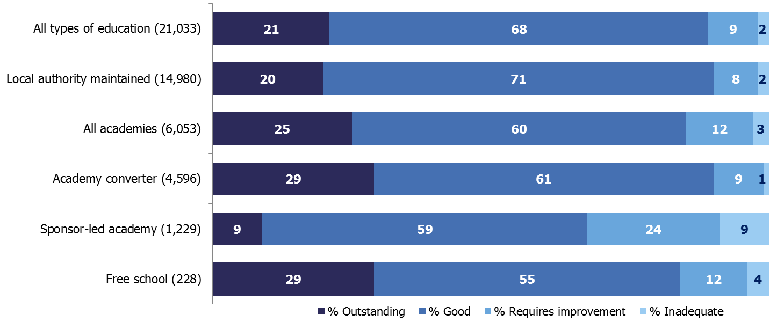
Figure 2: Most recent overall effectiveness as at 31 August 2017, by education type (revised chart including predecessor grades)

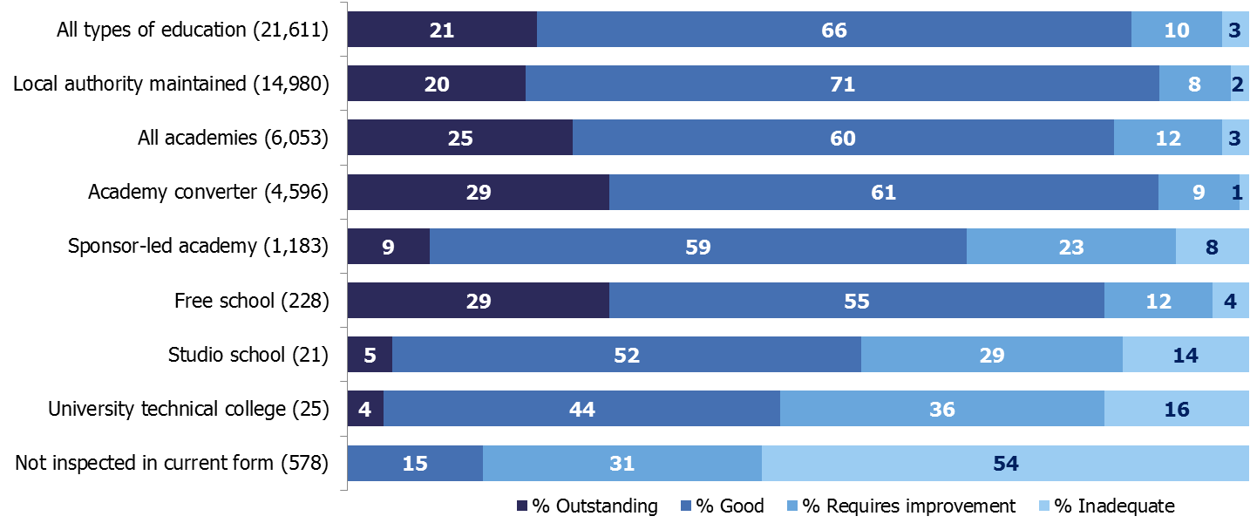

Minor changes to releases to improve naming and usability (questions 3 and 4)
- University technical colleges and studio schools are currently in the ‘sponsor-led academy’ group as well as being included in ‘all academies’ and ‘all types of school’. Our proposal is to remove them from the ‘sponsor-led academy’ category and put them in their own categories. They would remain within the general ‘all academies’ and ‘all types of school’ categories too.
- We propose moving and separating out university technical colleges and studio schools because they are substantially different from sponsor-led academies and from each other. Standards in each of these types of school are less clear when presented in one category together.
- Our current management information and official statistics currently refer to ‘maintained schools and academies’. We propose to change future releases to refer to ‘state-funded schools’. This avoids any confusion between ‘maintained’ in the general sense of state-funded and ‘maintained’ in the specific sense of maintained by the local authority. This change to ‘state-funded’ is also in line with the terminology used by the Department for Education in their statistical first releases.

The consultation process
- We welcome your responses to this consultation. It opens on 30 November 2017 and closes on 18 January 2018.
- The information you provide will inform our consideration of reporting of inspection outcomes for maintained schools and academies.
- We will publish a response to the consultation in March 2018.
Sending back your response
- There are three ways to complete and submit your response.
- Online electronic questionnaire:
- Visit our website to complete and submit an electronic version of the response form: www.gov.uk/government/consultations/changes-to-ofsteds-statistical-reporting-of-inspection-outcomes-for-maintained-schools-and-academies.
- Download and email:
- Visit our website to download a Word version of this document, the response form can be found on page 10. This can be completed on your computer: www.gov.uk/government/consultations/changes-to-ofsteds-statistical-reporting-of-inspection-outcomes-for-maintained-schools-and-academies.
- When you have completed the form, please email it to inspectioninsight@ofsted.gov.uk with ‘Changes to Ofsted’s statistical reporting of school inspection outcomes’ in the subject line.
- Print and post:
- Visit our website to print a Word or PDF version of this document, the response form can be found on page 10. This can be filled in by hand: www.gov.uk/government/consultations/changes-to-ofsteds-statistical-reporting-of-inspection-outcomes-for-maintained-schools-and-academies.
- When you have completed it, please post it to:
Louise Butler
Data and Insight
Ofsted
Aviation House
125 Kingsway
London
WC2B 6SE.

Questionnaire for changes to Ofsted’s statistical reporting of inspection outcomes for maintained schools and academies
Confidentiality
The information you provide will be held by us. It will only be used for the purposes of consultation and research; it may influence policies; inform inspection and regulatory practice; and help us to become more effective
We will treat your identity in confidence, if you disclose it to us.
Are you responding on behalf of an organisation?
Yes please complete Section 1 and the following questions
No please complete Section 2 and the following questions

Section 1
If you would like us to consider publishing the views of your organisation, please indicate this below.
Organisation:
Section 2
Which of the below best describes you? Please tick one option.
I am:
Employed in a school (e.g. teacher, head teacher, governor etc.) |  | Parent
Person with an interest in our data |  | Government department
Research organisation |  | Leader/manager in a multi-academy trust
Press |  | Leader/manager in a local authority
Professional organisation |  | Member of Parliament
Other (please specify)

Making the data more comprehensive and accessible
Question 1
We propose to include grades from the predecessor schools of schools that have not yet been inspected in their current form, where possible, in our data.
For more information about this proposal, see paragraphs 9-18 of this consultation document.

Do you...
Strongly agree | Agree | Neither agree nor disagree | Disagree | Strongly disagree | Don’t know

Please add any comments to our proposal:

Question 2
We are considering ways to present grades from the predecessor schools of schools that have not yet been inspected in their current form. Our proposal is to include them as a new row in the school type chart (chart 6 of the official statistics) as ‘Schools not inspected in their current form’.
For more information about this proposal, see paragraphs 19-22 of this consultation document.

Do you...
Strongly agree | Agree | Neither agree nor disagree | Disagree | Strongly disagree | Don’t know

Please add any comments to our proposal:

Minor changes to releases to improve naming and usability
Question 3
We are considering removing university technical colleges and studio schools from the ‘sponsor-led academy’ category while keeping them in the general ‘all academies’ and ‘all types of school’ categories, and creating two new categories for these types of schools.
For more information about this proposal, see paragraphs 23–24 of this consultation document.
Do you...
Strongly agree | Agree | Neither agree nor disagree | Disagree | Strongly disagree | Don’t know

Please add any comments to our proposal:

Question 4

We are proposing changing the name of future official statistics and management information releases to refer to ‘state-funded schools’ rather than ‘maintained schools and academies’.
For more information about this proposal, see paragraph 25 of this consultation document.
Do you...
Strongly agree | Agree | Neither agree nor disagree | Disagree | Strongly disagree | Don’t know

Please add any comments to our proposal:

Other improvements
Question 5
Are there any other ways we could improve the maintained schools and academies statistics releases?

Please add any comments:

Question 6
Do you have anything else you would like to add to this consultation?

Please add any comments:

What did you think of this consultation?
One of the commitments in our strategic plan is to monitor whether our consultations are accessible to those wishing to take part.
How did you hear about this consultation?
- Ofsted website
- ‘Ofsted News’, Ofsted’s monthly newsletter
- Ofsted conference
- Twitter (@ofstednews)
- Another organisation (please specify, if known)
- Other (please specify)

Please tell us what you thought of this consultation by answering the questions below.
 | Agree | Neither agree nor disagree | Disagree | Don’t know
I found the consultation information clear and easy to understand.
I found the consultation easy to find on the Ofsted website.
I had enough information about the consultation topic.
I would take part in a future Ofsted consultation.

Is there anything you would like us to improve or do differently for future consultations? If so, please tell us below.

Additional questions about you
Your answers to the following questions will help us to evaluate how successfully we are communicating messages from inspection to all sections of society. We would like to assure you that completion of this section is optional; you do not have to answer any of the questions. All responses are confidential.
Please tick the appropriate box.
1. Gender
Female | Male

2. Age
Under 14 | 14–18 | 19–24 | 25–34 | 35–44 | 45–54 | 55–64 | 65+

3. Ethnic origin
(a) How would you describe your national group?
British or mixed British
English
Irish
Northern Irish
Scottish
Welsh
Other (specify if you wish)
(b) How would you describe your ethnic group?
Asian |  | Mixed ethnic origin
Bangladeshi |  | Asian and White
Indian |  | Black African and White
Pakistani |  | Black Caribbean and White
Any other Asian background  (specify if you wish) |  | Any other mixed ethnic background  (specify if you wish)
Black |  | White
African |  | Any White background (specify if you wish)
Caribbean |  | Any other ethnic background
Any other Black background (specify if you wish) |  | Any other background (specify if you wish)
Chinese
Any Chinese background
(specify if you wish)

4. Sexual orientation
Heterosexual | Lesbian | Gay | Bisexual

5. Religion/belief
Buddhist |  | Muslim
Christian |  | Sikh
Hindu |  | Any other, please state:
Jewish |  | None

6. Disability
Do you consider yourself to have a disability? | Yes | No

The Office for Standards in Education, Children's Services and Skills (Ofsted) regulates and inspects to achieve excellence in the care of children and young people, and in education and skills for learners of all ages. It regulates and inspects childcare and children's social care, and inspects the Children and Family Court Advisory and Support Service (Cafcass), schools, colleges, initial teacher training, further education and skills, adult and community learning, and education and training in prisons and other secure establishments. It assesses council children’s services, and inspects services for children looked after, safeguarding and child protection.
If you would like a copy of this document in a different format, such as large print or Braille, please telephone 0300 123 1231, or email enquiries@ofsted.gov.uk.
You may reuse this information (not including logos) free of charge in any format or medium, under the terms of the Open Government Licence. To view this licence, visit www.nationalarchives.gov.uk/doc/open-government-licence, write to the Information Policy Team, The National Archives, Kew, London TW9 4DU, or email: psi@nationalarchives.gsi.gov.uk.
This publication is available at www.gov.uk/government/organisations/ofsted.
Interested in our work? You can subscribe to our monthly newsletter for more information and updates: http://eepurl.com/iTrDn.

Piccadilly Gate
Store Street
Manchester
M1 2WD

T: 0300 123 1231
Textphone: 0161 618 8524
E: enquiries@ofsted.gov.uk
W: www.gov.uk/ofsted
No. 170049
© Crown copyright 2017

Ofsted’s inspection data summary report; https://www.gov.uk/government/collections/using-ofsteds-inspection-dashboard
The official statistics with the most recent inspection outcomes as at 31 August 2017 were published on 30 November 2017: www.gov.uk/government/collections/maintained-schools-and-academies-inspections-and-outcomes-official-statistics.
Details of the links between predecessor and current schools will be taken from the Department for Education’s ‘Get information about schools’ database.
These figures are based on applying the new methodology to the August 2017 figures used in the Official Statistics published on 30 November 2017.

