

“Insert unit title here”
GAS ESCAPE EMERGENCY PLAN (GEEP)

“Unit” GEEP VER 1.0 Feb 16

After the unit has carried out a Risk Assessment, they are required to annotate their own findings within this plan.

Contents:

Foreword
Amendment State
Distribution List
Unit Commanders Foreword
Unit Organisation and Arrangements Statement for Safety, Health, Environmental Protection, and Sustainable Development
Definitions
Chapter 1 Introduction
Scope
Mission
Risk Assessment
Action Plan
Command and Control
Service Support
Outside Agencies
Command and Signal
Communications
Media and Public Interest
Security
Health and Safety
Training and Exercises
Annex A- Gas Leak Immediate Action Poster
Chapter 2 Actions to be carried out by a Person Discovering a Gas Escape from a Cylinder (JSP 319 Part 1 Chapter 5
Scope
Gas Supplier Emergency Contact Telephone No
Chapter 3: Actions to be carried out by a Person Discovering a gas escape from Bulk LPG Compound (JSP 319 Part 2 Volume 2 Chapter 5)
Scope
Gas Leak
Table 1: Suggested Bulk LPG Evacuation Distances
Bulk LPG Supplier Emergency Contact Telephone No
Chapter 4: Actions to be carried out by a Person Discovering a Leak from a Bulk Cryogenic Vessel (JSP 319 Part 2 Volume 1 Chapters 11-12)
Scope
Cryogenic Liquid Leak
Cryogenic Liquid Supplier Emergency Contact Telephone No
Annex A –Extract of DIO GSMP – Section C- (LPG Networks); Emergency Service Response to Gas Escapes
Chapter 5: Unit Actions/Duties on Gas Escape / Cryogenic Spillage Incident
Scope
Annex A - Duties of Guard / Ops Room
Annex B - Duties of Incident Commander
Annex C 1 - Duties of Maintenance Management Organisation
Annex C2 – Typical MOD/DIO /MMO/ Communications in the event of a Gas supply Emergency (Extract from DIO GSMP)
Annex D - Duties of Media Officer
Annex E - Contact Numbers
Annex F - Reporting Gas Escapes / Incidents
Annex G 1 - Site Plan of Gas Cylinder Compound & Local Muster Point
Annex G 2 Site Plan of Bulk LPG Compound & Local Muster Point
Annex H - Register of Hazardous Products Held

“Insert unit title” GEEP Amendment Sheet

Amendment: |  | Incorporated By
No | Date | Name | Signature | Date

Distribution List

Copy No | Holder (Complete as appropriate)
01 | Insert Holders of the UGLRP - Example – CO / HoE
02 | Example – QM Tech
03 | Example – FL Flt OC
04 | Example – Gas Compound Manager
05 | Example – Custodian/ 4Cs Manager of adjacent bulk LPG Compound
06 | Example SHEF A
07 | Example - DIO
08 | Example - RPC
09 | Example – Guardroom/ main gate security staff
10 | Example – DFRMO
11 | Example – HQ Air fuel Role Office (Air units only)

Unit Commanders Foreword

References:

A. JSP 815
B. JSP 418
C. JSP 319

MOD Policy

1. MOD policy is to conduct activities in accordance with the current Safety, Health, Environmental Protection and Sustainable Development Policy Statement by the Secretary of State for Defence. Supporting detailed Organisation and Arrangements (O&A) that support this Policy Statement are detailed in reference A. The MOD regulations covering environmental issues are at Reference B. MOD gas emergency procedures (leaks, fires) are detailed in Reference C.

3. It is MOD policy, in accordance with Reference B, that establishments where hazardous or potentially polluting substances are used or stored, including gases and cryogenic liquids, are to have a unit Gas Escape Emergency Plan (GEEP) in place to deal with any emergency incident involving these substances. Such a plan is essential in order to ensure an establishment can prevent, and minimise any hazardous and environmental incidents occurring resulting from the uncontrolled leakage of gases and cryogenic liquids.

4. The purpose of this statement is to ensure that (insert establishment title) is to comply with all relevant environmental and safety legislation and I have issued my own O&A statement to this effect, which are to be applied across this unit. The heads of each department and line managers are responsible to me for the implementation of my Safety, Health, Environmental Protection and Sustainable Development O&A Statement.

AN OTHER
Lt Col
Commanding Officer Dated dd/mm/yy

Organisation and Arrangements Statement for Safety Health, Environmental Protection and Sustainable Development

“Insert the current Head of Establishment Organisation and Arrangements statement for Safety Health, Environmental Protection and Sustainable Development here.”

Definitions

1. The following definitions are used throughout this GEEP.

2. Gas – Any substance that is completely gaseous at 1.013 bar and 20°C or has a vapour pressure exceeding 3 bar at 50 °C. (Includes pure substances as well as mixtures)

b. Cryogenic liquid – Gas which liquefies at 1.013 bar at temperature below -30°C. (Cryogenic fluids can be stored or transported only in thermally insulated containers. These gases are also known as liquefied gases or liquefied refrigerant gases as appropriate)

c. Gas escape – An uncontrolled release of gas from cylinder, storage vessel, pipework, tank, road tanker, refuelling vessel or other container in which it is held.

d. Spillage – An uncontrolled release of liquid from pipework, tank, road tanker, refuelling vessel or other container in which it is held. (Note; cryogenic liquids will readily evaporate into gas)

3. For the purpose of this document, gases and cryogenic liquids and containers include:

- Industrial, medical and LPG gases stored in transportable gas cylinders.

- Bulk LPG stored in vessels.

- Bulk Cryogenic liquids stored in fixed tanks, mobile tanks >2000 L capacity.

- Pipework - pipe or system of pipes together with associated ancillary equipment holding pressure within a boundary / system.

- Pipeline¹ - a pipe or system of pipes used for the conveyance of relevant fluid across the boundaries of premises, together with any apparatus for inducing or facilitating the flow of relevant fluid.

4. To be in line with the DIO Gas Safety Management Plan (GSMP), the following incident classification should be used when assessing the hazard by personnel on site in terms of the risks posed of a gas escape:

- Level 1 Incident: A gas escape that represents an existing or probable hazard to persons or property. Requires immediate repair or continuous action until the condition is no longer hazardous. Medium pressure leaks (from medium pressure pipelines / pipework) are automatically to be deemed Level 1 incidents.

- Level 2 Incident: A gas escape that is recognised as being non-hazardous at the time of detection, but needs scheduled repair based on probable future hazard.

- Level 3 Incident: A gas escape that is recognised as being non-hazardous at the time of detection and can be reasonably expected to remain non-hazardous.
Note: Units are required to annotate any definitions that they may use.
Chapter 1: Introduction

Reference:

A. JSP 319
B. JSP 418
C. JSP 815

1. The purpose of this emergency plan in to provide the Command with an effective response to gas leaks / escape / cryogenic liquid spills from gas cylinders, bulk LPG vessels and bulk cryogenic liquid storage tanks held in the workplace on the MOD estate.

WARNING: This document shall not to be used for the escape of natural gas from an External Gas Distribution Network (EGDN), or MOD Gas Distribution networks or buildings, pipelines / appliances supplied from these networks. Emergency procedures for natural gas leaks in these pipeline networks, supplied buildings and user appliances are detailed in DIO Gas Safety Case.

Scope

2. A gas escape is defined as an uncontrolled release of product from cylinder, storage vessel, pipework, tank, road tanker, refuelling vessel or other container in which it is held and cannot be contained. The resultant action will depend on the physical and chemical properties of the subject gas; gas stored under high pressure, gas may be heavier / lighter than air, gas may be toxic, flammable etc.

3. Some gases, if released, have the potential to cause significant environmental harm, (e.g. Fluorinated – F-Gases) and as such are subject to specific environmental legislation.

4. Most gases used by MOD, regardless of their toxicity, are non – oxygen based. Therefore, they have the potential to displace the existing breathable atmosphere, which, if in confined spaces, can lead to asphyxiation.

WARNING: Risk to personnel. All gas escapes are to be considered as an Asphyxiant first and foremost; irrespective of other hazardous properties of the gas.

WARNING: Risk to personnel. Flammable gas escapes have the potential to produce very large flammable atmospheres that may persist some considerable distance from the source. Flammable gases heavier than air may also encroach into below ground spaces such as service ducts, drainage systems and cellars.

5. A spillage of cryogenic liquid is defined as an uncontrolled release of a volume of product from a primary container. The most probable course of a spillage is as a direct result of accident, the malfunction of equipment, or procedural malpractice associated with the operation of installations, equipment or vehicles.

WARNING: Risk to personnel. Cryogenic liquids can cause cold burns and frostbite to personnel.

WARNING: Risk to personnel. Cryogenic liquids will quickly evaporate, leading to a very large gas enriched atmosphere and resultant asphyxiant hazards – see gas warnings above.

WARNING: Risk to personnel. Cryogenic liquids can cause cold embrittlement on metals rubbers and plastics, which may fail under loading or impact.

6. In accordance with References A, B and C, it is necessary to have an efficient plan detailing the activities of personnel and the actions they should take to deal successfully with gas escape / cryogenic liquid leak at (Unit/ establishment name). Satellite stations (name if applicable) and detached units / units on exercise are under the responsibility of (Unit/ establishment name) and therefore the GEEP must include these locations / activities.

Mission

7. To prevent the contamination of the environment in the event of a spillage of cryogenic liquid, regardless of its volume. To allow gas to safely dissipate and prevent harm to personnel, equipment, infrastructure and the environment in the event of a gas leak.

Risk Assessment

8. All sections/ departments are to include a copy of a site specific risk assessment for each area where gases and cryogenic liquids are stored (including bulk LPG). Formal Risk Assessments for the sections/ departments shall be carried out identify key areas of potential risk. (Unit / establishment name Environmental Protection Officer, name, position) holds the master register of the Risk Assessments raised. The Risk Assessments provide the evidence for the development of this GEEP. A Register of Hazardous areas and Hazardous Products Held is at Chapter 5 Annex H.

Action Plan

9. Execution of the (Unit / establishment name) Gas Escape Emergency Plan (GEEP) is conducted as a sequence of staged actions. The person discovering the gas escape / spillage will normally initiate this sequence. The immediate actions are to isolate and contain the gas escape / spillage (only if safe to do so) and summon assistance. Immediate Action (IA) posters (example at Annex A), are to be prominently positioned at all locations where gases / bulk LPG / cryogenic liquid are stored. During normal working hours the (delegated representative, position) will be called to attend all gas escapes/ spillages at (Unit / establishment, name; and or satellite station, detached units as applicable). During silent hours, the person discovering the gas escape / spillage is to inform either the (Guardroom or Ops room, location) who will activate the callout procedure. Dependant on the seriousness / complexity of the gas escape /spill, the (delegated representative, position) may require the services of on-site contractors, e.g. DIO, RPC, MMO etc. Even though every gas escape will be different; action plans based on practiced scenarios and gas escape/ spillage response history should be used as guidance.

Command and Control

10. The person discovering the gas escape / spillage or the senior person at the scene is to adopt the role of Incident Commander until relieved by the (delegated representative, position). The incident commander is responsible for co-ordinating the immediate response to the gas escape / spillage using any manpower and material at their disposal.

11. If all attempts to contain the gas escape / spillage fail using the establishment resources; the (delegated representative, position) shall be authorised to call upon the services of the respective gas supplier emergency contact number. If the gas escape / spillage has the potential to become a complex project; the (Unit/ establishment name) Task Force, commanded by (position / e.g. O/C Depot), supported by the (delegated representative, position), and including appropriate team members is to be established at the earliest opportunity. The Task Force is to co-ordinate the recovery programme ensuring that all response activities are safe, and that all objectives and processes are understood by all parties. (4Cs)

Service Support

12. The unit (delegated representative, position) is to be informed of any gas escape / spillage that occur so that a register of gas escapes / spillage’s can be maintained.

Outside Agencies

13. A list of contact telephone numbers of service and civilian agencies is at Chapter 5 Annex E.

Command and Signal

14. In the event of a gas escape / spillage, an incident signal MOD Form 7777 – Gas Incident Report (Chapter 5 Annex F) is to be completed and distributed accordingly. Upon completion of the recovery operation a MOD Form 7777-SITREP is then to be completed and distributed.

Communications

15. Good communications are essential to effect execution of this GEEP. The Incident Commander is to control the use of communications around the incident area.

Media and Public Interest

16. Media. Large, serious gas escapes /spillages will generate considerable media interest. All enquiries from the media are to be directed to the (unit /establishment press officer/ position). Under no circumstances are personnel directly involved with the operation to answer media questions, make statements or give personal opinions.

17. Members of the Public. Members of the public may display considerable interest in any off base incidents or those close to the camp perimeter. Personnel are to remain polite and courteous when asked questions by members of the public, and the questions are to be referred to the (unit /establishment press officer/ position / name). Personal opinions are not to be expressed.

Security

18. To protect the clean-up operation and to protect individuals/members of the public it is essential that the perimeter of the gas escape / spillage site be secured. This will be executed through the establishment of a cordon and an Incident Control Point (ICP). The ICP will be under the command of the Incident Commander.

Health and Safety

19. The preservation of human life is of the utmost importance. Response to a gas escape / spillage incident will require personnel to enter a potential hazardous area. Every method of reducing the exposure and risk to the individuals is to be employed. All Health & Safety processes in accordance with JSP 375 shall be complied with in the course of emergency / spill response activities. Appropriate PPE required for response should be made readily available.

Training and Exercises

20. All personnel involved in the storage, handling and transportation of hazardous products on (Unit/ establishment name) are to be suitably trained in emergency procedures involving gas escapes and cryogenic liquid spillages.

21. (Unit/ establishment name) will practice / exercise on an annual basis. This will be either as a practical or desktop exercise. Delete/ amend as applicable. Major incidents will also be practised annually as an exercise/key player desktop exercise with the involvement of the local outside agencies where possible. (Top Tier MACR sites only)

22. The practice / exercise should involve all departments/ sections to ensure its effectiveness. The arrangement for the practice will be published separately.

23. The objective of these practices/ exercises is to test the effectiveness of the GEEP, however, as it will involve a certain amount of artificiality all personnel are to fully co-operate with the organiser. Any objective suggestions on how to improve the plan should be submitted to the unit (delegated representative, position).

24. Training for Individuals. The fact that this document is called a Gas Escape Emergency Plan (GEEP highlights the hazards and possible dangerous nature of a gas escape / spillage within the unit or off-unit. To ensure that (Unit/ establishment name) is prepared to deal with a gas escape / spillage emergency there is a requirement for personnel nominated to respond to an incident to have the following training; this training is to be carried out at least annually:

- Fire Training.

b. Familiarisation of the hazardous areas within unit, emergency cut-off switches location of telephones drainage.

c. Familiarisation of the extent of cordons imposed, based on type / size of gas leak cryogenic liquid spillage

d. The types of products held within the unit and their associated hazards.

e. Familiarisation with the correct use of Personnel Protective Equipment (PPE).

f. First aid training.

Annex A- Gas Escape Immediate Action Poster

Gas Leak Action

Action to be taken by person(s) discovering a gas leak

- Attempt to prevent further leakage if considered safe to do so by closing valves or ceasing operations.
- Eliminate any potential sources of ignition.
- Ventilate the area.
- Evacuate to appropriate muster point UPWIND of the gas leak area.
- Establish safety cordon until the area is safe.
- Raise the alarm by ringing and give the following information:
- Name, Rank and Telephone Number.
- Exact location of gas leak (e.g. Unit, Bldg Nº, Area).
- Type and size of gas leak (cylinder, bulk vessel & product if known).
- Container markings, e.g. HAZCHEM / UN Numbers etc.
- Number of casualties (if known).
- Any additional information.
- If possible, and safe to do so, contact the gas supplier emergency telephone number

REMAIN AT THE LOCATION UNTIL RELIEVED BY THE INCIDENT COMMANDER

Unit to insert location here – LPG min distance 300m

Ext:(Unit to complete)

Relevant gas suppliers emergency No -unit to complete)

To be affixed onto gas cylinder / bulk LPG compound fence or other applicable location.

Chapter 2: Actions to be carried out by a Person Discovering a Gas Escape from a Gas Cylinder (JSP 319 Part 1 Chapter 5)

Scope

Gas cylinders have a finite gas storage capacity dependant on gas properties, pressure of gas stored and cylinder volume (up to 4000L of gas stored at 230 bar pressure within a cylinder).

1. Prior to response action ensure you are upwind and attempt to identify casualty cylinder (inert, flammable, Toxic) (precautionary label / colour scheme). Do not attempt to gain access to casualty cylinder if gas properties are not known or are Toxic.

2. Do not attempt access if casualty cylinder is stored in an indoor compound / confined space. Await specialist support from emergency services / gas cylinder owner.

3. In the event of a gas escape from a valve which has not ignited, and if it safe to do so, attempt to close the valve. Carry out the following actions.

- Eliminate any potential sources of ignition.

- Ventilate the area.

- Evacuate the area / establish safety cordon until the area is safe. (Evacuation area dependant on gas property, cylinder size, pressure of stored gas).

4. If the valve cannot be closed, or gas is still escaping from the valve, do not attempt to tighten the casualty cylinder valve or tamper with safety devices. Carry out the following action:

- Eliminate any potential sources of ignition.

- Ventilate the area.

- Evacuate the area / establish safety cordon until the area is safe.

- Call emergency services as appropriate.

e. Contact casualty cylinder owner (gas cylinder supplier) via their 24 Hr. emergency Telephone Number. (Telephone number can be found on the gas cylinder label - use another cylinder in a remote location- not the casualty cylinder).

Gas Supplier Emergency Contact Telephone No
Unit to place relevant Gas supplier emergency contact numbers here, e.g.

BOC Gases – 0800 111 333 / Speciality Gases 0800 02 0800
Air Liquide – 01675 462 695
Energas – 01482 329 333
Calor - 03457 444 999
Flogas – 03457 200 100
Chapter 3: Actions to be carried out by a Person Discovering a Gas Escape Leak from a Bulk LPG Compound (JSP 319 Part 2 Volume 2 Chapter 5)

Scope

1. LPG can be released in liquid and / or gas, dependant on the circumstances (liquid propane will quickly evaporate). An LPG gas escape will mainly originate from supply pipework or from equipment located above the “water line” of LPG stored within the vessel. Liquid LPG may leak during failures at bulk deliveries or significant storage tank failures.

2. This chapter should be read in conjunction with DIO Gas Safety Management Plan Section C Chapter 13. (See Annex A for extract of GSMP).

Gas Leak

3. LPG escapes are normally identified by:

- Smell (LPG has a stenching agent – e.g. “mercaptan” added to it).

- Noise

- Refrigeration (hoar frost) surrounding the leak source.

- “Heat haze” or “shimmering” effect as LPG evaporates within the local atmosphere.

4. When LPG escapes have been identified, an urgent assessment should be made of the volume of gas being released by estimating the time & rate of discharge.

5. Prevailing winds, total areas involved, personnel at risk, and possible ignition hazards should be evaluated to produce an evacuation area.

6. An evacuation area, (Chapter 5 Annex G2) should be established around any uncontrolled escape of LPG and should be kept under constant review. Leaks of liquid LPG can remain flammable for considerable distances from the original leak source. The evacuation area can be influenced by wind / weather and topography and this should be taken into consideration. Suggested evacuation areas are as follows:

Table 1: Suggested Bulk LPG Leak Evacuation Distances
Observable Leak | Evacuation Distance
Small vapour escape characterised by a “smell of gas” | 30 m
Large vapour escape characterised by a loud “hissing of gas” | 100 m
Liquid leak characterised by a “roar of gas” | 300 m
UKLPGA COP 3

7. Attempt to isolate the escape by non-flammable means, only if safe to do so.

8. Contact the Guardroom, emergency services.

9. Contact the gas supplier (emergency number on vessel body).

10. Contact the MMO Responsible Person (Gas).

11. Isolate sources of ignition and ventilate the area.

12. Do not operate electrical equipment unless a competent authority has deemed it safe to do so. (Flammable gases may have encroached into non / insufficiently rated ATEX electrical equipment).

13. Extinguish naked lights (e.g. no smoking) and avoid causing sparks (use of non-ferrous tools).

14. Position appropriate fire fighting equipment.

15. Cover drains and sewers. (PCS –JSP 317).

16. Disperse vapour with water spray.

WARNING: Risk to personnel. Flammable gas escapes have the potential to produce very large flammable atmospheres that may persist some considerable distance from the source. Flammable gases heavier than air may also encroach into below ground spaces such as service ducts, drainage systems and cellars.

WARNING: Risk to personnel. Users must be made aware that clothing, PPE or PCS that becomes “wetted” with LPG remains a severe fire hazard to the user and bystanders until all the LPG has been safety vented from it. LPG saturated clothing or PPE may also induce frostbite or hypothermia.

Bulk LPG Supplier Emergency Contact Telephone No

Unit to place relevant Gas supplier emergency contact numbers here, e.g

Calor - 03457 444 999
Flogas – 03457 200 100

Annex A –Extract of DIO Gas Safety Management Plan – Section C- (LPG Networks); Emergency Service Response to Gas Escapes

GSMP (Section C) – Site Name

13 EMERGENCY SERVICE RESPONSE TO GAS ESCAPES

13.1 General
The generic processes and procedures are described in Section 13 of the Gas Safety Case. The same document also contains the following flow charts showing the MOD / MMO approach to the management of gas leak emergencies:

• Figure 13.1 – Emergency Management Overview
• Figure 13.2 – Incident Notification
• Figure 13.3 – Initial Responses
• Figure 13.4 – Emergency Services at Scene of Incident
• Figure 13.5 – Assessing the Level of Hazard
• Figure 13.6 – Resolving the Gas Incident

An incident management report form and incident management check list are shown in Gas Safety Case Appendix I.

All site specific details are included within this GSMP

13.2 Emergency Contacts
Details of Principal on-site and off-site emergency services are shown in Section 1 of this document.

• The first point of contact will be the on-site emergency services, where present, who will coordinate the management of the incident as necessary. Where there is no on-site emergency service presence the first point of contact will be the RP(Gas), or another, similarly competent person appointed by the MMO.
• The RP (Gas) will be notified and will provide assistance to the Emergency Services and communicate with other involved parties.
• The Gas Supplier will be notified via contact with the MMO Call Centre.
• The GSM must contact the HSE in the event of any death or injury to persons under the RIDDOR Regulations.

13.3 Response to Gas Escapes
Response times should be within 1 hour to 95% of uncontrolled gas escapes, and within 2 hours to controlled gas escapes. Any gas leak must be stopped or made safe within a maximum of 12 hours of it being reported. This site, as all MOD sites, has access to a 24 hour emergency response service. See Section 1 for details.

13.4 Initial Response
The first responders to the incident may be the site-based emergency services, RP (Gas) or another, similarly competent person appointed by the MMO. (See Section 1 for Details). Regardless of who attends the incident first it is essential that the following items are addressed:

• Assess the level of danger to personnel and property – GSC Figure 13.5
• Organise evacuations, cordons and road closures where necessary
• Ensure communications with the MMO (Help Desk) and RP (Gas) are established.
• Assist Gas Supplier operatives if they attend site before MOD / MMO personnel.
• Assess any requirement to involve external emergency services

13.5 Assessing Level of Hazard
The level of hazard should be assessed by personnel on site in terms of the risks posed. The following incident classification should be used:

• Level 1 Incident: A leak that represents an existing or probable hazard to persons or property. Requires immediate repair or continuous action until the condition is no longer hazardous. Medium pressure leaks are automatically to be deemed Level 1 incidents.
• Level 2 Incident: A leak that is recognised as being non-hazardous at the time of detection, but needs scheduled repair based on probable future hazard.
• Level 3 Incident: A leak that is recognised as being non-hazardous at the time of detection and can be reasonably expected to remain non-hazardous.

The process for assessing the level of hazard is shown in Gas Safety Case Section 13 Figure 13.5

13.6 Resolving the Gas Leak / Incident
Any gas leak must be stopped or made safe within a maximum of 12 hours of it being reported. Resolution of the incident is to be as set out in Figure 13.6 below.

13.7 Communications
In the event that telephone systems are unavailable, alternative methods of communication available on site are described in Section 11

13.8 Risk assessment review
After an incident has been resolved the Risk Assessments should be updated, incorporating lessons learnt from the incident. The process for updating Risk Assessments is shown in Section 5.

13.9 Recording Incidents
The proceedings of all incidents should be recorded on the appropriate form and held in central and local records. Forms B1, Incident Report – Gas Distribution System and B2 Check List for Major Gas Emergencies are shown in Annex B to this document.

13.9.1 Provision of Emergency Service Providers
In addition to standard emergency service including Fire, Police, Ambulance and the National Gas Emergency Centre, this MOD establishments has on-site emergency services as described in Section 1

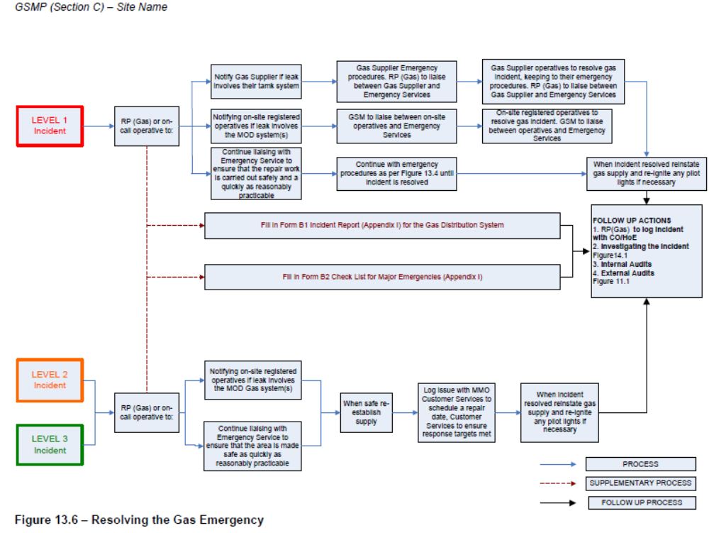
Chapter 4: Actions to be carried out by a Person Discovering a Leak from a Bulk Cryogenic Vessel (JSP 319 Part 2 Volume 1 Chapters 11-12)

Scope

Cryogenic liquids can be released in liquid and gas, dependant on the circumstances. Liquid cryogenics may leak during failures at bulk deliveries or significant storage tank failures.

WARNING: Due to the extreme low temperatures of cryogenic liquids (LOx boiling point minus 183°C, LiN boiling point minus 196°C), cold injuries to personnel and brittle fracture of materials can occur.

WARNING: Spilled cryogenic liquid will readily evaporate at room temperature (ratio of respective volumes of liquid to gas; 1:840 for LOx, & 1:680 for LiN). Therefore, dependant on the cryogenic liquid, the evaporated gas will cause either oxygen enriched / depleted area / asphyxiant atmosphere, (LOx / LiN once gasified, will expel the local atmosphere).

WARNING: Risk to personnel. LOx, though not a flammable material, will readily support combustion (even with “normal” non-combustible materials). Users must be made aware that clothing, PPE or PCS that becomes “wetted” with LOx remains a severe fire hazard to the user and bystanders until all the LOx has been safety vented from it. LOx saturated clothing or PPE may also induce frostbite or hypothermia.

WARNING: Oils, greases, & some other organic materials are liable to spontaneous combustion or explosion in the presence of LOx / or gaseous oxygen, (certain organic materials soaked in LOx are prone to detonation by the energy of impact).

WARNING: Spilled LiN & Liquid Argon, (boiling point lower than LOx) can result in:

- LOx from the local atmosphere being condensed in contact with LiN.

- Resultant gaseous depleted local atmosphere.

Cryogenic Leak

1. Leaks are normally identified by:

- Free liquid (LOx is a pale blue colour, LiN is colourless).

- Excessive condensation (clouding / fog) of the surrounding atmosphere. (Cryogenic liquid causing atmospheric water vapour to immediately precipitate around the spill, resulting in dense fog).

- Noise.

- Refrigeration (hoar frost) surrounding the leak source.

- When leaks have been identified, an urgent assessment should be made of the volume of cryogenic liquid being released by estimating the time & rate of discharge.
3. Prevailing winds, total areas involved, personnel at risk, and possible ignition hazards should be evaluated to produce an evacuation area.

4. An evacuation area should be established around any uncontrolled leak of cryogenic liquid and should be kept under constant review. The resultant gas from cryogenic liquid can persist & migrate over considerable distances. The evacuation area can be influenced by wind / weather and topography and should be taken into consideration.

5. Attempt to isolate the leak by non-flammable means, only if safe to do so.

6. Contact the Guardroom, emergency services.

7. Do not attempt to enter confined spaces where migrated cryogenic liquid has entered.

8. Contact the gas supplier.

9. Isolate sources of ignition and ventilate the area.

10. Cover drains and sewers. (PCS –JSP 317).

11. LOx - Extinguish naked lights (e.g. no smoking) and avoid causing sparks (use of non-ferrous tools).

12. LOx- Position appropriate fire fighting equipment.

Cryogenic Gas Supplier Emergency Contact Telephone No

Unit to place relevant Gas supplier emergency contact numbers here, e.g.

BOC Gases – 0800 111 333 / Speciality Gases 0800 02 0800
Air Liquide – 01675 462 695

Chapter 5: Unit Actions/Duties on Gas Escape/ Cryogenic Spillage Incident (Extract from DIO GSMP)

Scope

1. This Chapter contains appendices detailing the actions to be taken by nominated /designated individuals in the event of a gas incident. The plan details the minimum actions only and as the incident evolves, additional organisations or agencies may need to be contacted.

2. As part of this procedure; the relevant 4Cs duty holder should be contacted and be included in these emergency plans (Extract from DIO Gas Safety Management Plan- GSMP below)

Site 4Cs Duty Holder

3. On each MOD establishment the CO/HoE is required to appoint a site MOD 4Cs Duty Holder (DH) in line with JSP 375 Volume 2, Leaflet 34. The four main elements required in any visiting worker and contractor management system are: co-ordination, co-operation, communication, and control. Effective application of the four elements of this system is often referred to in MOD as the 4Cs system. This has the objective of reducing the likelihood of harm or damage arising from the actions of MOD, visiting workers and contractors working on MOD sites. The 4C Duty Holder responsibilities during an emergency can be summarised into the key areas below:

1. Emergency preparedness. The 4C Duty Holder must ensure that arrangements are in place to deal with emergencies and that all relevant parties are aware of such arrangements through Establishment safety and emergency briefings. This includes emergencies associated with the safe flow of gas in the distribution network. Emergency information that is required to be passed to consumers in the event of a supply emergency would be via the GSM/RP (Gas). In a gas emergency this may take the form of;

- A site wide public address announcement.

- Internal MOD E-mail to inform consumers.

- Direct contact by MOD/MMO employees to consumers on a door to door basis. This would be backed up by a leaflet through the door if no direct contact was made. In practice, a combination of all three methods may be used to inform consumers of a gas supply emergency.

2. Identification of hazards. The 4C Duty Holder must combine all Area Registers into an Establishment Hazard Register, which is to be made be available to all site personnel, hosts, visiting workers/contractors in order for them to understand fully the potential hazards that they will have to consider and mitigate.

3. Communication of hazards. The 4C Duty Holder must ensure that systems are in place for visiting workers/contractors to receive a relevant site safety briefing and to understand the nature of the hazards in their proposed area of work. Such briefings must:

- Include daily changing hazards, Emergency and Disaster Plans, and evacuation procedures.

- Ensure that all hazards in the specific area are identified and explained, and:-

- Take place prior to the commencement of work

4. The call-out system works on the following cascade principle:

Person discovering gas leak / spillage
Dial Ext 2222
MOD Operator
DUTY OPS controller / guardroom
Fire service
Service police
Station / Centralised Gas Cylinder Compound Owner, Cryogenic compound owner, Bulk LPG Compound owner
4C DUTY HOLDER
(Unit details here)
MMO Responsible Person (Gas)
(RP Gas details here)

Media Officer
Unit Commander

Gas Supplier Emergency Contact
(Gas Supplier Details Here)
Incident Commander / site incident Controller
Unit / site task force established
(If required) (MMO, RPC, AP (PET) USHEA, waste manager)

Annex A - Duties of Guard / Ops Room

Record the details from the person reporting the gas leak
Obtain the following details
The location of the leak
Contact Gas supplier emergency No

Heavier than air gases /cryogenic liquids has the leak entered the drainage system?
What action has been taken?
During Silent Hours
Deploy the Guard to enforce cordon
Call out all key personnel information to the Ops Room.
If necessary, contact building custodian / store manager, MMO RP Gas
Hand over control to Incident Commander / Site Incident Controller upon arrival
The Type & approximate Quantity of leak? (Gas cylinder, bulk LPG, cryogenic?)

Annex B - Duties of Incident Commander / Site Incident Controller

Confirm the details at Chapter 5 have been carried out

Proceed to the location of the incident

Identify the person who initially reported the incident
Request brief of situation

Assume command of the situation

Confirm containment action has been carried out

Clear and cordon area if not already done

Maintain a log of events

Arrival of Gas Supplier / Emergency Services
Brief on the incident, the current situation, any implications and what action has taken place.
Handover control

Annex C1 - Duties of Maintenance Management Organisation (MMO)

Provide advice to the Incident Control Officer / Gas Supplier, Emergency Services
Supply any current infrastructure drawings to emergency services on request, including underground pipelines and adjacent pipelines / cables within casualty infrastructure vicinity.

Liaise with RPC, informing Command on corrective repair action on infrastructure as required

When any repair activity is required, ensuring that the MMO contractors are managed under 4Cs and that any maintenance work by contractors complies with current SSoW practices

Maintain a record of all damages caused during the leakage

Advise on what remedial action measures are required to be taken

Liaise with the Incident Control Officer on all aspects of the incident

Arrange for the disposal of any contaminated material from the drainage system

Annex C2 – Typical MOD/DIO /MMO/ Communications in the event of a Gas supply Emergency (Extract from DIO GSMP)
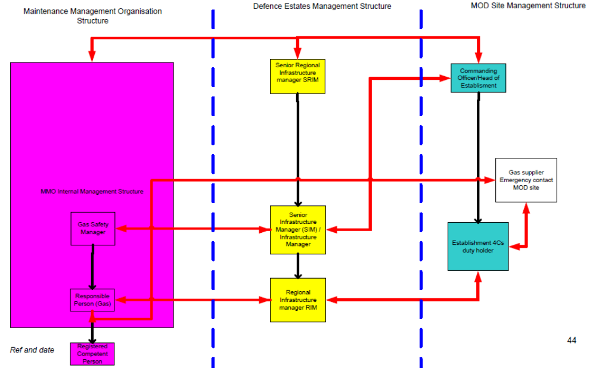
Annex D - Duties of Media Officer

No statement is to be issued by anyone within the unit without authorisation. The unit Media Officer is to co-ordinate all releases of information and is to brief personnel on cordon and security duties of the statement to be made if questioned by the media or public.
Only statements authorised by the Commanding Officer/Head of establishment are to be made to the press.
Members of the public may display considerable interest in any off base incidents or those close to the camp perimeter. When answering questions from members of the public all personnel are to be polite and courteous referring any direct or abusive questions, especially those on the cause of the pollution, to the Press Officer.

Significant gas leaks will generate considerable media interest. All enquiries from the media and the public are to be directed to the unit media officer. Under no circumstances are personnel directly involved with the operation to answer media questions, make statements or give personal opinions.

Annex E - Contact Numbers

1. This Annex contains the relevant contact numbers that would be required in the event of a spillage.

UNIT CONTACT TELEPHONE NUMBERS
UNIT TO AMEND CONTACT TELEPHONE NUMBERS HERE

Working Hours Silent Hours

MOD Operator 2222 2222
Guard Room XXXX XXXX
Ops Rooms XXXX XXXX
FL Pollution Control Officer XXXX XXXX
MMO XXXX XXXX
Fire Section XXXX XXXX
Medical Centre XXXX XXXX
QM Tech Dept XXXX XXXX
MT Section XXXX XXXX
Fuels Section XXXX XXXX
Bulk Cryogenic Section XXXX XXXX
Duty Officer XXXX XXXX
Media Officer XXXX XXXX
Aquatrine ALR XXXX XXXX

OUTSIDE AGENCIES

Fire Service (Insert local authority numbers)
Police (Insert local authority numbers)
Local Environment Agency (Insert local authority numbers)
Parish Councillor (Insert number here)
Gas Supplier (Insert Gas supplier number – found on vessel body, cylinder label of through MOD contract owner)

Annex F - Reporting Gas Escapes/ Incidents

1. JSP 319 part 1 Chapter 4 Annex B details how / when Mod Form 7777 is to be raised.
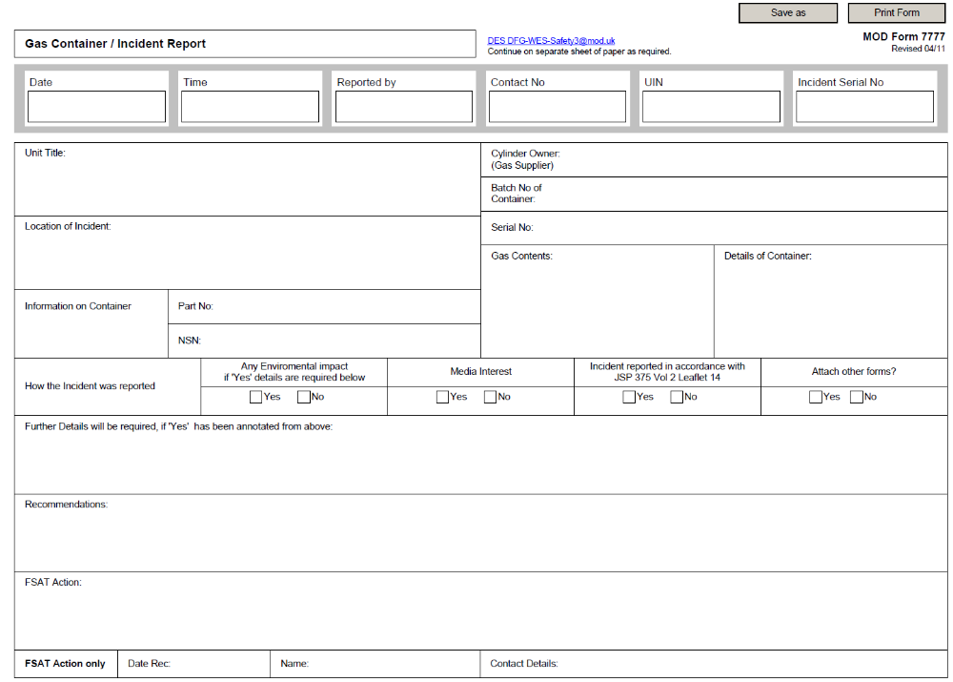
Annex G1 - Site Plan of gas cylinder compound & local muster point. “Insert site name and map here”
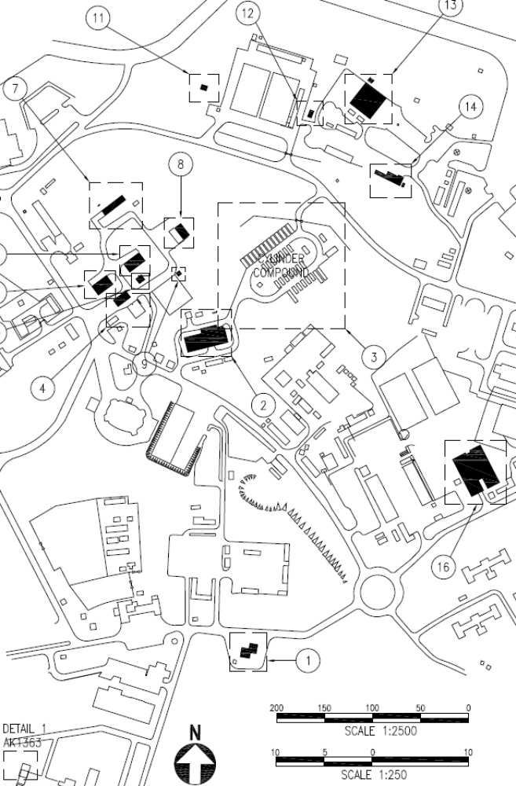
0 100 200 300 400
Fire Hydrants
Muster Point
– Car Park
Max 250 m exclusion zone - dependant on RA
01 – Cyl Compound
Annex G2 Site Plan of Bulk LPG Compound “Insert site name and map here”
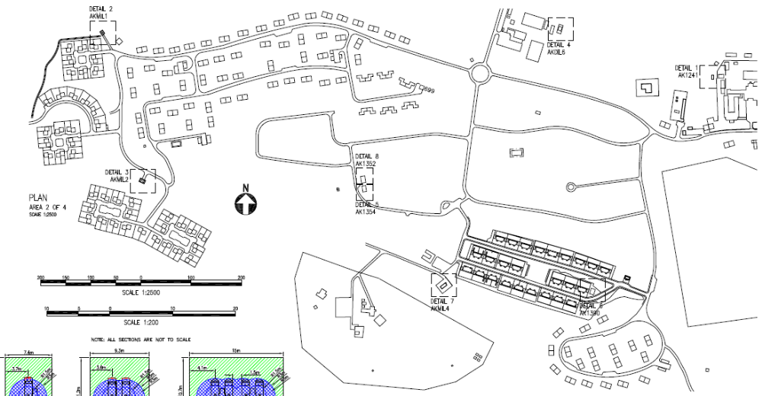
Bulk LPG Compound

Fire Hydrants
250 m Exclusion zones
Muster Point
Muster Point
02- Bulk LPG Compound
04- Bulk LPG Compound
03- Bulk LPG Compound
Annex H - Register of Hazardous Products Held

- Below is a list of all hazardous products and their locations within this unit. All personnel are to make themselves aware of the areas in which these products are located. Hazardous warning signs will indicate the areas/buildings or stores where these products are held.

Insert unit holdings in table below
Empty Cylinders- treat same as full- same risk.
Ser  (a) | Location  (b) | Product  (c) | Max Qty  (Cyls /Lts) | Remarks  (e)
01 | Gas cylinder compound  (location) | Acetylene (full) | 32 x size D  (59 kg) | BOC supply – stored in Pallets
 | Gas cylinder compound | Acetylene (empty*) | 16 x size D  (59 kg) | BOC supply – stored in Pallets
 | Gas cylinder compound | LPG (full) | 8 x 47 KG | Flogas supply – free standing
 | Gas cylinder compound | LPG (empty) | 2 x 47 KG | Flogas supply – free standing
 | Gas cylinder compound | Argon (full) | 32 x size W  (85 kg) | BOC supply – stored in Pallets
 | Gas cylinder compound | Argon (empty) | 32 x size W  (85 kg) | BOC supply – stored in Pallets
 | Gas cylinder compound | Industrial Oxygen (full) | 15 x size K  (75 kg) | BOC supply – stored in Pallets
 | Gas cylinder compound | Industrial Oxygen (empty) | 2 x size K  (75 kg) | BOC supply – stored in Pallets
 | Gas cylinder compound | Industrial nitrogen (full) | 8 x size K  (75 kg) | BOC supply – stored in Pallets
 | Gas cylinder compound | Industrial nitrogen (empty) | 2 x size K  (75 kg) | BOC supply – stored in Pallets
02 | Bulk LPG compound  (location) | Bulk LPG | 2 x 3600 L LPG vessel | Flogas - supply
03 | Bulk LPG compound  (location) | Bulk LPG | 2 x 3600 L LPG vessel | Flogas - supply
04 | Bulk LPG compound  (location) | Bulk LPG | 2 x 3600 L LPG vessel | Flogas - supply

Full definition of “Pipework” and “Pipeline” contained Regulation 2 of PSSR 2000.
DIO Gas Safety Management Plan available at this link http://defenceintranet.diif.r.mil.uk/Organisations/Orgs/DIO/Reference/Publications/Pages/GasSafety.aspx
EGDNs comprise: National Grid Plc. Southern Gas Networks Ltd., Scotia Gas Networks Ltd. Wales and the West Utilities Ltd. and Northern Gas Networks Ltd.
DIO Gas Safety Case; Chapter 13- Emergency Service response to Gas Escapes

