|  |  |
| --- | --- |
| Ministry of Justice | August 2017 |

**Freedom of Information Act (FOIA) Request –** 112995

You asked for the following information from the Ministry of Justice (MoJ):

**I am writing to made a freedom of information request on human trafficking**

**I note the following Ministry of Justice information given to the Independent Slavery Commissioner**

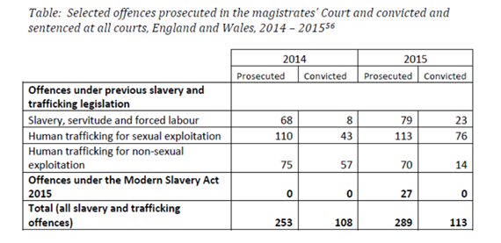

**I was wondering if it was possible to send me similar data for the year 2016 and any years prior to 2014?**

**I would also be grateful for an explanation of the difference between the various offences contained in the left hand column, especially the basis of the distinction between slavery, servitude and forced labour and human trafficking (for example, is the former controlling the work and the other  involvement in transporting? Can one be convicted of slavery, servitude and forced labour on its own or does it always accompany one of the two types of trafficking?)**

**Finally, do you hold data on the sex/gender of those convicted of human trafficking offences? If so could send me that *per year* for as many years as you have?**

**Ideally for each of your categories, as in….**

**2016                                                                                       Sex of those convicted**

**Male      Female**

**Slavery, servitude and forced labour                        -              -**

**Human trafficking for sexual exploitation               -              -**

**Human trafficking for non-sexual exploitation     -              -**

**Offences under the Modern Slavery Act 2015**

**Total (all slavery and trafficking)**

**Or if not and you hold it only as a total could that will be acceptable too, as in…**

**Sex of those convicted of people trafficking**

**Male      Female**

**2016**

**2015**

**2014**

**2013**

**2012**

**etc**

Your request has been handled under the FOIA.

I can confirm that the MoJ holds all of the recorded information that you have requested.

Information concerning the question regarding similar data to what is quoted in the above table is in the attached annex for the period from 2004 to 2013

However, data in this format for 2016 it is exempt from disclosure under section 22(1) of the FOIA, because it is intended for future publication.

This is a qualified exemption which means that the decision to disclose the information is subject to the public interest test. When assessing whether or not it was in the public interest to disclose the information to you, we took into account the following factors:

**Public interest considerations favouring disclosure**

* Disclosure would improve transparency in the operations of Government, and of the justice system in particular.

**Public interest considerations favouring withholding the information**

* It is in the public interest to adhere to the existing publication process for official statistics, which includes time for the data to be collated and properly verified.
* It is in the public interest to ensure that data used in the compilation of official statistics comply with the Code of Practice for Official Statistics and that resulting outputs are produced to the highest quality. Statistics of high quality are produced to sound methods, with all users having easy and equal access that is fair and open, and are managed impartially and objectively in the public interest. Premature publication could undermine the principle of making the information available to all at the same time through the official publication process.

We reached the view that, on balance, the public interest is better served by withholding this information under section 22 of the FOIA at this time.

I can confirm that the MoJ holds the information that you have requested about the sex/ gender of human trafficking offenders, and also note you have not linked the question to your one above. This information held is exempt from disclosure under section 21 of the FOIA, because it is reasonably accessible to you. The information for those offenders found guilty of the offences, can be found in the Criminal Justice System outcomes by offence data tool within the below link:

<https://www.gov.uk/government/statistics/criminal-justice-system-statistics-quarterly-december-2016>

Offence (from which you can select the offences you want – ‘Modern slavery’ is the description in this tool for offences under the Modern Slavery Act 2015) and gender drop down boxes are available. To note, this information has been compiled on a principal offences basis, whereas the data in the attached table has been compiled on an ‘all offence’ basis – this information on the sex/gender of offenders is not directly comparable to the volumes of offenders prosecuted and convicted.

Your question concerning the application of the offences is a policy question, and is not a request for recorded information, so would not be considered to be handled under the FOIA. As this is an area where policy is held by the Home Office, they will be best able to assist you, and I have provided their general correspondence address below:-

[public.enquiries@homeoffice.gsi.gov.uk](mailto:public.enquiries@homeoffice.gsi.gov.uk)