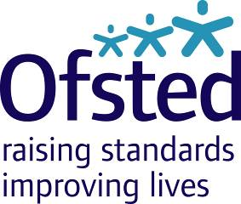
Ofsted Board
Tuesday 18 July 2017
9:00am – 1:00pm, Room 802, Aviation House
Attendees: Julius Weinberg (Chair), Amanda Spielman (HMCI), John Cridland CBE, Linda Farrant, John Hughes, James Kempton, Paul Snell CBE, Matthew Coffey (Chief Operating Officer), Paul Armitage (Deputy Director, Social Care – attending on behalf of Eleanor Schooling), Louise Grainger (Director of Finance, Planning and Commercial), Luke Tryl (Director, Corporate Strategy), Paul Kett (DfE observer), Amy Finch (Private Secretary to HMCI) and Amelia Athwal (Board Secretary)
Apologies: Venessa Willms OBE, Sean Harford (National Director, Education), Eleanor Schooling (National Director, Social Care)

Private meeting for Board Members only: 9:00am – 10:00am

Board meeting: 10:00am – 1:00pm
- Welcome, apologies and declarations of interest Chair
- Minutes, matters arising, action log and forward look Chair
- HMCI update HMCI
- COO update: Strategic Performance and Risk Report (Q1) Matthew Coffey
- Education update Matthew Purves
- Social care update Paul Armitage
- Strategic Priorities Luke Tryl
- Finance report (Period 2) Louise Grainger
- Audit and Risk Assurance Committee update Linda Farrant / Louise Grainger
The following is enclosed:
- Risk report
- Draft minutes from the meeting on 14 June 2017

- AOB ALL

