Children’s Social Care in England

This annual release covers:
- Inspection outcomes for local authority children’s services inspections from November 2013, covering all inspections published by 30 April 2017;
- Inspection outcomes for all regulated, and other, children’s social care provision 1 April 2016 to 31 March 2017;
- Inspection outcome of most recent inspection, for all regulated, and other, children’s social care provisions, as at 31 March 2017;
- Information about the providers of children’s social care, including the numbers of providers and places, as at 31 March 2017.

Main Points

More of the local authorities (LAs) inspected to date were judged good or outstanding than inadequate for the SIF. | Thirty-seven LAs were judged to be good or outstanding, and thirty were judged to be inadequate, of 127 inspected LAs. [p.4]
Only a very small number of LAs were judged inadequate across all three key judgements and overall effectiveness. | Only 8% (10 LAs) of inspected LAs were judged inadequate for overall effectiveness and for all three key judgements as at 31 March 2017. [p.7]
LAs’ prior grades are not an effective predictor of their SIF grade. | For example, LAs judged adequate for Safeguarding pre-SIF were as likely to be graded good as to be graded inadequate for Help and protection under the SIF. [p.13]
The number of children’s homes increased by a larger amount than at any other time in the last five years. | As at 31 March 2017, there were 2,145 active children’s homes – an increase of 74 homes compared with 31 March 2016 (2,071). [p.17]
There is a continuing reduction in local authority-run children’s homes. | As at 31 March 2017, LAs ran 20% of children’s homes compared with 22% last year and 26% as at 31 March 2013. [p.19]
The majority of children’s homes judged to be inadequate at their first inspection in 2016-17 improved during the year. | In 2016-17, 85% of children’s homes judged to be inadequate at their first inspection had improved to either good or requires improvement to be good by 31 March 2017, predominantly at their subsequent inspection. [p.25]
Contents
Introduction 3
Inspection of local authority children’s services 4
Overall effectiveness from November 2013 to March 2017 4
Key judgements from November 2013 to March 2017 6
Outcomes across all key judgements 7
Children looked after sub-judgements to March 2017 8
Overall effectiveness by LA type and location to March 2017 9
Inspections of local authorities: some comparisons 13
Reviews of Local Safeguarding Children Boards 15
All children’s homes 16
Providers and places as at 31 March 2017 16
Overall effectiveness for all children’s homes 21
State of the nation for all children’s homes as at 31 March 2017 21
All children’s homes inspections in year 2016-17 24
Overall effectiveness for all children’s homes inspections – change since last inspection 26
Regional outcomes for all children’s homes in year 2016-17 27
Sector data for all children’s homes in year 2016-17 28
Interim inspections for all children’s homes in year 2016-17 31
Other social care providers 33
List of Charts 36
List of Tables 36
List of Maps 36
Revisions to previous release 37
Notes 37
Glossary 38

Acknowledgements
Thanks to the following for their contribution to this statistical release: Jeremy Honeywill, Emily Moreton, and Rich Jones.

Introduction
Ofsted inspects the 152 local authorities (LAs) responsible for ensuring and overseeing the effective delivery of social care services for children.
Her Majesty’s Inspectors (HMI) conduct these inspections of local authority services for children who need help and protection, children looked after, and care leavers, under the single inspection framework (SIF). All LAs will be inspected at least once between November 2013 and December 2017.
In addition to the SIF, and conducted at the same time, Her Majesty’s Inspectors (HMI) conduct reviews of the Local Safeguarding Children Boards (LSCBs) that are responsible for safeguarding, and promoting the welfare of, children.
There were 2,691, providers of children’s social care and providers of residential accommodation for children in boarding schools and further education colleges in England, as at the end of March 2017.
Most of these providers are registered and regulated by Ofsted, and inspected, in the main, by Regulatory Inspectors. These include children’s homes, independent fostering agencies, and voluntary adoption agencies. Some providers are registered but not regulated, including boarding schools and secure training centres.
Most types of provision receive an inspection once in a three year period and may receive additional concern-driven inspections. The exceptions to this are children’s homes (including secure children’s homes and residential special schools dual registered as children’s homes), residential special schools, secure training centres, and residential holiday schemes for disabled children. These are inspected annually.
Social care inspection outcomes provide important information for policy development, as well as for planning and providing public services, for example by informing LAs about the quality of social care provisions nationally and by area.

Inspection of local authority children’s services
There are approximately 12 million children in England, of whom just over 3% are classified at any one time as children in need (394,000 children). Around 1% are children looked after (70,000 children) or on a child protection plan (50,000 children).

Overall effectiveness from November 2013 to March 2017
There were 127 SIF inspections published by 30 April 2017. This makes up 84% of all LAs responsible for children’s social care in England and is quite close to being a full picture of all LAs in England. [Data Tables: LA Inspection]

Compared with 31 March 2016, the percentage of LAs judged good increased as at 31 March 2017, while the percentage judged requires improvement to be good fell. In 2016-17, children were more likely to be living in LAs judged to be good or outstanding than in those judged to be inadequate. Children living in the east of the country were more likely than those living in the west to be in good or outstanding LAs.
Chart 1: SIF Overall effectiveness to March 2017
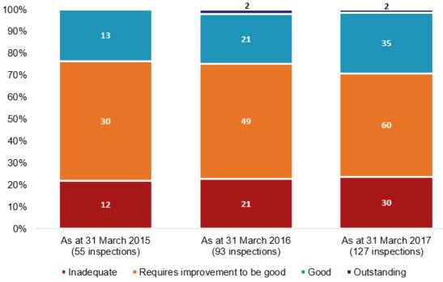

Map 1: SIF inspection Overall effectiveness judgements to March 2017
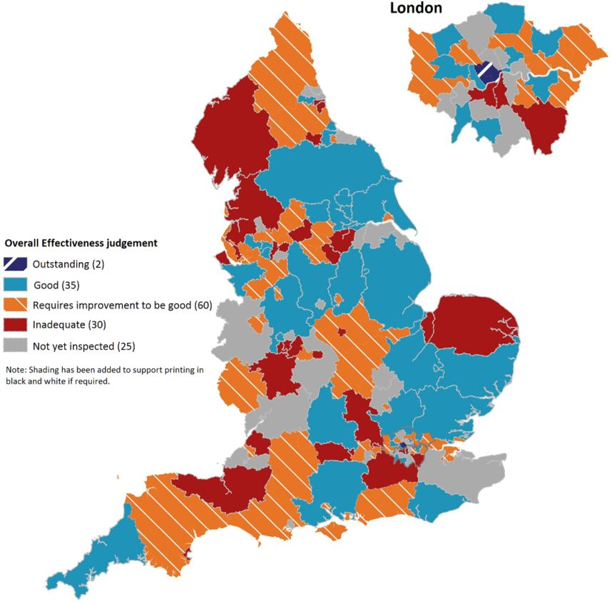

Key judgements from November 2013 to March 2017
The Overall effectiveness judgement for the SIF is derived from three key judgements:
- the experiences and progress of Children who need help and protection;
- the experiences and progress of Children looked after and achieving permanence;
- Leadership, management and governance.
There has not been much change in the percentage of LAs judged to be good or outstanding for each key judgement, compared with 31 March 2016. [Data Tables: LA level at 31 March 2017]
Chart 2: Key judgement grades to March 2017
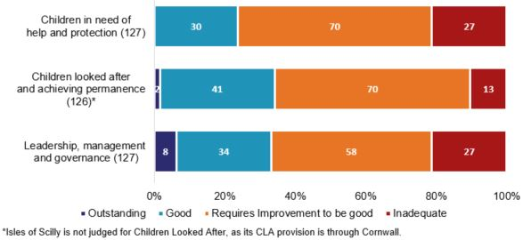

Help and protection appears to be the key judgement where achieving a good or better grade is most challenging, with only 24% of LAs achieving a good judgement, and none achieving outstanding. There are many factors that go into the eventual judgement for an LA around Help and protection, and it is not currently possible to draw conclusions about why fewer LAs are being judged good or better in this area than in others.

Children looked after and achieving permanence is the key judgement where LAs perform most strongly, with the highest percentage of good or outstanding judgements (34%) and the lowest percentage of inadequate (10%).

However, Leadership, management and governance is the area where LAs were most likely to be judged outstanding (6%).

Outcomes across all key judgements
Only a very small number of LAs (10, or 8%) were judged inadequate across all three key judgements. Of these 10 LAs, only two (Bromley and Sunderland) were also judged inadequate for both sub-judgements. [Data Tables: LA level at 31 March 2017]

Map 2: LAs judged inadequate for Help and protection & Leadership and management
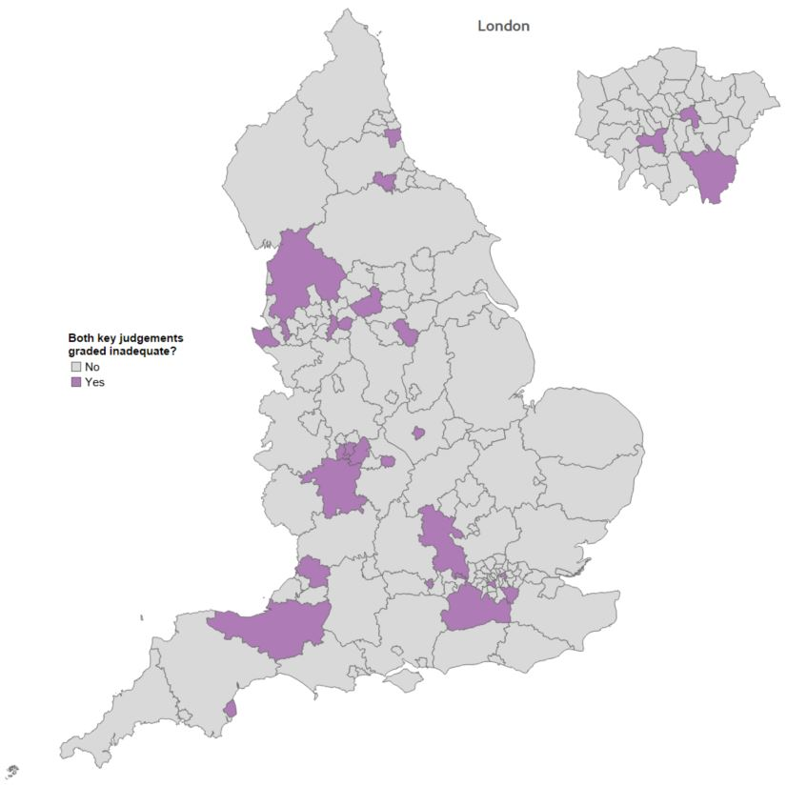
Twenty-five LAs (20%) were judged inadequate for both Help and protection and Leadership and management key judgements. This increase was disproportionate to the increase in inspections overall: the number of LAs inspected increased by a third, while the number judged inadequate for these two key judgements doubled. This was despite there being no change in how Ofsted inspected between the years.
Ten of these LAs (40%) were in the West Midlands or the North West, despite only 25% of inspected LAs being in those regions.

Children looked after sub-judgements to March 2017
The key judgement area Children looked after has two sub-judgements: Adoption performance and Experiences and progress of care leavers.
Chart 3: SIF Adoption performance sub-judgement to March 2017
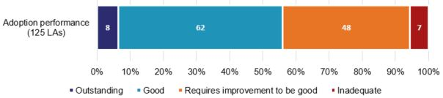

The percentage of LAs judged to be good or outstanding for Adoption performance remains at 56%. [Data Tables: LA level at 31 March 2017]
Fewer LAs were judged inadequate during 2016-17 for the Adoption performance sub-judgement (four) than for the Care leavers sub-judgement (seven).

Chart 4: SIF Experiences and progress of care leavers sub-judgement to March 2017
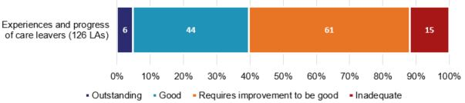

The percentage of LAs judged to be good or outstanding for Experiences and progress of care leavers has increased slightly since March 2016, from 37% to 40%. [Data Tables: LA level at 31 March 2017]
Within this, there has also been a larger increase in the number of LAs judged to be outstanding, from two to six. The four LAs judged outstanding in 2016-17 for this sub-judgement were from London (Ealing and Hackney) and North East, Yorkshire and the Humber regions (East Riding of Yorkshire and Stockton-on-Tees).
One LA (Birmingham) was reinspected during the year, and improved from inadequate to requires improvement to be good for this sub-judgement. Four newly inspected LAs (Bromley, Havering, Wirral, and Worcestershire) were judged to be inadequate for this sub-judgement. As a result, the number of LAs judged inadequate for this sub-judgement increased from 12 to 15.
There are many factors that go into the eventual judgement for an LA around children leaving care. However, one that shows a clear split between LAs judged outstanding for this sub-judgement and those judged inadequate is around appropriate housing for children leaving care. All four LAs judged outstanding for this sub-judgement in 2016-17 were reported to have very high numbers of care leavers in appropriate accommodation. By comparison, three of the four LAs judged inadequate for this sub-judgement in 2016-17 struggled in this area.

Overall effectiveness by LA type and location to March 2017
Each region in England varies in terms of geographical size and the number of LAs within it, and not all regions have yet been inspected proportionate to the number of LAs within them.
All regions now have at least one LA judged good or better for Overall effectiveness, after the South West had its first two good outcomes in 2016-17 (Cornwall and Isles of Scilly). [Data Tables: LA level at 31 March 2017]

Chart 5: Regional Overall effectiveness grades to March 2017
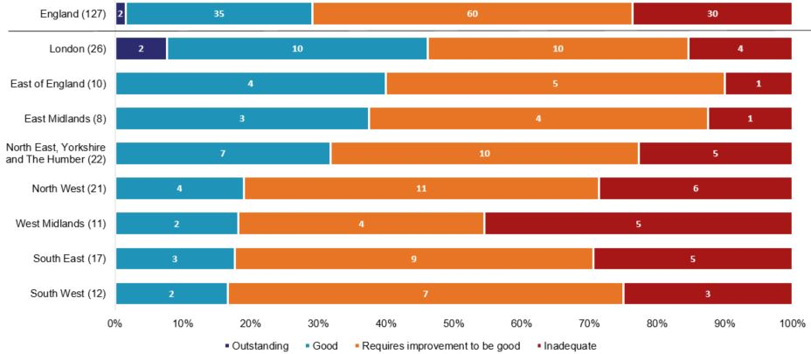

The South East has fallen from being the region with the second highest percentage of its LAs judged good or better to being the second lowest, since March 2016. This is mainly due to the first three LAs inspected in the region under the SIF being judged good, and all subsequently inspected LAs being judged requires improvement to be good or inadequate. This is unlike other regions, where good or outstanding outcomes have occurred throughout the inspection period.

The West Midlands continues to have the highest percentage of LAs judged to be inadequate, at 45%, with only three LAs still to be inspected. However, there does not appear to be anything specific to the region that might explain this.

Map 3: Percentage of inspected LAs judged to be good or outstanding to March 2017
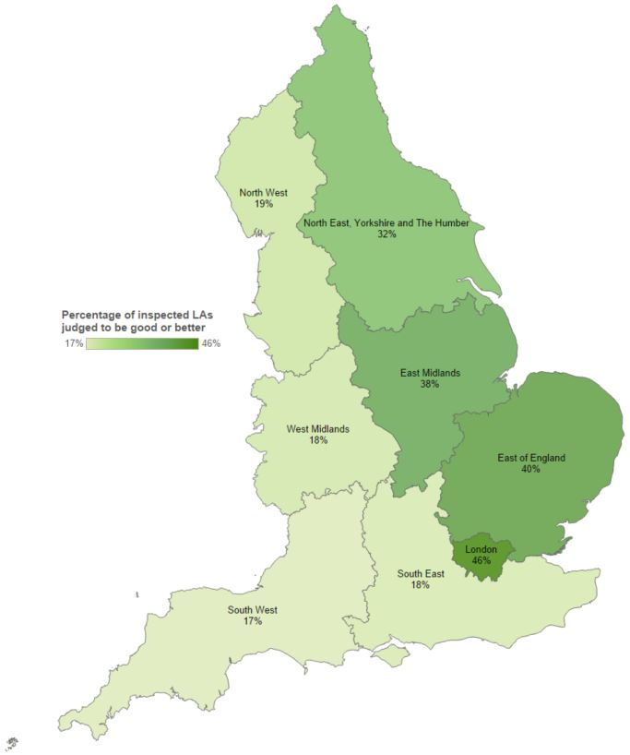

There is a higher percentage of LAs judged to be good or better in regions in the east of the country, compared with the west of the country. Although the reasons for this are unclear, strong leadership is an important factor in achieving a good or better Overall effectiveness grade.

Other factors:
It is difficult, without in-depth research, to fully understand the reasons behind some of the changes and variations that are seen in the data relating to SIF inspections. It is also difficult to say in many cases whether a pattern is causation or correlation. Below, we have included some patterns in the data that are of interest, and may warrant more in-depth investigation to fully understand if, and how, they are related to inspection outcomes.

LA type:
A higher percentage of shire counties were judged good or better (50%) than any other type. London boroughs had the next highest percentage, at 46%. However, this does not necessarily mean that regions with higher numbers of shire counties also have higher numbers of LAs judged good or better. [Data Tables: LA level at 31 Mar 17]

Unitary authorities were more likely than any other LA type to be judged requires improvement to be good (70%). These make up the majority (11 of 17) of the South East’s inspected LAs, and so the recent inspections of these LA types in that region may partially explain the fall in the percentage of good or better LAs in the South East over time. However, despite research into other factors, such as numbers of children and level of deprivation, no other pattern to explain this has become evident. [Data Tables: LA level at 31 March 17]

Social worker percentage turnover:
Chart 6: Changes in social worker percentage turnover post-SIF, by Overall effectiveness grade
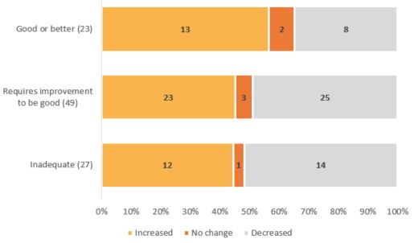

For those LAs inspected in 2013-2015, more LAs judged good or better saw increased staff turnover after their SIF than for any other Overall effectiveness judgement. This is contrary to the widely held belief that staff turnover is more likely following an inadequate judgement.

Rate of Children in Need (CiN):
Chart 7: Number of LAs judged (a) good or better and (b) inadequate, by rate of CiN
a)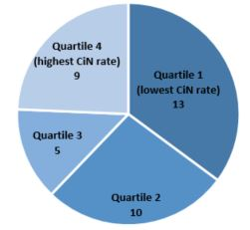 b) 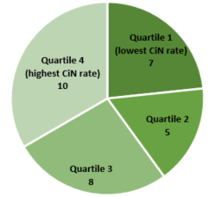

More LAs judged good or outstanding fell within Quartile One for the lowest rate of Children in Need than did LAs judged inadequate. The reverse was true when looking at Quartile Four, for the highest rate of Children in Need.

Level of deprivation:
Chart 8: Level of deprivation, by SIF Overall effectiveness
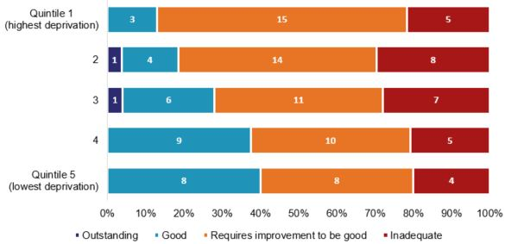

Although there appears to be some relationship between levels of deprivation and good Overall effectiveness outcomes, this is not the case for LAs with inadequate outcomes. LAs with the lowest levels of deprivation were more commonly judged good or outstanding than LAs with the highest levels, and less commonly judged requires improvement to be good. However, the numbers of LAs judged to be inadequate were very similar for the highest and lowest levels of deprivation.

Inspections of local authorities: some comparisons
Because of the different frameworks used to inspect LAs since 2009, it is difficult to compare the SIF Overall effectiveness judgement with those from previous inspection frameworks. Generally, LAs were more likely to receive a lower grade under the SIF compared with previous judgements; however, this was not true for LAs previously judged adequate, and suggests that previous grade cannot be used as a predictor of an LA’s grade under the SIF for these key judgements.
There are two key judgements in the SIF inspections, though, where it is possible to draw some comparisons to a previous inspection judgement:
- Children who need help and protection with the Safeguarding or Child protection inspection outcomes;

- Children looked after and achieving permanence with the Looked After Children inspection outcomes.
Table 1: Children who need help & protection, change from previous inspection
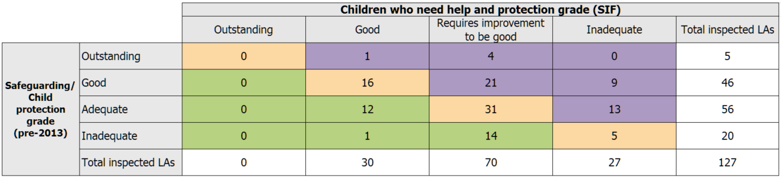

As part of the move to the SIF framework, Ofsted focused more on the experiences of children, including how they are helped and protected. As a result, more LAs received a lower grade for Help and protection (38%) than received a higher one (21%), compared with grades for Safeguarding/Child protection. Of those LAs which did receive a higher grade for Help and protection, 60% (16) had their SIF within two years of their previous inspection. [Data Tables: LA level at 31 Mar 17]
However, the pattern of change was not the same for all previous grades. For example, of the 56 LAs previously judged adequate, broadly the same percentage received a higher grade (21%) as received a lower one (23%) under the SIF.
Table 2: Children looked after & achieving permanence, change from previous inspection
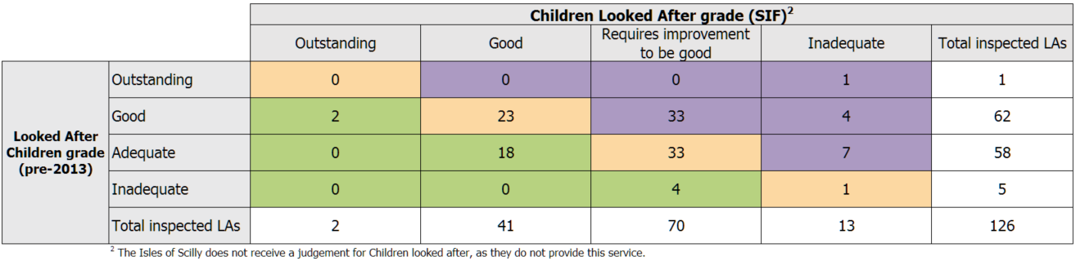

Similar to the shift in focus for Help and protection, there was also a move to focus more on children’s experiences around being Looked After. As a result, there were again more LAs receiving a lower grade for this sub-judgement (37%) than a higher grade (17%), compared with the Looked After Children grade. However, only 25% (six) of LAs which received a higher grade for Children looked after had their SIF within two years of their previous inspection. [Data Tables: LA level at 31 Mar 17]
Again, as with Help and protection, the pattern of change was not the same for all previous grades. Of the 58 LAs judged adequate for Looked After Children, more than twice as many (31%, 18 LAs) received a higher grade under the SIF as received a lower grade (12%, seven LAs).

Reviews of Local Safeguarding Children Boards
There were 127 reviews of LSCBs up to 31 March 2017. [Data Tables: LA Inspection]
Map 4: Overall effectiveness judgements for LSCB reviews to March 2017

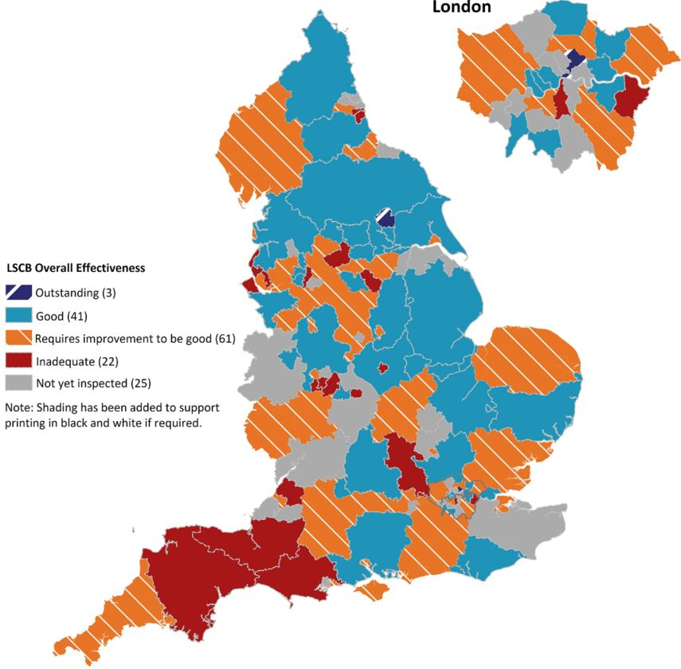

Three LSCBs have now been judged outstanding; these were all judged good for SIF Overall effectiveness. For the majority of inspected LAs (65%, 83), Help and protection and LSCB grades were the same. Where there was a difference, the LSCB grade was more likely to be higher (25% of LAs compared with 9% where it was lower).

All children’s homes

Providers and places as at 31 March 2017
There has been an increase in the number of children’s homes – a far greater increase than at any other point in the last five years. Privately run, for-profit, homes continue to account for the majority of all homes, whilst the number of LA-run homes continues to fall. If short break only homes are excluded, then more than one third of LAs nationally (and more than two thirds of the LAs in London) do not run any homes. Seven per cent of homes active at 31 March 2016 either closed or were re-registered in 2016-17.
Children’s homes, of all types, accounted for three quarters of all social care providers in England at the end of March 2017.
There were 2,145 active children’s homes at the end of the year, a 4% increase from the previous year (2,071). [Data Tables: Providers+places at 31 Mar 2017]

There were 11,664 registered places in all children’s homes, representing less than a 1% (25) increase from the figure at the same time the previous year (11,639).

Chart 9: Percentage of children’s homes run by each sector
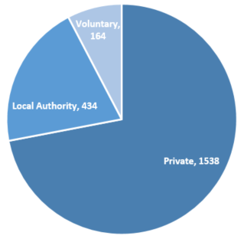
- LAs ran 434, or 20%, of all homes.
- Private organisations ran 1,538, or 72%, of all homes. These organisations are run for profit.
- Voluntary organisations ran 164, or 8%, of all homes. These are run as non-profit making organisations.
As at 31 March 2017, children’s homes were made up of the following sub-types:
- 2,050 children’s homes, with 9,124 places - this was an increase of 78 homes and 247 places from last year.
- 81 residential special schools registered as children’s homes, with 2,302 places - this was a decrease of four schools and 225 places from last year.
- 14 secure children’s homes, with 238 places - this was no change in the number of homes and an increase of three places from last year.
Between 1 April 2016 and 31 March 2017, a total of 228 children’s homes registered and began to operate, and offered 1,016 places. Of these, 75 were re-registrations. In the same period, 154 children’s homes with 834 places were de-registered, predominately via resignations/voluntary cancellations, with three Ofsted-initiated cancellations.

Children’s homes
Around 11% of children’s homes as at 31 March 2017 registered within the year; two homes both registered and de-registered within the same year (seven places).
Re-registrations:
Almost all re-registrations, 72 of 75, were children’s homes. Most of the re-registrations (49) were of children’s homes that had de-registered in 2016-17. Of these 49 homes: 36 were the result of a change in ownership, including 13 which left the LA sector; 13 stayed under the same ownership, three of which changed provider type from residential special school to children’s home.
Seven children’s homes were re-registrations of homes that had closed in 2015-16 and 16 were re-registrations of children’s homes that had closed prior to April 2015.
Regions:
Chart 10: Number of (a) children’s homes (b) places, by region
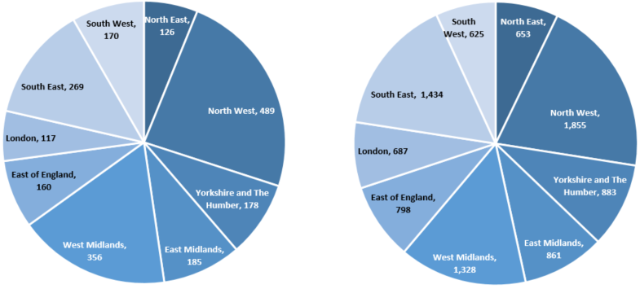
The regional distribution of homes and the regional distribution of places are similar but not identical. [Data Tables: Providers+places at 31 Mar 2017]
The regional picture of where children’s homes are located has remained largely unchanged since March 2016, with no regional proportion changing by more than one percentage point since last year. The North West still has almost one quarter of all homes and only two regions had fewer homes than last year – London (eight fewer) and the East of England (one fewer).
The regional picture of where children’s home places were located also remained largely unchanged since last year – again, no regional proportion changed by more than one percentage point. The South West had fewer places to offer despite having five more children’s homes than at 31 March 2016.

Sector:
The majority of children’s homes were run by private providers. Private providers ran 1,481 homes (72%), similar to 2016. Voluntary organisations ran 142 homes (7%), a decrease of two homes from 2016. The remainder (20%) were run by LAs. [Data Tables: Providers+places at 31 Mar 2017]

The number of LA-run homes fell by 4% from 2016, continuing the trend of reducing numbers of LA-run homes: a reduction of 5% from 2015 to 2016 and of 8% from 2014 to 2015. Despite this, the overall percentage of homes run by LAs decreased by only two percentage points (from 22% to 20%).

There are 111 LAs which run some or all of the children’s homes in their area, including short-break only homes. When short-break only homes are not counted, there are 96 LAs running some or all of the homes in their area; one third of LAs do not run any of the homes in their area. These figures represent a decrease of four and six LAs, respectively, from last year. [Data Tables: LA children’s homes map]

Around 9% of all children’s homes across England are short breaks only homes, accounting for around 12% of all places. This was a small reduction from the previous year (10% and 14% respectively).

The regions in which short break homes provide the largest proportions of their places are: London (17% of their available children’s homes places), the North East and the South West (both 15%).
Table 3: Children’s homes at 31 March 2017, by number of beds and region
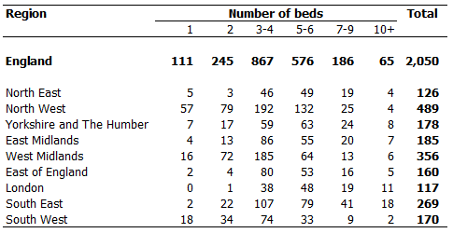

There are large regional variations in the size of children’s homes. The proportions of small homes (one or two beds) range from just 1% in London and 4% in the East of England to 25% in the West Midlands and 28% in the North West. As for large homes (10 or more beds), proportions range from 1% in both the South West and the North West to 7% in the South East and 9% in London. In terms of the regional size profile, there has been very little change since last year. [Data Tables: Providers+places at 31 Mar 2017]
Comparing the latest data with historical data revealed no substantial change in the national size profile. However, there has been a tendency towards smaller homes with the proportion of homes with seven or more beds reducing from 16% at 31 March 2013 to 12% at 31 March 2017, and the proportion of 3-4 bed homes increasing from 38% to 42% in the same period.

Residential special schools registered as children’s homes
Residential special schools, which are often large in size, tend to be in more rural areas. The region with the highest number of residential special schools registered as children’s homes is the South East (17).
All but three of these homes are private or voluntary-run, with just over two thirds (57) run by the private sector.

Secure children’s homes
All but one secure children’s home are LA-run; the sole exception is voluntary-run.
The DfE recently reported that, at 31 March 2017, the 14 secure children’s homes open in England offered 232 approved places (no change from their reported figures for the previous year). They also reported occupancy and availability rates, which is data not collected or held by Ofsted. Of the 232 approved places reported by the DfE, 205 (88%) were available, of which 184 were occupied.

Although there has been some suggestion that the number of secure children’s homes places has fallen over time because of an increase in one-bed non-secure homes, the figures above suggest that this is not the case. Of the 151 children’s homes that newly registered in 2016-17, only 4% (six homes) were one-bed homes, and only 23% (34 homes) were one to two-bed homes. [Data Tables: Providers+places at 31 Mar 2017]

Overall effectiveness for all children’s homes
There are two ways to look at information about Overall effectiveness:
- State of the nation: this looks at all providers active on 31 March 2017, and what their most recent inspection judgement was at this date; for each provider, only their most recent full inspection is included. Providers that have not yet had an inspection are excluded; providers inspected prior to 1 April 2016 but not since will have their pre-2016 judgement included. [Data Tables: Provider level at 31 March 2017]
- In year: this looks at all inspections that took place between 1 April 2016 and 31 March 2017, and what judgement these resulted in; this will include providers that closed before the end of the year, and for some providers will include more than one inspection. Some providers will be excluded as they were not inspected in the year. [Data Tables: Provider level in year]

State of the nation for all children’s homes as at 31 March 2017
The proportion of children’s homes judged to be good or better was at its highest in the last five years. Homes in the North East, the South East, and Yorkshire and the Humber were most likely to be judged good or better. A slightly larger proportion of LA-run homes were judged to be good or better than of private or voluntary-run homes.
Of the 2,145 active homes of all types as at 31 March 2017, in total 2,018 had received a full inspection. [Data Tables: Provider level at 31 Mar 2017]
Chart 11: Children’s homes latest Overall effectiveness judgement, as at 31 March 2017
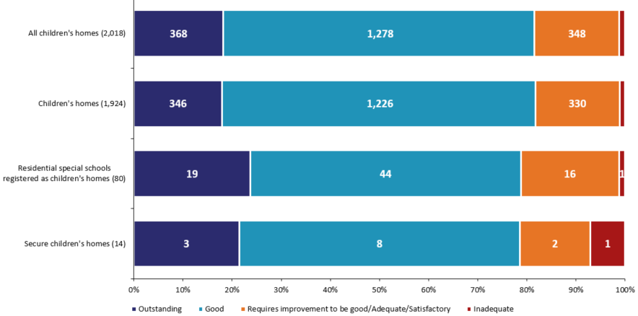

As at 31 March 2017, 82% of all children’s homes were good or better, compared with 79% the previous year. This continued the increase seen last year (from 70% as at 31 March 2015) and surpassed the previous highest level of 81% good or better as at 31 March 2012. This ongoing increase is believed to be in part due to the impact of the quality standards on the quality of care, as well as swift and firm responses by Ofsted to providers who do not meet these standards, demonstrated in increased enforcement work over time. [Data Tables: Latest OE 31 Mar Time Series]

Nationally, LA-run homes (85%) had a slightly higher percentage of good or better homes than both the voluntary (83%) and the private (80%) sectors.
All but one of the eight health authority-run homes inspected were judged good or better.
Chart 12: Children’s homes latest Overall effectiveness inspection judgement, as at 31 March 2017, by region
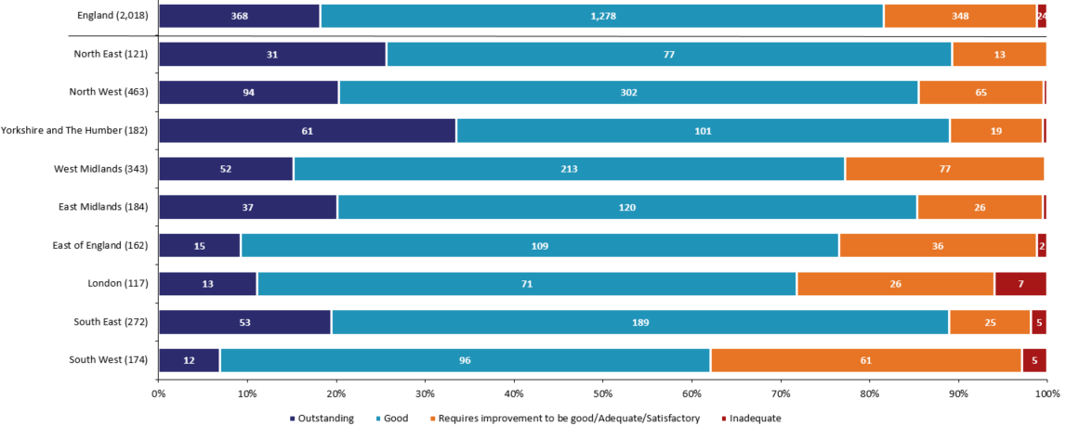

The North East, the South East, and the Yorkshire and the Humber regions had the highest percentages of good or better homes, all at 89%. The region with the lowest percentage of good or better homes was the South West (62%).

Ofsted re-inspects inadequate provision until it either improves or ceases to be registered. For this reason, the number of inadequate homes in the state of the nation is much lower than the number of inspections resulting in an inadequate judgement in 2016-17. Children’s homes inspected more than once in 2016-17 are addressed later in this release.

All children’s homes inspections in year 2016-17
Whilst a similar proportion of inspections in 2016-17 resulted in a good or better outcome compared with 2015-16, proportionally fewer homes this year were judged requires improvement to be good. This meant that proportionally more homes were judged inadequate this year than in 2015-16.

Chart 13: Children’s homes Overall effectiveness judgements 2016-17
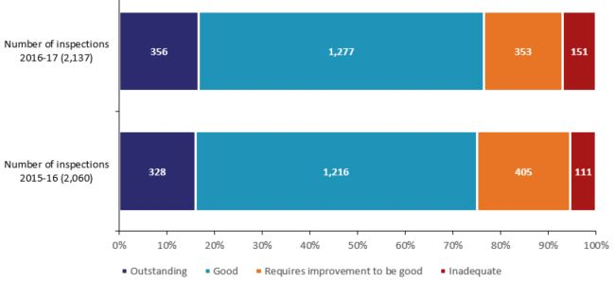
There were 2,137 full inspections of all types of children’s homes between 1 April 2016 and 31 March 2017, equating to 77 more than in the previous year. [Data Tables: Provider level in year]
The pattern of outcome judgements was very similar to the previous year. The percentage of children’s homes judged good or better increased by one percentage point to 76%; for homes judged inadequate, the increase was two percentage points (to 7%). In contrast, the percentage of requires improvement to be good outcomes decreased by three percentage points (to 17%). These changes are likely to be a result of further embedding of the quality standards since their introduction in 2015, leading both to improved quality of care, and, where homes have not been able to address continued issues in their practice, those being judged as inadequate.
One hundred and twenty eight homes were judged inadequate at least once during the year. All but three of these homes were judged inadequate at their first full inspection of the 2016-17 inspection cycle. Of the 128 homes in total, 22 were judged inadequate twice and one judged inadequate on three occasions.
As the above indicates, homes inspected on more than one occasion, and judged inadequate, generally improved at their subsequent inspection in year. In total, 103 children’s homes, of all types, received more than one full inspection in 2016-17.
Of these, 100 were judged inadequate at their first inspection in the year:
- Seventy-nine improved to either requires improvement to be good (46) or good (33) at their second inspection in the year;
- Fourteen remained inadequate at their second inspection and were not inspected again within the year (six of which subsequently resigned);
- Six, having already been judged to be inadequate twice in the year, improved to either requires improvement to be good (five) or good (one);
- One was judged inadequate for a third time and remained so as at 31 March 2017.
Inadequate provision, therefore, improved more quickly than last year. As shown above, 85% of provisions judged to be inadequate in 2016-17 improved to either good or requires improvement to be good during the year (79% at the subsequent inspection). This compares with 68% of provisions judged to be inadequate in 2015-16 (62% at the subsequent inspection).

Overall effectiveness for all children’s homes inspections – change since last inspection
Most homes achieved the same inspection judgement as the previous year. Very similar numbers of homes improved as declined.
Chart 14: Change to Overall effectiveness judgement compared with previous inspection
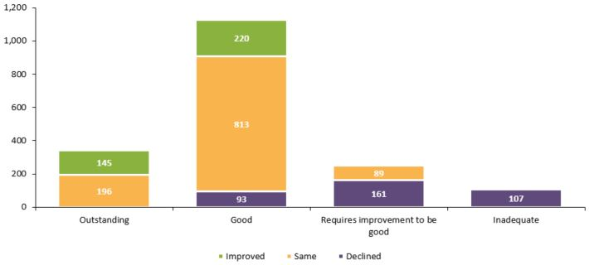
There were 1,829 homes inspected in the period 1 April 2016 to 31 March 2017 that had also been inspected in 2015-16 (90% of all homes inspected in 2016-17). Of these, 60% remained unchanged in their judgement (1,099); unlike last year, when more homes improved than declined, this year, when there were changes, homes were just as likely to decline (361) as improve (369).
Of the 18 homes still judged inadequate as at 31 March 2016: eight were judged to be good in 2016-17; four requires improvement to be good; one inadequate again; and three resigned.,
Just over a third of the homes judged outstanding in 2015-16 that were subsequently inspected in 2016-17 declined (112 homes), predominantly to good (93 homes). Homes previously judged to be good were most likely to remain at good. Of the good homes that declined, 60 out of 204 homes (29%) were judged to be inadequate in 2016-17, compared with 28 out of 184 homes (15%) in 2015-16. This is likely to be due to the impact that an unexpected change – such as a change of manager, admittance of a child with more challenging needs, or even a series of emergency placements – can have on children’s homes. Because many homes are quite small, these factors can have a greater impact than for other provision types, where there are often more children, or children are not all placed together (such as fostering placements).

Regional outcomes for all children’s homes in year 2016-17
There is a regional variation in the Overall effectiveness outcomes for children’s homes. Nationally, homes with a previous inspection judgement of requires improvement to be good or inadequate were more likely to have improved to good or better than to have stayed the same or declined. However, this was not the case in London or the South West.
Chart 15: Children’s homes Overall effectiveness 2016-17, by region
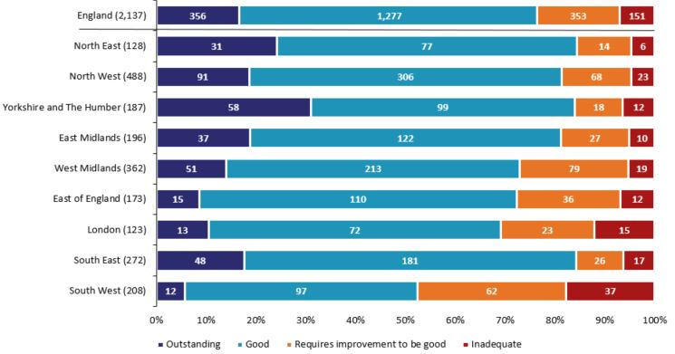

The regions with the highest percentages of good or better inspection judgements between 1 April 2016 and 31 March 2017 were the North East, the South East, and Yorkshire and the Humber (all 84%).
The regions with the lowest percentages of inspections resulting in good or better judgements were the South West (52%) and London (69%). These were two of only three regions to have a lower proportion of inspections resulting in good or better judgements in 2016-17 than in 2015-16 – the South West saw the biggest decline (four percentage points) despite already achieving by far the lowest proportion of good or better judgements.
The three regions to have the highest percentages of homes declining in their Overall effectiveness judgements were the South West (27%), the North West (23%) and the West Midlands (22%).
Chart 16: Change for children’s homes previously judged requires improvement to be good for Overall effectiveness, by region
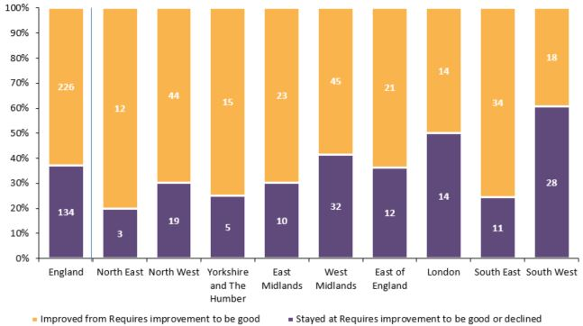
Of the 360 homes judged requires improvement to be good in 2015-16 and inspected in 2016-17, almost two thirds (226) are now judged good or better. The North East (80%), South East (76%), and Yorkshire and the Humber (75%) showed the most marked improvement. A large number of factors can lead to improvement, one of which is strong relationships and partnership working: between providers and outside agencies (to see what they can offer children looked after); and across sectors between providers themselves. The regions with the least improvement were the South West (39%) and London (50%).

Sector data for all children’s homes in year 2016-17
In a change from last year, LA-run homes outperformed both private- and voluntary-run homes in 2016-17, with a larger proportion of LA-run homes being judged good or better compared with private- or voluntary-run homes.
Chart 17: Children’s homes Overall effectiveness 2016-17, by sector
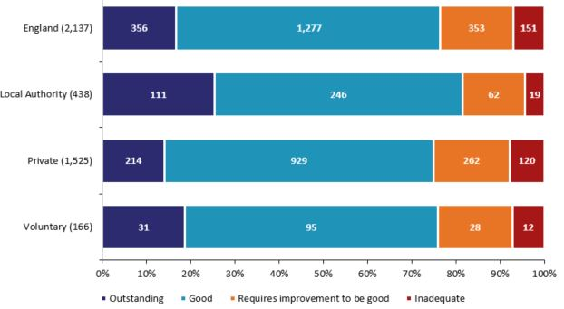
LA-run homes, which make up 20% of all children’s homes, had the best performance profile, with a higher percentage of good or better homes, when compared with privately-run and voluntary-run homes, which make up 72% and 8% respectively. This contrasts with 2015-16, when voluntary-run homes had the best performance profile, though the reasons for this shift are unclear.
LA-run homes also had the highest percentage of outstanding Overall effectiveness judgements for the period, at 25%. In comparison, privately-run and voluntary-run homes had 14% and 19% respectively.
Seven of the eight health authority-run homes inspected during 2016-17 were judged good and one was judged requires improvement to be good.

Map 1
Map 5: Local authority-run children’s homes receiving a good or better overall effectiveness judgement at full inspection, by region, in 2016-17
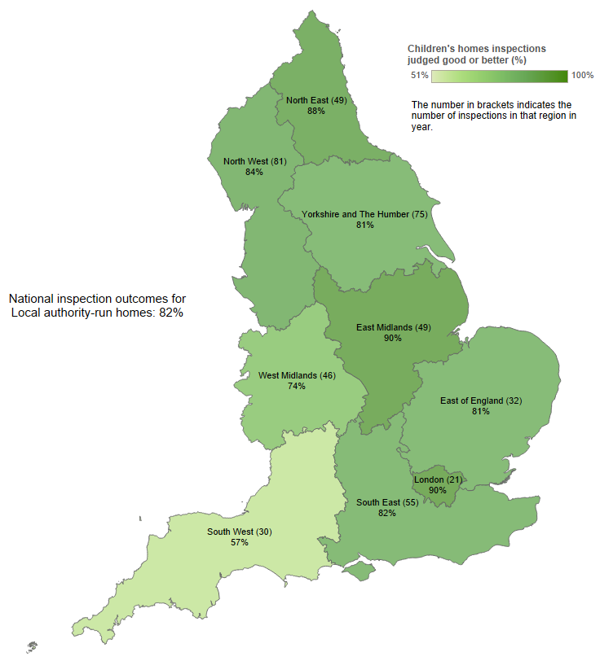
Map 6: Private and voluntary-run children’s homes receiving a good or better overall effectiveness judgement at full inspection, by region, in 2016-17
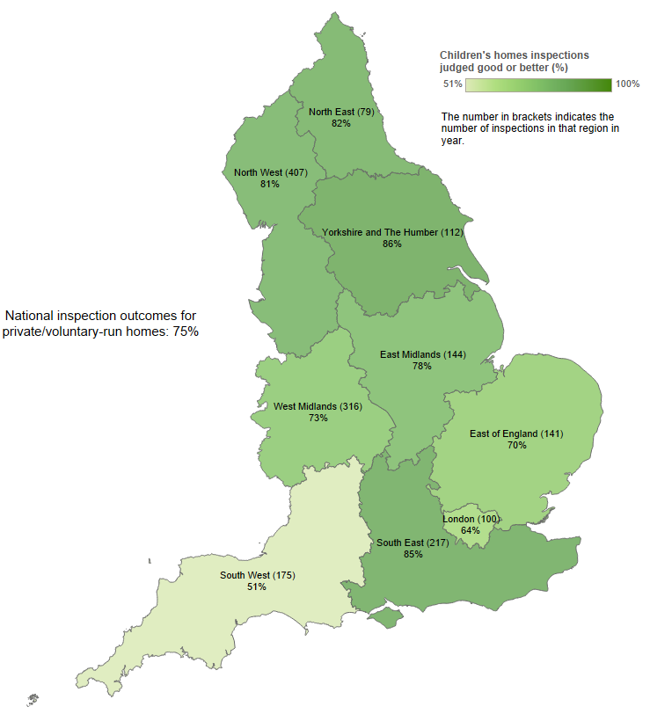

In line with the national sectorial picture, LA-run homes, when compared with privately-run and voluntary-run homes combined, had a higher percentage of homes judged good or better in seven of the nine regions. London had the biggest difference between the two groups (90% for LA-run homes compared with 64% for private- and voluntary-run homes), followed by the East Midlands (90% compared with 78%), and the East of England (81% compared with 70%).
The two regions where voluntary-run and privately-run homes combined outperformed LA-run homes in having a higher percentage of good or better homes were Yorkshire and the Humber (86% for private- and voluntary-run homes compared with 81% for LA-run homes), and the South East (85% compared with 82%).

Interim inspections for all children’s homes in year 2016-17
Chart 18: Children’s homes interim inspections judgements 2016-17
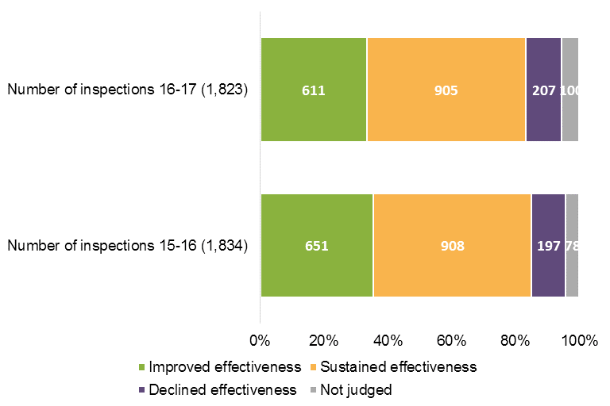

Between 1 April 2016 and 31 March 2017, there were 1,823 interim inspections of all types of children’s homes. Half of these resulted in sustained effectiveness judgements, with a third receiving an improved effectiveness judgement.
Chart 19: Interim inspections judgements compared with subsequent full inspection
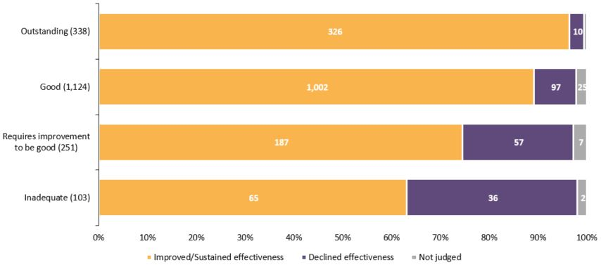

The majority of homes, regardless of their eventual full inspection grade, were judged to have sustained or improved effectiveness at the preceding interim inspection.
The North East (65%) had by far the highest percentage of interim inspections resulting in improved effectiveness judgements. The region with the next highest percentage was the East Midlands (47%).
The South East and the South West (17% each) had the highest percentage of inspections resulting in a declined effectiveness judgement.
The number of interim inspections will be very different in 2017-18, as might be the judgement profile. Following a change in the regulations, good or outstanding children’s homes not identified as high risk will not routinely receive an interim inspection.

Other social care providers
The grade profile of independent fostering agencies as at 31 March 2017 improved from the previous year, with almost nine out of every 10 agencies judged good or better. The grade profile of voluntary adoption agencies remains very high, but in 2016-17 two agencies were judged inadequate when there were previously no inadequate voluntary adoption agencies. LAs continue to run the most residential special schools, but there is a continuing trend of LA-run schools closing and the number of schools with academy status increasing.

The number of providers and places offered by social care providers other than children’s homes as at 31 March 2017 is relatively similar to that offered a year earlier. There were, though, some differences:
- Residential special schools: a decrease of eight (5%), to 157, compared with last year, and a decrease of 37 (19%) from 31 March 2012. The number of places (5,336) decreased by 193 (3%) from last year and by 992 (16%) from 31 March 2012. This decrease in providers and places can be partly attributed to re-registrations as children’s homes, although this is not as prevalent as we had thought it might be (accounting for less than a quarter of residential special school closures in the last five years);

- Further education colleges with residential accommodation: an increase of four, to 42, from the previous year. The increase in places was 28% over the last two years (4,641 in March 2015 to 5,926 in March 2017);

- Residential holiday schemes for disabled children: an increase to 15 schemes; more than a doubling of the number of schemes since 31 March 2015.
[Data Tables: Providers + Places six monthly]

Whilst the overall numbers of providers and/or places has not altered greatly compared with the 2016 snapshot, the sector has seen some change in terms of the actual providers. For instance, the increase by seven in independent fostering agencies was brought about by 25 in-year registrations and 18 de-registrations. Similarly, the increase in boarding schools of four was the result of seven in-year registrations and three de-registrations.

The sector profile of social care providers other than children’s homes has remained relatively static, with the exception of residential special schools. As at 31 March 2017, just over two fifths of all residential special schools were run by LAs (64, down from 79) and about a sixth were academies (26, up from 16). This continues the trend towards fewer LA-run schools and more academies. The proportions of residential special schools run by the private and voluntary sectors was consistent with the previous year.

Chart 20: Other social care providers’ latest Overall effectiveness judgement, as at 31 March 2017
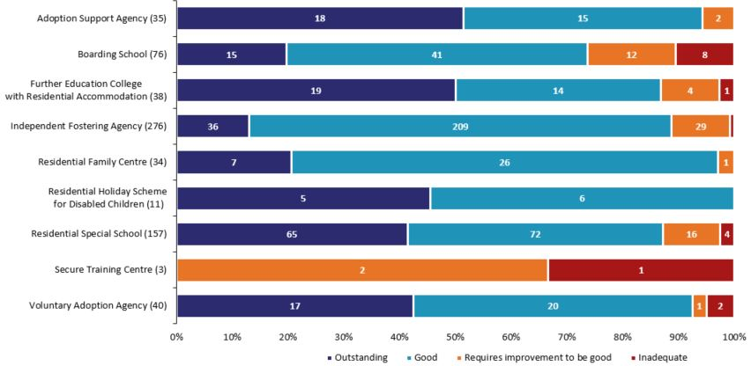

The state of the nation picture for these providers is generally very positive indeed, with the exception of secure training centres which were judged requires improvement to be good (two) or inadequate (one) in 2016-17. The 2016-17 Chief Inspector of Prisons Annual Report also commented on outcomes for secure training centres, highlighting insufficient safety, high levels of violence, and overuse of force to manage children, as well as the impact of staffing shortages and uncertainty about the future. By contrast, 79% of secure children’s homes were judged to be good or better (11) as at 31 March 2017; and 71% of secure children’s homes were judged to be good or better (10) for the Help and protection key judgement. [Data Tables: Provider level at 31 March 2017]

Four provider types have improved their proportion of good or better provisions in comparison to the state of the nation as at 31 March 2016: 89% of independent fostering agencies (IFAs) were good or better as at 31 March 2017 (85% previously); as were 74% of boarding schools (68% previously); 87% of further education colleges with residential accommodation (82% previously); and 97% of residential family centres (94% previously).

Whilst still high (93%), voluntary adoption agencies had a lower proportion of good or better provision than as at 31 March 2016 (97%). This is due to the fact that two agencies were judged to be inadequate during 2016-17 whereas previously there were no inadequate voluntary adoption agencies. One of the agencies was judged to be inadequate at its first inspection, whilst the other declined from good.

Chart 21: Other social care providers’ Overall effectiveness judgements at inspections which took place in 2016-17
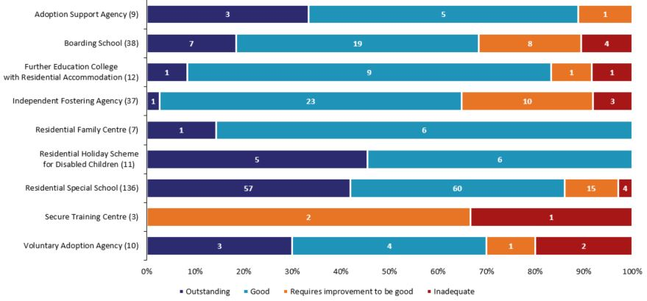

With regards to inspections in 2016-17, Ofsted carried out 263 inspections of social care providers other than children’s homes, 133 fewer than in 2015-16. This was predominantly as a result of a reduction in independent fostering agency inspection activity.

Adoption support agencies are inspected once in every three year period, of which 2016-17 was the final year. Seven of the nine agencies inspected in 2016-17 had been inspected before and, of those, five (71%) remained at the same grade (four remained good and one was judged requires improvement to be good having previously been judged to be adequate). All but one of the 136 residential special schools inspected in 2016-17 had been inspected before – 91 of these (67%) remained at the same grade, all but six of which were good or better.

List of Charts
Chart 1: SIF Overall effectiveness to March 2017 4
Chart 2: Key judgement grades to March 2017 6
Chart 3: SIF Adoption performance sub-judgement to March 2017 8
Chart 4: SIF Experiences and progress of care leavers sub-judgement to March 2017 8
Chart 5: Regional Overall effectiveness grades to March 2017 9
Chart 6: Changes in social worker percentage turnover post-SIF, by Overall effectiveness grade 12
Chart 7: Number of LAs judged (a) good or better and (b) inadequate, by rate of CiN 12
Chart 8: Level of deprivation, by SIF Overall effectiveness 13
Chart 9: Percentage of children’s homes run by each sector 16
Chart 10: Number of (a) children’s homes (b) places, by region 18
Chart 11: Children’s homes latest Overall effectiveness judgement, as at 31 March 2017 22
Chart 12: Children’s homes latest Overall effectiveness inspection judgement, as at 31 March 2017, by region 23
Chart 13: Children’s homes Overall effectiveness judgements 2016-17 24
Chart 14: Change to Overall effectiveness judgement compared with previous inspection 26
Chart 15: Children’s homes Overall effectiveness 2016-17, by region 27
Chart 16: Change for children’s homes previously judged requires improvement to be good for Overall effectiveness, by region 28
Chart 17: Children’s homes Overall effectiveness 2016-17, by sector 29
Chart 18: Children’s homes interim inspections judgements 2016-17 31
Chart 19: Interim inspections judgements compared with subsequent full inspection 32
Chart 20: Other social care providers’ latest Overall effectiveness judgement, as at 31 March 2017 34
Chart 21: Other social care providers’ Overall effectiveness judgements at inspections which took place in 2016-17 35

List of Tables
Table 1: Children who need help & protection, change from previous inspection 14
Table 2: Children looked after and achieving permanence judgements, change from previous inspection 14
Table 3: Children’s homes at 31 March 2017, by number of beds and region 20

List of Maps
Map 1: SIF inspection Overall effectiveness judgements to March 2017 5
Map 2: LAs judged inadequate for Help and protection & Leadership and management 7
Map 3: Percentage of inspected LAs judged to be good or outstanding to March 2017 10
Map 4: Overall effectiveness judgements for LSCB reviews to March 2017 15
Map 5: Local authority-run children’s homes receiving a good or better overall effectiveness judgement at full inspection, by region, in 2016-17 30
Map 6: Private and voluntary-run children’s homes receiving a good or better overall effectiveness judgement at full inspection, by region, in 2016-17 30

Revisions to previous release
Revised data covering children’s homes in the period 1 April 2016 to 30 September 2016 has been released and can be found on the Ofsted website as part of this release: www.gov.uk/government/collections/childrens-social-care-statistics.

- The revision of statistics relating to 1 April 2016 to 30 September 2016 from ‘provisional’ to ‘revised’ status includes outcomes relating to a further 47 inspections. These consist of an additional 39 full inspections, six interim inspections, and two monitoring inspections of children’s homes, which took place in this period and have been published since 31 October 2016.

- Of the additional 39 full inspections, 32 children’s homes received good or better Overall effectiveness judgements and seven received requires improvement to be good or inadequate.

- These additional inspections had no impact on the grade profile presented in the previous provisional data. The grade profile for the six month period remained the same.

Notes
Ofsted consulted with users in 2014 to seek views on the proposed arrangements for the frequency and content of social care inspection official statistics, which is described in more detail in the accompanying Quality and Methodology report. Ofsted also has representation at relevant meetings and forums to seek feedback about whether our publications meet user needs, which include regional meetings of performance leads from LAs. Ofsted’s participation helps inform about user views, and suggested improvements are taken on board. Ofsted also engages with other organisations including the Department for Education (DfE) and representations from the private and voluntary sectors.
An explanation about key uses of this data, and further contextual information and the arrangements for quality assurance are provided in the accompanying Quality and Methodology report.
The Quality and Methodology report can be found at the following webpage: www.gov.uk/government/collections/childrens-social-care-statistics#children-s-social-care-in-england under the heading ‘Children’s social care in England’.
Ofsted also publishes data for all remits, including social care, as part of the annual Data View, available here: https://public.tableau.com/profile/ofsted#!/vizhome/Dataview/Viewregionalperformanceovertime
Glossary

For a full definition of the terms below, please see the Glossary tab within the underlying data tables.

Adoption agencies
Adoption agencies can be voluntary- or LA-run, and aim to place children successfully into adoptive families recruited and prepared by the service.

Adoption support agencies
Adoption support agencies provide services to anyone touched by adoption, as children and adults.

Boarding schools
Although the majority of boarding schools are independent and inspected by other inspectorates, some are maintained boarding schools where both education and the welfare of boarders are the subject of Ofsted inspection.

Children’s homes
A children’s home is an establishment that provides care and accommodation wholly or mainly for children. Children’s homes vary in size and nature, and fulfil a range of purposes to meet the different needs of children and young people.

Fostering agencies
Fostering agencies can be independent or LA-run, and work to recruit, prepare, assess, train, and support foster carers.

Further education colleges with residential accommodation
The care provision of further education colleges that provide, or arrange, residential accommodation for one or more students under the age of 18 years.

Places
The term ‘places’ used in this report refers to the number of places for which the social care provider (usually of residential care) has capacity; this will not usually be the same as the actual number of children receiving services.

Providers
The institutions, organisations, or agencies that provide services to the relevant children and young people.

Residential family centres
Residential family centres provide accommodation, assessment and guidance for children and their parents.

Residential holiday schemes for disabled children
A residential holiday scheme for disabled children provides care and accommodation wholly or mainly for disabled children for a specified period for the purposes of a holiday, or for recreational, sporting, cultural or educational purposes.

Residential special schools
Residential special schools provide education and accommodation to both full boarders and children resident only during the week, including children with very specialist needs.

Sector
‘Sector’ refers to the type of provider that owns the children’s social care provision.

Academy: These are publicly funded independent schools who are run by trusts.

Health Authority: These are NHS Trust-run.

LA: These are public bodies responsible for the children’s social care provision.

Private: These are for-profit organisations mostly with limited company status. These can also be individually owned children’s social care provisions and run for profit.

Voluntary: These are mostly not-for-profit organisations, mainly with charitable status; and individually owned provisions run on a not-for-profit basis.

Secure children’s homes
Secure children’s homes accommodate children and young people who are remanded or have been sentenced for committing a criminal offence, or whose behaviour is deemed to present a significant threat to their own and others’ safety.

Secure training centres
Secure training centres accommodate young people between the ages of 12 and 17 who have been remanded or sentenced by the courts.

If you have any comments or feedback on this publication, please contact the Social Care Data Team on 03000 130020 or socialcaredata@ofsted.gov.uk.

© Crown copyright
You may re-use this information (not including logos) free of charge in any format or medium, under the terms of the Open Government Licence. To view this licence, visit www.nationalarchives.gov.uk/doc/open-government-licence/ or write to the Information Policy Team, The National Archives, Kew, London, TW9 4DU or e-mail: psi@nationalarchives.gsi.gov.uk

SIF = Single Inspection Framework
Department for Education (DfE) guidance, Working together to safeguard children, March 2015 www.gov.uk/government/publications/working-together-to-safeguard-children--2
This figure includes three secure training centres, which are not included in the interactive tables in the accompanying Excel document.
A table showing the figures for all provider types can be found in the accompanying Excel document.
Ofsted does not inspect all boarding schools; see Glossary for details.
For full details of all provider types, please refer to the Glossary tab in the data tables, available online.
Further details of the purpose and relevance of this report are available in the Quality and Methodology report, available online.
Department for Education National Statistics, Children looked after in England, including adoption, September 2016: www.gov.uk/government/statistics/children-looked-after-in-england-including-adoption-2015-to-2016 and DfE National Statistics, Characteristics of children in need: 2015 to 2016, November 2016: www.gov.uk/government/statistics/characteristics-of-children-in-need-2015-to-2016
Children looked after and achieving permanence has two further sub-judgements: adoption performance; and experiences and progress of care leavers.
A recently published research study by the University of Manchester also found that more than 50% of children referred to children’s services in 2010-11 were re-referred within the next five years, and that this was particularly an issue in LAs where social workers held high caseloads (more than 10 children in need). Children’s services in England: repeat referrals, 2017, available here: www.gov.uk/government/publications/childrens-services-in-england-repeat-referrals
City of London and Isles of Scilly were not judged for Adoption performance, as they have no adopted children.
Isles of Scilly is not judged for Care leavers, as they have no children in care.
Source: DfE Information on Children’s Social Care Workforce.
Because this uses data from the year after the SIF inspection, this is not available for LAs inspected in 2016-17.
Rate of Children in Need refers to the number of children in need per 10,000 children aged under 18. A higher rate indicates more children in need as a proportion of all children in the LA.
The terminology changed from “adequate” judgements, in LA inspections prior to 2013, to “requires improvement to be good” judgements, from 2013 onwards, in the SIF.
The Safeguarding inspections were from July 2009-July 2012, and the Child Protection inspections from July 2012-July 2013.
The Looked After Children inspections were from July 2009 to July 2012. The data also includes a handful of Targeted Looked After Children inspections which were conducted in the summer of 2013.
The timing of a SIF inspection is influenced by a number of factors, and so the gap between pre-SIF and SIF inspections varies depending on inspection scheduling. Two LAs have had a second SIF; both of them remained inadequate.
Ofsted conducts reviews of Local Safeguarding Children Boards (LSCBs) alongside the SIF inspections of LA children’s services. Their LSCB Overall effectiveness judgement is not, however, directly comparable to the SIF Overall effectiveness judgement. This review arrangement has been in place since November 2013.
The three LSCBs (City of London, Hackney, and City of York) were all judged good or better for Children Looked After, and Leadership and management sub-judgements. Hackney and City of London were judged good for Children in need of help and protection; City of York was judged requires improvement to be good.
The majority of children’s homes re-registrations (where a children’s home registration ends and a new registration starts on the same premises) are due to a change in ownership.
Nine homes are also run by health authorities and are excluded from this chart.
In this release, this sub-type of children’s home means any home that does not fall within the other two sub types below, that is, is not a residential special school registered as a children’s home and is not a secure children’s home. Further details about children’s homes and what they are can be found in the glossary.
Schools that provide accommodation for pupils for more than 295 days each year, including specialist and mainstream schools, must register as a children’s home if, within any two-year period, one child or more, who boards at the school or in lodgings arranged by the school, stays for more than 295 days over any 12-month period within those two years.
It is not always possible to easily distinguish residential special schools registered as children's homes from children's homes and as such changes in the numbers of these homes are sometimes the result of updated information rather than new registrations or de-registrations.
Secure children’s homes are defined by section 25 of the Children Act 1989. They accommodate children and young people who are remanded or have been sentenced for committing a criminal offence. They also accommodate children and young people who are placed there by a court because their behaviour is deemed to present a significant and immediate threat to their safety or the safety of others, unless they are placed in a secure environment.
The difference in the number of newly registered places (joiners) and de-registered places (leavers) from 31 March 2016 to 31 March 2017 does not always match the actual change in the number of places over the year. It is not always possible to easily distinguish residential special schools registered as children's homes from children's homes and as such changes in the numbers of places are sometimes the result of updated information rather than new registrations or de-registrations. Secondly, for all provision types in these data, providers who were active at both the start and end period can also change the number of places they have; these are known as steady state places.
Children’s homes, as distinct from residential special schools registered as children’s homes and secure children’s homes, provide care that meets the various, diverse needs of children looked after. Some specialise in a particular set of needs, such as children on the autistic spectrum or children with behavioural difficulties. They are inspected at least once every year.
The other three were re-registrations of residential special schools registered as children’s homes. One was previously registered as residential special schools but re-registered as residential special schools registered as children’s homes, and the two were a re-registrations due to new ownership.
Sector refers to the type of provider that owns the children’s social care provision. Definitions of the different types of provider are available in the glossary at the end of this document.
The children that receive short-break care only are a discrete group of children whose needs mainly relate to their disabilities. For the most part, they live with their families and are “looked after” only when staying in these short-break homes.
Residential special schools registered as children’s homes specialise in educational provision for very vulnerable children, some of whom (those who are resident for more than 295 days in a year) are children looked after.
Secure children’s homes provide services to young people who have placed themselves, or others, at risk of harm. These homes meet the young people’s needs within a secure environment, including residential care, educational facilities and healthcare provision.
www.gov.uk/government/statistics/children-accommodated-in-secure-childrens-homes-31-march-2017
Residential Care in England, DfE, July 2016, available here: www.gov.uk/government/publications/childrens-residential-care-in-england
Homes found at some point to be inadequate, or homes for which concerns were raised which required additional inspections.
Homes with no children on roll and with no plans to accept children within the following three months after the inspection would have taken place, were not inspected. Additionally, some homes registered too late in the year to receive a full inspection prior to the end of March.
The inspection is the most recent full inspection the provision had received and is not necessarily from 2016-17.
Most of these (2,028) were inspections of children’s homes, while 4% (94) were inspections of residential special schools registered as children’s homes, and less than 1% (15) were of secure children’s homes.
“Requires improvement to be good” was previously “adequate”, prior to the change in inspection framework on 1 April 2015.
Two homes were originally found to be requires improvement to be good at their first full inspection of the cycle and one home was originally found to be good at their first full inspection of the cycle.
Failures in safeguarding, leadership and management, and restraint and restrictive practices are three common factors leading to an inadequate Overall effectiveness judgement.
Ninety four of these were children’s homes, eight were residential special schools registered as children’s homes, and one was a secure children’s home.
Around ten per cent (196) of children’s homes inspected in 2016-17 had no comparable judgement in 2015-16. This is because, for example, a provider was registered late in the year and had not yet received their first inspection by the end of the period.
One of the eight homes judged to be good in 2016-17 since resigned and one was subsequently cancelled.
A further two homes did not receive full inspections in 2016-17 due to having no children in placement as a result of having restriction of accommodation notices in place, and as such remain inadequate.
Two thirds of the 60 homes judged inadequate in 2016-17 having been judged good in 2015-16 subsequently improved to either good or requires improvement to be good during the year. Ten homes remained inadequate (five having been inspected at least once more in 2016-17) and 10 homes closed during the year (one of which was judged inadequate for a second time in 2016-17 before closing).
There were also eight inspections of health authority-run children’s homes in 2016-17.
One hundred (5%) interim inspections did not result in an inspection judgement as no children were being cared for at the time of the inspection.
All secure children’s homes, however, will still receive two inspections in the year, with one of them likely to be an interim inspection, regardless of inspection outcomes.
For all provision types in this data, the change in overall places from 31 March 2016 to 31 March 2017 does not necessarily equal the difference between the number of places in newly registered provisions (joiners) and the number of places in de-registered provisions (leavers). This is because provisions which were active at the start of the period and the end of the period may also have changed the number of places they are registered for/estimated to have.
For residential special schools, boarding schools and further education colleges with residential accommodation, the social care inspection looks at the welfare of the child/young person. The education they receive is not part of the social care inspection. Data on the education inspections of these types of provisions can be found at: www.gov.uk/government/collections/independent-schools-inspection-and-outcomes and www.gov.uk/government/collections/maintained-schools-and-academies-inspections-and-outcomes-official-statistics
HM Chief Inspector of Prisons for England and Wales Annual Report, 2016-17, p.68, available here: www.gov.uk/government/publications/hm-chief-inspector-of-prisons-annual-report-2016-to-2017
2016-17 was the first year of a three year inspection period for boarding schools and residential family centres, and the final year of a three year inspection period for adoption support agencies, further education colleges with residential accommodation, and voluntary adoption agencies. Independent fostering agencies are inspected under a rolling three year programme of inspection. Residential holiday schemes for disabled children, residential special schools, and secure training centres are inspected on an annual basis.
Of the remaining 21 residential special schools active as at 31 March 2017, a further 20 were also inspected in 2016-17 but the reports were not published by 30 April 2017. As such they have not been included in this release.

