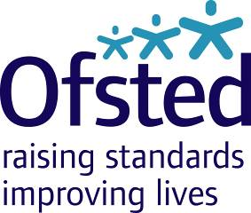
Ofsted Board
Tuesday 21 November 2017
9:30am – 1:00pm, Room 802, Aviation House
Attendees: Julius Weinberg (Chair), Amanda Spielman (HMCI), John Cridland CBE, Linda Farrant, John Hughes, James Kempton, Paul Snell CBE, Venessa Willms OBE, Louise Grainger (Director of Finance, Planning and Commercial), Eleanor Schooling (National Director, Social Care), Sean Harford (National Director, Education), Karen Shepperson (Director, People and Operations), Luke Tryl (Director, Corporate Strategy), Paul Kett (DfE observer)
Amelia Athwal (note taker)
Apologies: Matthew Coffey (Chief Operating Officer)

Strategy session: 10:00am – 10:45am

- Adolescents, does how we inspect stop us from seeing them? Eleanor Schooling

Board meeting: 10:45am – 1:00pm

- Welcome, apologies and declarations of interest Chair
- Minutes, matters arising, action log and forward look Chair
- Strategic Risk Register Louise Grainger
- Strategy Update Luke Tryl
- Strategy evaluation metrics Luke Tryl
- Research programme Luke Tryl
- HMCI update HMCI
- COO update Karen Shepperson
- Education update Sean Harford
- Social Care update (ILACS) Eleanor Schooling
- Finance report (Period 6) Louise Grainger
- Budget and corporate planning Louise Grainger
- Audit and Risk Committee Membership Chair
- AOB ALL

