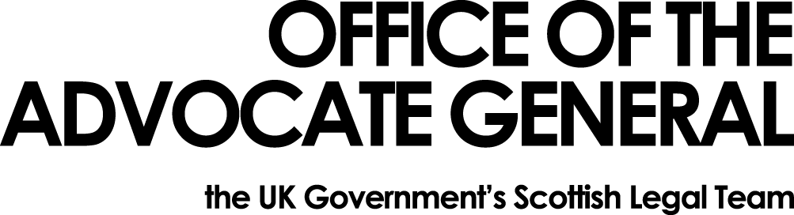
[REDACTED] | Area G-G  OAG  Victoria Quay  Edinburgh EH6 6QQ  24 August 2017

Dear [REDACTED]

Freedom of Information Request

Thank you for your email of 31 July 2017 requesting information under the Freedom of Information Act 2000 (FOIA). You asked for:

Any correspondence, whether written or electronic, between the Office of the Advocate General for Scotland and any other UK government department or agency regarding either:
- the Confidence and Supply Agreement between the Conservative and Unionist Party and the Democratic Unionist Party; or
- UK government financial support for Northern Ireland
sent since 9th June 2017.

Having completed our search for information, I can tell you that there has been no correspondence between the Office of the Advocate General and any other UK Government department regarding either the Confidence and Supply Agreement between the Conservative and Unionist party and the DUP or UK Governement financial support for Northern Ireland.

You may, if dissatisfied with the treatment of your request, ask the Office of the Advocate General to conduct an internal review of its decision. The internal review will be conducted by someone other than the person who took the initial decision. Requests for internal review should be addressed to the Information Officer, Office the Advocate General, Victoria Quay, Edinburgh, EH6 6QQ.

If following the internal review you remain dissatisfied with the treatment of your request by OAG then you may take your complaint to the Information Commissioner, whose address is Wycliffe House, Water Lane, Wilmslow, Cheshire, SK9 5AF. Details of the complaints procedure can be found here:
https://ico.org.uk/concerns

Yours sincerely

[REDACTED]

