COMMUNICATIONS PLAN TEMPLATE
Introduction to this document:
There are a wide range of stakeholder groups that must be taken into consideration during the ‘spinning out’ of a public service (and once the new organisation goes live). Each stakeholder group is likely to have a particular set of requirements and expectations of the new organisation. Different stakeholder groups may require different processes to secure their involvement and commitment to helping build the new organisation, especially since they are not at the same level of awareness and might have a different attitude towards the new organisation (whether positive or negative).
This template has been developed to provide you and your team with a starting point in developing a Communications Strategy and Plan.
We hope you find this template useful, and we would love to hear about your feedback so feel free to get in touch info@mutualventures.co.uk.
Best of luck,
The Mutual Ventures Team

Key steps for developing a Communications Strategy/Plan
- Stakeholder identification, mapping and prioritisation: This involves a session with key staff where all stakeholders (internal and external) are listed. The groups are then plotted on a chart which recognises both the impact that each group can have on the change process and the new organisation and also their attitude and awareness. Based on their position on the chart each stakeholder group is prioritised into priority 1, 2 and 3 in descending order of priority.
- Action Plans and Communications Plan: The next step is to develop action plans for each stakeholder group setting out why they need to be communicated with, what key messages they need to receive, how the message will be communicated. The action plans forms the basis of the Communications Plan.
STEP 1: Identify, map and prioritise your stakeholders
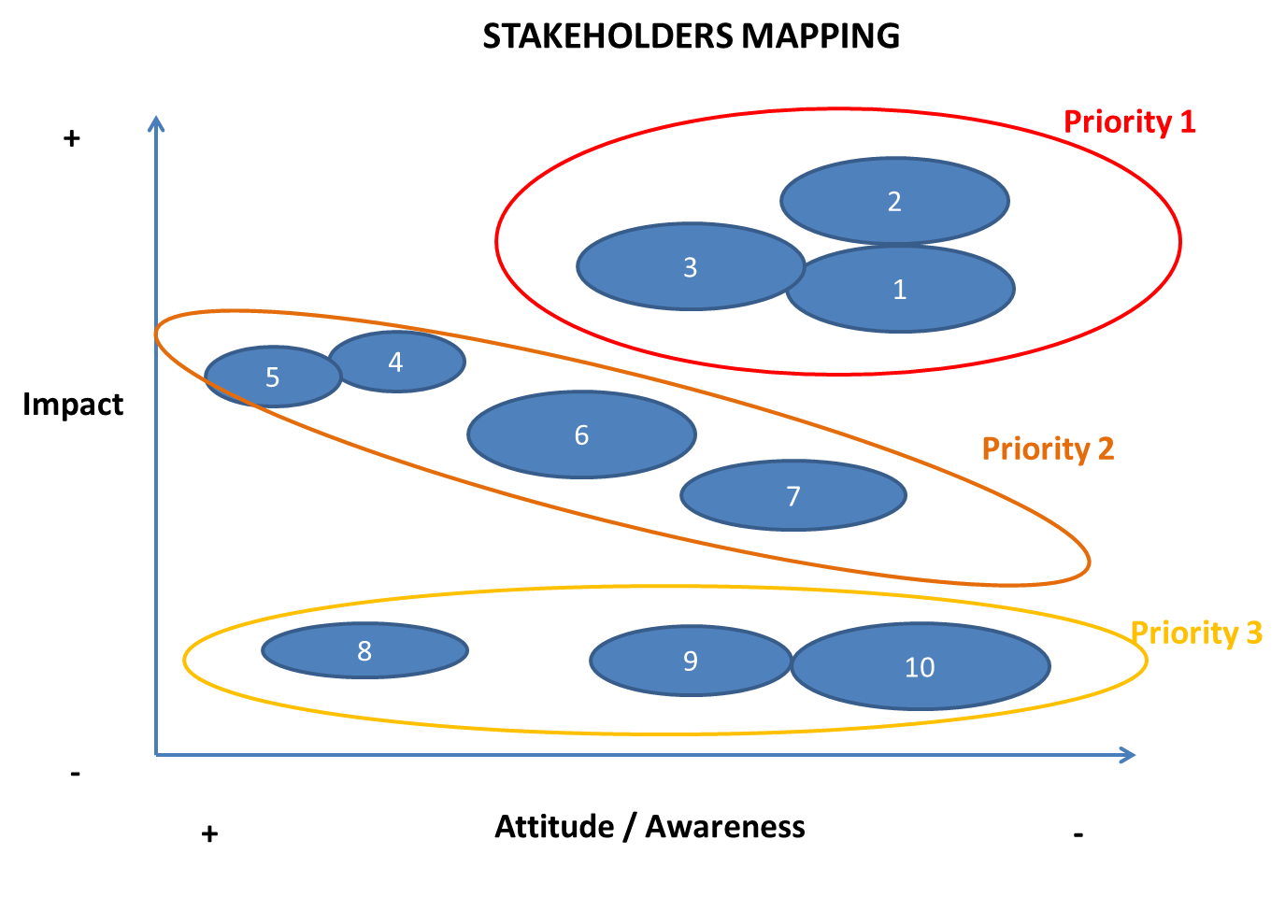
Priority 1 communications - These stakeholder groups are highly influential to the success of the proposed change. They may be unaware of the change or currently have an unfavourable view. They require focused and timely communications. The stakeholders in this group are primarily important due to their influence on the process of setting up the new organisation.

Priority 2 communications - Whilst these stakeholders do not necessarily have a more favourable view of the proposed change they are less critical to its success. They are likely to require less frequent and less focused communications. The stakeholders in this group primarily have an influence on the future development of the organisation.

Priority 3 communications - These stakeholders are less critical to the success of proposed change but will they will require some informative communications, possibly just an initial message.
STEP 2a: Develop an action plan for each group of stakeholders
Stakeholder Group | Why | What  (Key messages) | How  (Channel) | When | Who
E.g. Councillor | Key Council decision maker | Basic information pack | Info pack by email + face to face briefing | Monthly | Project Manager

STEP 2b: Develop Communications Plan
Once stakeholders have been identified, mapped and prioritised, and action plans have developed for the priority stakeholder groups, all of this is brought together into a Communications Plan. Below is the suggested template for the Communications Strategy/Plan:
Communications Plan
- Identifying and grouping Stakeholders
Figure 1 – Stakeholder groupings
Stakeholder Group | Stakeholders

- Stakeholder mapping exercise
Figure 2: Prioritised Stakeholder Matrix
Insert stakeholder map from Step 1 above.
- Action Plan
Priority 1
Stakeholder Group | Why | What  (Key messages) | How  (Channel) | When | Who
Priority 2
Stakeholder Group | Why | What  (Key messages) | How  (Channel) | When | Who

Priority 3
Stakeholder Group | Why | What  (Key messages) | How  (Channel) | When | Who

Other key tools and resources:
Below is a list of some of the other key tools that have been developed by Mutual Ventures and can be used to feed into your business plan:
- MV Business Plan Template
- MV Market Analysis Template
- MV Service Definition Template
- MV Financial Analysis Template
- MV Transition Plan Template

