

“Insert unit title here”
Site Specific Comprehensive Fire Plan for Gas, Fuel & Lubricant Storage Facilities

“Unit” Fire Plan VER 2.0 April 16
Author WO2 Carlisle

After the unit has carried out a Fire Risk Assessment, they are required to annotate their own findings within this plan.

Contents:

Foreword
Amendment State
Distribution List
Chapter 1
Regulation and Enforcement of Fire Safety Legislation
Scope
Introduction
Roles and Responsibilities
Enforcement Model
Chapter 2
Enforcement Flowchart
Chapter 3
Fire Action Poster
Visitors Brief
Example of Fire Training Record
Chapter 4
Fire Plan
Situation
Mission
Action Plan
Command and Control
Service Support
Outside Agencies
Command and Signal
Communications
Media and Public Interest
Security
Clean Up Operation
Training
Individual Training
Fire Prevention Measures
Fire Practice
Chapter 5
Example of F&L/MTFI site diagram
Chapter 6
Example of Gas Cylinder Compound diagram

“Insert unit title” Amendment Sheet

Amendment: |  | Incorporated By
No | Date | Name | Signature | Date | Remarks
001 | 01/04/16 | WO2 Carlisle | M Carlisle | 01/04/16 | Fire Practice Exercise carried out.

Distribution List

Copy No | Holder (Complete as appropriate)
01 | Insert Holders of the UGLRP - Example – CO / HoE
02 | Example – QM Tech
03 | Example – FL Flt OC
04 | Example – BFI
05 | Example – MTFI
06 | Example SHEF A
07 | Example - DIO
08 | Example - RPC
09 | Example – Guardroom / Main gate security staff
10 | Example – DFRMO
11 | Example – HQ Air fuel Role Office (Air units only)

Chapter 1

Regulation and Enforcement of Fire Safety Legislation

Scope

1. This details the methodology by which the Defence Fire Safety Regulator (DFSR) will verify that all relevant premises have a suitable and sufficient fire risk assessment and that Responsible Persons (RP) are discharging their legal obligations to maintain compliance with UK Fire Safety legislation, Defence regulation and the obligations placed upon the Secretary of State by virtue of the subject legislation and regulations.

Introduction

2. The method of enforcement most suited to the MOD business (including areas of the Defence Estate used for 3rd party income generation) is based on resolving issues with agreed Actions Plans (APs) prior to any formal action.

Roles and Responsibilities

3. The Secretary of State for Defence has delegated powers by Charter to the Director General of the Defence Safety Authority (DG DSA). By delegations to the individual regulatory domains, DG DSA empowers regulators to appoint inspectors and undertake the duties of safety regulation and enforcement across Defence. In the case of the DFSR, this covers safety regulation relating to the Regulatory Reform (Fire Safety) Order and allied legislation as it applies to the Defence in Scotland and Northern Ireland. The DFSR discharges the duties of the Fire Safety Enforcing Authority for National Fire Safety Legislation, Statutory Fire Safety Regulations, Defence Regulations and any applicable Policy and Standards. The DFSR also discharges the statutory ‘Duty to Consult’ with Building Control Authorities.

4. With the exception of Domestic Dwellings, legislation requires that all MOD owned and occupied premises to have a suitable and sufficient Fire Risk Assessment (FRA). This is achieved by virtue of the MOD Fire Safety Management Plan (FSMP).More information can be sought in JSP 426 Chapters 2, 3 and 4 provide further direction regarding FSMP, FRA and risk based Audit policy, as well as the training and competence levels required for those undertaking fire safety duties across Defence.

Enforcement Model

5. The enforcement model employs a tiered approach commencing with an initial expectation that the RP/s will achieve and maintain legislative compliance. However, where enforcement expectations are such that a ‘soft’ approach fails to achieve compliance, the enforcement model allows for a harder line to be adopted in order to protect relevant persons.

6. The enforcement and enforcement expectations flowcharts provide guidance on the enforcement route employed by the DFSR.

Chapter 2
Enforcement Flowchart

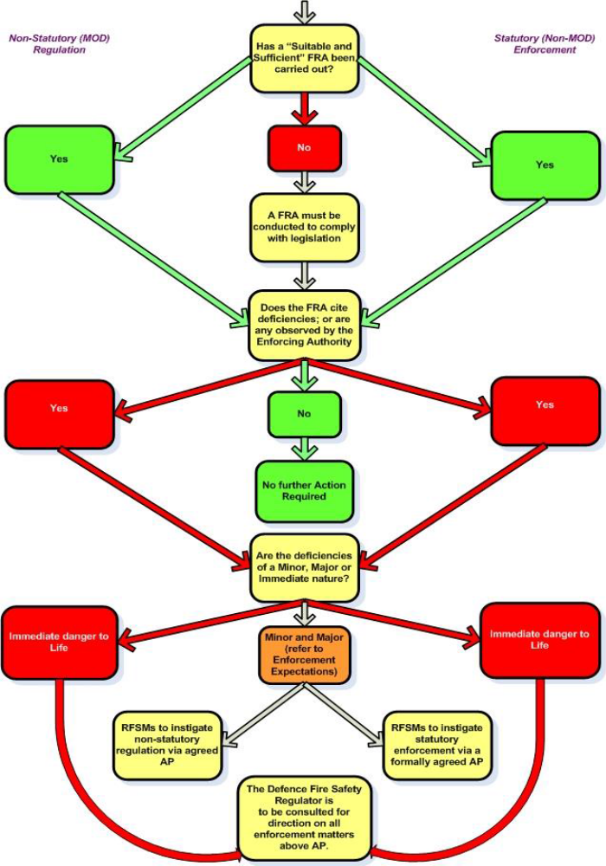

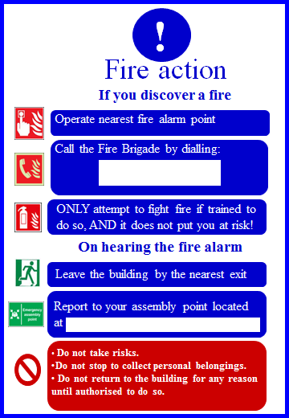

Visitors Brief

1. On entry to the BFI/MTFI/GAS Compound all visitors should receive the following brief:

- This is a hazardous area containing toxic and flammable products and visitors should be accompanied by Site personnel at all times.

- It is recommended that Personal Protective Clothing (PPE) be worn at all times.

c. Visitors must be briefed on the Fire Plan including methods of raising the alarm, actions on hearing the alarm, and the location of the nearest muster point.

d. Smoking is strictly prohibited on site.

e. All mobile phones, smart watches, personal radios, lighters, battery-operated items and
other electrical equipment is to be secured in the contraband box at the site entrance.

Example Fire Safety Training Record of Gas/Fuel Operator

Date: |  |  | Station/Unit Details:
Rank/Grade/Name: |  |  | Training Declaration Signature:

Subjects Covered

 |  | The significant findings from the fire risk assessment and fire safety policies
 |  | What to do on discovering a fire
 |  | How to raising the alarm, including the locations of fire break glass points
 |  | The action to take upon hearing the fire alarm
 |  | The evacuation procedure for alerting Military, Contractors and visitors including, where  appropriate, directing them to exits and assembly points at a place of total safety
 |  | The arrangements for calling the fire and rescue service
 |  | The location and , where appropriate, the correct use of portable fire extinguishers and fire-fighting equipment
 |  | Knowledge of escape routes including stairways and especially those not in regular use, and away from flammable material.
 |  | How to open all emergency exit doors
 |  | The appreciation of the importance of fire doors, keeping them closed and not wedged open to prevent the spread of smoke and heat, keeping escape routes unobstructed
 |  | Where appropriate, isolating electrical power and gas supplies and stopping machines and processes
 |  | The reasons for not using lifts (except those specifically constructed as evacuation lifts)
 |  | The safe use, risks from storing and working with highly flammable/ explosive substances
 |  | General fire precautions, fire awareness and good housekeeping practices
 |  | The no smoking policy around the BFI/MTFI installation.
 |  | Identifying fire hazards and fire incidents reporting procedures.
 |  | Equipment fault reporting procedures.

Names of those attending:
PRINT NAME |  |  |  | SIGNATURE
I confirm that I have delivered the above subjects to those named above as attending.
Rank/Grade/Name: |  |  | Date:
Signed: |  |  | Position:

Chapter 4
Template for Comprehensive Fire Plan - F&L

COMPREHENSIVE FIRE PLAN FOR FUEL, LUBRICANT AND GAS STORAGE FACILITIES

References:

A. JSP 317 Pt 1 & 2 (V6.0 Apr 16)
B. JSP 426 Pt 2 (V1.0 Mar 16)
C. JSP 319 V4.1 (June 16)

SITUATION

1. Prior to conducting operations within the F&L/ MTFI/BFI/BULK LPG/CRYROGENIC GAS/CYL COMPOUNDS, there is a requirement for this site specific fire plan to be implemented. This plan identifies key personalities and highlights the immediate actions to be carried out in the event of a fire. In accordance with references A and C, the following points were considered when creating this fire plan:

- Provision and maintenance of a means of escape.

- Provision of access in for external agencies / Fire Service.

- Provision of an effective fire alarm system.

- Provision and siting of correct fire fighting equipment.

- Provision of an adequate water supply.

- Provision of suitable firewater/foam run off collection (if applicable)

- Provision of training for personnel, including fire fighting, muster and immediate action drills.

- Maintaining records of equipment testing / maintenance and personnel training.

- Designation of Responsibilities.

- Completion of a site Fire Risk Assessment.

MISSION

2. To prevent the outbreak of fire in a potentially hazardous area in order to protect both personnel and equipment on site.

ACTION PLAN

3. The execution of the Fire Plan is to be immediate on discovery of a fire. Immediate actions are to raise the alarm, evacuate the surrounding area, attempt to combat the fire if safe to do so, and contact the Fire Service. The Unit Fire Safety Manager is the Fire Officer for the site and should be informed immediately in the event of fire. IA drills on discovering a fire are detailed at Annex A.

4. Muster Point. In the event of fire, the muster point will be the RMP car park opposite RHQ. All personnel not directly involved in fighting the fire must assemble there. All adjacent office buildings, Sqn Lines and Fuel Parks must be evacuated as soon as the alarm is raised. Senior personnel are to ensure that all personnel are accounted for and conduct a roll call.

COMMAND AND CONTROL

5. Incident Comd. The most senior rank present is to assume the role of Incident Comd until relieved by the Senior Fire Officer (DFSRS or Local Authority Fire Service (LAFS). Using the manpower and fire fighting equipment available, the Incident Comd is responsible for coordinating the immediate response to the fire if safe to do so.

6. External Assistance. The fire service is to be called immediately to all outbreaks of fire by the quickest means possible. By telephone through the military exchange on telephone number ………….. or by the 999 system.

SERVICE SUPPORT

7. Fire Extinguishers. These will be distributed on site as follows:

a. 2 x 9ltr foam easily accessible from access point.

8. Water Supply. The nearest water supplies are located at: …………….

(List location of nearest hydrants or EWS tanks.

9. Equipment Siting. All fire fighting equipment should be checked for serviceability, sited by the Fire Officer and maintained in accordance with reference B. All site personnel should be fully conversant on the site Fire Plan, as part of their duties.

OUTSIDE AGENCIES

10. If there is an on-site fire brigade they will be familiar with local procedures and will assume immediate control. The Local Authority Fire Service will have to be met and directed to the incident and they will be briefed by the ICP.

11. Medical. Med Centre is 2 mins from the BFCV Park. All casualties should be taken directly there or an ambulance called on 3333. The Incident Comd is responsible for the coordination of all casevacs whether by ambulance or air.

COMMAND AND SIGNAL

12. Reporting. The Incident Comd is responsible for the immediate reporting of the fire through the correct chain of command. MOD Form 1059 is to be completed.

COMMUNICATIONS

13. Unless certified ATEX Compliant, no communications equipment is to be used on hazardous area zones.

MEDIA INTEREST & MEMBERS OF THE PUBLIC

14. Media. In the event of a serious fire, with the involvement of external agencies, increased Media interest may be generated. All Media should be directed to the Media Officer where they will receive a brief. Personnel directly involved in the incident should not offer statements or personal opinions in any circumstances.

15. Members of the Public. Personnel should remain courteous to civilian interest, directing any questions to the Media Officer. In the interests of safety, civilians and visitors should be directed away from the incident site to the muster point. Any visitors to the packed fuel compound must receive a brief on arrival as detailed at Annex B.

SECURITY

16. The Incident Comd is to establish an Incident Control Point (ICP) and cordon the area once it has been evacuated. Access should be restricted to those personnel trained in the use of fire fighting equipment, and Medics.

CLEAN UP OPERATION

17. Extensive use of foam product during fire-fighting can cause contamination of local water sources. Local water companies and the Environment Agency should be informed at the Fire Officer’s discretion via the Garrison G4 Chain of Command.

TRAINING

18. All personnel involved in the storage, handling and transportation of hazardous products require trg in safe procedures in a packed fuel compound and fire fighting equipment handling.

19. Training Record. All individual Fire Trg must be carried out at least annually and recorded. Any further trg conducted on Exercise should also be logged.

INDIVIDUAL TRAINING

20. The objective of all fire safety training is common to all and centres on the need to equip MOD personnel to respond safely and effectively to a fire emergency. To enable this, it is MOD policy that personnel are appropriately trained in fire safety by competent persons as follows:

- Action to be taken in the event of fire; including particular actions relating to the premises or equipment: i.e. gas / power emergency shut off facility.

- Raising the alarm (both alerting others in the vicinity and calling the fire service).

c. Evacuation, assembly and roll-call procedures.

d. Use of fire fighting and escape equipment / facilities.

e. Particular Hazards: Personnel shall be briefed on any particular hazards that could result from a fire in their workplace and any related precautions or actions.

f. General Fire Safety Briefing: As well as the particular actions to be taken in the event of a fire emergency, personnel should be given a general brief on fire safety at their establishment. This should cover such topics as the outline of the establishment fire safety organisation, the need for strict fire safety discipline; including compliance with controls on smoking and the correct use of electrical and gas supplies and equipment, the importance of maintaining escape routes free and available; and the need for employees to alert management to any fire safety risks that come to their attention.

g. The Fire Officer is to have received all necessary formal trg. All others operating on the packed fuel compound should have the opportunity to train further in the following:

1. Products held and their associated hazards.

2. Safe Operating Procedures on a packed fuel compound.

3. Immediate Action drills and raising the alarm in the event of fire.

4. Duties of Incident Comd and Fire Piquet.

5. First Aid Training.

FIRE PREVENTION MEASURES

21. Routine Checks. In the interests of fire prevention, SSM HQ Sqn is to carry out checks of the site and equipment at regular intervals and log all findings. Fire hazards and anomalies are to be eliminated or reported immediately.

22. Correct Procedures. Safe operating procedures are to be strictly adhered to in the packed fuel compound.

FIRE PRACTICE

23. The Fire Officer is responsible for coordinating Fire Practice on the site at least annually.

Carlisle
WO2
Tech WO

Annexes:

A. Actions on Discovering a Fire.
B. Fire Action Notice
C. Visitors’ Brief.
D. Example Fire Safety Training Record

Distribution:

OC HQ SQN
QM (A)
Regt Fire Officer
MTO
Fuel Manager
Regt Ops
SSM HQ
DFS

20 TPT SQN - FIRE SAFETY ORDERS - PART 2

ACTION ON THE OUTBREAK OF FIRE

BY PERSON DISCOVERING THE FIRE

1. Shout “FIRE” continuously and raise the alarm by sounding the nearest fire alarm. ONLY ATTEMPT TO FIGHT THE FIRE IF IT IS SAFE TO DO SO, by means of the FIRE EXTINGUISHERS located at the ENTRANCE of the compound.

2. Contact the Emergency services via Ext 4444 stating the EXACT LOCATION OF THE FIRE, 1 F&M REGT PACKED F&L COMPOUND.

3. Once all persons are evacuated, await assistance from the fire brigade. Response Time is expected to be 2 minutes.

by THE guardroom

4. Alert the fire Piquet (if nominated) and dispatch to the fire.

5. Ensure the General Fire Alarm (if available) is sounded.

6. Post a member of the guard at the main gate with a water supply map to guide the fire brigade to the scene of the fire.

7. A hazardous area map which will incorporate DSEAR and details of any hazardous products held with quantities.

8. The Guardroom is to log all information received.

BY THE FIRE PIQUET

9. On the alarm being raised proceed to the scene of the fire with the fire fighting equipment, by the fastest possible means.

10. The OIC Fire Piquet is to take charge of the fire fighting until the arrival of the Unit Fire Officer, Unit Fire NCO or Fire Brigade.

BY THE REMAINDER OF THE UNIT/DEPARTMENT

11. If practical attempt to close all doors and windows of the buildings in your area of responsibility.

12. All buildings are to be evacuated as quickly as possible.

13. All personnel are to move IMMEDIATELY to the Evacuation Area 200m away at the RMP car park which is the designated muster assembly area.

14. Senior Person present is to take a roll call noting all persons present and accounted for.

15. The senior person present is to carry out the following:

a. Send a runner to report to the Guardroom.

b. Inform the Guardroom by the fastest possible means when all personnel are accounted for.

c. On arrival of the Fire Brigade, he/she is to assist if possible.

d. MAXIMUM HOLDINGS for this compound are:

Ser | Location | Product | Max Qty (Ltrs/Kgs) | Remarks
01 | F&L Compound | AL 11 | 200 | Max Holdings
 |  | OEP 220 | 1000 | Max Holdings
 |  | OM 15 | 150 | Max Holdings
 |  | OMD 55 | 2000 | Max Holdings
02 | Gas Compound | LPG | 10Kg | Max Holdings
03 | MTFI | Dieso | 20,000ltrs | Max Holdings

16. All personnel not detailed as runners or for specific tasks are to remain at the emergency muster point until stood down by the Senior Person present

17. Note: DO NOT RE-ENTER THE COMPOUND UNTIL IT IS DECLARED SAFE TO DO SO BY THE SENIOR FIRE BRIGADE OFFICER PRESENT.

18. The Muster area for this department is: THE RMP CAR PARK OPPOSITE RHQ LOCATED 200m AWAY.

Chapter 5
Example of F&L/MTFI site diagram

SITE PLAN OF “INSERT SITE NAME”

Chapter 6
Example of Gas Cylinder Compound diagram

SITE PLAN OF “INSERT SITE NAME”

