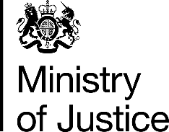 | June 2017

Freedom of Information Act (FOIA) Request – 112219

You asked for the following information from the Ministry of Justice (MoJ):

I am looking for an update of a previous FOI request (FOI 96866 184-15).

I am requesting, under the terms of the Freedom of Information Act, information on the number of criminal cases taken to trial for selected cases for 2016.

Specifically, I would like details on criminal trials for selected criminal cases - I have set out the categories of offenses in the table provided in the attachment.

For each category of offense, I would like to know the number of defendants involved (if it is not possible to provide the number of defendants, please provide the number of cases).

Would it be possible to have the same data for 2014, and 2015, under the ‘new timeliness methodology’ used for the 2016 data here?

Your request has been handled under the FOIA.

I can confirm that the department holds the information that you have asked for. Please see the attached tables, showing figures for 2014 (in Table 1) and 2015 (in Table 2) for the new timeliness methodology, including cases where the duration is over ten years.

