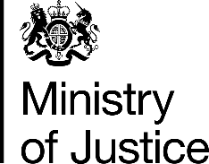 | August 2017

Freedom of Information Act (FOIA) Request – 113279

You asked for the following information from the Ministry of Justice (MoJ):

I hope you can help, I have tried a few places and I told you should be able to help.

I am working on a project for the jewellery trade, and need reliable, official statistics for prosecutions, relating to the Hallmarking Act 1973.

Would you be able to give me this information? If not, can you direct me where I can get this information?

I somewhat naively thought this would be a matter of public record and easy to find!

Many thanks for your anticipated help.

Your request has been handled under the FOIA.

I can confirm that the MoJ holds the information that you have requested and I have provided it in the attached annex

