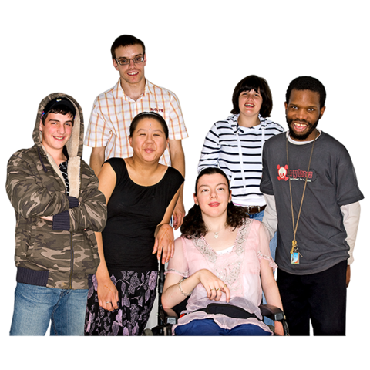

How do you feel about being an LGBT person living in the UK?

A survey with some questions for you to answer

Housing for disabled people.
What needs to change?

About this survey

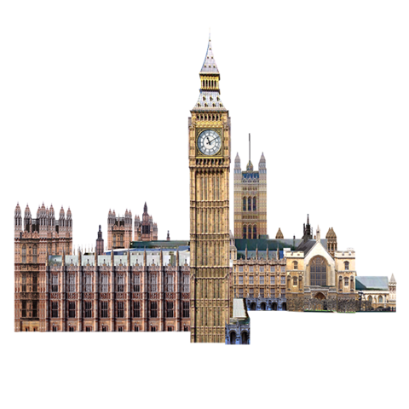

We are part of the UK Government.

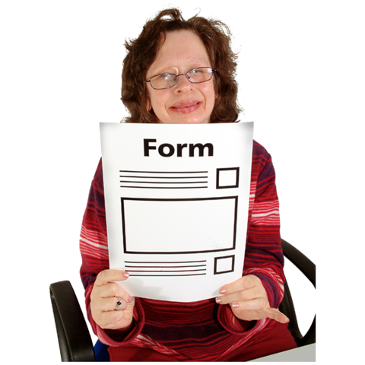
We want to know what life is like for LGBT people in the UK.

There are some questions for you to answer in this survey.

Your answers will help us know how to make life better for LGBT people.

This survey is for LGBT people. By this we mean people who are:
- Lesbian
- Gay
- Bisexual
- Transgender
- Intersex
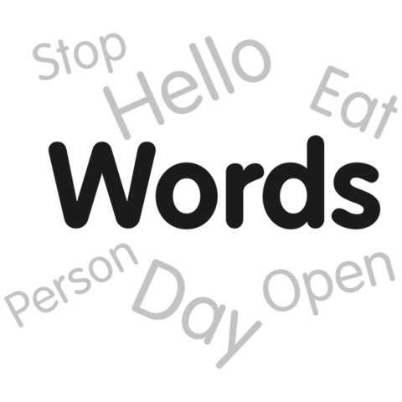
Or people who may feel different to some people about their gender or who they are attracted to.

There is a list of what these words mean from page 19.
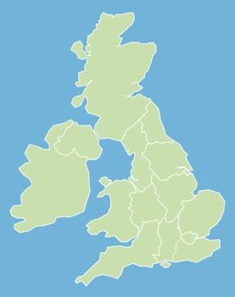
To answer these questions you must also be:
Scotland
- 16 years old or older
Northern Ireland
- living in the UK
Wales
England

There is a longer survey like this one.

This is a shorter survey for people who may find the long survey hard to fill in.

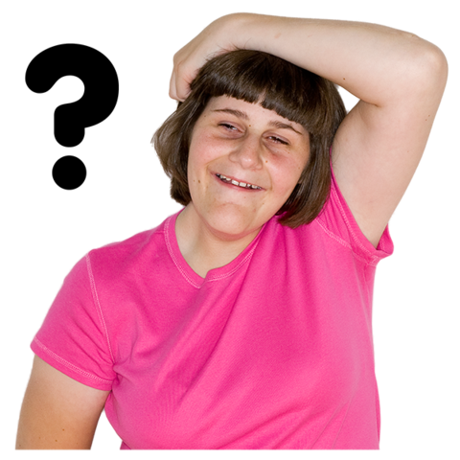
Some ideas in this survey may be hard to think about or understand.

You can talk to someone you trust about the questions if you like.

Or you can tell us that you are not sure or do not want to answer a question.
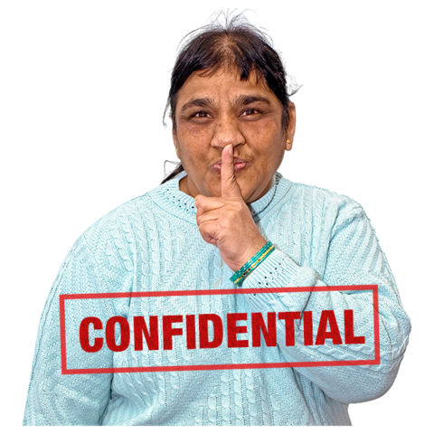

No one will know who you are when you answer the questions.

Please do not tell us your name, address, phone number or other personal details.

The questions

There is a list of hard words and what they mean at the end of this booklet from page 19.

It may be a good idea to look at this first.

Or you can look at it as you go along.

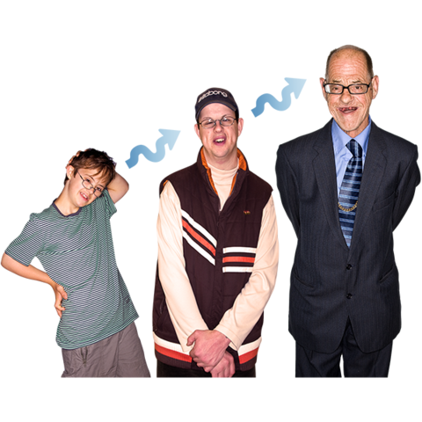

About you

1. How old are you?

2. This question is about your gender.

This means if you feel you are a woman, a man or something else.

Do you feel that you are:

A woman or girl

A man or boy

A trans woman or trans girl

A trans man or trans boy

Non-binary, Genderqueer, Agender or Gender fluid

I do not know

I do not want to say

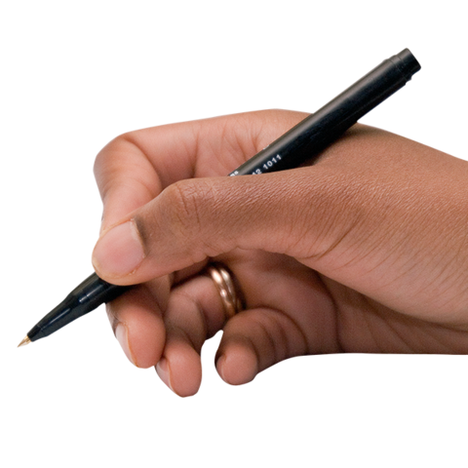
Something else. Please say what.

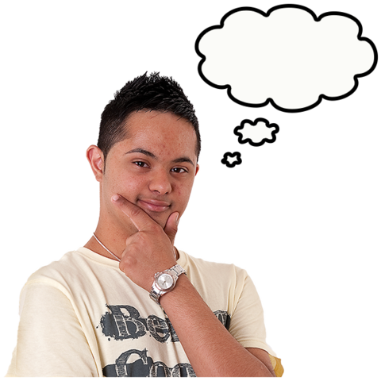
3. Would you say that you are transgender (trans)?

There is information about this word on page 20.

Yes

No

I do not know

I do not want to say
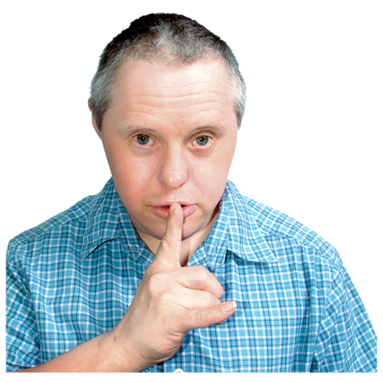

4. Do you ever keep how you feel about your gender secret because of what other people may think?

Yes

No

I do not want to say

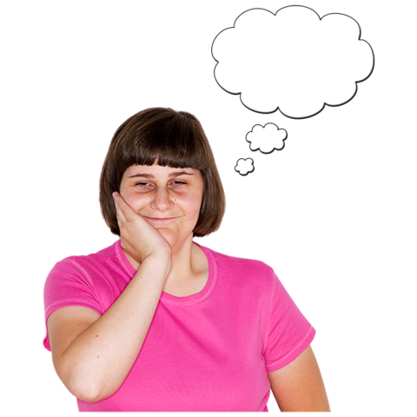
5. Do you feel you are intersex?

There is information about this word on page 20.

Yes

No

I do not know

I do not want to say

6. This question is about who you may be attracted to or want a relationship with.

This is called your sexual orientation.

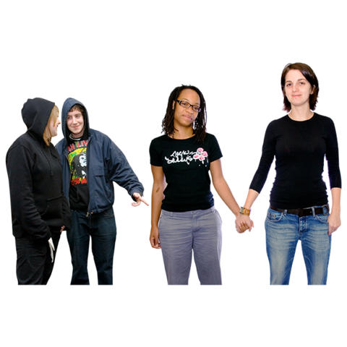
Do you feel you are:

Bisexual

(Someone who is attracted to men and women)

Gay or lesbian

(Men who are attracted to men.
And women who are attracted to women)
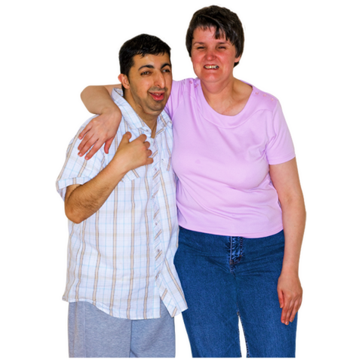
Straight (heterosexual)

(Men who are attracted to women.
And women who are attracted to men)

I do not know

I do not want to say

Something else. Please say what.

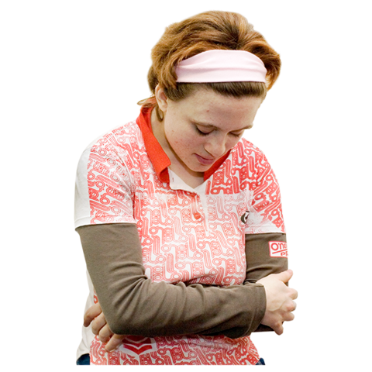
7. Do you ever keep who you are attracted to a secret because of what other people may think?

Yes

No

I do not want to say

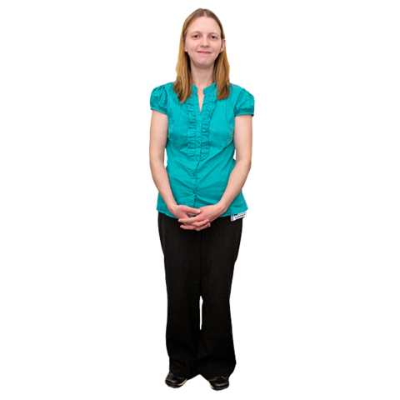
8. This question is about you and relationships with someone like a boyfriend, girlfriend, husband or wife

Are you:

Single. This means you are not in
a relationship at the moment.

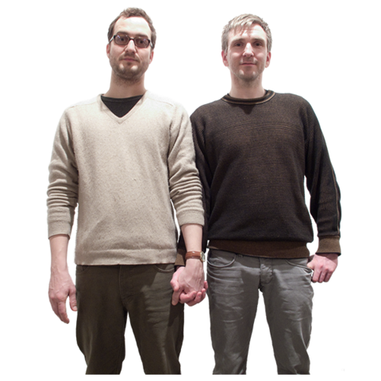
Married or in a civil partnership

A civil partnership is when a man and a man or a woman and a woman say they will stay together.

They have the same rights as married people.

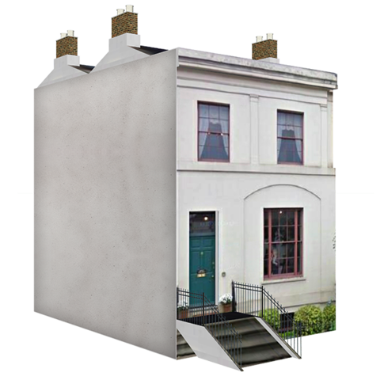
Living with a partner

A partner is someone you are in a relationship with.

In a relationship but not living with a partner
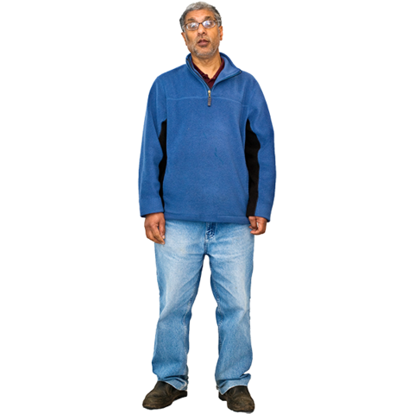
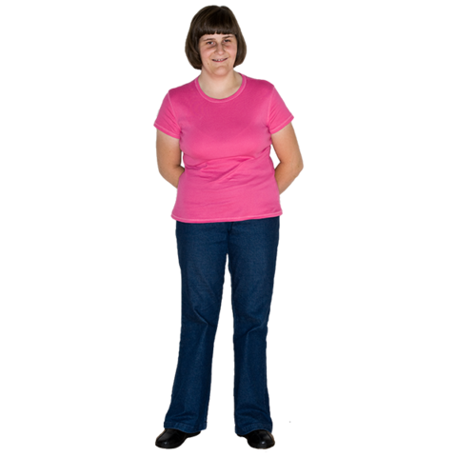

Divorced or separated
This means you were married but are not now. Or you are still married but are not together in the same way.

Widowed. If your partner died

I do not want to say.

9. What is your ethnic group?

This is about things like where you and your family are from and the language you speak.

White

Asian or Asian British

Black, African, Caribbean
or Black British

More than one ethnic group

Something else

I do not want to say

10. Which part of the UK do you live in?

North East

North West

Midlands

East of England

London

South East

South West

Wales

Scotland

Northern Ireland

I do not want to say

Living in the UK

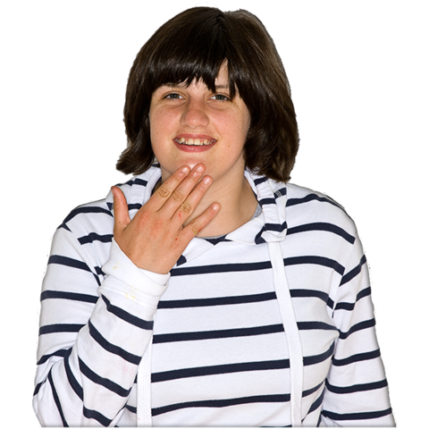
11. How do you feel about being an LGBT person in the UK?

I feel very happy about it

I feel happy about it

I feel OK about it (not happy or sad)
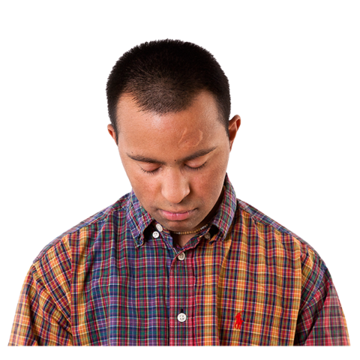

I feel sad about it

I feel very sad about it

I do not want to say

Your life and what has happened to you

Please do not use more than 250 words for each answer.

12. What was it like for you being an LGBT person at school, college or university?

13. What is it like being an LGBT person at work?

14. What is it like getting healthcare as an LGBT person?

This could be healthcare from a doctor, dentist, hospital or somewhere else.

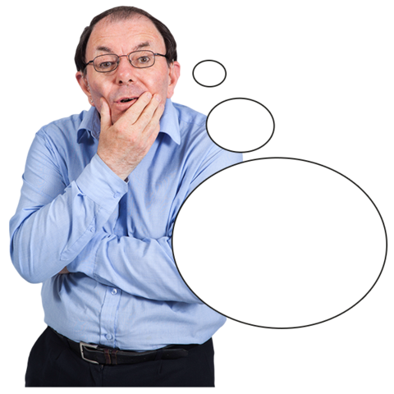
15. Is there anything else you want to tell us about being an LGBT person in the UK?

Please do not use more than 500 words.

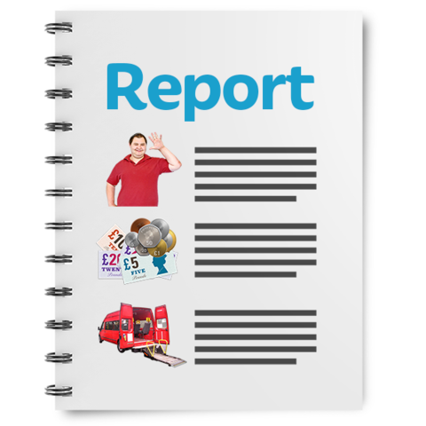
Can we use some of what you say in our reports or information?

Other people will not know who you are when we do this.

Yes No

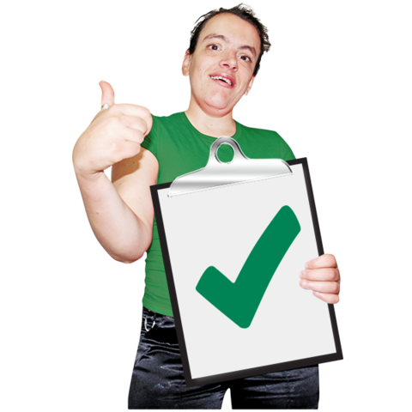

Thank you!

§

What do words in this survey mean?

Here are what some words in this survey mean.

LGBT people | In this survey we talk about LGBT people.  When we say this it can mean people who are:  - Lesbian  - Gay  - Bisexual  - Transgender  - And people who may feel something else about their gender or who they are attracted to.  There is more information about these things below.
Bisexual (or Bi) | This means people who are attracted to men and women.
Gay | This means men who are attracted to other men.  Or women who are attracted to other women. Some women may say they are gay, not lesbian.
Gender | When someone is born they are usually told they are a boy or a girl.  Your gender is about whether you feel you are a boy, a girl or something else.
Intersex | Intersex people have bodies that may be a bit different to what people think a boy or girl should be like.  For example, their private parts may look a bit different to what people think a boy or girl should look like.  People are usually told this by doctors when they are born or when they are young.
Lesbian | This means women who are attracted to other women.
Transgender  (or trans)  Trans woman or trans girl  Trans man or trans boy  Non-binary, Genderqueer,  Agender  Gender fluid | Transgender people feel they are a different gender to the one they were given when they were born.  For example, some people are told they are a boy. But they feel they are a girl.  Or the other way around.  This is someone who was told they were a boy when they were born. But they feel they are a girl or a woman.  This is someone who was told they were a girl when they were born. But they feel they are a boy or a man.  Some people feel they are not a man or a woman.  They may feel like they are both.  Or they may feel they are something different.  There are lots of words that people may use about themselves, like:  - Non-binary  - Genderqueer  - Agender  - Gender fluid
Sexual Orientation  Attracted to | Your sexual orientation is about who you may be attracted to or want a relationship with.  Attracted to means you may fancy or want a relationship with a person.

Pictures by Photosymbols

