Howsham Fish Pass Consultation: Decision Document

Final report 15 June 2017

We are the Environment Agency. We protect and improve the environment.
Acting to reduce the impacts of a changing climate on people and wildlife is at the heart of everything we do.
We reduce the risks to people, properties and businesses from flooding and coastal erosion.
We protect and improve the quality of water, making sure there is enough for people, businesses, agriculture and the environment. Our work helps to ensure people can enjoy the water environment through angling and navigation.
We look after land quality, promote sustainable land management and help protect and enhance wildlife habitats. And we work closely with businesses to help them comply with environmental regulations.
We can’t do this alone. We work with government, local councils, businesses, civil society groups and communities to make our environment a better place for people and wildlife.

Published by:
Environment Agency  Horizon House, Deanery Road,  Bristol BS1 5AH  Email: enquiries@environment-agency.gov.uk  www.gov.uk/environment-agency  © Environment Agency 2017  All rights reserved. This document may be reproduced with prior permission of the Environment Agency. | Further copies of this report are available  from our publications catalogue: www.gov.uk/government/publications  or our National Customer Contact Centre:  T: 03708 506506  Email: enquiries@environment-agency.gov.uk.
Foreword
Background
The River Derwent from Ryemouth to Barmby-on-the-Marsh, where it joins the River Ouse, is designated as nationally and internationally important, reflecting the special characteristics of this unique lowland river. However, its condition is classed as unfavourable due to diffuse pollution from agricultural run-off, siltation, historic flood defences and structures in the channel, such as weirs constructed for navigation and mills.
To improve the environmental quality of the river, we are working with Natural England to look at what changes are needed at our weirs and other structures on the river. As part of this project, we plan to install fish passage at Howsham Weir, which is one of five structures we own on the lower River Derwent.

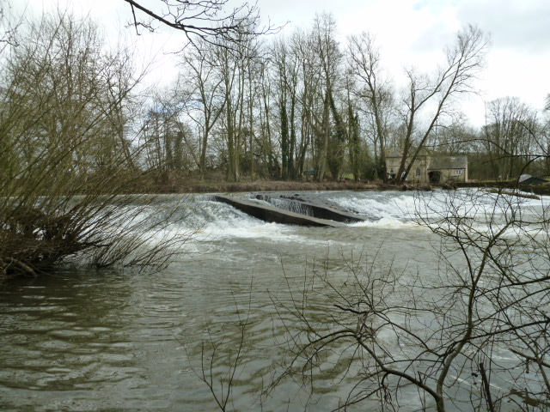
Figure 1: Howsham Weir

What is happening at Howsham?
Howsham Weir is an obstacle to migrating fish, eel and lamprey. We plan to put fish passage in place here to bring about a number of benefits including:
- improving fish populations, especially eel and lamprey, by helping them to move freely between the river and coastal waters to access breeding, nursery or feeding grounds;
- helping species naturally re-colonise the river upstream after floods, droughts or pollution;
- contributing to meeting legal fish passage obligations and environmental targets.

How will it affect you?
This stretch of river and the weir are popular with canoeists and anglers. Our proposal to install fish passage is likely to affect these activities. For canoeists, there will be changes to the chute at Howsham Weir. For anglers, fish movement will change, with a benefit to fish populations in the river as a whole.

Executive summary
This document explains how we have reached our decision on providing fish passage at Howsham Weir, following consultation and engagement in 2016.
The upstream reaches of the River Derwent and the Rye have extremely low numbers of lamprey, eels and salmon. Obstacles to migration are a significant problem for all these species. The Environment Agency has duties under national and international legislation to protect them, and it also has a duty to promote recreation in carrying out its activities. Howsham Weir is frequently used by canoeists.
We need to balance our duties, providing the best possible fish passage whilst considering recreation. Finding a solution that would be fully effective for migratory salmonids was likely to affect existing use of the canoe chute, so we carried out a public consultation. We looked at a number of options, including ideas put forward in the consultation.
Our decision is to construct one enhanced Larinier fish pass next to the existing hydropower turbines. To increase water flow for the fish pass we will reduce the flow through the canoe chute by about 10%. We will install eel and lamprey tiles at two locations on the weir.
We have consulted the canoeing representatives who joined our engagement panel on how best to alter the canoe chute to achieve the lower flow.
We expect to commence construction during the spring or summer of 2018, once the design is finalised and contractors are appointed.

We are grateful for the contribution from, and commitment of members of the engagement panel in helping us to consider options, and for working with us towards a solution which balances all interests.

Contents
Foreword 3
Executive summary 4
Introduction 6
Doing more for the Derwent 6
Howsham Weir fish pass project 6
Challenges at Howsham Weir 7
Canoeing at Howsham Weir 8
Consultation 8
Consultation process: 9
Results of consultation 9
Further work after the consultation 10
Decision making 11
What we considered 11
Decision 11
Plans for fish passage improvement 12
Lamprey and Eels 12
Migratory Salmonids 13
Next steps 14

Introduction
Doing more for the Derwent

Doing More for the Derwent is a joint programme between the Environment Agency and Natural England which aims to make changes to our weirs and other structures to improve the environmental quality of the river. We aim to:
- better connect habitat;
- improve fish populations;
- meet legal obligations for fish passage and environmental targets.

Howsham Weir fish pass project
Howsham Weir is one of five structures we own on the River Derwent where we are working with Natural England to address environmental quality problems as part of the Doing More for the Derwent programme.
The aim is to enable species to pass the weir on their journey between coastal waters and the upper catchment. This will also make it easier for them to naturally re-colonise the river upstream after floods, droughts or pollution.
.

Challenges at Howsham Weir
A number of aspects of Howsham Weir make it a particularly challenging site at which to install fish passage.
- The site is difficult to reach with heavy machinery, and there is little space around the weir.
- Howsham is an important site for canoeing and kayaking, and the canoe chute on the weir is a key part of this (see below - Canoeing at Howsham Weir).
- There are already hydropower turbines and a waterwheel operating at the weir, and there is limited water available to use for a fish pass.
- The weir is in poor condition.
These issues limit the kind of fish passage that can be put in place at Howsham.

Canoe chute

New turbine
Existing turbine
Figure 2 : Plan of Howsham Weir
Canoeing at Howsham Weir

Canoeing and kayaking takes place in the mill channel downstream of the waterwheel and in the main river up and downstream of the weir. The canoe chute enables the canoeists to pass along a slalom course across the weir. It is a principal feature of the site as its high water velocity, width and standing wave are used to practise particular canoe slalom and white water kayaking skills.
The chute is used weekly to train young people, and there is an annual national slalom event. It is the only facility of its kind in this area, where the rivers are generally slow flowing. A considerable number of canoeists who trained at Howsham have gone on to compete internationally.

Consultation
To provide fish passage for migratory salmonids at Howsham weir, the ideal solution would be a fish pass next to the hydropower turbines and fish pass baffles in the canoe chute near the north end. This would account for fish moving on the outside of the river bend, and flows from the turbines and canoe chute which attract fish to both ends of the weir.
The design project started with the aim of building two fish passes. However, it soon became apparent that this would have a considerable effect on the use of the canoe chute at Howsham for canoeing and kayaking.
We worked with fish and canoe experts to explore ideas. However, we could not find a solution that would be fully effective for passage of migratory salmonids without preventing the existing use of the chute. Therefore the project board, made up of the Environment Agency and Natural England, decided to carry out a public consultation to gather views, ideas and opinions from anyone who may be affected.
Consultation process
- We ran an on-line public consultation between July and September 2016. The consultation document available at https://www.gov.uk/government/consultations/howsham-weir-fish-passage-consultation set out the problems and options.
- As part of the consultation, a drop-in session was held near Howsham on 18 July 2016, with around 30 attendees representing various interests.
- At the drop-in session and through the consultation people were asked to put their names forward if they would be able to represent their area of interest on an engagement panel.

The engagement panel met twice in the autumn and winter of 2016 to discuss the options. The panel was run by an independent facilitator and included representatives of:
- Ryedale District Council
- Howsham Parish Council
- Natural England
- Howsham Mill
- fisheries expert
- angling clubs
- local and regional canoeing and kayaking
- British Canoeing
- local landowners and residents
- the Derwent Catchment Partnership.

Results of consultation
We received 23 responses to the consultation. Our response to these can be found online here: https://www.gov.uk/government/consultations/howsham-weir-fish-passage-consultation. Key points were:
- A majority of respondents stressed the importance of the site for the use of canoes, kayaks and Canadian canoes.
- There were questions about the need for two fish passes on the weir, especially because of the possible impact on canoeing.
- Most respondents were supportive of providing fish passage at the weir. Some stated that as much as possible should be done to improve fish populations.
- Most respondents put forward constructive suggestions of ways to combine fish and canoe passage. Splitting the canoe chute lengthways to accommodate recreation and fish passage was not possible. There were suggestions of putting a gate on the canoe chute to close it when not in use, for water to flow through a second fish pass.

Further work after the consultation
Following the consultation and engagement, the project team looked in more detail at the option of an automatically controlled gate to switch flows between fish passage and canoe slalom. We found that, because of its complexity, the gate solution would have significant risks in construction, maintenance and safety, and would be likely to lead to further delays because of the additional feasibility and design work needed. The project board concluded that this would not be affordable, because the cost could take up a large proportion of the funding for the Doing More for the Derwent Programme. If we are unable to improve our other structures on the lower Derwent then fish populations in the catchment as a whole would not improve.
The gate option and some other options involved placing a second fish pass next to the canoe chute. Problems in accessing this part of the weir would make construction and maintenance of a fish pass risky and costly. For such a fish pass to be effective, the flow through the canoe chute would need to be halved. A trial carried out with the co-operation of Howsham Mill and the canoeists who use Howsham weir showed that this caused canoes to be grounded.

Decision making

What we considered
Once the consultation and engagement was complete we reviewed the remaining options and consulted our fish pass experts. The following key points informed our conclusions:
- More than half of the respondents to the consultation were canoeists. They stressed the importance of the site for the use of canoes, kayaks and Canadian canoes. They also noted how frequently it is used, particularly for training young people who go on to compete nationally and internationally.
- There was no solution that worked ideally for fish and at the same time protected the current use of the canoe chute. Several members of the engagement panel said that a balance should be found between different needs.
- The likely difference in efficiency for fish passage between a single pass and two passes was explained in the engagement panel meetings. During the consultation and engagement no-one put forward the view that the option of installing a single fish pass should be discounted.
- Canoeing representatives at the engagement panel accepted that if there were a single pass at the south end of the weir it would need to be as large as practical, and that this would mean reducing flow through the canoe chute by around 10%.
- When our national panel of fish pass experts considered the site they recommended improvements to a single fish pass to provide the best possible attraction for migratory salmonids.
- A vertical slot pass was suggested for lamprey passage. While this can often be a very effective solution, it this is an extremely large structure and there would be difficulties with engineering and access. There is not enough space at Howsham to fit this pass.

Decision
This document has described the consultation process and facts we took into account in reaching a decision on how to improve fish passage at Howsham Weir.
The project board decided that, given the outcomes of the consultation and the unique nature of this site, it is not appropriate to construct two fish passes at present. We need to strike a balance between our duties towards fish passage and recreation.
We have decided that we will make a substantial improvement to fish migration by:
- installing a single, enhanced Larinier pass next to the hydropower turbines;
- partially reducing flow through the canoe chute;
- installing eel and lamprey tiles at two locations on the weir.

If in future our evidence of fish populations in the Derwent catchment shows that Howsham Weir is still a significant obstacle to fish passage, then we may decide to look at this again.
The following section describes the planned changes at Howsham Weir.

Plans for fish passage improvement
This section describes what we plan to put in place for the species which use the site.

Canoe chute

New turbine
Existing turbine
Eel and lamprey tiles
Larinier pass

Figure 3: Plan of proposed fish passage improvements
Lamprey and Eels

Standard eel and lamprey tiles will be attached to the weir next to the Larinier pass and in between the canoe chute and north bank. These will be specially engineered on advice from our fish pass experts to sit at an angle on the weir, to improve their performance for lamprey passage.

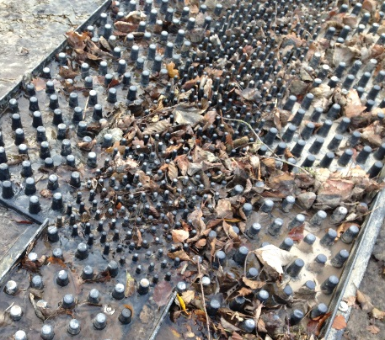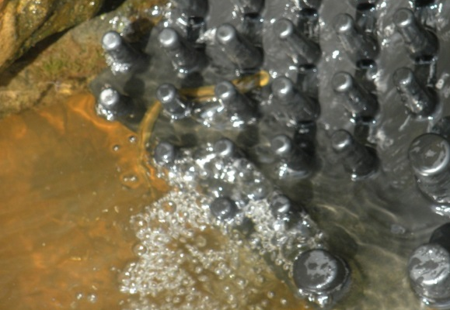
Figure 4: Left: eel tile example; Right lamprey tile example
Figure 5: Left: eel tile surface; Right lamprey tile surface

Figure 6 Above: eel and lamprey tiles alongside each other; Right: angled V shaped attachment of the eel and lamprey tile structure onto the weir.

Migratory Salmonids

We plan to construct one Larinier fish pass next to the hydropower turbines. This is a standard type of fish pass known to work well for migratory salmonids. To offset the lack of a second pass, this pass will be modified to improve its attractiveness to fish:
- There will be a narrow channel without baffles built into the pass. This will create a high velocity stream of water to attract more fish to the pass.
- Flow through the canoe chute will be reduced by around 10%. This water will flow through the fish pass instead, to make it more attractive to migratory salmonids.
The crest of the weir will be levelled to make sure the appropriate flows pass through the pass. We have discussed with the canoeing representatives who joined the engagement panel how best to reduce the flow through the canoe chute. As a result we plan to narrow the chute by about 10% to make sure that the correct amount of water flows through the fish pass and the canoe chute.

Figure 7: Larinier pass with built in channel (also showing eel and lamprey tiles along the left side)

This Larinier pass will also benefit coarse fish. The status of coarse fish in this part of the Derwent is currently good. Coarse fish will be able to use it during approximately one third of the range of flows when we would normally expect them to move. A pass long enough to allow coarse fish to move all of the time would need to be longer and would block water entering the hydropower turbines and waterwheel, or extend too far downstream to be attractive to fish. The Larinier planned for Howsham is an improvement that will allow greater mixing and movement of populations of coarse fish between the upstream and downstream reaches. It will make coarse fish here more resilient to pollution, floods or droughts.

Note: Experts have advised that the solutions described above are not likely to adversely affect spawning gravels, lamprey habitat and freshwater crowfoot which are located downstream of the weir.

Next steps
We are completing the design for the structures described above, and when complete we will appoint a contractor using appropriate procurement procedures. We intend to carry out the construction work in spring or summer 2018, river flows permitting.

