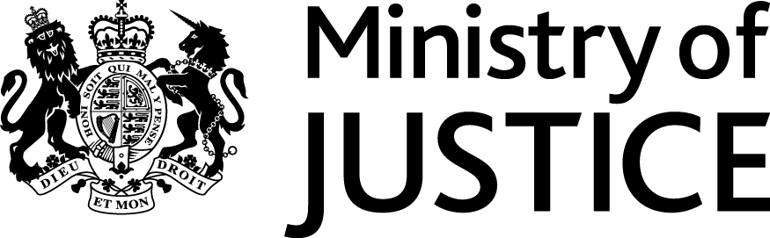 |  |  | June 2017
Freedom of Information Act (FOIA) Request – 112108

You asked for the following information from the Ministry of Justice:

To ask the Secretary of State for Justice, how many female offenders received an immediate sentence of (a) fewer than six months and (b) six months or more, by offence group, in each police force area in (i) Wales and (ii) England in 2011 to 2016.

and

I have been unable to locate. Can you assist please?

Probation Officer North Wales The Ministry of Justice has provided the following answer to your written parliamentary question (71001): Question: To ask the Secretary of State for Justice, how many female offenders received an immediate sentence of (a) fewer than six months and (b) six months or more, by offence group, in each police force area in (i) Wales and (ii) England in 2011 to 2016. (71001) Tabled on: 18 April 2017 Answer: Dr Phillip Lee: The number and length of custodial sentence for female offenders, in England and Wales, from 2011 to 2015 can be viewed in the table attached.

Further to section 12(4) of the FOIA, regulation 5 of the (Appropriate Limit and Fees) Regulations 2004, provides that multiple requests can be aggregated in circumstances where two or more requests relate to any extent, to the same or similar information, and have been received within 60 consecutive working days. I have therefore considered that as your emails are seeking information relating to sentencing, it is appropriate to aggregate these to a single request.

I can confirm that the department holds the information that you have asked for and this is provided to you in the attached document.

