# SIN China secured £13.2m in R&D funding, £17.4m in Foreign Direct Investment and £11.2m in Export Wins for the UK as a result of the Pujiang Innovation Forum in Shanghai

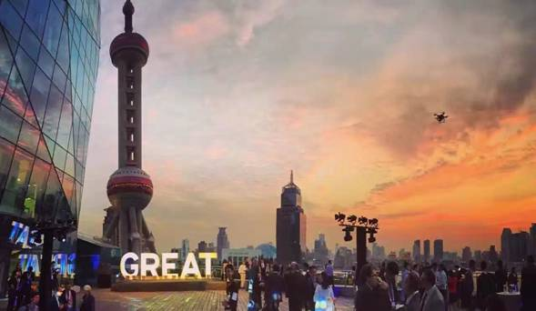

The SIN China team used the Pujiang Innovation Forum in Shanghai to tell a compelling story of UK-China collaboration and boost partnerships across a range of sectors, securing £13.2m in R&D funding, £17.4m in Foreign Direct Investment and £11.2m in Export Wins for the UK.

The Pujiang Innovation Forum is China’s leading annual innovation conference and SIN China secured Country of Honour status for the UK in 2016. Supported by GREAT funding, the team arranged a ‘UK-China Innovation is GREAT Showcase’ to demonstrate UK strengths and celebrate UK-China collaboration. SIN formed a multi-disciplinary delegation of 150 UK experts led by Jo Johnson and Sir Mark Walport and including 5 university Vice-Chancellors, 3 Research Council CEOs and graphene Nobel Prize winner Sir Kostya Novoselov. A keynote speech by China’s Science Minister, Wan Gang, gave the UK Showcase national attention including a large media circulation. Sub-forums explored collaboration in space, energy, innovation, graphene, education technology and the creative sector.

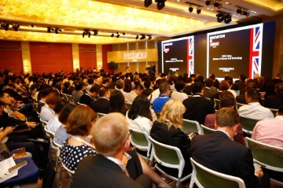

The event also promoted and facilitated outcomes that SIN China had been working towards including; the opening of a joint UK-China Centre of Excellence for Plant and Microbial Sciences, £13.2m in R&D funding committed for projects in the clean energy sector and 9 agreements signed on space technologies and satellites. A Pujiang warm-up event in London hosted an entrepreneurship competition by Cocoon Networks, completing a SIN project to support Cocoon in establishing a £17.4m business incubator in London. SIN worked with DIT to support this project and also supported DIT in leveraging Export Wins of £11.2m from Pujiang.

High-level government connections are key to doing business in China. Pujiang carried on the momentum from President Xi’s State Visit in positioning the UK as a preferred business partner. The UK’s success as Country of Honour also led to the offer of the same role at a prestigious trade event in 2017, the China International Industry Fair.

SIN China Contact: [Gareth.Taylor@fco.gov.uk](mailto:Gareth.Taylor@fco.gov.uk)