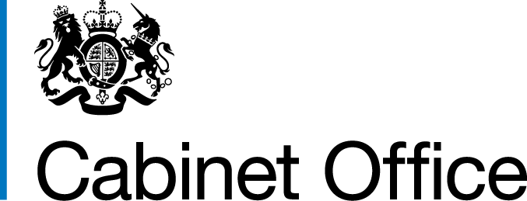

Gender Pay Gap Report
1 April 2016 – 31 March 2017
8 December 2017

This information is also available on the website: www.gender-pay-gap.service.gov.uk

Contents
Background 2
Profile of the Cabinet Office 3
Analysis 4
What Cabinet Office has been doing to tackle the Gender Pay Gap 7

Background
Earlier this year, the Government introduced world-leading legislation that made it statutory for all organisations with 250 or more employees to report annually on their gender pay gap. Government departments are covered by the Equality Act 2010 (Specific Duties and Public Authorities) Regulations 2017 that came into force on 31 March 2017. These regulations underpin the Public Sector Equality Duty and require the relevant organisations to publish their gender pay gap data by 30 March 2018 and then annually, including mean and median gender pay gaps; the mean and median gender bonus gaps; the proportion of men and women who received bonuses; and the proportions of male and female employees in each pay quartile.

The gender pay gap shows the difference in the average pay between all men and women in a workforce. If a workforce has a particularly high gender pay gap, this can indicate there may be a number of issues to deal with, and the individual calculations may help to identify what those issues are.

The gender pay gap is different to equal pay. Equal pay deals with the pay differences between men and women who carry out the same jobs, similar jobs or work of equal value. It is unlawful to pay people unequally because they are a man or a woman.

Government special advisers
To assist transparency, the Cabinet Office is also publishing figures for Government special advisers. In view of the small numbers involved, it would not be appropriate for individual departments to publish this information.

As of March 2017, across special advisers in all government departments, the mean gender pay differential was -2.8%, the median pay gender pay was -0.7%.

Due to the statistically small sample size, figures will fluctuate from year to year.

The Cabinet Office supports the fair treatment and reward of all staff irrespective of gender and is committed to creating a culture that is transparent, diverse, and inclusive. To support this we launched a refreshed Diversity and Inclusion Strategy in September 2017.

This is the Cabinet Office’s first report. It is based on a snapshot of all CO staff as at 31 March 2017.

Profile of the Cabinet Office
The Cabinet Office is the centre of government.

Its Purpose is:

- to maintain the integrity of the Union, coordinate the security of the realm and sustain a flourishing democracy;
- to support the design and implementation of HM Government’s policies and the Prime Minister’s priorities; and
- to ensure the delivery of the finest public services by attracting and developing the best public servants and improving the efficiency of government.

Cabinet Office Civil Service grades range from administrative to Senior Civil Servants. Grades vary according to the level of responsibility that staff have and each grade has a set pay range.

The gender pay gap figures also include Crown Commercial Services (CCS). There were 2,511 staff in Cabinet Office and 741 staff in CCS as at 31 March 2017 giving a combined total of 3,252 staff.

Analysis
As at 31 March 2017, there was an equal 50/50% split of male and female staff in Cabinet Office.

Base Pay

The mean gender pay gap (the difference between men’s and women’s average hourly pay) is 10% and the median gender pay gap is 12.3%.
These figures are slightly lower than the Civil Service average (mean pay gap 11%, median pay gap 12.7%) as per Office of National Statistics, March 2017, however this is not directly comparable in terms of methodology.
These figures do not take into account other factors, which can influence pay, such as grade, or seniority, location or length of service.
The median gender pay gap is larger than the mean gap because it reflects the make up of the workforce:
- Cabinet Office has a slightly higher proportion of females (51%) than males (49%) in our non-senior civil service roles.

- There are a higher number of males (59%) than females (41%) in senior civil service roles.

- There are a number of professions within Cabinet Office (digital, intelligence services) that have a higher proportion of men working at Grade 6/7 and Senior Civil Service levels.

Bonus Pay
Cabinet Office offers an in-year reward and recognition scheme, as well as end of year performance awards to staff marked exceeded in any annual pay award. Some Senior Civil Servants have personal bonus arrangements, which are also included in the bonus figures.
Median bonus pay gap - 0% | 30% of women received a bonus
Mean bonus pay gap – 19.1% | 32% of men received a bonus

Whilst more women received a bonus, the bonuses they received were, on average, smaller. This is due to there being fewer women in grades below the Senior Civil Service and awards vary in value by grade.

Hourly Pay Quartiles

The hourly pay quartiles show the proportion of men and women that are in each pay quartile, when we arrange staff in order of hourly pay rate. The lower and lower middle quartiles have higher proportions of female staff than male staff. This is primarily because there are more females in grades below the Senior Civil Service and there a number of professions that have a higher proportion of men working at Grade 6/7 and Senior Civil Service levels. Also, grading systems are not directly comparable across Cabinet Office and CCS.

This is shown in more detail in the following grade balance for Cabinet Office:

Grade (increasing seniority) | Number of men (% of men who work in this grade) | Number of women (% of women who work in this grade) | % Female
AA/AO | 65 (2%) | 92 (3%) | 41%
EO | 205 (6%) | 261 (8%) | 56%
HEO/SEO | 440 (14%) | 489 (15%) | 53%
Grade 6/7 | 652 (20%) | 573 (18%) | 47%
SCS (centrally managed only) | 146 (4%) | 103 (3%) | 41%
Other grades (professional/fast stream) | 120 (4%) | 106 (3%) | 47%
Total (excluding those with unknown grade) | 1628 | 1624 | 50%

In comparison, this table shows the proportion of men and women at each grade in the Civil Service* overall:

Grade (increasing seniority) | Number of men (% of men who work in this grade) | Number of women (% of women who work in this grade) | % Female
AA/AO | 62,688 (34%) | 86,861 (40%) | 58%
EO | 48,308 (26%) | 62,463 (29%) | 56%
HEO/SEO | 51,003 (27%) | 47,846 (22%) | 48%
Grade 6/7 | 22,566 (12%) | 18,801 (9%) | 45%
SCS (centrally managed only) | 2,466 (1%) | 1,771 (1%) | 42%
Total (including those with unknown grade) | 193,100 | 226,380 | 54%
*SCS data from Cabinet Office SCS database. Other data from ONS’s Civil Service Statistics 2017. Both as of 31/03/17

What Cabinet Office has been doing to tackle the Gender Pay Gap
We are committed to taking steps to reduce the Gender Pay Gap and achieve a broader gender balance across the grades. We have been working on this by:

- Improving the diversity of the Senior Civil Servants:
- Having diverse recruitment panels for all campaigns.
- Advertising all roles externally by default to attract the broadest pool of applicants.

- Attracting and retaining a diverse workforce through:
- Mandating gender-mixed panels for all levels of recruitment
- Developing an inclusive culture and workplace enabling all staff to reach their potential
- Promoting our flexible working offer
- Promoting shared parental leave
- Embedding and championing staff networks on Gender, Flexible Working and Carers to provide additional staff support
- Access to Civil Service Job Share Finder
- Mandating Recruitment & Selection Training for hiring managers, colleagues who sift and those who sit on interview panels in order to promote D&I and ensure unconscious bias training is undertaken.

- Introducing a new approach to pay for staff below the Senior Civil Service to enable them to progress off the pay range minimum.

- Improving the diversity of our talent pipeline by:
- Increasing the diversity of core talent programmes
- Promoting the Positive Action Pathway.

We have achieved change but these figures show more can be done and that is why we have identified the following actions that we believe will help us close the gap even more.

- Benchmarking salaries at SCS roles at Director and above and reviewing the pay structures for staff below the SCS as part of the wider pay and reward strategy work.

- Developing a 5 year pay and reward strategy.

- Extending our candidate reach by utilising social media, alternative recruitment/career platforms and networking events to attract a wider and more diverse range of candidates.

- Measuring the impact of the attraction and recruitment strategy.

- Increasing inclusivity through the Diversity and Inclusion Strategy by:
- Supporting all staff to develop their careers and reach their potential through promotion of learning and development opportunities, talent schemes, career conversations, coaching and mentoring, and job shadowing (the career offer).
- Nominating our talented female employees for leadership programmes developed specifically for women (e.g. Top Flight, Forward Institute)
- Participating in the cross-government ‘Positive Action Pathway’ programmes which provide development support specifically targeted at those with protected characteristics - including women.

- Measuring the impact of our Diversity and Inclusion Strategy.

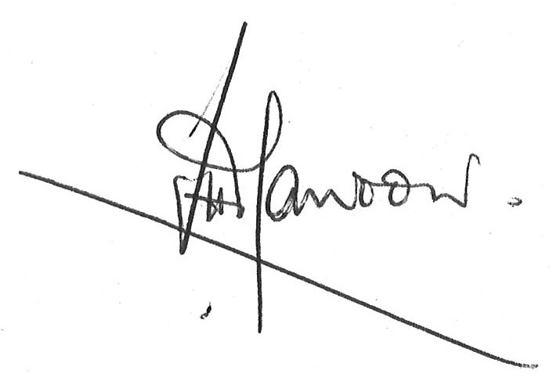

John Manzoni, Chief Executive of the Civil Service and Permanent Secretary (Cabinet Office)

8 December 2017

© Crown copyright 2017
Produced by Cabinet Office

You may re-use this information (excluding logos) free of charge in any format or medium, under the terms of the Open Government Licence. To view this licence, visit http://www.nationalarchives.gov.uk/doc/open-government-licence/ or email: psi@nationalarchives.gsi.gov.uk

Where we have identified any third party copyright material you will need to obtain permission from the copyright holders concerned.

Alternative format versions of this report are available on request from beverley.bird@cabinetoffice.gov.uk

