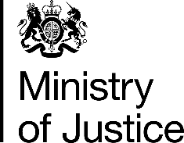 | June 2017

Freedom of Information Act (FOIA) Request – 112470

You asked for the following information from the Ministry of Justice (MoJ):

Thank you for your reply. Ideally we need to know the number of people with release addresses in Surrey, Hampshire and West Sussex - (and if possible number of people discharged homeless to these counties, with no home address). We only need to establish an idea of how many people return from prison to these areas - to see what demand there might be for mentoring and support services.

Your request is being handled under the FOIA. I can confirm that MoJ holds the information you have requested.

For the period 1st October to 31st December 2016, I can confirm that 604 offenders were released to addresses in Hampshire, Surrey and West Sussex.

Please note that this number excludes any release with no release address and any pre-CJA less than 12 month sentences (which does not have a probation release record). Do also note that this data is taken from an administrative database and as such subject to the limitations of reporting from such records.

