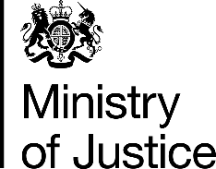 | July 2017

Freedom of Information Act (FOIA) Request – 112949

You asked for the following information from the Ministry of Justice (MoJ):

Thank you for your response. I appreciate that the information requested would exceed your limit of £600 however, I have amended the request, would it be possible for the information below to be provided. If this request also exceeds your limit of £600 please can you provide this information for 2016 only.

Infringement Convictions relating to the Copyright Designs and Patents Act 1988 | 2015  Calendar Year | 2016  Calendar Year
Total number of convictions of the above Act in each year
What was the maximum sentence and financial penalty in each year?

Your request has been handled under the FOIA.

I can confirm that the MoJ holds the information that you have requested and I have provided it in the attached annex.

Your request for the maximum sentence has been interpreted as being for the longest custodial sentence imposed.

