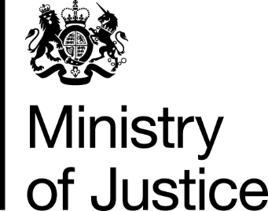
 | Our Reference: 628-16 FOI 108635 |  | January 2017

Freedom of Information Request

You asked for the following information from the Ministry of Justice (MoJ):

Could you please give me a court by court breakdown of the number of community sentences imposed on women in each of the past five years and include these as a percentage of the total sentences imposed on women

Your request has been handled under the Freedom of Information Act 2000 (FOIA), and we apologise for the delay in response, which was due to administrative errors.

I can confirm that the MoJ holds the information that you have asked for and it is provide to you in the attached table.

The number of adult female offenders sentenced at all courts, by reporting area, and with community sentence rate, in England and Wales, from 2011 to 2015 can be viewed in the table.

Please be aware that with regard to magistrates’ courts data we have presented local justice areas rather than individual courts as the codes within the MoJ Court Proceedings Database which identify these are unique identifiers for a court as part of the judicial structure. For example, data is provided for the LJA of Norfolk which includes data from the magistrates’ Courts of Norwich, Kings Lynn and Great Yarmouth. Local Justice Areas can change over time.

