This document was archived in February 2016 because it is no longer current.

Innovative curriculum design to raise attainment: Middlestone Moor Primary School

URN: 131886
Local authority: Durham
Date published: 11 December 2012
Reference: 120372
Brief description

This example shows how an innovative approach to curriculum design at Middlestone Moor School has transformed the provision in core and foundation subjects. Standards are above average and rising as a result of pupils’ excellent academic progress and very good personal development. Independent study skills, creative and formal writing skills, self-confidence and understanding of scientific enquiry are strong characteristics and begin from an early age. Social, moral, spiritual and cultural aspects are carefully integrated into every topic.
Overview – the school’s message

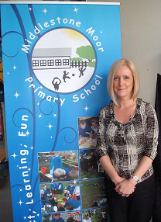
‘When I joined the school in 2005, pupils were underachieving. An unchanging curriculum seemed to suit teachers more than pupils, and many staff and children had low expectations. I set out to build a team spirit in the school, and to empower teachers by being aware of wider educational developments; knowing their own skills and how to develop them; and having pride in themselves and their jobs.
The curriculum has to inspire children to learn by encouraging an enquiry-based learning ethos. All pupils must come to believe that they can improve, irrespective of their ability. Staff were encouraged to look at good practice in other settings, and to research what they could from education providers, such as Newcastle University. Because teachers enjoy this approach, it has become self-renewing; we never teach the same topic twice, but are always inventing new ways to cover the curriculum. We now have a meaningful context for teaching literacy; children actually want to write!’
Helen Wilson, Headteacher
The good practice in detail

Background
The attainment of pupils on entry to the school is well below average. In 2008, Key Stage 1 attainment was significantly below average, but by 2011 had risen to average. Key Stage 2 attainment in 2008 was average; by 2011 it was significantly above average. Attendance in 2008 was below average; now it is above.

The process of change underpinning these improvements began with a clear leadership focus designed to build a team spirit in the school. Once the fundamental elements were established, the curriculum was scrutinised. This review resulted in an innovative, cross-curricular topic approach that has transformed pupils’ progress, and improved literacy, numeracy and attainment in all subjects to above average. Children now know how to take responsibility for their own learning.

Curriculum design features
The first requirement was that the full National Curriculum must be covered, thoroughly. Given that non-negotiable baseline, the proposed half-termly topics could be about anything, in any combination of subjects, but must be interesting, exciting, motivating and meaningful to pupils. Pupils were given a voice in this process so they had a sense of ownership. Topic content varies in response to monitoring and evaluation of pupils’ progress and this information is used to inform the next topic. The sequence operates as follows:

- dissect the National Curriculum programmes of study
It frees up time for us and children to learn what we are interested in.
- assign the parts to Year groups or key stages
- think of a topic title and overall idea, then choose parts of the programmes of study that may fit
- design the topic in detail, including the learning objectives by subject
- design the ‘sweep up’ topic for the summer term, to deal with left-over programmes of study, including things that were not covered as originally planned
- do it afresh next year, because the process of developing new topics is what motivates teachers; it is this self-renewing practice that is so important in raising standards.
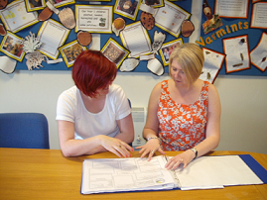
Every topic is rooted in the National Curriculum, and provides full coverage over time. Robust monitoring by subject coordinators ensures that the planned content is delivered. But the importance of letting pupils ‘see a piece of learning through to the end’ is more important in the short term than rushing to attempt comprehensive coverage. Detailed monitoring and evaluation after each topic identifies the omissions, and these are then threaded back into later topics. All staff contribute and this process is central to the success of this approach; so much so that topics later in the year are not planned in detail until earlier ones have been completed, because the content and focus are driven by the evaluation of earlier topics. Coordinators constantly update a coverage map for every subject, for each year group, so that they know what still needs to be covered. They also assess pupils’ understanding of the content, to ensure that effective learning has occurred: if not, elements are revisited in the catch-up topics later in the year.
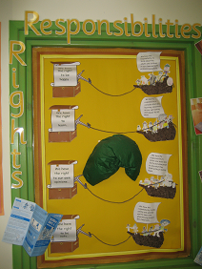
All staff, including teaching assistants, contribute to each topic, irrespective of the year group, so the full imaginative and innovative intellect of the school professionals is applied to the design; this ensures high quality materials and creative approaches to learning. As a result, teachers are well motivated.
One key consequence of teachers regularly thinking imaginatively has been the richness of writing ideas they suggest to pupils. It was imaginative writing that inspectors first noticed displayed on the Year 2 wall that triggered further investigation to find out how such young children were writing so well, and so much. They were doing work on ‘Witches’, and had been asked to write down, in long sentences, ‘Ten things you might find in a Witch’s pocket’. One answer really captured the extent of their imagination; ‘Doors to other worlds!’ The whole school contributed to the ‘Middlestone Moor Book of Spells’.
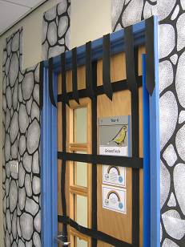
The quality of the learning environment is excellent and demonstrates the value that teachers place on pupils’ work. This seemingly peripheral principle has become critical to the achievement of pupils, because they are putting their best efforts into working to high standards to get their work on show. It is the most tangible feature of the school that strikes visitors immediately; pupils’ high-quality work is on display on every available square inch of wall, and sometimes ceiling and floor space!

The quality of the learning environment is also important for teachers; quotes from the world’s best educational experts can be found in staff rooms, so that everyone is always having to think and respond to ideas; for example: ‘Teaching like we’ve always done will deliver progress like it always was’. New topics are important events, and kept secret by the staff until the day arrives; teachers decorate their classroom doors over the weekend, so pupils get their first clue about them when they arrive in school on Monday.
A moral purpose
Every topic covers many curriculum subjects, but all include substantial literacy and numeracy elements that give pupils meaningful contexts in which to apply and develop these basic skills. For example, Year 2 science featured ‘Pepperoni’, one of two school guinea pigs, and pupils were learning how to hold him carefully.
Even rocks and soils can be interesting if you’ve designed the topic yourself!

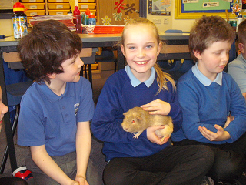
Each topic also includes deliberate social, moral, cultural and spiritual features that tackle pupils’ personal development systematically and in context as part of subject-based learning. Teachers build in open-ended questions, using the examples suggested by the Self-Organised Learning Environment (SOLE) approach (pioneered by Professor Sugata Mitra from Newcastle University). For example, questions include: ‘What is the most amazing thing about the human body?’; ‘What kind of animals are endangered and why?;, ‘If the world is so beautiful, why are people worried about it?’; ‘Was the Raj good or bad?’ Pupils are guided to answer for themselves, and learn how to organise research-based tasks. The questions are deliberately planned to be beyond pupils’ current knowledge and understanding.
The school is a partner in the United Nations UNICEF Rights of a Child Charter; and topics usually address one or more of the rights systematically. The rewards and behaviour policy is linked to this charter, so when children demonstrate an action supported in the ‘rights’ they are rewarded; which builds children’s self-control and sense of social responsibility.
The school’s background

Middlestone Moor Primary School occupies a new building in the heart of Spennymoor, a former mining community. It is of average size, with almost all pupils from a White British heritage. The school was part of the national pilot scheme which enables all pupils to access free school meals. A higher than average number of pupils have special educational needs and/or disabilities There is a Nursery with 26 places and a Reception class.
Are you thinking of putting these ideas into practice; or already doing something similar that could help other providers; or just interested? We'd welcome your views and ideas. Get in touch here.
To view other good practice examples, go to: www.ofsted.gov.uk/resources/goodpractice

