Category 2 Variation (Short)

& Deposit Consent

Application

Name of Project incl Field: XXXX

PWA: XX/W/XX

PA ref: to be supplied by OGA

Operator Document No: XXXX – to be supplied by Operator

Contact: Name (Holder)

Role: Job Title

Email: work email address

Tel: work telephone number

Address: Legal Consent issued via email, if you require a hard copy of the consent in the post please provide full UK postal address

Earliest proposed start of work: DD MMM YY (Any works associated with the application to include deposits)

Completion Instructions:
1. All questions must be answered in the order they are presented.
2. The numbering of the questions is not to be altered.
3. All Company Names are to be shown as per Companies House.
4. Additional information is to be provided in the relevant section following from the main paragraph.
5. All coordinates must be provided in WGS84 format (XX^{O} XX’ XX.XX”N XX^{O} XX’ XX.XX”E).
6. All coordinates must be provided in WGS84 format (XX^{O} XX’ XX.XX”N XX^{O} XX’ XX.XX”W).
7. All Table As and DepCon Forms are to be provided in landscape.
8. All attached drawings or schematics must be a high resolution with routes and co-ordinates shown in bold.
9. Please send As-Built Drawings to OGA Case Officer on completion of works.
10. If Branding must be used it should be restricted to the front page only.
11. Please ensure the application is thoroughly checked before submitting to OGA.
12. Remove OGA advice in red including completion instructions and change blue text to black.
13. Submit this application as 1 pdf initially to claire.grant@oga.gsi.gov.uk and thereafter to the case officer.
Document Control - Optional - to be completed by the Operator

Insert completed Tables of Document revisions as per example below

Approvals- Optional - to be completed by the Operator

 | Name | Signature | Date
Prepared by |  |  | DD MMM YY
Reviewed by
Approved by

Revision Control – to be completed by the Operator

Revision No | Reference | Changes/Comments | Issue Date
0 | Issued for comments to OGA |  | DD MMM YY
1 | Application revised following feedback provided on review on DD MMM YY.
 | …
5 | Final Issued Version

Distribution List – Optional - to be completed by the Operator

Name | Company | No of Copies
…………

Contents
1 Introduction 4
2 Administrative Details 4
2.1 Overview - Description and diagram of project 4
2.2 HSE 500m Safety Zone 5
2.3 PWA 5
2.4 Project location from shore 5
2.5 Method of pipeline installation 5
2.6 Block Crossing Agreements 5
2.7 Telecom cable crossings 6
2.8 Pipeline Crossing Agreements 6
2.9 Median Line Agreement 6
2.10 Applicant 7
2.11 Holder, User, Operator and Owner 8
2.12 Environmental permits 9
3 Variation Details 9
3.1 Trenching 9
3.2 Table A(s) and Drawings(s) 9
3.3 Permanent Deposits 14
3.4 Temporary Deposits 14

Annex X – DepCon Table(s) and Drawing(s) 15
Annex X – Block Crossing Agreements (to be provided for all Blocks being crossed) 17
Annex X – Cable Crossing Agreements (to be provided for all cables being crossed) 18
Annex X – Pipeline Crossing Agreements (to be provided for all Pipelines being crossed) 19

Note: - Once all sections within the application have been completed: Please right click on the contents page above and select “Update Field” then “Update Page Numbers Only”. This will ensure the location of text in the application matches the contents page exactly.

Introduction
Insert introductory paragraph outlining a brief description of the work, referencing the field, a brief overview of required deposits as per example in blue.

In accordance with the Petroleum Act 1998 and under the Guidance of the Oil and Gas Authority guidance notes (Company Name of PWA Holder) apply for authorisation to replace a 4” hydraulic jumper and deposit materials on the seabed in association with (Field Name).

Administrative Details

2.1 Overview - Description and diagram of project
Insert a brief description of the work, why it is needed (see example in blue). Where one has been prepared, it is useful to have a 3D project layout diagram (not necessarily to scale) showing pipeline(s) to be covered in the project (see below drawing).

This variation of the PWA covers the installation of a hydraulic jumper between (Structure Name) and (Structure Name). This jumper replaces the functionality of the existing umbilical jumper’s hydraulic hose which is thought to have failed based on diagnostic tests performed from the FPSO. The failed hydraulic hose will be disconnected and left in situ attached to the electrical and scale inhibitor cores which will remain in service. The existing umbilical jumper is not currently numbered on the existing PWA and is to be numbered for the first time in this variation application.

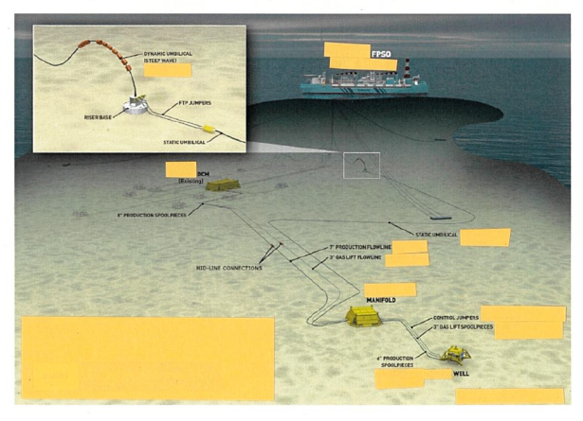

2.2 HSE 500m Safety Zone
Select whether or not work will be carried out within a HSE recognised safety zone.

Works will be carried out totally within a HSE recognised 500m safety zone (name of structure).

or

Works will be carried out totally outside a HSE recognised 500m safety zone.

or

Works will be carried out partially within a HSE recognised 500m safety zone (name of structure).

2.3 PWA

Provide reference as to which PWA the Variation application is associated as per example in blue.

PWA: XX/W/XX

2.4 Approximate Project location from shore
Provide the approximate location details as per example in blue.

The project location is approximately XXXkm due east of Aberdeen.

2.5 Method of pipeline installation
Insert the details of the method of pipeline installation, see example in blue.

Installation is scheduled to begin in (state date MMM YY) using a dynamically positioned pipe lay vessel. The pipeline will be installed using the S-lay method.

2.6 Block Crossing Agreements
Complete table to show details of all blocks crossed and reference the Block Crossing Agreements letters which should be provided in an Annex, see example in blue.

No Blocks are to be crossed therefore no block crossings are required.

or

All blocks to be crossed are 100% owned by (Company Name - applying for authorisation) therefore no block crossings are required.

or

The pipeline traverses blocks 2/1a, 2/1b & 3. Block crossing agreements have been confirmed as shown below. Agreement letters are contained in Annex X.

Block Crossing Agreements

UK Block Number | Licence Number | Agreement Confirmation from
2/1a | 4 | (Company Name A)
2/1b | 5 | (Company Name B)
3 | 6 | (Company Name C)

2.7 Telecom cable crossings
Details to be provided that the proposed route(s) have been checked for the presence of telecom cables against the KIS-ORCA, and details of findings, see example in blue.

(Company Name) has checked for the presence of telecom & offshore renewable cables against Kingfisher Information Service Offshore Renewable Cable Awareness (KIS-ORCA) and has found no evidence of any existing lines in the vicinity of the planned route for the new cable.

or

Cable crossing agreements are provided at Annex X.

Telecom Cable Crossing Agreements

Cable Name/Location | Owner of Cable
XXXX to XXXX Submarine Communications Cable | (Company Name P)
YYYY to YYYY Submarine Communications Cable | (Company Name Q)

2.8 Pipeline Crossing Agreements
Insert details of any pipeline crossing (see example in blue). Written confirmation from the owner of any pipeline whose pipe is being crossed that there are no objections is required, in an Annex and referenced as such.

No pipelines are crossed and therefore no pipeline crossing agreements are required.

or

The pipeline(s) crosses PL1, PLU2 and PL3 which are all owned by operator name (company applying for application, name to be exactly as per the licence) therefore no pipeline crossing agreement letter(s) are required.

or

The pipelines crosses pipeline PL10, PL11 & PL12. Pipeline crossing agreements have been confirmed as shown below. Agreement letters are contained in Annex X.

Pipeline Crossing Agreements

Pipeline Number | Owner of Pipeline
PL10 | (Company Name P)
PL11 | (Company Name Q)
PL12 | (Company Name R)

2.9 Median Line Agreement
Median line is not crossed and no Median Line agreement is required.

We (Company Name of Holder) confirm that we are in discussions with the Norwegian Ministry regarding this project to ensure all regulatory requirements will be met. (Contact email address and name……… Norwegian Ministry)

or

We (Company Name of the Holder) confirm that we have held (are in) discussions with the Norwegian Ministry regarding this project and they are content all regulatory requirements have been met (letter of agreement in Annex X). (Contact email address and name……… Norwegian Ministry)

2.10 Applicant
Provide the following statement as appropriate referencing the company name exactly as presented on Companies House/Licence.

The PWA is solely being applied for by (Company name) and no partners are involved.

or

(Company Name) on behalf of itself and its partners as specified in 2.11 makes this Pipeline Works Authorisation variation application.

2.11 Holder, User, Operator and Owner information

Submitted by: [Company Name] (Holder of PWA)
on behalf of: [Partners Company Name]
Field Name: XXXX Field
PWA ref & date of issue: [XX/W/XX, dd/mmm/yy] (or date PWA authorised if pre-PWA numbering)
List Pipelines within PWA & Associated Variations: [PLXXXX – PLXXXX, PLXXXX] (Only pipeline numbers are required)
PA Ref: [PA/XXXX]
1. Date of licence transfer: [dd/mmm/yy]
2. Commercial agreement: [dd/mmm/yy]

All details to be stated exactly as per Companies House (i.e. no abbreviations unless listed in Companies House).

Names, registered addresses and registered company numbers of Holder; Users; Operator and Owners

Complete company details & annotate () whether Holder, User, Operator or Owner | Holder | User(s) | Operator | Owner(s)
Company Name  UK registered Company address  Registered Company Number |  |  |  | 
Company Name W  UK registered Company address  Registered Company Number |  |  |  | 
Company Name X  UK registered Company address  Registered Company Number |  |  |  | 
Company Name Y  UK registered Company address  Registered Company Number |  |  |  | 
Company Name Z  UK registered Company address  Registered Company Number |  |  |  | 

2.12 Relevant environmental permits
A statement should be provided stating the action taken to satisfy any relevant environmental regulations (i.e. Environmental Statement (ES), Direction and Exemption) including date (month and year) they were/will be submitted. Please liaise with DECC EMT emt@decc.gsi.gov.uk. Timely submission is advised to avoid potential delays.

3 Variation Details

3.1 Trenching

State whether pipeline(s) is to be trenched and/or buried and/or backfilled and target depth of trench see examples below in blue.

The pipeline will not be trenched.

or

The pipeline will be trenched by jetting and cutting seabed condition dependant and simultaneously buried such that the top of the pipeline is a minimum of X.Xm below the natural seabed and target trench depth of X.Xm. The trench shall maintain a distance of XXm from any existing pipelines.

3.2 Table A(s)

A completed Table A must be provided for each new pipeline/umbilical and a Table A to show variation to existing line (as left on the seabed), showing only main component parts and providing coordinates (WGS84) for the ‘From’ and ‘To’ points of pipeline.
New main component parts such as ESDV, Manifolds, SSIV, Termination Units or component(s) that effect flow should have their own ident number and the same component description should feature in columns 3 to 5 (This only applies to the main production or umbilical pipeline).
If the pipeline dimensions/specifications are the same then they can be combined into one ident number rather than several separate idents (this includes spools).
All idents are to follow the direction of flow.
Column 6 should be completed to show total overall length of pipeline (total of all idented lengths).

The following pages contain Table As for PLUXXXX and PLYYYY.

Table A Contents
Services Umbilical Jumper PLUXXXX
Hydraulic Jumper PLYYYY
Hydraulic Jumper Replacement Schematic (Example Drawing Template 1)

When completing the table A please check every page has all the approved headers as seen in the example tables.
If a pipeline has a number of idents and covers several pages, please ensure column 1 on each page has the pipeline number shown (e.g. PLXXXX cont.).

TABLE A
PIPELINE NAME (Field Name) Services Umbilical Jumper PLUXXXX
APPLICANT (Company Name)
PROJECT NAME (Field Name) Development

PWA (PWA Number in format XX/W/XX)
REFERENCE DRAWING XXXXX

Col 1 | Col 2 | Col 3 | Col 4 | Col 5 | Col 6 | Col 7 | Col 8 | Col 9 | Col 10 | Col 11 | Col 12
Pipeline No. | Ident No. | From | To | Description of Component Parts of the Pipeline | Length (m) | External Diameter (mm) | Internal Diameter (mm) | Wall Thickness (mm) | Type  of Insulation/Coating | MAOP (Barg) | Products to be conveyed
PLUXXXX |  | YYY Manifold  XXº XX’ XX.XX” N  XXº XX’ XX.XX” E | XXX Well  XXº XX’ XX.XX” N  XXº XX’ XX.XX” E | Services Umbilical Jumper | XX |  |  |  |  |  | Hydraulic, Electrical,  Scale Inhibitor
PLUXXXX | 1 | YYY Manifold | XXX Well | Services Umbilical Jumper | XX | XX | XX  XX  XX | XX  XX  XX | - | XX  XX  XX | 1 x Hydraulic (disconnected)  1 x Electrical,  1 x Scale Inhibitor

The above Services Umbilical Jumper PLUXXXX was not covered in the original PWA XX/W/XX when it was laid in XXXX, but has been allocated pipeline number PLUXXXX to bring in under the current PWA regime. The Hydraulic core is to be disconnected and left in situ, remaining attached to the electrical and scale inhibitor cores which will remain in service. (Note for example only)

If it is a Services Umbilical it should start at the FPSO/Platform or Manifold and go to the Well as the service will be coming from the FPSO/Platform to the reservoir.

Idents should be shown as 1, 2, 3 etc.

TABLE A
PIPELINE NAME (Field Name) Hydraulic Jumper PLYYYY
APPLICANT (Company Name)
PROJECT NAME (Field Name) Development

PWA (PWA Number in format XX/W/XX)
REFERENCE DRAWING XXXXX

Col 1 | Col 2 | Col 3 | Col 4 | Col 5 | Col 6 | Col 7 | Col 8 | Col 9 | Col 10 | Col 11 | Col 12
Pipeline No. | Ident No. | From | To | Description of Component Parts of the Pipeline | Length (m) | External Diameter (mm) | Internal Diameter (mm) | Wall Thickness (mm) | Type  of Insulation/Coating | MAOP (Barg) | Products to be conveyed
PLYYYY |  | YYY Manifold  XXº XX’ XX.XX” N  XXº XX’ XX.XX” E | XXX Well  XXº XX’ XX.XX” N  XXº XX’ XX.XX” E | Hydraulic Jumper | XX |  |  |  |  |  | Hydraulic
PLYYYY | 1 | YYY Manifold | XXX Well | Hydraulic Jumper | XX | XX | XX | XX | - | XX | 1 x Hydraulic

This Hydraulic Jumper replaces the functionality of failed Hydraulic core in PLUXXXX. (Note for example only)

If it is a Services Umbilical it should start at the FPSO/Platform or Manifold and go to the Well as the service will be coming from the FPSO/Platform to the reservoir.

Idents should be shown as 1, 2, 3 etc.

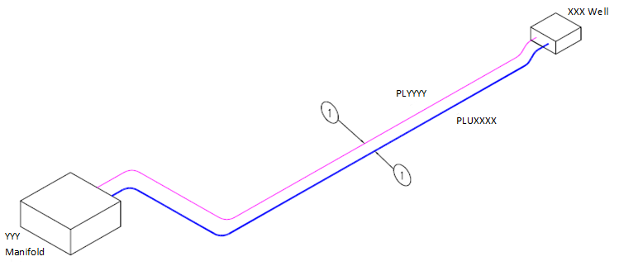

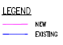

Title
Example Drawing Template 1
Drawing Number  XXXXX | Sheet  1 of 1 | Rev | Rev | Revision | Date | App.

3.3 Permanent Deposits
OGA advice – Please read before completing
A PWA must be in place before deposit consents can be authorised. A Deposit Consent is for the support and protection of a pipeline, if the deposit is not for this; contact DECC EMT to apply for a Marine Coastal Access Act (MCAA) licence. Materials which are to be laid prior to this date should also be applied for through a MCAA licence.
Column 2 should specify a period to allow for works to be completed, with a contingency to allow for any potential delays (Max. 6 months); longer periods must be discussed with the Manager of Consents and Authorisations.
Column 4 the operator should consider whether exact amounts are known or whether a reasonable contingency is required. If the latter then this should be built into the number requested in column 4 and the table footnoted to say………”Includes contingency of X mattresses” or “include X% as a contingency”.
A rock berm profile should be included within the application to support any requests to deposit rock. The rock berm profile must include height and width dimensions and may be shown in the text or as part of the Deposit Consent drawing(s).

Select either

The Deposit Consent application can be found in Annex X and are requested for the support and protection of a pipeline/umbilical.

or

Deposits are not required for this scope of work.

Typical Rock Berm Profile (example only)

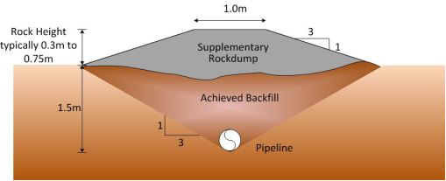

3.4 Temporary Deposits
Temporary deposits to be included but are for information only. Please apply to DECC Environmental Management Team for a permit emt@decc.gsi.gov.uk .

ANNEX X

DEPCON TABLE

APPLICANT [Holder of the PWA]

PROJECT NAME [Field Name] Development Project

PWA [PWA Number in format XX/W/XX]

Col 1 | Col 2 | Col 3 | Col 4 | Col 5 | Col 6 | Col 7
Pipeline Number | Proposed date  (Mar 15 – May 15) | Type & size of materials  (Display only the required criteria below) | Quantity (Number) | Location of deposit (including co-ordinates in WGS84 format) |  | Drawing number
 |  |  |  | From: | To: | Drawing number
PL1 | Mar 15– Aug 15 | XXm x XXm x XXm concrete mattresses | 13 | ZZZ Manifold  XX^{O} XX’ XX.XX”N XX^{O} XX’ XX.XX”E | XXX Well  XX^{O} XX’ XX.XX”N  XX^{O} XX’ XX.XX”E | Field-DepCon-Date-1
PL1 | Apr 15 – Sep 15 | Rock  1-5” Grade | 2.8 te | ZZZ Manifold  XX^{O} XX’ XX.XX”N XX^{O} XX’ XX.XX”E | XXX Well  XX^{O} XX’ XX.XX”N  XX^{O} XX’ XX.XX”E | Field-DepCon-Date-1
PL2 | Mar 15 – Aug 15 | XXm x XXm x XXm concrete mattresses | 7 | ZZZ Manifold  XX^{O} XX’ XX.XX”N XX^{O} XX’ XX.XX”E | YYY Well  XX^{O} XX’ XX.XX”N  XX^{O} XX’ XX.XX”E | Field-DepCon-Date-1
PL2 | Apr 15 – Sep 15 | Grout Bags  XXKg | 100 | ZZZ Manifold  XX^{O} XX’ XX.XX”N XX^{O} XX’ XX.XX”E | YYY Well  XX^{O} XX’ XX.XX”N  XX^{O} XX’ XX.XX”E | Field-DepCon-Date-1

When completing the DepCon table please ensure every page has all the approved headers shown above.
The Quantity (number) in Column 4 should be the number of deposits as described in Column 3 of the table. The quantity shown above is for illustrative purposes only.

This Consent authorises only Deposits exactly as described, up to the maximum quantities specified in column 4 to be laid, in the positions listed and within the period stated within the Table - nothing else can be laid. If anything different to what has been authorised within this Consent is required you must have prior consent from OGA before it can be laid.

A maximum of a 6 month period may be requested in Column 2 (except where the quantities of deposits are small and a maximum of a 3 month period will be consented).
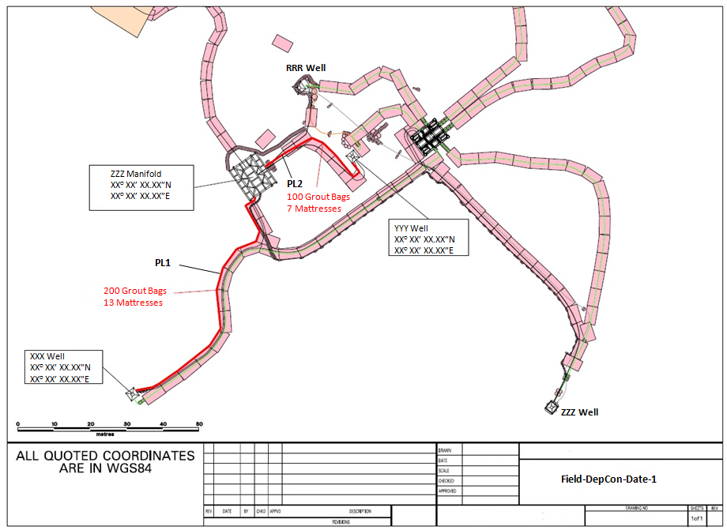
2.8 te Rock
13 Mattresses

Annex X – Block Crossing Agreements (to be provided for all Blocks being crossed)

Licensee – Company Name A letterhead

Company Name
Registered Address

Date
Dear XXXX,

We, (Company Name A) Limited (“Licensee”), confirm that we (in our capacity as the Operator of Block (2/1a) have no objection in principle to the crossing of Block (2/1a) by the (Field Name) pipelines and/or cable to be installed by (Company Name – Holder of PWA) as part of the (Field Name) development located in Block (1) in the (Northern North) Sea.

Yours faithfully,

Director/secretary of Licensee
(Someone with appropriate authority to approve block crossing agreement)

Annex X – Cable Crossing Agreements (to be provided for all cables being crossed)

Cable Company Name letterhead

Company Name
Registered Address

Date
Dear XXXX,

We, (Cable Company Name A), confirm that we (in our capacity as the owner of cable (XXXX) have no objection in principle to the crossing of cable (XXXX) by the (Field Name) pipelines and/or cable to be installed by (Company Name – Holder of PWA) as part of the (Field Name) development located in Block (1) in the (Northern North) Sea.

Yours faithfully,

Director/secretary of Licensee
(Someone with appropriate authority to approve cable crossing agreement)

Annex X – Pipeline Crossing Agreements (to be provided for all Pipelines being crossed)

Pipeline Owners – Company Name F letterhead

Company Name

Registered Address

Date

Dear XXXX,

We refer to the Pipeline Crossing Agreement between (Company Name F) and (Company Name – Holder of PWA) in respect to the crossing of (PL10) by the (Field Name) Gas Export Pipeline.

The Agreement was entered into by (Company Name F) as (PL10) Operator on behalf of (PL10) Owners and (Company Name – Holder of PWA) as the (Field Name) Gas Export Pipeline Operator on behalf of the (Field Name) Gas Export Pipeline Owners on DD MMM YY.

As such the (PL10) Owners have approved the crossing of (PL10) by the (Field Name) Gas Export Pipeline.

Yours faithfully,

Managing Director/Business Manager
(Someone with appropriate authority to approve pipeline crossing agreement)

PWA VARIATION CATEGORY 2 APPLICATION CHECKLIST

Variations are issued when companies change either the technical specification for works less than 500 meters or totally within a HSE recognised safety zone, and when there is a change to Holder, User, Operator, Owner or a Term in the original PWA.
Reminder: Where there are no objections, it takes approximately 6 - 8 weeks from receipt of a satisfactory application to issuing the authorisation.
This is not an application form - it is a guide as to what is to be provided on a single application in PDF format; key items that must be included in applications are listed below:
COVER
Name of Project
Company Contact with telephone number and email address
If a 3rd party are submitting the application their contact details must be provided in addition to contact details for the Company who will be the Holder of the PWA/who holds the PWA
Dates when offshore construction/installation is to start and when pipeline is planned to be brought into use (This should be followed up with a letter confirming when the pipeline(s) has been brought into use)

ADMINISTRATIVE DETAIL
TO INCLUDE FOLLOWING DETAILS:
Overview – a brief description of work is to be provided and why it is needed
HSE 500m safety zone - Statement to be provided indicating whether or not work will be carried out within a HSE recognised 500m safety zone (structure to be named)
PWA – reference is to be provided as to which PWA is being varied
Project location from shore - approximate details to be provided
Pipeline installation – details of method
Block Crossing Agreements - Written agreement to be provided
Telecom cables – details to be provided that the proposed route for the has been checked for the presence of telecom cables against the Kingfisher Information Service - Offshore Renewable and Cable Awareness (KIS-ORCA)
Pipeline Crossing Agreements - Written confirmation from the owner of any pipeline whose pipe is being crossed that there are no objections
Applicant – details of who is making the application (Holder) and on whose behalf the application is being made
Holder, User(s), Operator and Owner(s) - names, registered UK addresses and registered company numbers to be provided exactly as per Companies House for the Holder, User(s), Operator and Owner(s)
Environmental Regulations - Paragraph stating action taken to satisfy any relevant environmental regulations (i.e. Environmental Permits submitted or details of other ES which covers application)
Please submit your Environmental Permits as early as possibly to DECC EMT to prevent any delays to the approval of the application

VARIATION DETAILS
Trenching - Whether pipeline(s) is to be trenched (+method) and/or buried and/or backfilled and target depth of trench
Table A - completed for each new or amended pipeline/umbilical, showing only main component parts (geographical co-ordinates in degrees, minutes and seconds in WGS 84 format, i.e. 00° 00’ 00.00” N, 00° 00’ 00.00” E) for start and end points of pipeline
Simple schematic/isometric – illustrating information on the Table A (One schematic/isometric may show information for several pipelines, providing pipelines are clearly identified. Details of pipes inside manifolds not required)
Deposit Consent - where applicable, application on appropriate form, for a DepCon (See DepCon Template)

Please submit application and direct all queries to Consents and Authorisations Manager claire.grant@oga.gsi.gov.uk on 03000201014.

