Consultation on Regulation (EC) No 1371/2007
  - Summary of responses
Moving Britain Ahead

The Department for Transport has actively considered the needs of blind and partially sighted people in accessing this document. The text will be made available in full on the Department’s website. The text may be freely downloaded and translated by individuals or organisations for conversion into other accessible formats. If you have other needs in this regard please contact the Department.

Department for Transport
Great Minster House
33 Horseferry Road
London SW1P 4DR
Telephone 0300 330 3000
General enquiries https://forms.dft.gov.uk
Website www.gov.uk/dft

© Crown copyright 2015

Copyright in the typographical arrangement rests with the Crown.

You may re-use this information (not including logos or third-party material) free of charge in any format or medium, under the terms of the Open Government Licence v3.0. To view this licence visit http://www.nationalarchives.gov.uk/doc/open-government-licence/version/3 or write to the Information Policy Team, The National Archives, Kew, London TW9 4DU, or e-mail: psi@nationalarchives.gsi.gov.uk.

Where we have identified any third-party copyright information you will need to obtain permission from the copyright holders concerned.

Contents
Introduction 5
Background 5
Next Steps 6
Summary of responses 7
Summary of responses by PRO Article 8
Part 1 - Proposals to remove exemptions 9
Article 5 Bicycles on trains 10
Article 6 Exclusion of waiver and stipulation of limits 11
Article 7 Provision of public information regarding discontinuance of services 12
Article 8 Travel information 13
Article 10 Travel information & reservations 16
Article 13 Advance payments of compensation 18
Article 14 Contestation of liability 20
Article 18(1), (4) & (5) Assistance 21
Article 20(2) Information to disabled persons & persons with reduced mobility 23
Article 21 Accessibility 24
Article 22(1) & (2) Assistance at railway stations 25
Article 22(3) Assistance at railway stations 26
Article 23 Assistance on board 27
Article 24(b), (c) & (e) Conditions on which assistance is provided 28
Article 25 Compensation in respect of mobility or other specific equipment – removal of any limits on liability 29
Article 27 Complaints 30
Part 2 - Proposals to maintain exemptions 32
Article 4 Transport contract 28
Article 15 Liability for delays, missed connections & cancellations 31
Article 16 Reimbursement and rerouting in the event of delays 33
Article 17 Compensation of the ticket price 35
Article 18(2) & (3) Assistance 37
Article 24(a) & (d) Conditions on which assistance is provided 39
Article 28 Service quality standards 41
Article 29(1) & (2) Information to passengers about their rights 43
List of respondents 46

Introduction
This document summarises the responses that were received to the Government’s consultation on options for removing domestic exemptions from the EU Rail Passengers’ Rights and Obligations Regulation (EC No 1371/2007) ("the PRO"). The PRO sets out a number of obligations which the rail sector must comply with in full by 2024. Like many other EU member states, the UK currently has exemptions in place making full use of the power under the PRO to exempt domestic rail passenger services from the "non-core" articles for a total period of 15 years. The aim of the consultation, carried out between 14th October and 23rd December 2014, was to gather evidence to enable us to gain a better understanding of where the rail industry is already meeting or exceeding the EU standards, and to help us identify where we may be able to bring certain provisions into force earlier than the 2024 deadline required by the PRO.

Background
The PRO establishes minimum standards in the following areas:
Information to be provided by railway undertakings, the conclusion of transport contracts, the issuing of tickets and implementation of a computerised information and reservation system for rail transport;
Liability of railway undertakings and their insurance obligations for passengers and their luggage;
Obligations of railway undertakings to passengers in the event of delay, missed connections and cancellations;
Protection of and assistance to disabled persons and persons with reduced mobility ("DPRMs") travelling by rail;
Definition and monitoring of service quality standards, the management of risks to the personal security of passengers and the handling of complaints; and
General rules on enforcement

The PRO consists of "core" and “non-core” Articles. The core Articles have applied to the UK's domestic and international rail transport services since December 2009. They are:
Article 9: availability of tickets, through tickets and reservations
Article 11: liability for passengers and luggage
Article 12: insurance
Articles 19 & 20(1): rights of passengers with reduced mobility
Article 26: personal security of passengers
The non-core Articles cover a wide variety of areas including on providing travel information, carrying bicycles, compensation for delays, missed connections or cancellations, assisting passengers when delays etc occur, accessibility and assistance for DPRMs, complaints handling and service quality standards.
The PRO only applies to railway undertakings and transport services that are licensed under Directive 2012/34/EU establishing a single European railway area. The exceptions from the EU licensing regime include local and regional standalone infrastructure and urban or suburban rail passenger services. This means the PRO does not apply to, for example, metros including London Underground and Glasgow subway, trams and tramways including the Greater Manchester Metrolink and heritage and tourist infrastructure and vehicles. Services subject to the passenger vehicle accessibility standards set out in the Rail Vehicle Accessibility (Non-Interoperable Rail System) Regulations 2010 (“RVAR") - ie light rail systems or other services not covered by EU accessibility standards - are also out of scope.
While the PRO must be complied with in full by December 2024, Member States have the power to exempt domestic rail passenger services from the "non-core" articles, initially for up to 5 years from when the Regulation entered into force in 2009, with the option to renew twice for a maximum period of 5 years each time, giving a potential total exemption period of 15 years.
In December 2009, the Government exercised this power to exempt Great Britain's domestic railways from all of the non-core Articles for a period of five years. The Statutory Instrument (SI) that provided this exemption expired in December 2014.
The Government then made a further SI to renew the exemptions in full for the second five year exemption period to December 2019, while consulting in parallel on options for removing some or all of these exemptions in 2015. This provided additional time for thorough consideration of the options available for removing exemptions, while retaining maximum flexibility to respond to issues raised by the organisations and individuals consulted.

Next Steps
The consultation sought information on where the industry is currently exceeding or meeting the PRO standards and the implications in terms of costs and benefits to passengers, bearing in mind that the PRO will apply in full from December 2024. Respondents were encouraged to submit additional detailed evidence on the costs and benefits in response to the consultation and the related Impact Assessment.
Some detailed costs evidence was received, which is currently being assessed so that the Government can ensure that it is sufficiently robust to form the basis of its decisions. To ensure we are transparent in responding to the consultation, and in accordance with good practice, we are publishing a summary of consultation responses now. After fully considering the responses to the consultation and carrying out further analysis of the options, the Government will decide which exemptions should be removed in advance of the 2024 deadline. The Government’s decision and the full response to the consultation will be published in 2016, following which we will make a further SI to remove the relevant exemptions with immediate effect.
Summary of responses
The Department received 31 responses in total. Respondents were asked to reply either using the online questionnaire or the consultation response template. A number of respondents did not answer the individual questions. They responded in a more general way in their own format, for example stating that they agreed with the proposal to remove exemptions that would impose no new costs on industry, but maintain exemptions where there would be costs.
Respondents can be broken down into groupings eg passenger representative and user bodies, disability organisations, rail industry organisations, and individuals. See the table below (Figure 1).
Not all questions were relevant to all respondents and some questions or parts of questions were directed at specific groups of respondents eg. tour operators, ticket vendors, station managers,
We would like to thank all respondents for their comments.
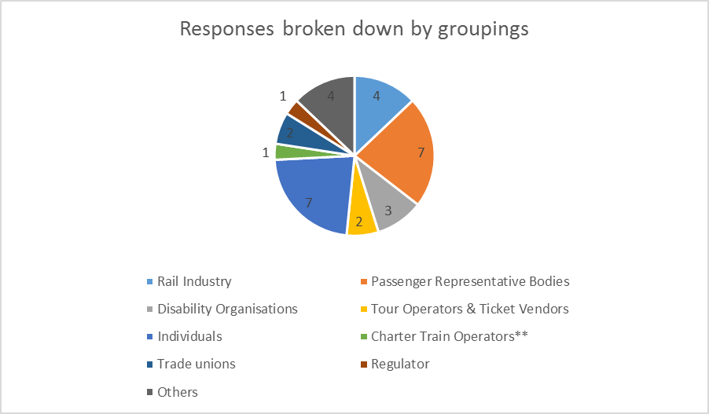
Figure 1 Table of responses broken down by groups

** No written response was received from any charter train operator but we did have a discussion with one operator during the consultation period.
Summary of responses by PRO Article
This section is in two parts – the articles where the consultation document suggested removing the exemptions and the questions and responses which relate to that, and the articles where the consultation document suggested maintaining the exemptions and the questions and answers which relate to that.
The following information provides a breakdown of the Yes/No answers that were given, and provides a selection of comments made. All questions asked respondents to provide the rationale having regard to impacts and benefits for passengers and additional costs to industry.
NB. Not all respondents answered all of the questions and not all questions were applicable to all respondents.
Part 1 - Proposals to remove exemptions

Article 5 Bicycles on trains

PRO Requirements and benefits
This article requires that railway undertakings must allow passengers to bring bicycles on trains – but only if this does not adversely affect the rail service and if the rolling-stock permits. A charge may be made for carrying the bicycle.

Do you agree with the proposal to remove the exemption for Article 5?

Yes | 16 | 94%
No | 1 | 6%

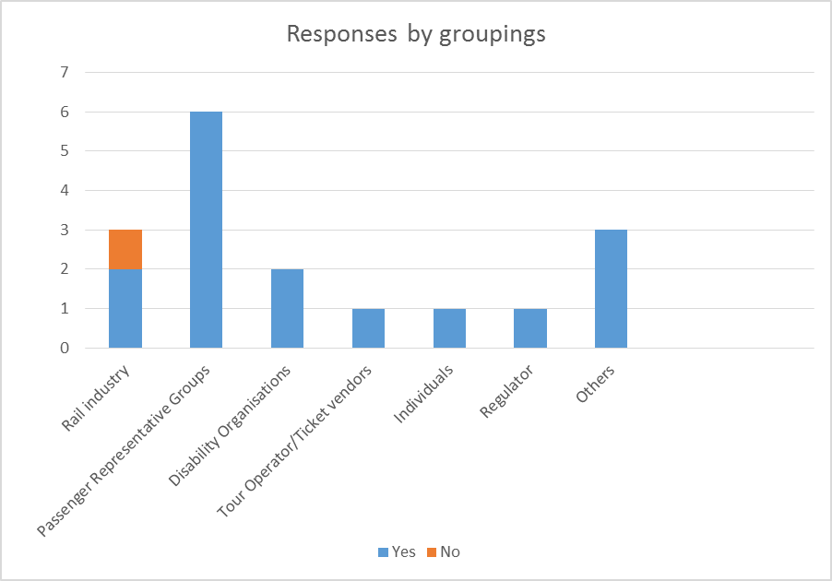
Those who agreed said:
- “The domestic regime and the PRO are in effect already aligned”
- “The PRO allows passengers to bring bicycles onto trains if it does not adversely affect the rail service and if the rolling stock permits…domestic GB requirements are already in line with this – hence we cannot see how there would be any additional costs from removing the exemption.”
Those who disagreed said:
- “the wording of the PRO is so loose that it could result in an inconsistent application of the PRO across Train Operating Companies (TOCs). This would make travelling by rail and bicycle more, not less, difficult, especially if a journey involved multiple TOCs.”

Article 6 Exclusion of waiver and stipulation of limits

PRO requirements and benefits
The PRO provides that obligations under the PRO cannot be limited by a contract (in Great Britain, the NRCoC) between a railway undertaking and the passenger. However, it provides that railway undertakings can offer more favourable contract conditions to the passenger than the minimum required by the PRO. The aim of this provision is to set minimum standards across the EU in the areas covered by the PRO.

Do you agree with the proposal to remove the exemption for Article 6?

Yes | 15 | 94%
No | 1 | 6%

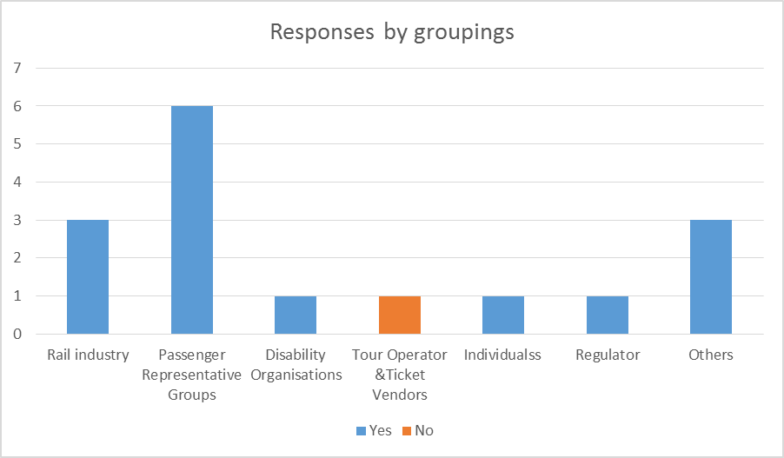

Those who agreed said:
- “The National Rail Conditions of Carriage already provide a contractual arrangement that provides over and above the PRO obligations.”
- “The article is already being complied with and no additional financial costs will be incurred.”

Those who disagreed said:
- “the inability to waive entitlements / impose additional restrictions could in some cases limit innovation - particularly….in ticketing technologies."

Article 7 Provision of public information regarding discontinuance of services

PRO requirements and benefits
This requires that advance notice must be given by railway undertakings to passengers regarding the discontinuance of services. Where this information may affect a passenger's journey they can then make alternative arrangements.

Do you agree with the proposal to remove the exemption for Article 7?

Yes | 16 | 94%
No | 1 | 6%

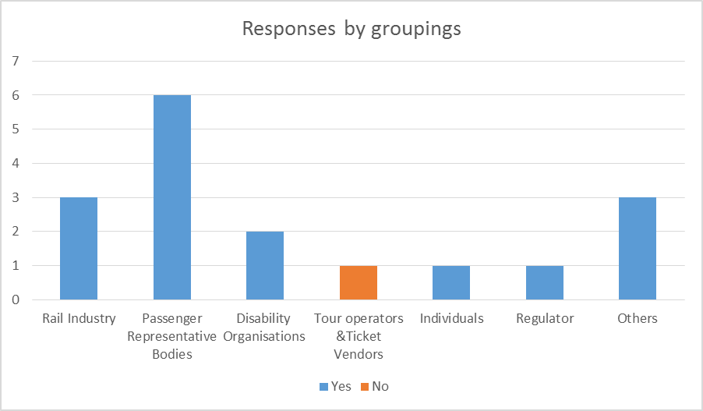
Those who agreed said:
- “it is particularly difficult for disabled people to source alternative transport if a suitable mode is changed or ceased. As a result they must be given as much notice as possible if a rail service is to be discontinued.”
- “We concur with the DfT’s assessment that current arrangements are already aligned with the PRO and there would be no additional costs.”

Those who disagreed said:
- “depends upon whether it is interpreted as acceptable for generic notification (eg a notice on a website) of the cancellation of a service. .. If .. there is an obligation to notify passengers booked on a specific service personally of a cancellation of their specific booked service, then robust information feeds and procedures do not currently exist to achieve this.”

Article 8 Travel information

PRO Requirements and benefits
This places an obligation on railway undertakings and, separately, ticket vendors working on their behalf, to provide (on request) specified information prior to travel. Additional information must be given during the journey by the railway undertaking. Ticket vendors working on their own account and tour operators must provide the same information where available. The specified information is listed below.

Article 8(1). Pre-Journey Information
Train operators and ticket vendors working on their behalf are required to provide specific pre-journey information to the passengers upon request. This includes:
General conditions applicable to the contract;
Time schedules and conditions for the fastest trip;
Time schedules and conditions for the lowest fares;
Accessibility, access and availability of facilities for DPRMs;
Accessibility and access conditions for bicycles;
Availability of seats in smoking/non-smoking accommodation and in first class and second class as well as couchettes and sleeping carriages;
Any activities likely to disrupt/delay services;
Availability of on-board services;
Procedures for reclaiming lost luggage;
Procedures for the submission of complaints.
Ticket vendors working on their own account and tour operators must provide the same information where available

Article 8(2). Information during the journey.
Railway undertakings must also provide the following information during the journey:
On-board services;
Next station;
Delays;
Main connecting services; and
Security and safety issues.

Article 8(3). Provision of information in an appropriate format.
Information provided before and during the journey shall be offered in the most appropriate format particularly for those with auditory or visual impairment.

Do you agree that the exemption for Article 8 can be removed? If "No", state which part or parts of the exemption cannot be removed giving your reasons.
Yes | 12 | 71%
No | 5 | 29%

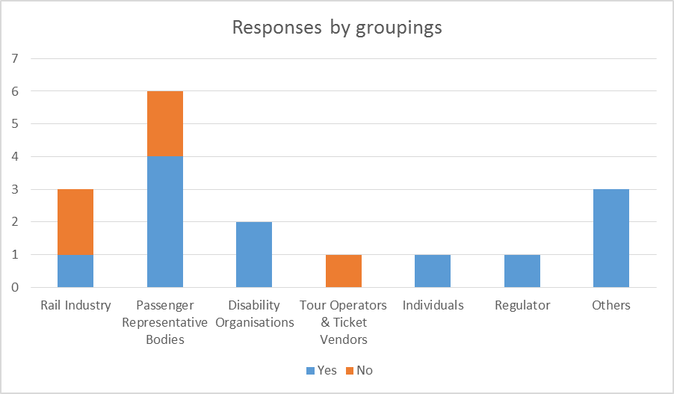
Those who agreed said:
- “Purely on cost arguments, all exemptions should be removed, but in practice the systems are far from satisfactory, particularly the on-board side. Announcements are often useless to disabled people with sensory impairments, and often audio announcements, even simple station name identification, are made as the train is pulling in to the platform, allowing no time for a person with mobility impairments to prepare to disembark.”
- “the broad requirements of the PRO are already covered through existing contractual or regulatory requirements and so can be removed at negligible cost”

Those who disagreed said:
- “The exemption for Article 8 should not be removed until it can be confirmed that the provision of the pre journey information required can be made using the internet. Without this option operators could be required to carry large amounts of paper leaflets at stations to meet the requirements of the Regulation; this approach has substantial cost implications. The requirement to advise on the availability of seats is also impractical as this data is not available to operators on a dynamic basis when trains are in operation.”
- “For Art 8(3), the DfT’s analysis notes that the date by which compliance with the RVAR and [the Technical Specification of Interoperability for Persons of Reduced Mobility] PRM TSI has to be achieved is 2020, and .. some rolling stock is not yet compliant. We are therefore a little surprised that the DfT considers the requirements of Art 8(3) are already met.”

Part (a) of the question was directed at ticket vendors and tour operators and asked about compliance with the current levels of Article 8(1) requirements. If practice was not fully aligned respondents were asked to provide estimated costs of becoming compliant.
- “ABTA has issued guidance to its Member tour operators and travel agents on passenger rights on all modes of transport to ensure, inter alia, that they meet their legal obligations. [In 2014] we issued specialist accessibility guidance to Members so that disabled and less mobile passengers get the most out of their travel and holiday arrangements – this includes a booking checklist, practical guides on each part of the passengers’ journey, companies’ legal obligations plus free online training.”

Part (b) of the question asked rail undertakings to provide details of train operator compliance with the industry's best practice guidance on journey information. An example of this:
- “We have undertaken a short survey of TOC compliance with the Good Practice Guide to which almost half the TOCs responded. If the findings from this sample are typical, then 61% (by earnings) of TOCs are fully compliant and the remainder are broadly compliant. Within the latter group, the few instances of minor non-compliance are being addressed ... Therefore, whilst any remaining costs of compliance arise from commitments / obligations outside the PRO, the timing of the lifting of exemptions would need to take into account the extent to which some TOCs may still be implementing their plans to achieve full compliance.”

Article 10 Travel information & reservations

PRO requirements and benefits
Article 10(1) to (4):
These provisions mandate the use of a Computerised Information and Reservation System for Rail Transport (CIRSRT) and establish rules concerning its implementation. The technical specifications for interoperability referred to in Directive 2008/57/EC apply.
Article 10(5):
Train operators and ticket vendors must comply with existing data protection law including Directive 95/46/EC (as amended) when disclosing personal information on individual bookings to other railway undertakings and/or ticket vendors.

Do you agree with our proposal that the Article 10 exemption should be removed?

Yes | 12 | 80%
No | 3 | 20%

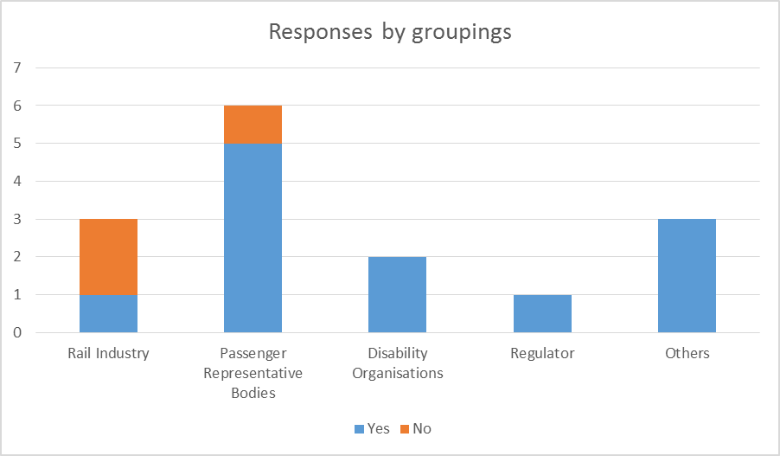

Those who agreed said:
- “We note that .. the DfT is of the view that the measures currently being undertaken by industry to implement the [the Technical Specification for Interoperability relating to Telematics Applications for Passenger Services] TAP TSI Regulation also meet the requirement in Article 10 for railway undertakings to adapt their CIRSRT in accordance with the deployment plan in that TSI. .. On this basis, we agree that the lifting of the exemption .. would not create additional cost.”
- “If you believe it to be a sensible cost neutral move we would agree but note that TAP TSI requirements will not be met until well into the next 5 year period.”

Those who disagreed said:
- “the UK rail industry is not expected to achieve compliance with the TAP TSI until 2018…The more appropriate solution would be to maintain the exemption until 2019, by which point the Network Rail implementation plan will have been concluded, meaning the exemption can be revoked with no risk to the industry.”

Article 13 Advance payments of compensation

PRO requirements and benefits
This mandates the provision of immediate and proportionate financial assistance by railway undertakings in the event of an accident (where passengers are killed or injured) to cover short-term needs, even though liability has yet to be determined.
Article 13(2) sets a minimum limit of Euro 21,000 in the event of a death and 13(3) sets out the status and liabilities arising from such a payment including the fact that a subsequent award can be reduced by the amount of the advance payment.

Do you agree with our proposal that the exemption for Article 13 can potentially be removed?

Yes | 14 | 87.5%
No | 2 | 12.5%

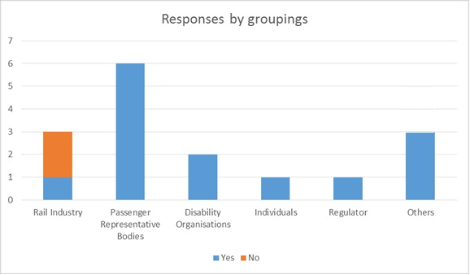

Those who agreed said:
- “We do not have access to the necessary data to determine the costs of implementation. However, we agree with the views expressed by DfT in para 4.8 of the consultation. Such a move would have a positive impact on bereaved families – not doing so would have an even greater negative reputational impact. The victim will inevitably be the innocent party in the event of such an accident and his/her family could easily face extreme hardship as a result. It seems right and proper that the regulation errs on the side of the weaker party at such times.”

Those who disagreed said:
- “whilst agreeing with the underlying intention of the legislation (ie to mitigate genuine hardship ..) we are unable to support the DfT's proposal to lift this exemption, given the financial risks .. arising from advance payments being made to those who are ultimately found not to be entitled to them. ..we consider that our current practice (.. a full range of humanitarian assistance, which includes .. financial support and is tailored to the needs of each individual) results in better outcomes for those affected.”

Article 14 Contestation of liability

PRO requirements and benefits
Where a railway undertaking contests its own liability for an accident, it must nevertheless make every reasonable effort to assist a passenger in making a claim for compensation from third parties.

Do you agree with our proposal that the Article 14 exemption should be removed?

Yes | 16 | 100%
No | 0 | 0%

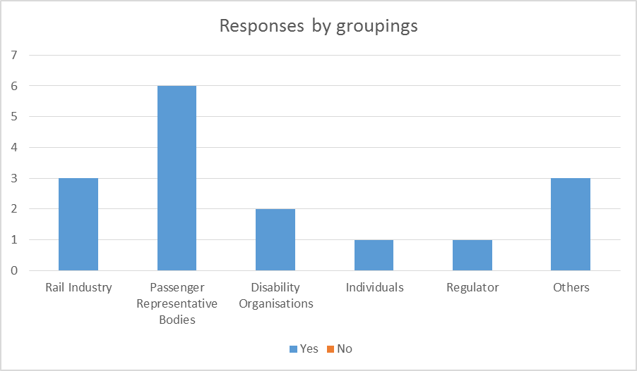

Those who agreed said:
- “We concur with the Department’s conclusions that no additional costs would arise from the removal of this exemption.”
- “We agree with the Department’s assessment that the exemption should be removed because current practice is already aligned with the PRO, or will be shortly.”

Article 18(1), (4) & (5) Assistance

PRO requirements and benefits
Article 18(1): Provision of Information.
Railway undertakings must keep passengers informed of the situation when trains are subject to delayed departures and delays during the journey.
Article 18(4): Certification of Tickets
Where there is disruption, the railway undertaking shall certify the same on the ticket when requested by the passenger.
Article 18(5): Assistance to Disabled Persons and Persons with Reduced Mobility.
When discharging these duties, the railway undertaking shall pay particular attention to the needs of DPRMs.

Do you agree with our proposal that the exemptions for Articles 18(1), (4) and (5) are removed?

Yes | 14 * | 93%
No | 1 * | 7%

* Three respondents singled out Article 18(4) as having cost or practical implications and suggested that the exemption should be maintained. All respondents agreed that the Article 18(1) and 18(5) exemptions should be removed.

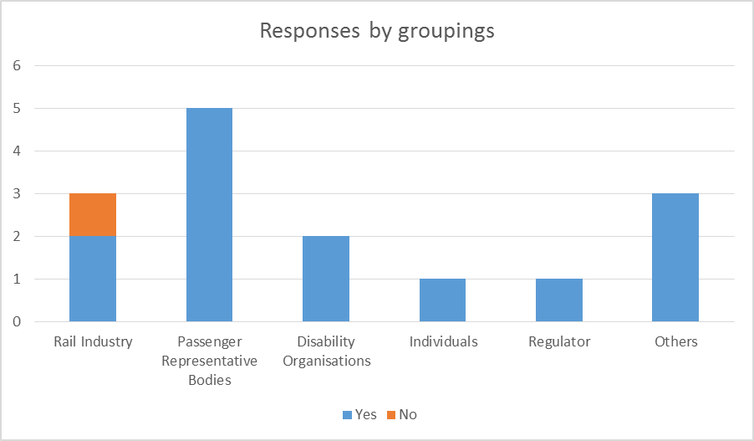

Those who agreed said:
- “We agree with DfT’s assessment. This is already provided, hence any additional costs will be negligible”

Those who disagreed (re Article 18(4)) said:
- “The exemption for Article 18(4) should be retained because it is impractical to certify disruption on a ticket given the size of the ticket and the increasing use of electronic media to carry tickets. The presence of disruption should be confirmed instead through the compensation process.”
- “up to c30 passengers on a typical crowded London arrival might [request certification of delays on tickets] .. this would translate into three staff needing to be solely allocated to this duty at a time [of widespread disruption] when resources are already stretched.”

Article 20(2) Information to disabled persons & persons with reduced mobility

PRO requirements and benefits
This requires, where requested, the train operator, ticket vendor or tour operator to notify the DPRM within 5 days of the reason they have been refused a ticket, reservation, or are required to be accompanied.

Do you agree with our proposal that the exemption for Article 20(2) is removed?

Yes | 13 | 100%
No | 0 | 0%

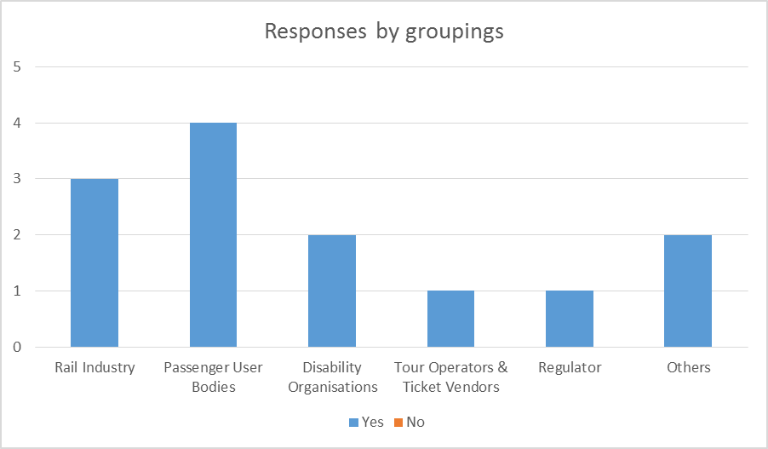

Those who agreed said:
- “ … the additional requirement to provide (on request) within 5 days written reasons to DPRMs who have been refused a ticket, reservation, or assistance, could be accommodated within the existing correspondence /complaints handling processes.”

Article 21 Accessibility

PRO requirements and benefits
Article 21(1): Accessibility of Stations, Rolling Stock and other Facilities
This requires that railway undertakings and station managers must ensure that stations, platforms rolling stock and other facilities are accessible to DPRMs through compliance with the PRM TSI.
Article 21(2): All reasonable efforts are made to provide access to travel by rail
This requires that in the absence of accompanying on-train staff or staff at a station, railway undertakings and station operators shall make all reasonable efforts to enable DPRMs to travel by rail.

Do you agree with our proposal that the exemption for Article 21 should be removed?
Yes | 15 | 100%
No | 0 | 0%

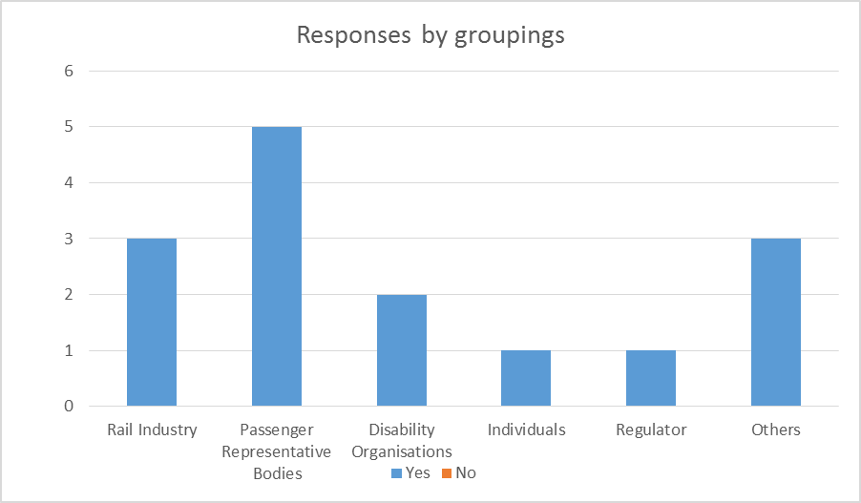
Those who agreed said:
- “The exemption from Article 21 should be removed, as the requirement to ensure the accessibility of stations and trains according to the Technical Standard for Interoperability for Persons of Reduced Mobility is already met by the UK rail industry. The industry has systems in place to ensure that the entire network (including unstaffed stations) is accessible.”
- “As mailine railway stations and rolling stock already comply with this, and RVAR vehicles are excluded, that it makes sense to remove this exemption. .. the term "reasonable" should be removed because it is highly subjective and open to many interpretations.”

Article 22(1) & (2) Assistance at railway stations

PRO requirements and benefits
Article 22(1): Assistance at Railway Station is Free of Charge
At staffed stations the station manager shall provide assistance with boarding or alighting trains for DPRMs. This assistance shall be provided free of charge.
Article 22(2): Derogation to Free of Charge Assistance
Member States may provide a derogation for a public service contract where alternative facilities or arrangements guaranteeing an equivalent or higher level of accessibility of transport services are in place.

Do you agree with our proposal that the exemptions for 22(1) and (2) are removed?

Yes | 15 | 100%
No | 0 | 0%

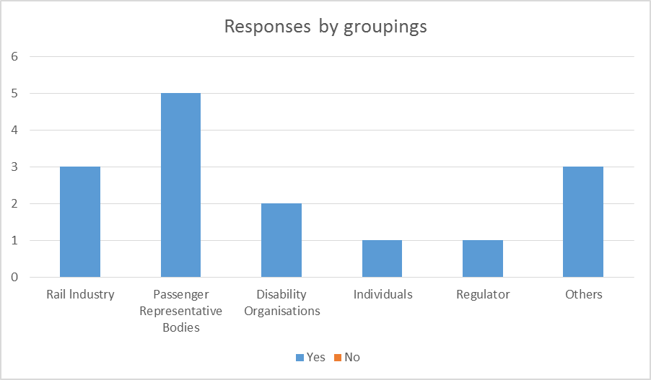

Those who agreed said:
- “The extra costs associated with this will be likely be negligible and any case would be outweighed by the benefits and reputation with passengers.”
- “Information space at stations should be there for the benefit of passengers, and not so that rail companies can make money!”

Article 22(3) Assistance at railway stations

PRO requirements and benefits
Article 22(3): Display of easily accessible information
At unstaffed stations, railway undertakings and the station manager shall ensure that there is easily available information regarding the nearest staffed station and directly available assistance for DPRMs.

Do you agree that Article 22(3) can potentially be removed?
Yes | 13 | 93%
No | 1 | 7%

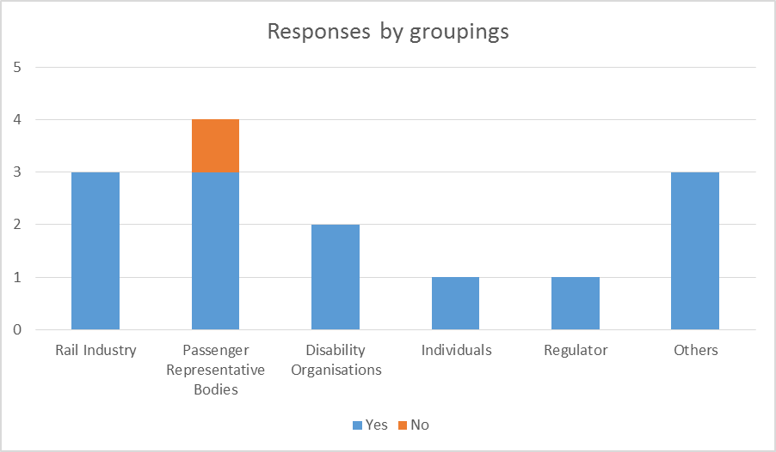
Those who agreed said:
- “The likely cost of providing such information is ridiculously small compared to other operating costs of train operators or Network Rail. We therefore do not believe that we or other respondents need to make an ‘efficient, value for money’ suggestion. We also see this as covered by the Equality Act’s duties for service providers in relation to disabled people. Allowing those responsible for train stations to hide behind an excuse that they have not reached their phased renewal is unnecessary and an affront to disabled travellers.”
- “Any increased costs or loss of revenue should be negligible compared with the benefits to DPRMs.”

Those who disagreed said:
- “If accessibility information is important it should not be less available at small stations.”

Article 23 Assistance on board

PRO requirements and benefits
Railway Undertakings must make reasonable efforts to provide on-board assistance to DPRMs (free of charge) to enable them to have access to the same services on the train as other passengers.

Do you agree with our proposal that the exemption for Article 23 should be removed?

Yes | 14 | 93%
No | 1 | 7%

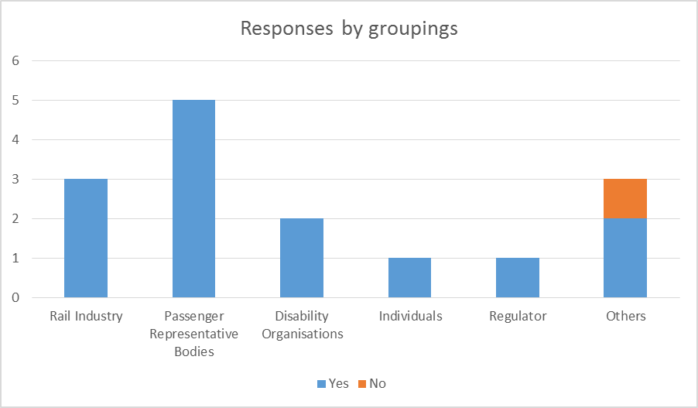

Those who agreed said:
- “There is a need for provision of wheelchair-accessible toilets on many trains, especially Class 158.”
- “ We agree that this should be removed, giving disabled passengers a more direct right to free services on board where these are needed to enable them to have access to the same services as other passengers.”

Those who disagreed said:
- “[some] rolling stock may not be compliant with the Technical Specification of Interoperability for Persons of Reduced Mobility before December 2019.”

Article 24(b), (c) & (e) Conditions on which assistance is provided

PRO requirements and benefits
When providing assistance to DPRMs at stations and on board trains in accordance with articles 22 and 23, railway undertakings, station managers, ticket vendors and tour operators must cooperate when providing assistance to DPRMs in accordance with the following conditions:
b) measures shall be taken for the necessary reception of notifications;
c) if no notification is made, reasonable efforts need to be made by the railway undertaking and station manager to provide assistance to travel;
e) that the DPRM presents themselves at a designated point at a stipulated time (not more than 60 minutes before travel).

Do you agree with our proposal that exemptions for parts (b), (c) and (e) of Article 24 can be removed?

Yes | 15 | 100%
No | 0 | 0%

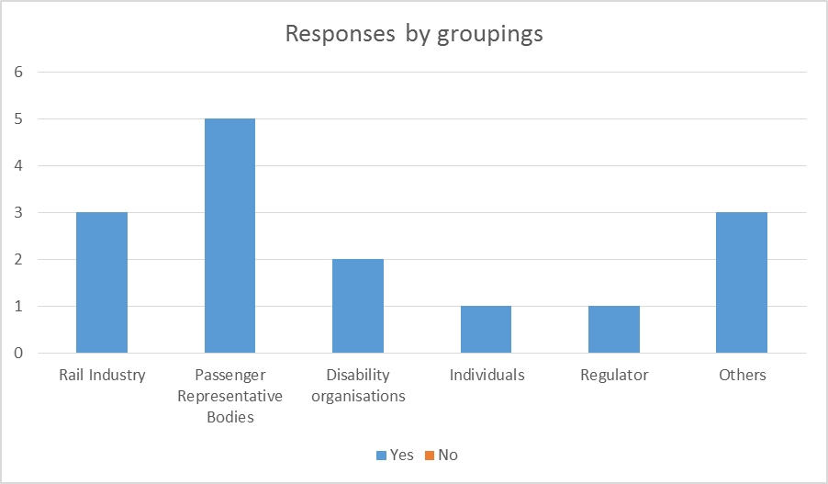
Those who agreed said:
- “We concur with the Department’s conclusions that no additional costs would arise from the removal of this exemption.”
- “The exemptions should be removed because current practice is already aligned with the PRO or will be shortly.”

Article 25 Compensation in respect of mobility or other specific equipment – removal of any limits on liability

PRO requirements and benefits
Where a railway undertaking is liable for loss of, or damage to, mobility or other specific equipment for DPRMs, there is no financial limit on the compensation payable in respect of that loss or damage. This means that the limits on a carrier’s liability for lost or damaged luggage in CIV do not apply to DPRMs’ equipment.

Do you agree with the proposal to remove the exemption for Article 25?

Yes | 15 | 100%
No | 0 | 0%

Those who agreed said:
- “We agree as the cost of some disability related equipment can be extremely high and outwith the traveller's ability to replace vital items. Taking a claim under the Equality Act is also an expensive, complex and cumbersome process.”
- “ .. the exemption for Article 25 should be removed. Where a rail company is responsible for damage to equipment used by a disabled person they should meet the full cost of that damage, provided that liability is proven.”

Article 27 Complaints

PRO Requirements and benefits
Article 27(1): Creation of complaints handling mechanism
Railway undertakings shall set up a complaint handling mechanism for rights and obligations covered by the PRO. They also need to publicise the contact details.
Article 27(2): Complaints Response Time
A response must be provided within one month. In justified cases the railway undertaking shall inform the passenger of a date within three months of the complaint by which a response can be expected.
Article 27(3): Complaints data published in annual report
Railway Undertakings should publish in their annual reports the number and categories of received complaints, processed complaints, response times and possible improvement actions undertaken.

Do you agree with the proposal to remove the exemption for all parts of Article 27?

Yes | 14 | 93%
No | 1 | 7%

Those who agreed said:
- “This is already provided for in Complaint Handling Procedures (CHP), hence any additional costs will be negligible. In any event ORR is currently reviewing the CHP guidance and this provides an opportunity to resolve any issues arising from this consultation. There is no reason why the PRO could not form a backstop with operators required through existing CHPs to go beyond this. …The key point is that the PRO forms the minimum without preventing TOCs from striving for better.”
- “Cost – Negligible. Benefit – Small”

Those who disagreed said:
- “Re Art 27(3) - .. the PRO proposals will create presentational issues around the relative performance of different sized train operators, which will result in reputational implications for some TOCs. .. we reject the suggestion that absolute data is more transparent and may thus increase competition. .. the publication of .. non-normalised complaints data is meaningless .. easy to misrepresent [and] obfuscates a proper understanding by the media and general public of performance. .. We feel the DfT underestimates the importance of reputation to commercial organisations, both in terms of the resources needed to handle additional media attention and of revenue that may be lost at the margin from potential customers deciding not to use rail due to reputational concerns.”

Part 2 - Proposals to maintain exemptions

Article 4 Transport contract

PRO requirements and benefits
Under Article 4 subject to more detailed rules in the PRO itself, the transport contract and the provision of travel information and tickets to passengers will be governed by Title II and Title III of CIV (see PRO Annex I).
Title II and III of CIV contain 20 Articles. The majority of these Articles are reflected in the current version of the National Rail Conditions of Carriage (NRCoC). However we have identified three key CIV Articles which go beyond the NRCoC:

CIV Article 7(2)(a): "the carrier or carriers" must be entered on the ticket
This Article requires Railway Undertakings to enter the "carrier, or carriers" on the ticket.

CIV Article 7(4): "The ticket shall be transferable if it has not been made out in the passenger's name and if the journey has not begun"
This Article allows a passenger who has purchased a ticket that has not been made out in their name to transfer (sell/offer) the ticket to another traveller if they are unable to use it.

CIV Article 11: "The carrier must, where necessary, certify on the ticket that the train has been cancelled or the connection missed."
This ensures that passengers will have cancellations or missed connections officially recorded on their train ticket, to enable them to travel on later, non-reserved services and assist with compensation claims and refunds.

Do you agree with the proposal to maintain the exemption for Article 4?

Yes | 12 | 75%
No | 4 | 25%
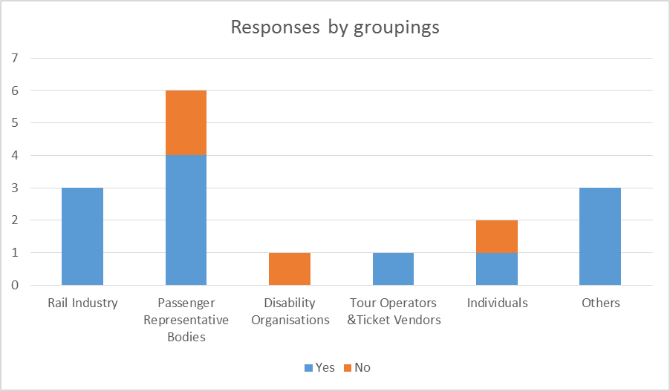

Those who agreed said:
- “Removing the exemption would not seem to add value. The issue of “commercial exploitation of ticket transferability” (outlined in para 3.12) is a concern.”

Those who disagreed said:
- “[industry's cost] figures assume that all losses arising from the transferability of tickets would be attributable to the regulation. This begs the questions of how much transferability already goes on - there is very little to stop off-peak and advance fares from being swapped now. ..As long as [Advance Purchase fares] are non-refundable .. the passengers should be able to pass it on to someone else.”

A number of respondents elaborated on the CIV articles (7(2)(a), 7(4) and 11) that had been discussed in the consultation document under Article 4. A few of these comments are provided below:

Re. CIV article 7(4)
- “Transferability of tickets could lead to misuse and possible commercial exploitation”

Re. CIV article 7(4) & 11
- “We are not convinced that current information systems are robust enough to ensure that certification of a ticket in the case of cancellations or missed connections is not necessary, in particular at gatelines.We can however understand the difficulties which may arise if tickets can be transferred, and mechanisms need to be in place to prevent advance tickets being bought by companies for resale, thus denying passengers the best deals.”

Re. CIV article 11
- “The requirement to note cancellations and missed connections on train tickets is clearly impractical given the physical size of the tickets and the staff time required, as well as the increasing prevalence of electronic ticketing media. Existing systems allow refunds to be issued fairly on an efficient basis.”

Part (a) question to Article 4
This asked for any other CIV articles (in PRO Annex 1 Title II and III) which may have additional costs to industry, or particular benefits for passengers, if the exemption was to be removed.
One rail industry respondent identified CIV article 7(2)(b) which requires the printing of the acronym ‘CIV’ on tickets to confirm carriage is subject to ‘these uniform rules’ (i.e. the CIV as annexed to the PRO), as an example of additional but negligible cost.
No other CIV articles were identified.

Article 15 Liability for delays, missed connections & cancellations

PRO requirements and benefits
Subject to the provisions in Chapter IV of the PRO on delays, missed connections and cancellations, the liability of railways undertakings in this area is governed by article 32 of CIV.
Article 32 provides that the carrier shall be liable to the passenger for the loss or damage resulting from the fact that the journey cannot be continued on the same day. The damages shall comprise the reasonable costs of accommodation and the reasonable cost occasioned by having to notify people expecting the passenger. UK law shall determine whether any further damages shall be due. There are limitations to liability where the late running/cancellation/missed connection is the result of:
Circumstances not connected with the operation of the railway which the carrier could not avoid, having taken due care;
Fault on the part of the passenger;
Behaviour of a third party which the carrier could not avoid having taken due care (another train company using the same track would not be treated as a third party for these purposes).

Do you agree with our proposal that the Article 15 exemption should be maintained?

Yes | 8 | 53%
No | 7 | 47%

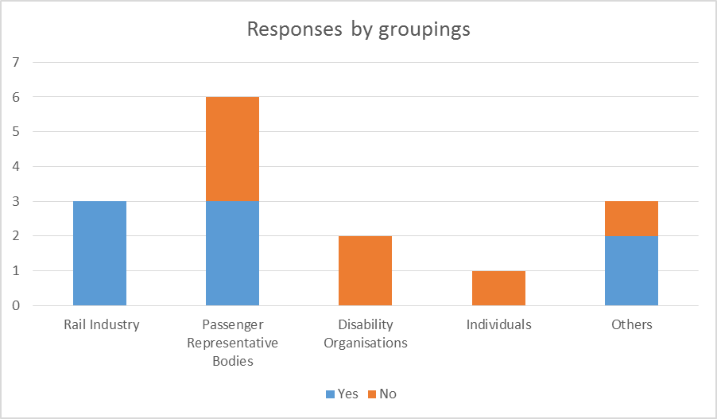

Those who agreed said:
- “The exemption for Article 15 should be retained, as the Article would significantly expand the liability of the rail industry under scenarios where major delays are caused by third parties.”

Those who disagreed said:
- “Disabled passengers are likely to face considerable extra costs, and significant problems, if their service is cancelled and there is no other service that day. ..It appears that the [proposal] to maintain this exemption is based purely on the potential of cost to a train operator who can influence the likelihood of this cost occurring. A disabled passenger cannot, and therefore should be recompensed where due care has not been taken.”
- “It is not the passengers' fault if the train is delayed .. for example, due to vandalism by a third party, so why should they bear the liability?”

Comments in response to part (a) of question: To what extent does current industry practice under NRCoC condition 45 overlap with the "due care" requirements of CIV 32? Please provide details of any relevant compliance costs.
- “The National Rail Conditions of Carriage and the PRO are similar, but the PRO has an additional clause to the extent that the train operator has to have taken 'due care' to avoid the delay. This is an overly cautious approach and we believe that revoking the PRO exemption would help incentivise train operators and Network Rail to improve their performance eg by reducing debris / rubbish on the track that can interfere with trains and trackside equipment.”
- “National Rail Conditions of Carriage are currently very closely matched with the PRO, except for the issue of whether a train company has taken "due care". ..it is very unlikely a TOC would not be taking due care, which should reduce the costs of complying with the PRO.”
- “TOCs .. already face strong commercial pressures to take action to prevent disruption to services. .. a TOC would almost certainly be able to demonstrate the taking of due care in the unlikely situation that such a case went to court. However, the circumstances in which the 'damages' referred to in CIV 32(1) would arise are virtually the same as those referred to as 'assistance' under Art 18(2)(b), for which there are no reliefs [from liability]. The costs, in practice, are also similar - the difference being only that under CIV 32 TOCs are liable for reimbursing accommodation costs incurred whereas under Art 18 they have to actually organise it (which is already the commitment under NRCoC clause 43).”

Article 16 Reimbursement and rerouting in the event of delays

PRO requirements and benefits
This requires that where it is reasonably expected that a delay will lead to arrival at the final destination more than 60 minutes late, passengers may choose:
refund of the fare for the entire journey when the journey will no longer serve the passenger’s originally planned purpose. The refund will include the return journey where appropriate; or
continuation or re-routing under comparable transport conditions to the final destination at the earliest opportunity; or
continuation or re-routing under comparable transport conditions to the final destination at a later date at the passenger’s convenience.
Train operators are obliged to reimburse or re-route passengers even in situations outside of the rail industry’s control.

Do you agree with our proposal that the Article 16 exemption should be maintained? In particular we welcome detailed cost information as per paragraphs 5.18 – 5.19 of the consultation document.

Yes | 6 | 37.5%
No | 10 | 62.5%

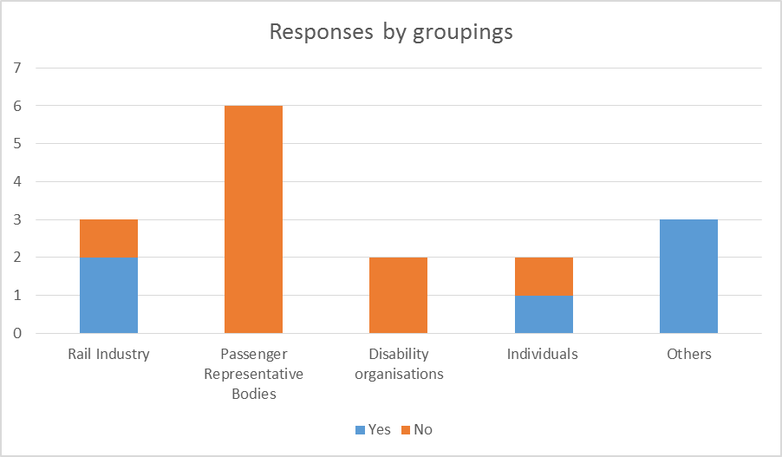

Those who agreed said:
- “There will undoubtedly be costs to the industry, especially as given the choice the majority of passengers would elect to receive a cash refund in lieu of rail vouchers.”
- “The exemption's .. removal will entail the industry incurring additional costs covering the issuing of replacement tickets for travel at a later date (for example) as well as a full refund of the cost of the ticket for the disrupted journey.. ”

Those who disagreed said:
- “passengers should enjoy the full benefits of the PRO, even though there may be costs to the industry. Passengers should also be able to opt for a cash refund, rather than rail vouchers.”
- “The next version of the NRCoC .. will allow customers to request the payment of compensation in money .. the incremental cost solely due to the removal of the exemption (ie excluding the impact of allowing abandonment and of paying compensation in cash) would be negligible. ”

Article 17 Compensation of the ticket price

PRO requirements and benefits
In the event of delays to the journey (where the passenger has not been reimbursed under Article 16) the levels and conditions for paying compensation are:
25% of the ticket price for a delay of 60 to 119 minutes;
50% of the ticket price for a delay over 120 minutes.
Where a passenger has a return ticket, the calculation for a delay on one leg will be half the return fare paid. The compensation rate will be as shown above (i.e. 25% or 50%)
Rail voucher payments are acceptable, but where a passenger requests cash, this must be paid.
The compensation must be paid within a month of the compensation request and no administration or similar fee may be deducted. Train companies can set a minimum threshold of up to 4 Euros before compensation is paid.
The passenger will not have a right to compensation when they are informed of the delay before buying their ticket or if the delay is less than 60 minutes due to continuation on a different service or re-routing.
Train companies are obliged to pay Article 17 compensation in circumstances which are outside of the rail industry’s control.

Do you agree with our proposal that the exemption should be maintained for Article 17?
Yes | 9 | 56%
No | 7 | 44%

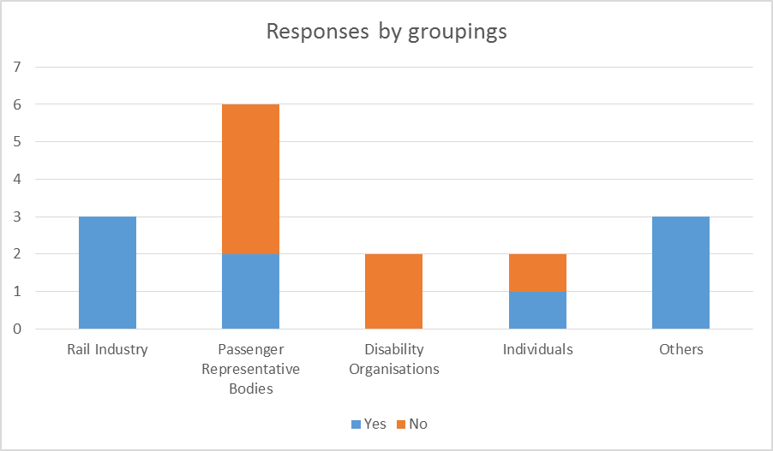

Those who agreed said:
- “We would want to see this adopted as soon as possible, but accept that further investigation into the potential impacts is required. We would welcome the payment of compensation in cash (on request), as soon as possible, in all cases as vouchers are likely to be of limited use to people that travel on an infrequent basis or hold long term season tickets.”

Those who disagreed said:
- “– how can passengers be expected to understand – and make a choice regards travelling taking into account – which train operators have Delay Repay and which don’t? If those who have adopted Delay Repay can financially cope with its more generous terms, those who haven’t adopted it can cope with Article 17.”

Article 18(2) & (3) Assistance

PRO requirements and benefits
Article 18(2)(a),(b) and (c): Provision of Assistance
In the case of delays over 60 minutes, the passenger shall be offered free of charge:
meals and refreshments in reasonable relation to the waiting time if these are available on the train or station or can be reasonably supplied;
hotel or other accommodation and transport between the station and the accommodation in cases where a stay of one or more nights becomes necessary. This is only where and when physically possible;
transport from the train to the station if the train is blocked on the track, to an alternative departure point or the final destination of the service. Again this is where physically possible.

Article 18(3): Alternative Transport
Where the railway service cannot be provided, the railway undertaking shall provide alternative transport as soon as possible.

Do you agree with our proposal that the exemptions for 18(2) and 18(3) should be maintained?

Yes | 7 | 54%
No | 6 | 46%

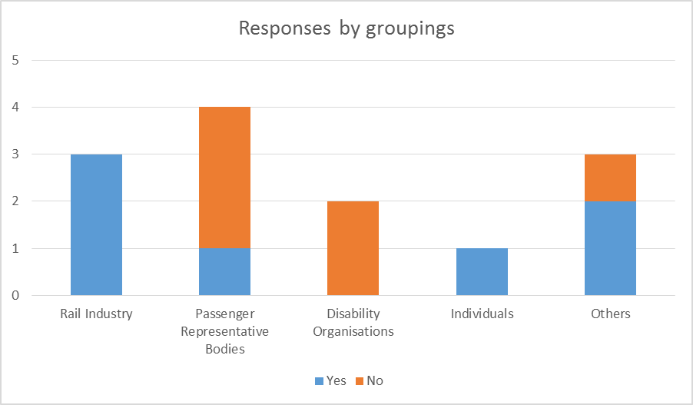

Those who agreed said:
- “.. The exemptions to Articles 18(2) and 18(3) should be retained, due to the additional liability and costs associated with the provision of refreshments and overnight accommodation under all circumstances when delays occur.”

Those who disagreed said:
- “We do not believe that this would place any greater burden on the industry over and above what is already provided on a voluntary basis or through the NRCoC.”

Article 24(a) & (d) Conditions on which assistance is provided

PRO requirements and benefits
When providing assistance to DPRMs at stations and on board trains in accordance with articles 22 and 23, railway undertakings, station managers, ticket vendors and tour operators must cooperate when providing assistance to DPRMs in accordance with the following conditions:
a) a requirement of 48 hours' notice to request assistance; one notification should be sufficient where a ticket permits multiple journeys;
d) designation of areas where DPRMs can announce their arrival at the railway station and if need be request assistance.

Do you agree with our proposal that exemptions for parts (a) and (d) should be maintained?

Yes | 9 | 60%
No | 6 | 40%

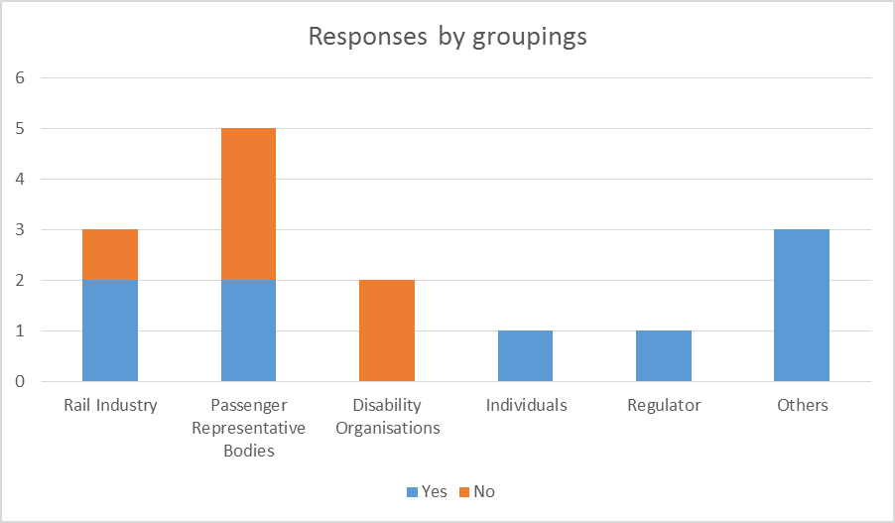

Those who agreed said:
- “With regards to notice periods, consideration should also be given to whether it is genuinely in the passenger’s best interests to only need to give one notification. Even if ICT systems were capable of booking assists over a 12 month period, this denies the passenger the flexibility to change trains to suit their needs. Similarly, as the UK has two timetable changes each year, it is unlikely that the schedules for the second change will have been agreed when the single notification is given. Consequently, even if there were ICT systems capable of looking 12 months ahead, it is probable that there would not be any trains in the system to book the assist on to.”

Those who disagreed said:
- “(d) -– in most stations this should not be a problem, in a large station with several entrances (e.g. Edinburgh Waverley) it is more difficult and potentially more expensive to set up and run, though at Waverley this is now largely in place. Passenger Assist has it recorded on the computer where a (regular) wants to be met.”

Article 28 Service quality standards

PRO Requirements and benefits
Railway Undertakings are required to define service quality standards that include at the very least the items listed below. They must also implement a quality management system to maintain service quality. The items listed in Annex III include:
Information and tickets;
Punctuality of services, and general principles to cope with disruptions to services;
Cancellation of services;
Cleanliness of rolling stock and station facilities (air quality in carriages, hygiene of sanitary facilities etc);
Customer satisfaction survey;
Complaints handling, refunds and compensation for non-compliance with service quality standards;
Assistance provided to disabled persons and persons with reduced mobility.
Train companies are also required to publish a separate annual report on their service quality performance which must be made available on the railway undertaking’s website and also on the website of the European Rail Agency (ERA).

Do you agree with the proposal to maintain the exemption for both parts of Article 28?
Yes | 6 | 43%
No | 8 | 57%

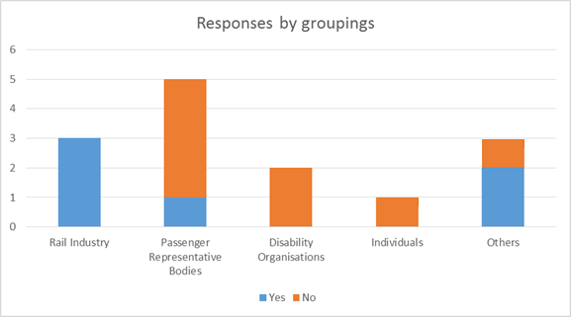

Those who agreed said:
- “Full compliance is likely to incur additional costs for those items where new monitoring systems are in place (eg air quality).”

Those who disagreed said:
- “Passenger satisfaction is not great across the rail industry and removing the exemption from this should focus industry minds on improving this.”

Article 29(1) & (2) Information to passengers about their rights

PRO Requirements and benefits
Article 29(1)
This article requires railway undertakings, station managers and tour operators to inform passengers of their rights and obligations under this Regulation when selling tickets. They may use a summary prepared by the European Commission for this purpose.
Article 29(2)
This requires railway undertakings and station managers to inform passengers on the train and at the station of the contact details of the PRO enforcement body and of the contact details of the complaints handling bodies.

Do you agree with the proposal to maintain the exemption for Article 29(1)?
Please provide your rationale having regard to impacts and benefits for passengers and costs to industry (in particular any costs arising from amending the NRCoC and from informing passengers of their rights when selling tickets on a train).

Yes | 8 | 57%
No | 6 | 43%

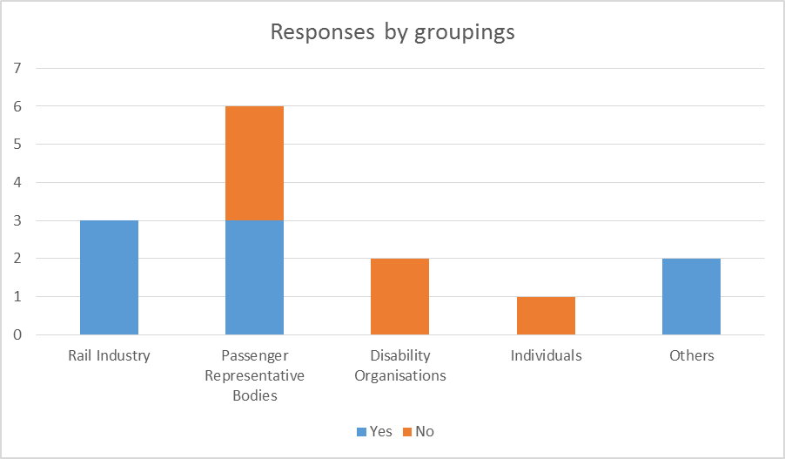

Those who agreed said:
- “… there does need to be something easier for the passenger to use (and the industry produce). The NRCoC is not suitable on its complete form and simplified versions/topic areas need to be developed.”

Those who disagreed said:
- “Para 8.16 refers to the issue of on train sales, but I am unsure why this could not be resolved by the train guard providing the passenger with either a notice sheet or a web address.”

Do you agree with our proposal to maintain the exemption for Article 29(2)?

Yes | 5 | 42%
No | 7 | 58%

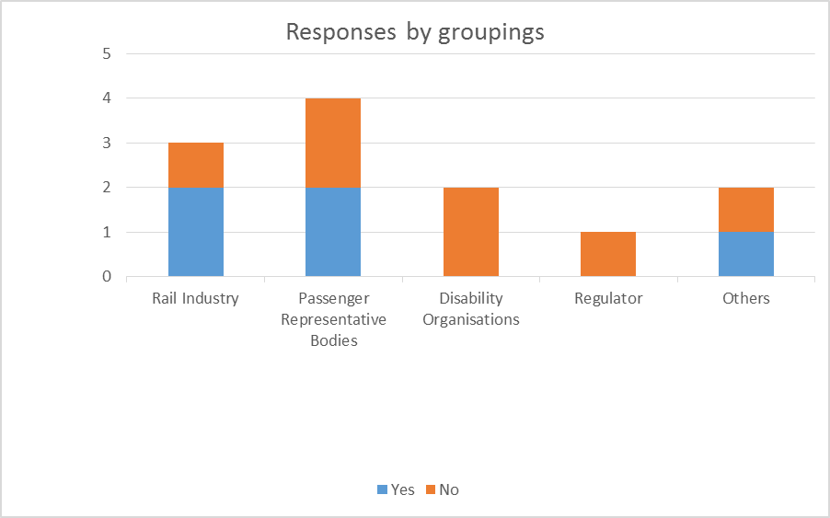

Those who agreed said:
- “There could be confusion about who to complain to if ORR’s contact information was also provided.”

Those who disagreed said:
- “We would welcome information on cost effective ways of delivering this requirement. Contact details of ORR, Passenger Focus and London Travelwatch are a basic requirement for passengers”
Some respondents did not answer the questions about individual Articles, but offered more general comments including:
- “Due to the almost non-existent market or incentives in the industry, a greater amount of regulation is needed”
- “Many of the questions raised in the consultation about refunds, reimbursements and rerouting and connections are made more complex by the fragmented and disjointed rail network. Passengers are often unaware of what services they can take and who to apply to for compensation. Much of these concerns would be alleviated by having a single, publicly owned operator.”
- “We agree with all the proposals in the section on DPRM. However, we feel that at the moment, there is a need for train operators to vastly improve the information they give to DPRMs on their rights to assistance and other reasonable adjustments such as a taxi from a station without stepfree access to the nearest stepfree station. While this is detailed in train operator’s DPPPs, we think TOCs should use poster space at stations to tell people that they are entitled to this as awareness is very low, although they do say they know that this is detailed in DPPPs that TOCs have.”
- “The National Rail Conditions of Carriage (NRCoC) – document is comprehensive and exceeds the requirements in the PRO, but it is very difficult, if not impossible, for the general rail passenger to navigate and understand. Further work is required to produce a version or subsets that can be used effectively by rail operators and their passengers – we support the work being done to produce a "National Guide to Tickets" publication and further documents may be required e.g. Disruption Handling and/or rights for journeys within one operator and/or across operators (connectivity).”

List of respondents
Abellio Greater Anglia (in support of ATOC’s response)
ABTA – The Travel Association
ASLEF
ATOC (Association of Train Operating Companies)
Avocet Line Rail Users Group (ALRUG)
Chiltern Railways
Cumbria County Council
FGW West Customer Panel
Ivybridge Town Council
London Travelwatch
ORR - Office of Rail Regulation (now Office of Rail and Road)
Passenger Focus (now Transport Focus)
Rail Future
Scottish Accessible Transport Alliance (SATA)
Scottish Disability Equality Forum
Tarka Rail Association Exeter to Barnstaple Rail Users Group
The Trainline.com
Torbay Line Rail Users Group
Transport for All
Transport for London (TfL)
Transport Scotland
TravelWatch North West
TSSA
West Coast Railways (discussion only, no written response)
7 Private individuals

Directive 2008/57/EC of 17 June 2008 on the interoperability of the rail system within the Community (Recast)
http://www.nationalrail.co.uk/static/documents/content/NRCOC.pdf

