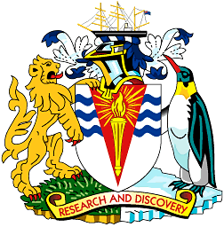
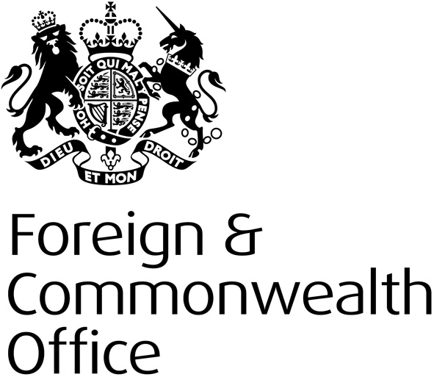
To: Station Leader, Rothera
Station Leader, Halley
Station Leader, King Edward Point
Station Leader, Bird Island
19 June 2015

MID-WINTER MESSAGE: DR PETER HAYES
HM COMMISSIONER FOR THE BRITISH ANTARCTIC TERRITORY AND DIRECTOR, OVERSEAS TERRITORIES, FOREIGN AND COMMONWEALTH OFFICE

As you prepare for the traditional Mid-winter festivities I send you and your teams my sincere thanks for all your hard work and dedication, as well as my very best wishes for your celebrations.

Amidst the festivities I am sure you will reflect on the considerable achievements of the summer, not least in the ever growing deep-field programmes, as well as the challenges of maintaining the stations in the dark winter months.

Those achievements and the scientific results that come from them are helping to maintain the place of the British Antarctic Survey and the United Kingdom as a whole at the very forefront of research in Antarctica and the wider region. That the joint FCO and BAS delegation returning from the recent Antarctic Treaty Consultative Meeting were able to secure positive and practical results on issues such as climate change; environmental impact assessments; and the updating of the protected area system is a testament to the continuing impact of British research. You should take great pride in the quality and quantity of all the work that goes into that research and in providing the logistical support for it to be done safely and successfully.

I know that the coming season will be as busy as the previous one and will see an even greater focus on deep-field activity. Thank you again for all you do to maintain the United Kingdom’s scientific footprint in Antarctica and the wider region.

As you look forward to the return of the sun, to winter trips and the season to come I wish you and your teams, and everyone working for BAS, a very enjoyable celebration, as well as a safe, swift and successful conclusion to the winter.

As you toast absent friends and families and your thoughts turn to home during your celebrations, I can assure you that you and your teams will be very much in ours.

Peter Hayes

With all very best wishes

Dr Peter Hayes
HM Commissioner of the British Antarctic Territory and Director, Overseas Territories, FCO.

