Research report

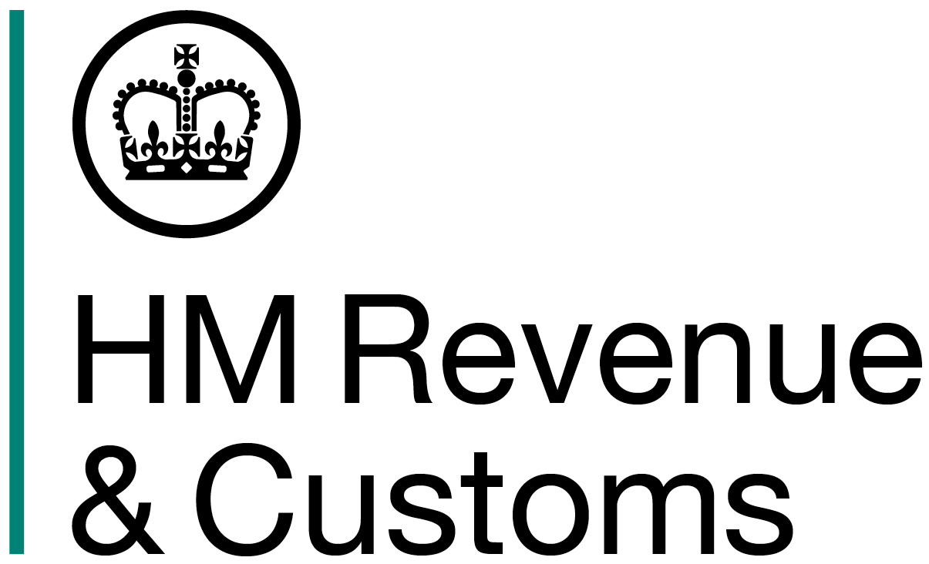
National Insurance Class 2 Contributions and the Self-Assessment Form

Qualitative Research with Self-Employed People

Personal Tax Customer & Stakeholder Team

April 2015

About Personal Tax Customer, Product & Process (PT CP&P)

Personal Tax Customer, Product & Process works with colleagues in Personal Tax and across HMRC to help develop our approach to implementing the customer centric business strategy. We use customer insight to help PT design, deliver and operate services for individual customers which

- improve customer experience
- maximise tax yield
- ensure that those who need help get the support they need, when they need it

PT CP&P also has a corporate role, to manage the relationship with the voluntary and community sector on behalf of HMRC

Contents

Research requirement 3
When the research took place 3
Who did the work 3
Method, Data and Tools used, Sample 4
Main Findings 6

© Crown Copyright 2015 - Published by Her Majesty’s Revenue and Customs.
Disclaimer: The views in this report are the authors’ own and do not necessarily reflect those of HM Revenue & Customs.

Research Requirement

In the 2014 budget, the Chancellor outlined proposals to collect Class 2 National Insurance Contributions (NICs) via the Self-Assessment (SA) process alongside Class 4 NICs and Income Tax.

This research study was commissioned specifically to test the changes being introduced to the SA form, in order to gauge levels of understanding around the key messages and clarity of the language and wording used (with a view to supporting customers and minimising low value contact). The research reviewed extracts of the SA form provided by HMRC and considered how far customers understood the content and the implications of this. In terms of key messages, the research explored how far customers understood:

- The obligations to pay Class 2 NICs (where their profits exceed the Small Profits Threshold - SPT);
- The choice of being able to make voluntary Class 2 contributions (where their profits are below the Small Profits Threshold – SPT); and
- The choice of payment allocation – that is, ticking a box to allocate payments made to HMRC Class 2 NICs before any outstanding tax charges and understanding all implications of that choice.

This research study built on previous work undertaken to explore current experiences of Class 2 NICs. Conducted in Autumn 2013, this consultation involved external qualitative research with self-employed people and aimed to gauge their thoughts on the current system of Class 2 NICs, explore knowledge gaps and their views on the proposal to start collecting these NICs through the Self-Assessment process.

When the research took place

The research was commissioned in February 2015. Fieldwork took place between 3rd and 12th March 2015.

Who did the work (research agency)

The research was designed and conducted by Ipsos MORI’s Social Research Institute, working in collaboration with HMRC.
Method, Data and Tools used, Sample

A total of ten mini focus groups (comprising of four or five participants) were conducted across two locations (London and Birmingham). A total of 46 took part in the research. Discussions were moderated by Ipsos MORI researchers.

Participants were recruited from a broad cross-section of self-employed people, based on the profile outlined below. Individuals were identified using free-find methods and were purposively selected using a screening questionnaire to ensure the groups covered a broad spread of employment sectors, ages and experience with the self-assessment process. Four of the groups were also screened by income to ensure representation of individuals on low incomes (who might choose whether or not to make voluntary Class 2 NI contributions).

The full group schedule and profile is detailed below:

Group number | Date/time | Location | Income profile | Experience profile | Sector profile | Age profile
1 | Tues 3 March | Birmingham | Low | High | Mixed | Mixed
2 | Tues 3 March | Birmingham | Low | Low | Mixed | Mixed
3 | Thurs 5 March | London | Low | High | Mixed | Mixed
4 | Thurs 5 March | London | Low | Low | Mixed | Mixed
5 | Mon 9 March | London | Mixed | High | Mixed | Mixed
6 | Mon 9 March | London | Mixed | Mixed | Mixed | 16-39
7 | Weds 11 March | London | High | Mixed | Mixed | Mixed
8 | Weds 11 March | London | High | Mixed | Mixed | Mixed
9 | Thurs 12 March | Birmingham | Mixed | Low | Mixed | Mixed
10 | Thurs 12 March | Birmingham | Mixed | Mixed | Mixed | 40-60

A discussion guide was developed by Ipsos MORI and the HMRC team to help guide the discussion and address the research objectives. The beginning of the discussion aimed to understand existing levels of awareness of National Insurance and the way it is administered. Participants were then invited to review the new NICs related questions on the SA100 and SA103S self-assessment forms and the accompanying guidance notes (drafts of which were provided by HMRC). Participants were asked to give their interpretations of the new questions and indicate any areas where they found the form wording or notes difficult to understand.

The new questions, and associated heading text, were as follows:

The Form SA103S addition focused on the voluntary payment of Class 2 NICs:

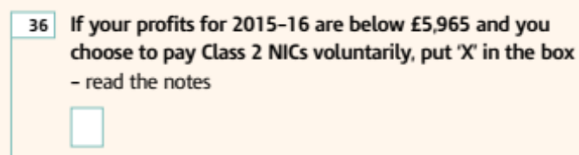

The Form SA100 addition focused on whether participants wished to prioritise their Class 2 NIC payments when paying their Self Assessment bill:

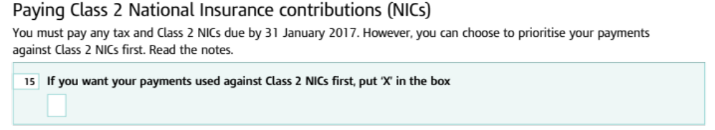

Main Findings

Some awareness of NICs and link with pensions and benefits, though little detailed knowledge.

While all the self-employed people interviewed had heard of National Insurance, few had detailed awareness of how the system worked. There was some limited awareness of the different classes of NICs, but few were able to say with certainty who paid each one, how they did so, or how an individual’s contribution was calculated.

Most knew that an individual’s NIC record was linked to their eligibility for a full state pension, and several recalled their parents impressing on them the need to pay their ‘stamp’. However, awareness of the link with benefit entitlement was lower, and some were under the impression that NICs went to fund broader public services, in the same way as tax. For example many assumed that NICs contributed to funding the National Health Service (NHS).

“I get the impression that a tiny portion of it goes towards your pension, and the rest of it goes into the general social welfare...benefits.”
Male, Birmingham, group 10

Younger participants in particular were sceptical that a full NI contribution record would guarantee them a pension in later life. This perspective influenced the views of these participants when it came to deciding whether it was worth making voluntary NI contributions to preserve one’s entitlement to a pension and benefits.

Participants had only a hazy recollection of communications from HMRC on the issue of National Insurance. A few recalled the recent letters informing them that direct debit payments would be stopping. Communications from HMRC that were not related to immediate demands for payment were rarely recalled.

The main point of contact with HMRC was said to come at the point of completing the self-assessment return. Some recalled contacting the HMRC helpline, and most were complimentary about the quality of assistance provided. However, participants used a range of other sources to help them understand their tax and NICs, including Google searches, informal peer networks, online communities and external sites such as moneysavingexpert.com.

Form SA103S – new question understood, but significant underlying uncertainty regarding implications.

The wording of the question relating to voluntary contributions was clearly understood. There was not felt to be any unfamiliar or ambiguous terminology.

“You don’t have to pay it, but if you want to you can.”
Female, Birmingham, Group 1

However, as noted above, while people understood at a general level that there was a link between contributions and entitlement (and that voluntary payments might occasionally have to be made); there was little detailed understanding of how contributions affected entitlement. This meant that many were unclear why, and in what circumstances, someone might want to tick the box indicating they wanted to pay voluntary contributions.

"Words are clear, but the information is not complete."
Male, London, Group 3

“It says 'you may want to pay voluntarily' and you just think…why would I want to pay voluntarily?”
Female, Birmingham, Group 10

In the guidance notes, the reference to protecting entitlement to ‘certain benefits’ was felt to be too vague. Participants felt the guidance notes should clearly outline which benefits were affected and how. In effect, the case for paying voluntarily needed to be made more strongly. For some, wording such as ‘you do not have to pay’ conveyed the message that payment was unimportant. There was also a widespread view that the form wording needed to encourage people more strongly to read the accompanying notes to ensure customers were able to gather additional information.

“Which benefits? Because then people are going to say, oh I could do with that, I'm going to pay it.”
Male, Birmingham, Group 9

“It needs a warning - 'Failure to contribute may lead to you not receiving a full state pension’.”
Male, Birmingham, Group 2

Some participants also mentioned that the guidance notes needed to signpost people to ways in which they could check the status of their own NICs, in order to be able to make an informed decision on whether to tick this box. There was also a preference expressed for the notes not to refer to people ‘deciding’ whether their profits were under £5,965, but rather ‘calculating’ whether this was the case.

Form SA100 – most participants were confused and some remained so even after explanation.

There was much greater confusion about the new question relating to the prioritisation of class 2 NIC payments in terms of both meaning and implications. Participants were often unclear on the meaning of the question and it was also felt to be ambiguous and contradictory – if both tax and NICs needed to be paid, people wondered, why were they being asked to prioritise one over the other? While the words ‘you must pay any tax and Class 2 NICs due’ suggested that both had to be paid in full, the reference to being able to prioritise then muddied the waters.

“I don't get what it means by 'prioritising your payments against'.”
Female, Birmingham, Group 1

"I'm confused why you would prioritise… why you would do that if you have to pay both?"
Male, London, Group 3

The concept of ‘prioritisation’ in this context was unfamiliar to people and participants generally did not feel they had the necessary information to allow them to make the choice of whether to prioritise NI payments or not. They wanted to know the relative consequences of being in arrears on either, and the scenario in which the choice to prioritise might need to be made. Were there financial penalties for not paying NICs due, in addition to the consequences for benefit entitlement? How large would the penalties and interest for non-payment of tax be compared to the benefits linked to NICs? Some ambiguous form wording – notably, the use of the phrase ‘prioritise against’, which was misinterpreted by many participants - caused further confusion. The use of the word ‘towards’ (which was shown as an option) was felt to be much less ambiguous and more positive than the word ‘against’ in this context in conveying the intended meaning accurately.

“It doesn't explain what your penalties are if you do choose to prioritise it.”
Male, Birmingham, Group 1

Almost no-one understood that the need to prioritise only arose where a tax and NIC bill was not being settled in full. They felt a much fuller explanation was needed, and that the existing guidance notes did not provide this. Some remained perplexed even after a fuller explanation was provided and as a result participants said they would be unlikely to tick the box.

