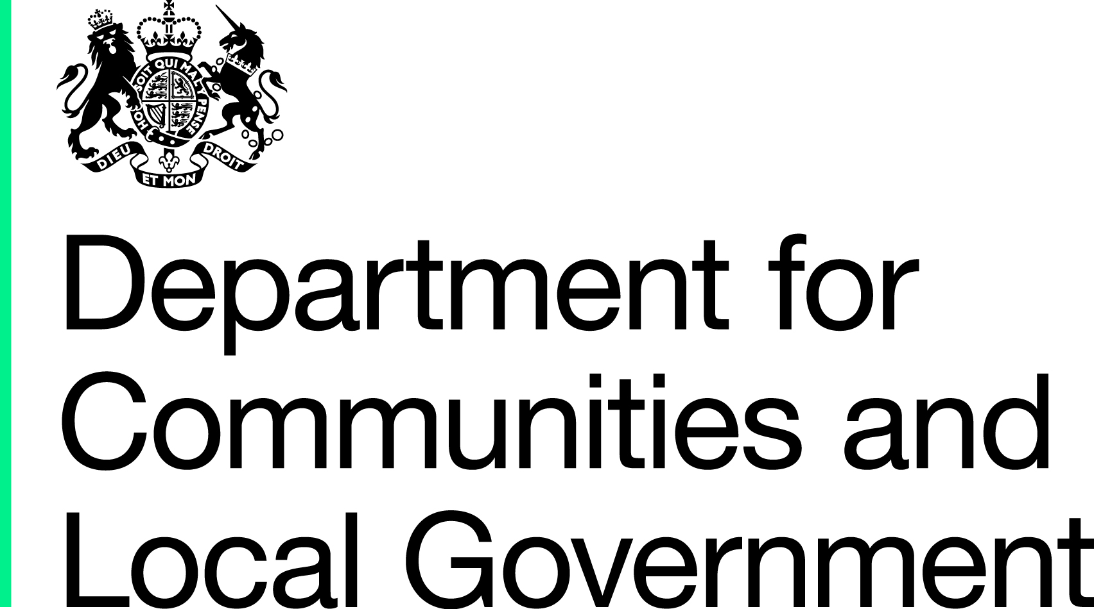

Community-Based English Language Competition

Stage One Prospectus

© Crown copyright, 2013

Copyright in the typographical arrangement rests with the Crown.

You may re-use this information (not including logos) free of charge in any format or medium, under the terms of the Open Government Licence. To view this licence, visit http://www.nationalarchives.gov.uk/doc/open-government-licence/ or write to the Information Policy Team, The National Archives, Kew, London TW9 4DU, or e-mail: psi@nationalarchives.gsi.gov.uk.

This document/publication is also available on our website at www.communities.gov.uk

Any enquiries regarding this document/publication should be sent to us at:

Department for Communities and Local Government
Eland House
Bressenden Place
London
SW1E 5DU
Telephone: 030 3444 0000

January, 2013
ISBN: 978-1-4098-3778-7

Ministerial Forewords



I am delighted to launch this Competition to
find innovative ideas to help people to learn
English in a way that works for them.

Lack of English is a fundamental barrier
to people’s ability to integrate into British
society: to participate in the life of their
local community; to support their children
through their education and to contribute
to the wider economy. The 2011 Census
contained questions about language for the
first time, and the findings published last
month showed that 5% of households across the UK do not contain
an adult with English as a main language – a figure which rises to 15% in London.

Improved English language skills help people to interact with their local communities, and to make contacts and friends. It increases self-confidence and enables them to join in with activities and issues in their local areas, to engage with their children’s teachers and make informed decisions about health and education options.

Confidence in English is also a prerequisite for social mobility. It allows individuals to realise their potential in education and in the workplace, and opens the door to wider opportunities. The Prime Minister has been clear that making sure migrants can speak English, the language of their new home, is a vital. It’s also something very practical we can do to promote integration. I reflected this sentiment in Creating the Conditions for Integration, which my Department published in February 2012.

The benefits of improved English language skills are also felt further afield. Our economic efficiency depends on enabling all citizens to participate fully in the jobs market, but it also depends on making the best use of everyone’s talents more broadly. As I pointed out last month, translating documents into foreign languages not only risks encouraging segregation, but is also hugely expensive for local authorities and other public bodies.

I want to help to build a society where people celebrate what they have in common; where everyone can achieve their aspirations and realise their potential irrespective of their background; and where everyone plays their part in social, civic and economic life together. Helping everyone to speak our common language is a good place to start.

Rt. Hon Eric Pickles MP
Secretary of State for Communities and Local Government


Britain wouldn’t be the place it is today without the extraordinary contribution made by people from ethnic minority backgrounds. Think of the Commonwealth soldiers who served with the Allies in two World Wars. Think of the immigrants, people like my dad, who came here to reinvigorate British industry in the mid 20th century. And think of Mo Farah - our national hero. Even before Mo crossed the finish line – twice – during the 2012 Olympics, the whole nation got behind this Somali-born Muslim. It says a lot about the diverse, integrated state of our country, that everyone – black, white and brown – was proud to drape themselves in red, white and blue.
Today Britain is in a global race, and it’s a race we can’t rely on Mo Farah to win for us. It’s a race that pits us against countries all over the world and success in the face of global economic competition will determine our future. We have got a secret weapon in the global race – the people that make up Britain today: our diverse communities. People with links to places across the world, with business acumen and ideas, with cultural insight and experiences and with endless untapped talent and networks. It’s crucial to unlock this potential.
Despite great individual examples, real barriers to integration remain. I believe that the things that stop people getting on with each other are the same as the things that stop them getting on in life. Integration and social mobility are inextricably linked and a common language is the fundamental basis of a common understanding. Research shows that English language proficiency is the second biggest predictor of occupational success, after qualifications. We are determined to find new and innovative ways to help people learn English, because we can’t afford to let people be held back in Britain any longer.

Rt. Hon Baroness Warsi
Senior Minister for Faith and Communities

Section 1

The Department for Communities and Local Government is launching a Competition to discover, and support, organisations than can deliver community-based English language programmes.

The Competition is open to all organisations.

What we are looking for

We want to use this Competition to discover innovative ways of delivering community-based English language programmes that will help to integrate their participants into their local communities. But we are also looking for programmes that deliver genuine value for money, and that can be sustained over the longer term – i.e. beyond the period of Government funding support.

The size of the total funding pot will be determined by the number of bids that meet the Department’s requirements, up to a maximum of £6m. We would expect the organisations, or groups of organisations which are collaborating, to which we award funding to be of sufficient size and experience to allow them to successfully handle a public funding allocation of this size.

We want to ensure that the programmes we support have the best chance of combining innovation with economies of scale. As a guide, we therefore anticipate funding no more than four projects, to deliver programmes across our target areas.

Previous experience has shown that community-based English language programmes that meet our outcomes, and are run over a period of at least 18 months, can be delivered for around £2000 per head, but we are now looking for approaches which can achieve even better value and reach.

This is a two stage competition. This Prospectus focuses primarily on the first stage, which is for Expressions of Interest. A second Prospectus will be published in early 2013 for the main competition.

Section 2

Competition Outcomes

We are looking for projects that, when fully developed, can deliver the high-level outcomes we are looking to achieve. These are:

- to deliver a programme that will provide English language training and support participants’ integration into their local communities
- to reach those groups in England with the lowest levels of English language skill
- to work in those areas of England with a high need for this type of English language support
- to design a project which can be sustained past the point of Government funding
- to design a project with the capacity to be scaled up to reach large numbers of learners.

Who we want to help

We want to target this provision at those most in need, and who may not have accessed English language tuition in the past. We want projects to reach those:
- with no, or a very basic command of, English
- not eligible for mainstream ESOL support, as delivered via the Skills Funding Agency (therefore not in employment or actively seeking employment)
- resident in areas with high levels of need for English Language provision
- aged 19 and above.

We expect target groups will be likely to include Pakistani, Bangladeshi and Somali communities, and that women from these communities will be particularly strongly represented. These communities have the lowest self-reported levels of fluency in English.

Where we are looking

We want to focus this investment in those areas where we know many residents have low levels of English. Whilst the following local authority areas offer a strong indication of areas on which we will be concentrating, the boundaries are not to be interpreted too strictly, as there are other areas where there is a high need for English language support, and which are home to a large number of those in our target groups.

London:
- Brent | - Camden
- Ealing | - Enfield
- Hackney | - Hammersmith and Fulham
- Haringey | - Harrow
- Hounslow | - Lambeth
- Newham | - Redbridge
- Tower Hamlets
The North West:
- Bradford | - Blackburn with Darwen
- Kirklees | - Hyndburn
- Oldham | - Manchester
- Rochdale | - Pendle
The Midlands:  - Birmingham  The South: | - Leicester
- Bristol | - Luton
- Slough

Section 3

The Competition Process

This is a two-stage process.

Stage One – Expression of Interest

The first stage is designed to develop ideas – both yours and ours. It is intended to get people talking about innovation in English language provision and the need for innovative approaches that will reach those members of our communities who most need language support.

At the first stage, we want to understand:

- what your idea is
- how you would implement it
- how sustainable your project is. You will need to demonstrate how you would ensure your project could continue after DCLG funding ends
- what experience you have in English language education, or of working with our target groups
- how you would collaborate with other organisations to achieve project aims.

Our Stage One objectives are:

- to assess the level of interest in this area
- to encourage discussion of the issues
- to stimulate collaboration between organisations
- and, to help you prepare for a Stage Two bid

Stage One is important for developing and testing your idea, and identifying what is needed to make it viable, and the types of organisation(s) you may wish to collaborate with.

Stage One submissions should set out the core ideas for your project, and be light-touch and outcomes focussed. The ideas submitted will be assessed against the high-level outcomes set out in Section 2 above. Those considered to best demonstrate the capacity to deliver these outcomes will be encouraged to apply to the second stage.

The Department will provide feedback on all Expressions of Interest.

Please be aware that we intend to publish some details of those Expressions of Interest that we consider are particularly strong.

The deadline for Stage One SUBMISSIONS is 15 March 2013.

Stage Two

Stage Two is the main part of the Competition, where organisations can bid for grant funding to deliver their projects. Entrants will be expected to demonstrate that they can deliver their proposals on the scale we are seeking.

Entries at Stage Two will be expected to complete a detailed bid which will set out how the project would work in practice, including:
- costings
- arrangements for financial sustainability
- partnership working, management and governance arrangements
- key milestones, outputs and outcomes.

Stage Two entries will be assessed against Value for Money criteria: for their effectiveness in delivering projects in line with our desired outcomes, that the proposals are efficient and the costs economical. We will then work with those organisations whose proposals best meet our desired outcomes to ensure that their final programme plans are suitably robust and deliverable.

Stage Two entrants will also be expected to illustrate how they would work collaboratively with other organisations, and to form the partnerships necessary, to deliver their proposals on the scale we are looking for.

A second Prospectus will be produced for Stage Two entrants, which will set out the assessment criteria in detail.

Not entering Stage One will not preclude you from entering Stage Two. However, there are advantages to organisations in entering the first stage, which include:
- an indication from the Department as to whether your proposal is likely to meet our intended outcomes
- additional time to work on your proposal
- additional time to identify and form partnerships with other organisations.

Open Day Event – 7 February

On 7 February we will be holding an Open Day event at the Department for interested organisations. This will provide you with further information on the Competition and what we are looking for from entries. It will also be an opportunity for you to meet with others working in the field – including potential partners.

Attendance will be on a first come, first served basis – please contact EnglishLanguageCompetition@communitites.gsi.gov.uk to reserve a place.

Section 4

Timetable of key events

15 January 2013: Opening date for Stage One submissions
7 February 2013: Open Day Event
14 March 2013: Closing date for Stage One submissions
April 2013: Provision of feedback on Stage One submissions
21 April 2013: Commencement of Stage Two

Development Support Grants

We are looking to make a small number of Development Support Grants available to smaller organisations who have produced strong submissions and may require help in developing a full business case for Stage Two.

To qualify for a grant, we normally define smaller organisations as those having a turnover of £8.3m or less. The organisation must be either a registered charity, or be an incorporated body whose Articles of Association demonstrate that its purposes are primarily charitable, philanthropic or benevolent. Grants will be paid under s.70 of the Charities Act. Private sector organisations are not eligible for a Development Support Grant.

A Development Support Grant will only be available to eligible organisations upon the completion of Stage One, and the money will be awarded in the financial year 2013-14.

The application process for this grant will be released at a later date - if you are interested in receiving more information about this grant, please tick the box on the application form.

In accepting a Development Support Grant, organisations will agree – via a Grant Funding Agreement – to use it on activities relating to the drawing up of a full business case for their project.

Terms and Conditions

The Department is not obliged to accept any proposals or to grant any funding for projects that do not meet its requirements, or to spend any of, or the entire pot of, money available.

It is at the sole discretion of the Department as to where projects are based. Funding will be awarded on the basis of the merits of the projects, not on their location and the Department reserves the right to fund projects in areas other than those listed in Section 2 above.

By taking part in Stage One, the applicant agrees that the Department may share and disseminate and use freely any information, know-how, system or process included in the Expression of Interest form.

Any funding will be awarded subject to applicants meeting the Department’s due diligence requirements.

How to apply

The Expression of Interest Form is attached to this Prospectus.

Please check the English Language Competition page of the Government website - http://www.gov.uk/government/publications/community-based-english-language-competition-stage-1-prospectus - regularly for updates.

EXPRESSION OF INTEREST FORM

COMMUNITY-BASED ENGLISH LANGUAGE COMPETITION

Please complete all sections of this form.

Organisational details
1.1 Organisation name
(in whose name the application is being made – if a partnership/consortium/BID, state the lead)
1.2 Contact name and main role
1.3 Address

1.4 Telephone number  (a) organisation  (b) contact | (a) | (b)
1.5 Email address of contact
1.6 Website address (if any)
1.7 Are you planning to collaborate with a partnership organisation? | Yes/No
1.8 Please provide details of the organisation or type of organisation you would partner

2. Please outline your idea, and demonstrate how it would meet the competition outcome on p.4 of the Prospectus.
[250 words max]
3. Please detail how you intend to implement your proposal.
[250 words max]
4. Please detail why you consider your idea to be financially sustainable beyond the point of funding from the Department.
[250 words max]
5. Please detail what experience you have of working with our target groups, or in the field of English language education.
[250 words max]
6. If you would like further information about applying for a Development

Support Grant (see p.8 of the Prospectus), please tick here:

Please submit your form electronically to EnglishLanguageCompetition@communities.gsi.gov.uk

This includes learners in receipt of income-related benefits - Council Tax Benefit, Housing Benefit, Income Support, Working Tax Credit, Pension Credit and contribution based ESA - unless in the Work Related Activity Group.

