This document has been archived because it is no longer current.

Sustainable development at the heart of a school: Emscote Infants School

URN: 125566
Local authority: Warwickshire
Date published: 5 April 2011
Reference: 130085
Brief description

This example shows how Emscote Infants School uses ‘eight doorways’ as a structure to build the curriculum and to embed sustainable development its work.
Overview – the school’s message

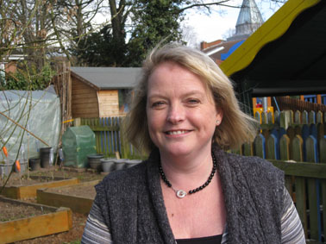
‘Sustainable development runs through everything we do. One teacher’s passion got us started and the Green Flag Award in 2004 was both a measure of our early success and a stimulus to do more. The sustainable agenda is driven by all our staff and our pupils who are passionate about their role in the future. The way in which pupils view the world has changed; they realise is not about “me”, and what they do affects others. And results have improved over the last four years in reading, writing and numeracy.
Advice for others? It will take time. Seize every opportunity to celebrate success and get some quick wins which are visible and encourage staff and pupils to do more.’
Debi Cossins, Headteacher
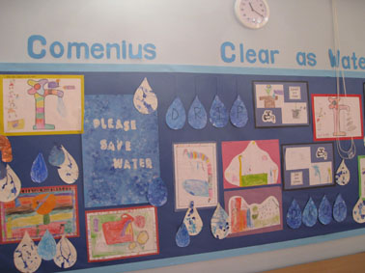
The good practice in detail

The commitment to sustainable development is obvious as soon as you step through the school gates. The grounds include woodlands, raised beds, bird boxes, bike parks and play areas. Classes are named after tree species and there are attractive wall displays throughout the school.

Deputy Head, Jon Queralt, is passionate about the role the school and the pupils can play in a more sustainable future. ‘It has taken four years to get where are today. In the past, we have had themed environment weeks and some other activities, but mostly driven by one teacher. We want the curriculum at Emscote to be as exciting as possible and sustainable development is part of that. But it‘s much more; it’s completely embedded throughout the school.’
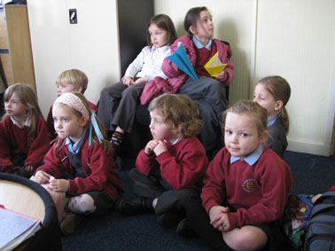
Much has been achieved in a relatively short time, by adopting a team approach, led by the senior leadership team, supported by all staff and governors, and involving parents, carers and the local community. They share their enthusiasm and skills with the children, who are full of ideas themselves and often take the lead in activities.
Initial ideas came thick and fast including raised beds, gardening clubs, toadstools in the grounds and ‘kerb aware’ programmes. ‘We used the eight doorways as a structure to assess what we were doing, what we needed to do and what we could do better’, says John. ‘It was a brilliant starting point. We found that our work through some doorways, such as food and health, was good, but we were lagging behind in others, such as the global arena. We have established a link with a school in Bo Sierra Leone and we are involved in a Comenius project about water with partners in Finland and Italy.’ This link shows some of the many activities and projects undertaken by the school.
Debi and Jon describe the key elements of the school’s journey:
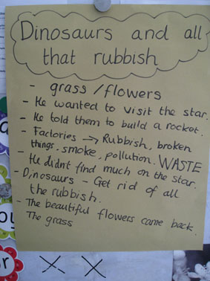
- Make a clear commitment and set out long-term objectives in a plan. Then build incrementally. The ‘Green Flag’ was a good starting point as it sent out a clear message about the school’s intentions.
- Embed sustainable development into daily life. For example, the school: accepts donations such as reception and office furniture from a local company; donates old tables and chairs to a local playgroup; hosts recycling points in the school grounds; participates in ‘Warwick in Bloom’; conserves rainwater; saves energy; and grows plants.
- Involve everyone, not just teachers and pupils. For example, the caretaker helps to save energy and to recycle and reuse furniture and equipment. One of the administrative team takes a lead in reducing the use of paper and other resources.
- Pupils have a key role. The ‘eco team’ provides a focus and is the engine for development. The membership changes and all pupils have an opportunity to participate. The school acts on their suggestions wherever possible. In recent months, the pupils have introduced a water saving scheme for rainwater which is used for the flower pots and beds. Outdoor play equipment and the gardening club were also their suggestions. Children monitor electricity use and lead initiatives to save electricity. Grace and Lauren designed easy to understand notices which are attached to all light switches in the school.
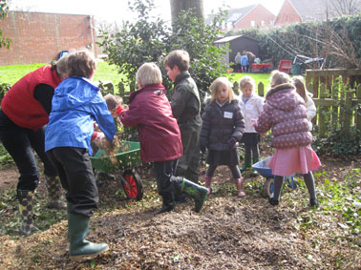
- Partnerships bring expertise, enthusiasm and more opportunities. They have helped to develop the school grounds, to provide safe areas where children can play and learn about the environment and about wildlife. Children engage with adults in a safe and supported way, and the school benefits from the extra resources. One local company planted a wildlife hedge in the grounds as part of its carbon offsetting strategy and constructed outdoor features and furniture to enhance the environment. Other organisations speak to the children about energy and water use.
- Involve the local community. Children pick litter (always carefully supervised) in local parks, and others help older people with their allotments. The school has designed a recycling poster for the Local Authority and is a recycling point. Parents, carers and grandparents bring their expertise and enthusiasm to help with activities such as gardening and road safety.
The school’s background

Emscote Infant School is smaller than most infant schools. Most pupils are from White British backgrounds and the rest are from a broad range of ethnic heritages. Very few pupils join the school at the early stages of learning English. The proportion of pupils eligible for free school meals is above the national average, as is the proportion of pupils with special educational needs and/or disabilities. The school has a number of national awards, including the ‘Active Mark’, ‘Healthy Schools’ and ‘ECO School Green Flag’ awards.

Are you thinking of putting these ideas into practice; or already doing something similar that could help other providers; or just interested? We'd welcome your views and ideas. Get in touch here.
To view other good practice examples, go to: www.ofsted.gov.uk/resources/goodpractice

