Children looked after placements by English local authorities
This release contains:

- Information about the characteristics, including age, gender and ethnicity, of all children looked after on 31 March 2014.

- Information about where all children looked after were living on 31 March 2014, including how far from their placing local authority they were living, the type of placement, how long they had been there, and the inspection judgements of the providers of these placements. It also includes analysis of some contextual data, such as the levels of crime and deprivation in the areas in which these children were living.

- Information about the providers of children’s social care, including the number of providers and places and their inspection judgements as at 31 March 2014.

Key Points
Black and Black British children who are looked after are more likely than children of other ethnicities to live in secure units, Young Offenders Institutions, or in prison | As at 31 March 2014, one fifth (20%) of children placed in secure units, YOIs or prisons were Black or Black British, though only 7% of all looked after children were of this ethnic group.
Almost one fifth of children were placed in children’s homes judged adequate or worse at the time of placement | 146 local authorities (97%) placed children in adequate or worse children’s homes: on 31 March 2014, 17% (1,014) were living in homes judged adequate; 2% (87) were in homes judged inadequate.
White children were more likely than Black and Minority Ethnicity (BME) children to be placed in areas of lowest deprivation and crime | 22% of White children and 14% of BME children were living in areas of lowest deprivation. 40% of BME children were living in areas of highest deprivation, and 39% in areas with highest crime, compared to one quarter of White children in both categories.
Key Points (continued)

Children in all placement types had lived there longer than they had in 2013 | As at 31 March 2013, one in four children looked after had been living in the same place for less than three months; as at 31 March 2014, this had dropped to one in five. Twenty-seven percent had been in the same place for two years or more as at 31 March 2013, which rose to 29% in 2014.
Children were slightly less likely than in 2013 to be placed within the local authority boundary | As at 31 March 2014, 43% (2,595) of children were placed within the boundary compared to just under 45% (2,791) the previous year. The proportion of children that were in children’s homes 50 miles or more from their local authority boundary rose slightly, from 17% (1,047) to 19% (1,129).

Contents

Introduction 5
Key Findings 8
An overall picture of the children and young people 8
Distance from local authority boundary 15
What type of placements were children living in? 20
Children living in placements whose providers are not inspected by Ofsted 22
How long had children been in their placements? 24
Characteristics of where the children were living 26
Rural/Urban areas 26
Deprivation 27
Crime 30
Independent Living 33
Provision and quality of children’s social care 35
Capacity and occupancy 36
Children’s Homes 36
Fostering 37
The quality of children’s placements 38
Children’s homes 38
Commissioning and ownership 40
Private and voluntary organisations 40
Children’s homes 41
Independent fostering agencies 42
Revisions to previous release 44
Methodology 44
List of tables and charts 44
Glossary 45

Acknowledgements
Thanks to the following for their contribution to this statistical release: Emily Moreton, Matt Watts, Donna Neill, Ed Jones, and Rich Jones.

Introduction

1. This is the second annual collection by Ofsted of information on all children looked after, the first of which took place on 31 March 2013. As with the 2013 collection, this builds and expands on information collated and validated by local authorities as part of the process of submitting their SSDA903 returns to the Department for Education (DfE). In particular, additional information was collected by Ofsted to enable matching of 903 data to Ofsted’s inspection judgement data as at 31 March 2014. All local authorities returned data sets to Ofsted, as they did in 2013.

2. In many ways, the picture as at 31 March 2014 is similar to 31 March 2013. The number of children looked after has increased slightly, but, in relation to separate types of placements, the changes are small.

3. Much of what was written in the 2013 Children Looked After Statistical First Release, therefore, is also true for this year, and we have aimed not just to repeat last year’s report. This report focuses on information that is new to this collection, particularly around age, gender and ethnicity. The aim of this addition to the collection was to look at how children’s characteristics may impact on their experiences of care, for example, around location or type of placement.

4. The data presented are a snapshot in time of children looked after and their placements, and an historical view of this. It is intended as a broad insight into the types of placements in which children looked after live and where they are living, which can be used to provide detail for and inform further analysis and debate. It is not intended to be a commentary on local authority decision-making, or to offer judgements on local authority performance.

5. The underlying data used for this release will be published separately in Excel format in October 2015.

6. The data are currently being used to inform the inspection of services for children in need of help and protection, children looked after and care leavers, which began in November 2013, and have involved over one third of local authorities so far. They are also used to inform inspection of independent fostering agencies and voluntary adoption agencies.

7. The process of collecting these data, and of the quality assurance work undertaken, has led to better quality data collection by both Ofsted and DfE. It has also resulted in the decision to include Ofsted URNs in the DfE 903 data collection for 2015-16, which will occur in spring 2016. One further report, on CLA data as at 31 March 2015, will be published by Ofsted in 2015. From 2016, Ofsted will discontinue the separate collection.

8. Although the data presented here are frequently in line with those presented by the DfE in their national statistics, there are some variations in the numbers presented here. The reasons for this are explored further below (paragraph 9).

Are Ofsted data for 31 March 2014 different to DfE published data?

9. The two sets of data are different for 2014, but much more aligned than in the previous year. As at 31 March 2014, the DfE reported that there were 68,840 children and young people being looked after, as opposed to the 68,554 cited here; a difference of approximately 290 children. Some explanations for this difference are given below.

10. The quality assurance process for this data collection checked for discrepancies in local authority submissions against the DfE statistical release and where these were found, local authorities were asked to explain any inconsistencies. Some indicated that they had updated their records since they had submitted their SSDA903 return, while others stated that they had submitted their return with errors that had since been corrected. Some records which had been submitted to the DfE were removed during the quality assurance process, in discussion with the submitting LA.

11. Further quality assurance was done on all records after final submissions were received from local authorities and quality assured in consultation with local authorities, and some records were removed as a result. Nineteen of these were removed as they had a placement start date after 31 March 2014, which was outside the date range for the return. A further 144 records were removed as they were children on short break placements; this return was not counting short break or respite placements.

12. The final difference between Ofsted data and the DfE data is the way in which some placement types are aggregated in DfE publications, which means the data cannot be directly compared. For example, the way in which the DfE have aggregated data about secure units, hostels and children’s home placements into one group has not been replicated here. Ofsted separately counts hostels as non-inspected provisions.

13. The quality assurance process also found some errors in placement codes given by local authorities to the DfE. Again, these were fewer than last year.

14. In 2014, there was a decrease in the number of placement codes being amended as part of the quality assurance process (Table 1). The number of children’s homes incorrectly coded, for example, reduced by almost three quarters, to 247. The number coded as being resident in adult care homes (R1) were greatly reduced in both overall initial number and the number that required recoding. Residential special schools remained problematic still, because they are easily confused with residential special schools that are also children’s homes, though, again, the discrepancies were reduced in number. The gap for fostering codes has all but disappeared. Z1s are now becoming what they were originally intended to be, codes to be used in only very exceptional circumstances. (Table 1)

Table 1 Summary of key placement codes before and after Ofsted quality assurance 2014

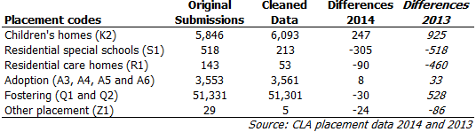

15. As a result of this quality assurance process and use of Ofsted’s internal database of social care providers, Ofsted are confident in the quality of the data and analysis presented in this report.

Key Findings

An overall picture of the children and young people

16. There were 68,554 children and young people looked after by 151 English local authorities as at 31 March 2014. This was an increase of 668 children, or 1%, on the previous year (67,886). (Table 2)

17. Three quarters of children were fostered (51,301), 9% (6,093) were in children’s homes, and 5% (3,561) were placed for adoption; the same percentages as in the previous year. (Table 2)

Table 2 Placement by type 2013 & 2014

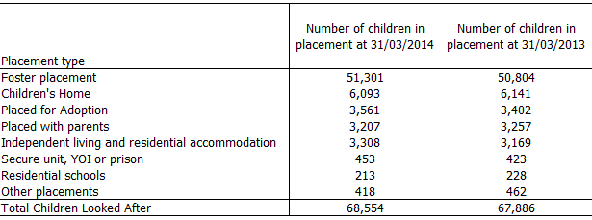

18. The data collected on personal characteristics data were in line with those published by the DfE:
Just over 55% were male and almost 45% female.
Seventy eight per cent were White and 22% were BME.
The largest age group was those aged 10 to 15 (37%)
One fifth (22%) were under 5 and one fifth (21%) were aged 16 and over.

19. Gender, age and ethnicity were not generally significant factors affecting children’s placements and experiences, with occasional exceptions, which are described where relevant.

20. Of the 68,554 children looked after, we did not receive placement location information for 4,074 children, compared to 3,684 in 2013.

21. Eighty-six percent of these children were placed for adoption, and their placement locations were kept confidential by local authorities; the number of children placed for adoption was also higher in 2014 than 2013, which most likely accounts for the increase in placements for which location information was unavailable.

22. The largest proportion of children looked after (more than a third) was aged between 10 and 15 years old as at 31 March 2014. However, as 43% of children were under 10 years old, the average age of children looked after was 10.5 years old. (Table 3)

Table 3 Number and proportion of children looked after by their age group

Age Group | Number of children | Percentage
Under 1 | 3,874 | 6%
1-4 | 11,410 | 17%
5-9 | 13,884 | 20%
10-15 | 25,056 | 37%
16 and over | 14,330 | 21%
 | 68,554 | 100%

23. The ethnicity of all children looked after on the snapshot date of 31 March 2014 is outlined in the following table. (Table 4)

Table 4 Number and proportion of children looked after by their ethnicity

Ethnicity | Number of children | Proportion of children looked after as at 31 March 2014 | Proportion of all children in England according to 2011 Census
White | 53,216 | 78% | 79%
Mixed | 6,185 | 9% | 5%
Black or Black British | 4,607 | 7% | 5%
Asian or Asian British | 2,554 | 4% | 10%
Chinese and other ethnic groups | 1,482 | 2% | 1%
Unknown | 510 | 1% | -
 | 68,554 | 100% | 100%

24. Overall, a higher proportion of children looked after were from BME backgrounds when compared to all children in England. This was true for all BME ethnic groups except for Asian or Asian British children, who made up a smaller proportion of children looked after compared to all children in England. (Chart 1)

Chart 1 Children looked after population in England on 31 March 2014 & 2011 Census of all children aged 0-17

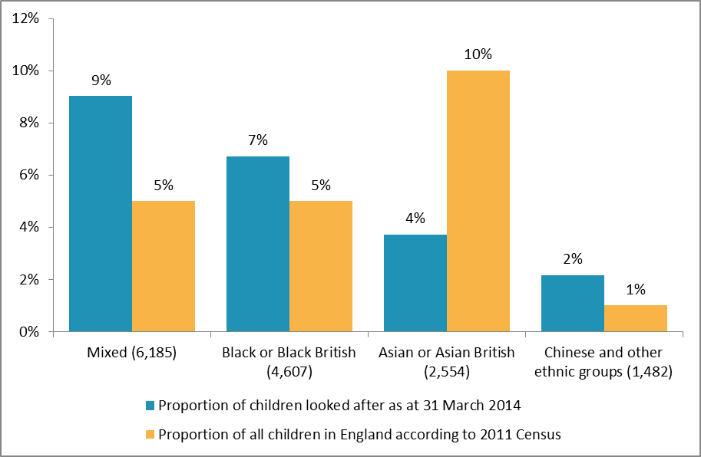

25. There were also 510 children for whom ethnicity information was not provided.

26. The average age of children looked after who were Black, Asian, or Chinese and from other ethnic groups tended to be higher than children who were of White or Mixed ethnicity. (Chart 2)

Chart 2 Ethnicity of children looked after according to their age group
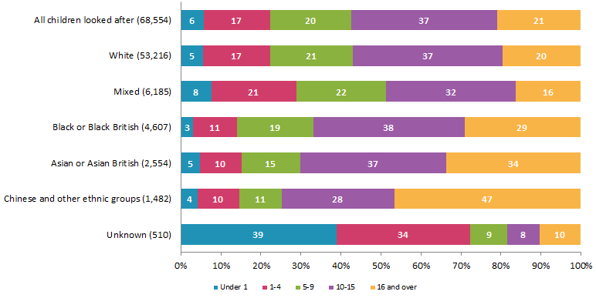

Where were the children living?

Map 1 Number of children placed in each local authority, as at 31 March 2014

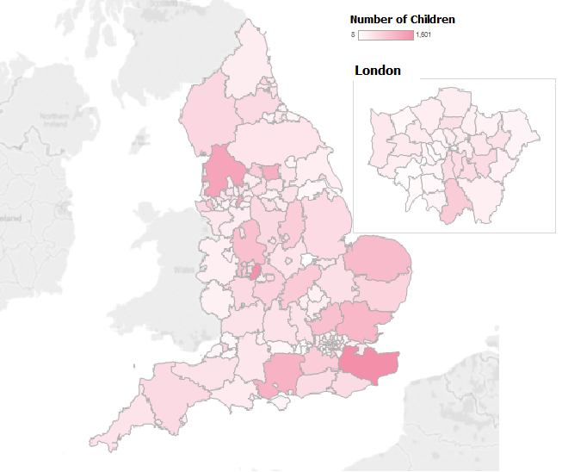

27. The data supplied by local authorities included information about where 64,481 children looked after were living, compared to 63,860 children in 2013.

28. There were 504 children who were living outside England. The majority of these (486) were in Scotland, Wales and Northern Ireland, with eight living outside the UK.

29. Of the 64,339 children and young people we know to be living in England, nearly one in five (11,617) were placed in the North West region of England.

30. When looking at numbers of children, two groups are considered: those who are the responsibility of the local authority (placed by), who may be living within the LA or outside the LA; and children who are living in the LA (living in). Although there will be a lot of overlap between the two groups, not all children placed by a local authority will be living in the LA, and vice versa. When considered as regions, there are similar numbers of children living in and placed by local authorities in each region; London was an exception, placing a higher proportion of children than lived in the region. (Chart 3)

Chart 3 Proportion of children living in and placed by each region, as at 31 March 2014

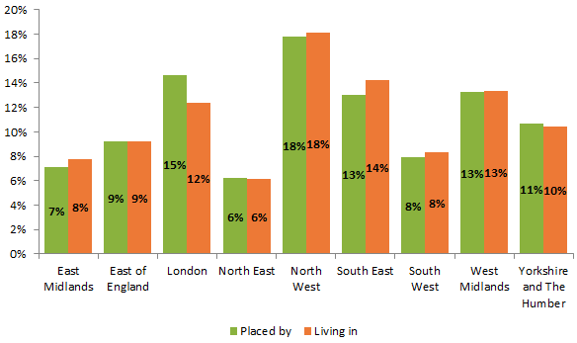

31. The differences in number of children living in versus being placed by LAs in each region became more marked when looking at particular types of placements. London, for example, had responsibility for substantially more children in children’s homes than it had living in children’s homes in the region. The reverse was true for the North West, South East and West Midlands. This may be a reflection of where in England children’s homes are located. (Chart 4)

Chart 4 Number of children living in and placed by each region in children’s homes, as at 31 March 2014

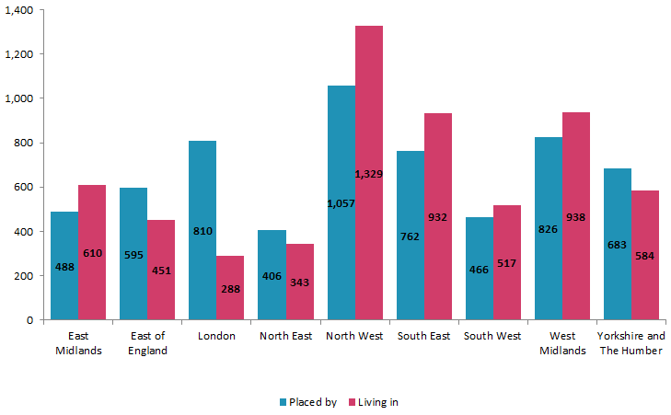

Distance from local authority boundary

32. Sixty-two percent (39,620) of the 64,309 children looked after for whom placement location was known were living within the local authority boundary, compared to 63% (40,457) in 2013. (Chart 5)

33. Ten per cent of all children looked after (6,462) were living more than 20 miles from their LA boundary, compared to 10% (6,216) in 2013. (Chart 5)

34. Five per cent of all children looked after (3,213) were living more than 50 miles from their LA boundary; the same proportion as in 2013 (3,049). (Chart 5)

35. Fewer children living in children’s homes were living within the local authority boundary than in 2013. Forty-three per cent (2,595) of children lived within the boundary compared to 45% (2,791) the previous year. (Chart 5)

36. The proportion of children that were in children’s homes 50 miles or more from their local authority boundary rose slightly, from 17% to 19%, with the number also rising slightly from 1,037 to 1,129. (Chart 5)

37. Almost 9 in 10 (45,089) children living in foster placements lived within or no more than 10 miles from their local authority boundary. (Chart 5)

38. Nearly two thirds of children in foster placements (32,132) were living within their local authority boundary. (Chart 5)

Chart 5 Proportion by placement type and distance
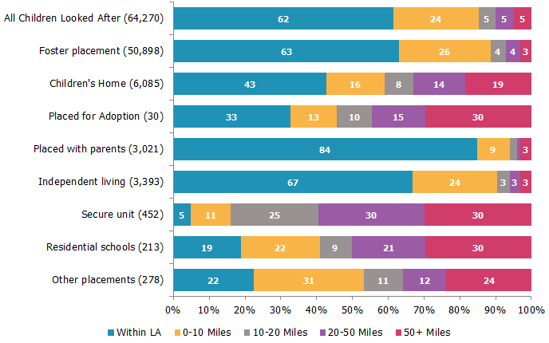

39. Children in the London region were almost twice as likely to be living outside their local authority than children in most other regions; 63% of children placed by London LAs were living out of the LA. (Map 2)

40. The North East and West Midlands had the next largest proportions of children living out of the LA, at 40% and 41% respectively. (Map 2)

41. All local authorities in the Yorkshire and the Humber region had less than half of their children living outside the LA boundary. (Map 2)

Map 2 Proportion of children outside LA boundary, as at 31 March 2014,

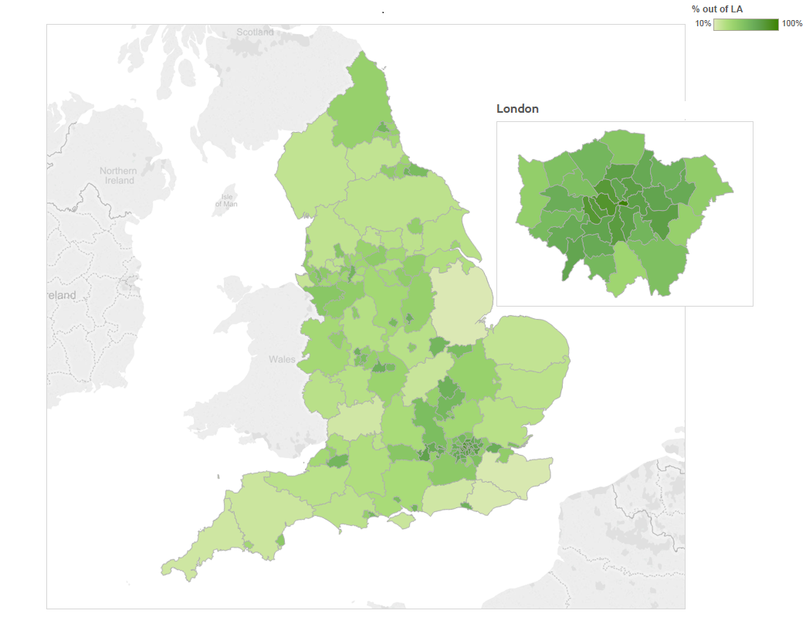
42. Of the ten LAs with the highest proportion of children (23% or more) living 20 miles or more from the LA boundary, five were in the London region, and four in the South East. (Map 3)

43. Five of the ten LAs with the lowest proportion of children living 20 miles or more from the boundary were in the North West region; twenty LAs across the country had less than 5% of their children living 20 miles or more from the boundary. (Map 3)

Map 3 Proportion of children 20 miles or more from LA boundary, as at 31 March 2014
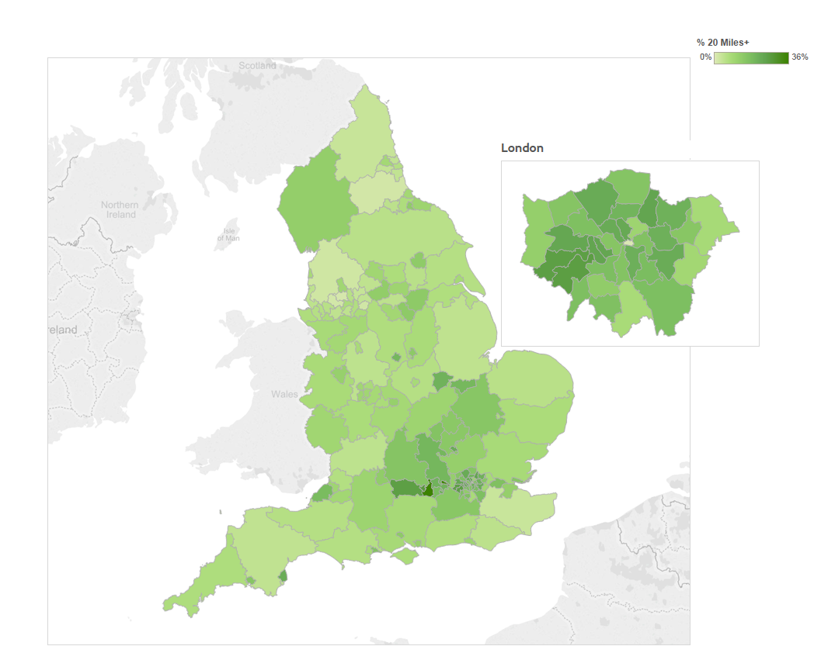

44. The older the child, the more likely they are to live further from their local authority boundary. Almost three quarters of children under one year old lived within their local authority boundary, while fewer than 60% of those over 10 years old lived within their own local authority. Indeed, one in 14 children looked after over the age of 10 lived more than 50 miles from their local authority boundary. (Chart 6)

Chart 6 Age of children looked after and the distance they lived from their LA boundary, as at 31 March 2014
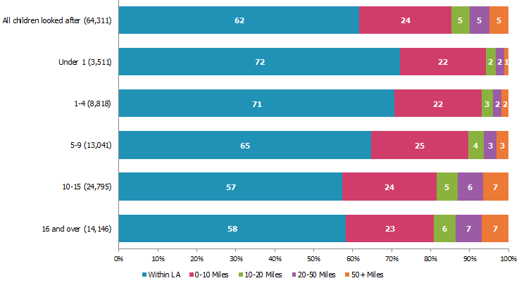

45. Children who are BME were more likely to be living outside of their local authority boundary than White children. Almost two thirds of White children lived within their local authority boundary, compared to just over half of BME children. (Chart 7)

46. However, BME children were not more likely than White children to live further than 10 miles from their LA which, as discussed below, is likely to be the result of BME children living in major conurbation LAs as opposed to Shire counties where more White children looked after live. (Chart 7)

Chart 7 Ethnicity of children looked after and the distance they lived from their LA boundary, as at 31 March 2014
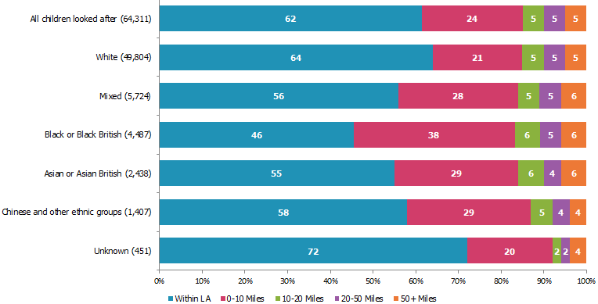

What type of placements were children living in?

47. The small rise (668) to 68,554 in the number of children looked after as at 31 March 2014 compared to the same day in 2013 was mostly due to an increase in the number of children living in fostering and adoption placements. (Chart 8)

48. There was a small rise (497) in the number of children fostered, from 50,804 in 2013 to 51,301 in 2014. This rise was mainly in other foster carer placements rather those with a relative or friend. (Chart 8)

49. There was a small drop (37) in the numbers in children’s homes, from 6,141 to 6,104. (Chart 8)

50. Five per cent of children were placed for adoption, the same proportion as last year. There was, however, a small increase in numbers of children from 3,402 to 3,561, which was an increase of five percentage points. (Chart 8)

51. Ten per cent of children placed for adoption were placed with their current foster carer.

52. Almost 5% of children looked after were placed with their own parents or other person with parental responsibility (3,207). (Chart 8)

53. The types of placements that children live in, and the proportion of children in those placements, remained unchanged as at 31 March 2014 from the previous year. (Chart 8)

Chart 8 Proportion of children living in each placement type, as at 31 March 2014,
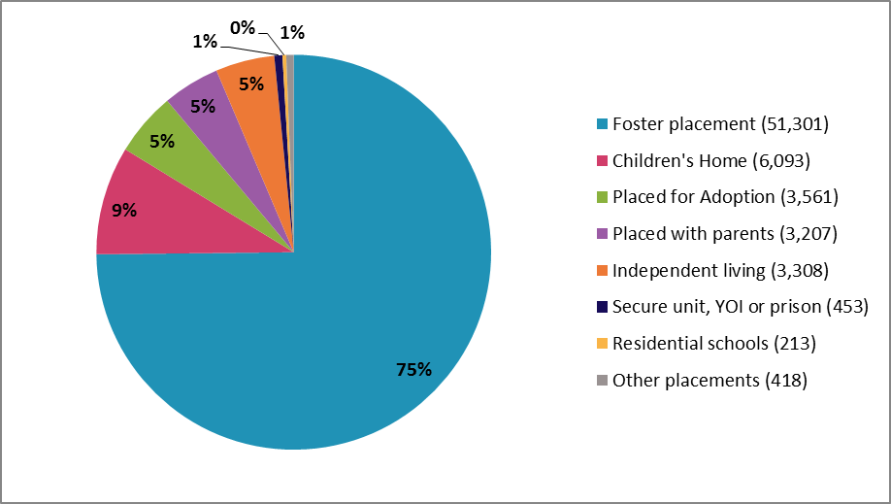
54. Three local authorities had no children placed for adoption at 31 March 2014: City of London, Hillingdon, and Lewisham.

55. Seven local authorities had around one tenth of children in their area placed for adoption, four of them in the north of England.

56. Ten local authorities reported no children placed with parents; six of these were in London. However, this may be because the LA did not include these placement types in their return.

57. Sixteen local authorities in total had 10% or more of their children looked after placed with parents; 11 of these were in the North West.

58. Sefton had the highest percentage of its children looked after placed with parents (19%).

59. Children living in children’s homes were more likely to be White at 82% with 18%, or one in five, being from BME backgrounds. (Chart 9)

60. Children who were placed for adoption were also more likely to be White at 83%, but they were also more likely than the general child looked after population to be of Mixed ethnicity at 11% compared with 9% nationally. (Chart 9)

61. A higher proportion of children who were looked after but placed with parents or with someone with parental responsibility were Asian (6%) compared with the proportion of Asian children looked after nationally (4%). So while Asian and Asian British children were less likely to be looked after than any other ethnic group, upon being looked after they were more likely to be placed with their parents or another person with parental responsibility. (Chart 9)

62. Young people who were from BME backgrounds were more likely to be living independently than White children. Of the total number of children living independently, 44% were from BME backgrounds, with over one in ten being Black or Black British. This correlates with findings above (page 11) that young people who were looked after and from BME backgrounds were more likely to be aged over 16 than White children. (Chart 9)

63. Children living in secure units, Young Offender Institutes and prisons are substantially more likely to be from BME backgrounds and in particular are more likely to be from Black and Black British backgrounds than the looked after population as a whole. One in five children (20%) living in secure units, YOIs or prison were Black. (Chart 9)

Chart 9 Proportion of children by placement type and ethnicity as at 31 March 2014

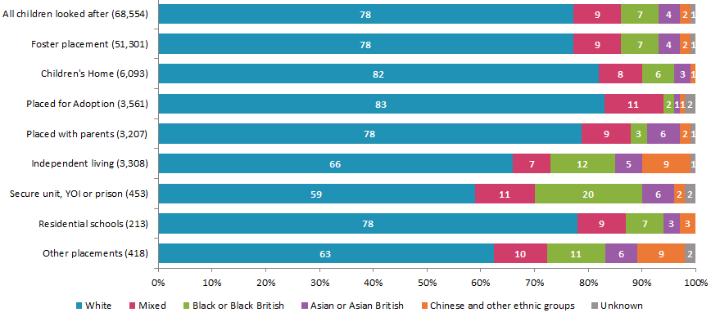

Children living in placements whose providers are not inspected by Ofsted

64. There were 7,157 (10%) children living in placements that are not inspected by Ofsted. These included those: placed with their own parents or persons with parental responsibility; in refuges; missing; in NHS or health trust locations; in independent living; in residential accommodation, such as hostels; in adult residential care homes; in residential employment; and in Young Offenders Institutions.,

Children reported missing

65. The number of children reported missing for more than 24 hours at 31 March remained the same as in 2013, 95, or 0.1%, of all children looked after. It is commonly agreed that this is a considerable underrepresentation of the real picture. The DfE data collection for 2014-15, which will be published in late 2015, is likely to provide a much richer and more accurate view of missing children than has been available previously.

66. As is usual when discussing such small numbers, drawing conclusions from such data should only be done with very great caution.

67. There were 93 children for whom a start date for going missing was provided.

68. Thirty-three had been missing for six months or longer, compared to 24 in 2013.

69. Twenty-two had been missing for one year or longer, compared to 12 the previous year, and six for two years or longer, compared to two the previous year.

70. The average age at which children went missing was 14 years.

71. Due to the length of time some children had been missing, the average age of children who were missing on 31 March 2014 was 15 years.

72. Almost three quarters of the children and young people reported missing (70) were male.

73. Chinese children made up almost one third of all missing children (29) in 2014. They were primarily placed in the South East, and so this may be accounted for by the disappearance of children thought to be trafficked into the UK and removed from foster care.

74. Thirty-nine local authorities had at least one missing child, compared to 33 LAs in 2013.

75. Of the 20 LAs with the largest children looked after populations on 31 March, 10 reported no children missing for more than 24 hours.

How long had children been in their placements?

76. Children have, overall, remained living in the same place for slightly longer than they had in the year ending March 2013. The following chart compares the length of time children looked after had been living in the same place as at 31 March 2013 and 31 March 2014.

77. The data on length of placement overall indicates some greater placement stability for some children. Children in all placement types had lived in their most recent placement longer than they had in 2013. (Chart 10)

Chart 10 Proportion of children looked after by length of time in placement, as at 31 March, for the years ending 2013 and 2014

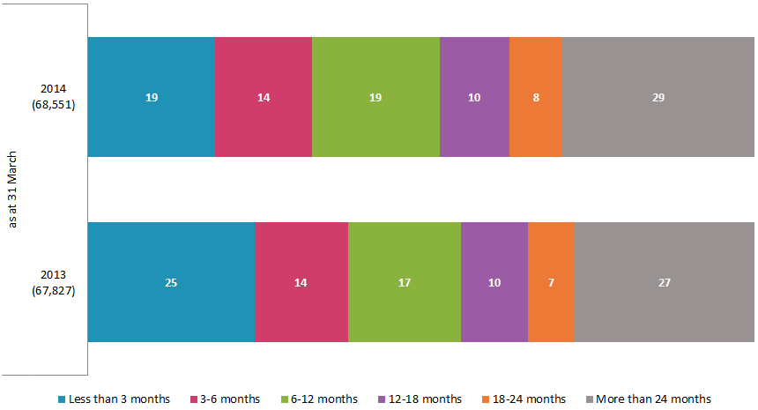

78. As at 31 March 2013, one in four children looked after had been living in the same place for less than three months; as at 31 March 2014, this had dropped to one in five. (Chart 11)

79. A slightly higher proportion of children, though, had been living in the same place for more than two years this year at 29%, compared with 27% in 2013. (Chart 11)

80. Children who were placed for adoption had lived in their placements for longer than they had as at 31 March 2013, despite government targets to reduce timescales for adoption. As at 31 March 2013, 71% had been in their adoption placement for less than six months, while for 2014 this had decreased to 64%. (Chart 11)

81. Children who were reported as living independently and in residential accommodation (over 16s) were also reported to have lived in their most recent placement for longer than they had in 2013. As at 31 March, 2013, 51% had been in their placement for less than three months, while for 2014 this had decreased to 39%. (Chart 11)

Chart 11 Length of time children had lived in their most recent placement as at 31 March 2014

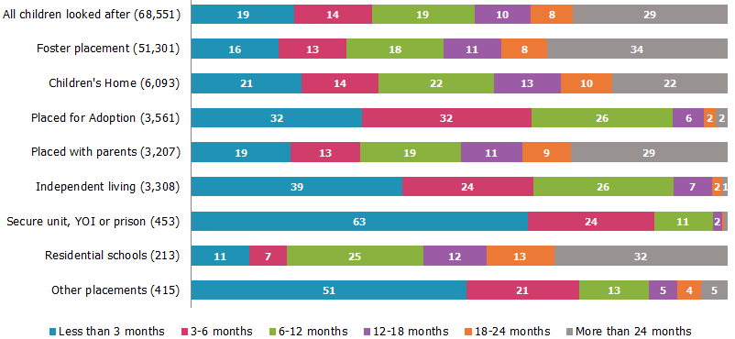

Characteristics of where the children were living

Rural/Urban areas

82. Over three quarters (83%) of children looked after, for whom placement location was known, were living in urban areas (52,982), similar to 2013. (Chart 12)

Chart 12 Proportion of children in rural and urban locations by placement type

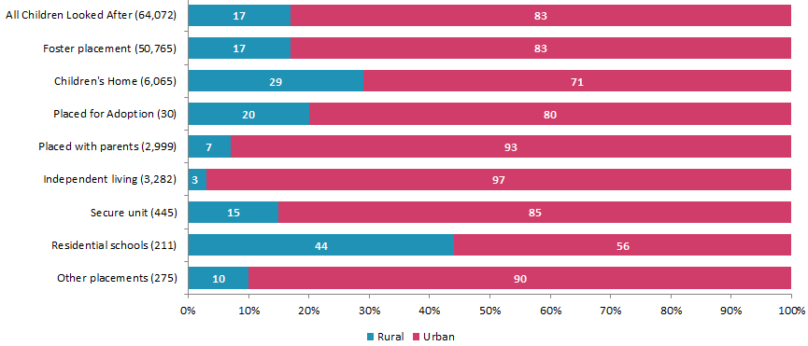

83. Around half of these children (46%) lived in a major urban conurbation area.

84. A total of 11,090 children looked after (17%) lived in rural towns and villages, an increase of 478 children since 2013.

85. There were 4,709 (7%) children looked after living in seaside towns. Of this group, 86% were fostered (an increase of 2 percentage points from 2013) and 10% were living in children’s homes, unchanged from 2013. Three percent were in independent living.

86. Children in the 10-15 age group were most likely to be living in rural areas, with one fifth of this group in rural placements.

87. Children aged 16 and over, and aged 1-4, were least likely, with one sixth in rural placements.

88. There was little variation between boys and girls around rural and urban locations.

89. White children were most likely to live in rural settings, with 20% of white children in rural placements (9,870).

90. Asian and Black children were least likely, at 6% each (136 and 267 children respectively).

91. The difference between ethnicity groups was reduced for children living in children’s homes, where around one quarter of children from every ethnic group were in rural settings.

Deprivation

92. It was possible to identify the deprivation level, through postcodes, of the locations of 63,749 (93%) children and young people looked after.

93. As with last year’s picture, similar numbers of children were living in all areas of deprivation, from the least deprived (Quartile 1) to the most deprived (Quartile 4). (Chart 13)

94. Just over one in four (17,763) children looked after were living in the most deprived areas of the country, while one in five were living in the least deprived (12,614). (Chart 13)

95. Children living in children’s homes were less likely to be living in the most deprived areas than children who are fostered: 19% of children in children’s homes, compared to 26% of fostered children. This represents a shift from 2013, when there was no difference between the two groups of children. (Chart 13)

96. The majority of children (55%) living in children’s homes were in the least deprived areas of England. (Chart 13)

97. There were 1,703 children (or 28%) living in children’s homes in the least deprived areas, compared to 1,165 (or 19%) in the least deprived. (Chart 13)

98. Children living in independent living or residential accommodation were more than twice as likely to live in the most deprived areas of the country. Forty-one per cent were living in the most deprived areas while 7% lived in the least deprived; this is the second lowest proportion after children placed with parents. This represents an improvement from the position in 2013, when 48% were in most deprived areas and 5% in least deprived. (Chart 13)

Chart 13 Proportion of children looked after by placement type and level of deprivation in local areas, as at 31 March 2014

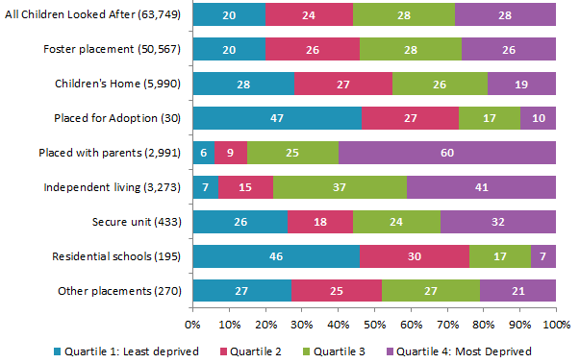

99. Fourteen local authorities placed at least a third of their children in the least deprived areas. This is an increase from only nine local authorities doing the same in 2013. Warrington placed the highest proportion of their children in least deprived areas (43%).

100. Thirteen local authorities placed more than half of their children in areas of most deprivation; eleven of these were in the London region (three in Outer London, the others in Inner London), with two additional LAs in the North West. This is similar to 2013 figures. (Map 4)

Map 4 Proportion of children placed in children’s homes in the most deprived areas, as at 31 March 2014
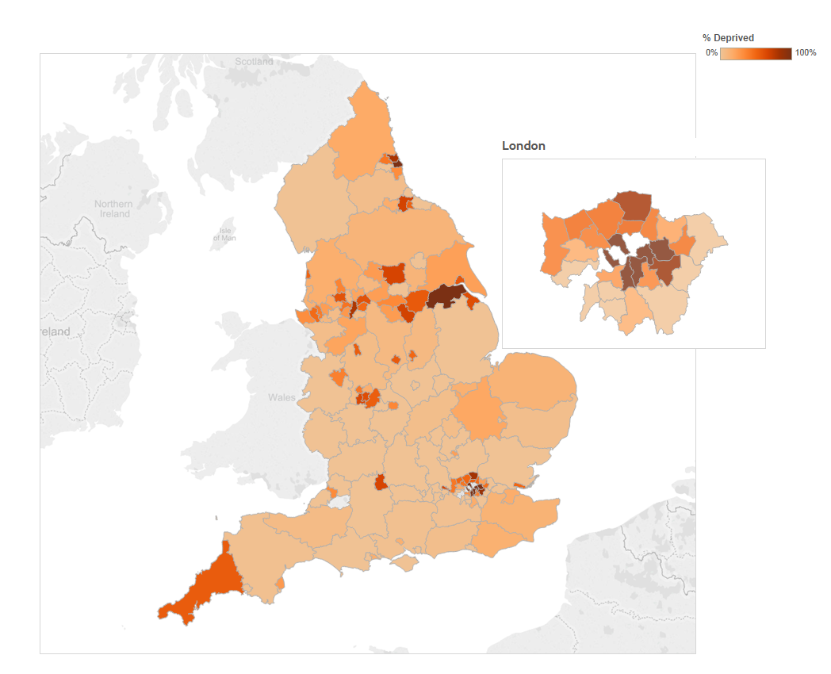

101. While, overall, children living in children’s homes are not more likely to live in the most deprived areas than the least deprived, there were five local authorities where children in children’s homes were more likely to live in the most deprived areas. Unlike in 2013, when the majority of these were in London, in 2014, only one was in London. There is also a general change from 2013, when larger authorities were the most likely to have children in children’s homes living in areas of more deprivation.

102. White children were most likely to be living in areas of least deprivation, with 22% in least deprived areas, compared to 14% of BME children. (Table 5)

103. A large proportion of all BME children (40%) were living in areas of highest deprivation, compared to one quarter of White children. (Table 5)

104. However, children of Mixed ethnicity were less likely than children from other BME backgrounds to live in the most deprived areas, with 34% (1,915 children) living there. (Table 5)

Table 5 Proportion of children living in each deprivation area, by ethnicity, as at 31 March 2014

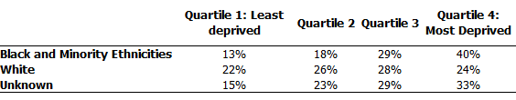

Crime
105. Just over one in four (18,128) children looked after were placed in areas of the country with the highest crime levels, while just over one in five were placed in areas with the lowest crime levels (13,422)., (Chart 14)

106. Children living in children’s homes were no more likely to be living in high crime areas than children in foster care, reflecting the situation in 2013. (Chart 14)

107. Half of children and young people living in independent accommodation and residential homes were living in areas with the highest crime levels (1,630), similar to 54% in 2013. (Chart 14)

108. Six per cent of young people in independent living accommodation (192) were living in areas with the lowest crime rates, which represents a slight increase form 4% in 2013. (Chart 14)

Chart 14 Proportion of children looked after by level of crime in local area, according to placement type, as at 31 March 2014

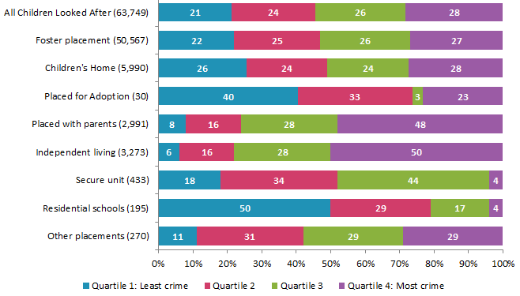

109. Although children living in children’s homes were not more likely to be living in high crime areas, thirteen local authorities placed more than half of the children placed in children’s homes into the highest areas for crime in the country. (Map 5)

110. Additionally, all children living in children’s homes in ten local authorities, two fewer than 2013, were placed in the highest areas for crime in the country; seven of these were in the London region. (Map 5)

111. In 2013, all children living in children’s homes in 12 local authorities were placed in the highest areas for crime in the country; of these, four have reduced the proportion of children in these areas. Although some of these LAs are among the most deprived in the country, which is closely linked to crime levels, not all are. (Map 5)

Map 5 Proportion of children placed in children’s homes in highest crime areas, as at 31 March 2014
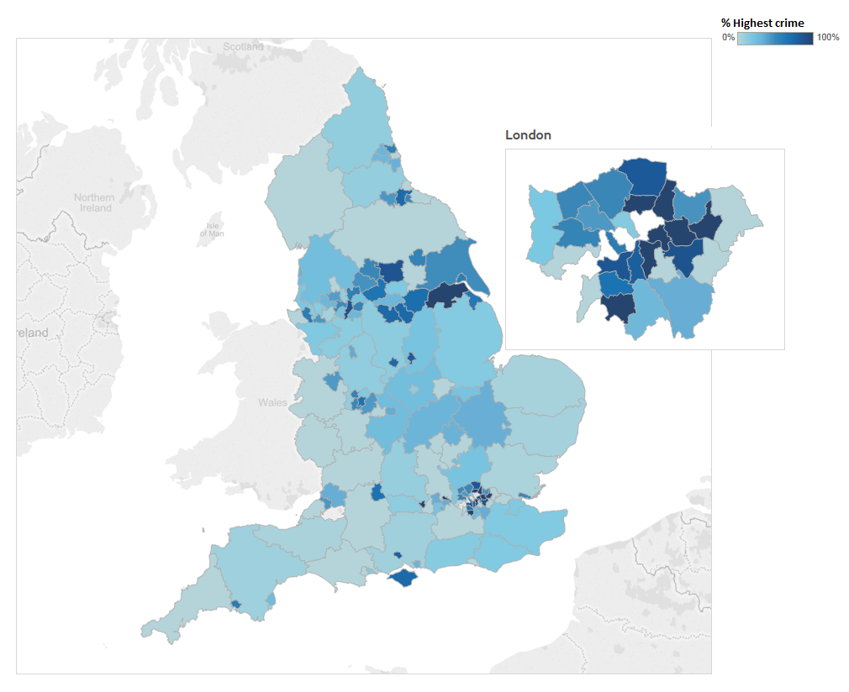

112. Older children were more likely to be living in areas with highest crime levels (32% or 4,540 children); this is mostly accounted for by the higher numbers of children in independent living being in highest crime areas (50% of children aged 16 and over in independent living were in highest crime areas). There were no particular variations based on gender.

113. Similar to findings in relation to areas of deprivation, White children were more likely to be placed in lowest crime areas compared to BME children (24% of White children, 11% of BME children).

114. Close to half of all BME children (39%) were in areas with highest crime, compared to one quarter of White children. This is almost certainly due to the connection between levels of crime and levels of deprivation. It may also be influenced by the higher proportion of BME children living in major urban conurbation LAs with correspondingly higher deprivation and crime levels, compared to White children, who are more likely to live in Shire counties.

Independent Living

115. By comparison to other regions, children who were the responsibility of the London region were most likely to be in independent living, with 6% (572 children) in independent living. (Chart 15)

116. Children in the North East were least likely, with 1% (42 children) in independent living. (Chart 15)

117. Children in independent living were most likely to be from the London region, with one quarter of all children in independent living being from London, in line with 2013. Chart 15)

118. The proportion of children placed in independent living dropped by one percentage point for the West Midlands, and increased by the same for the East of England from 2013; all other regions remained the same. (Chart 15)

Chart 15 Proportion of children in independent living by placing region, 2014 and 2013

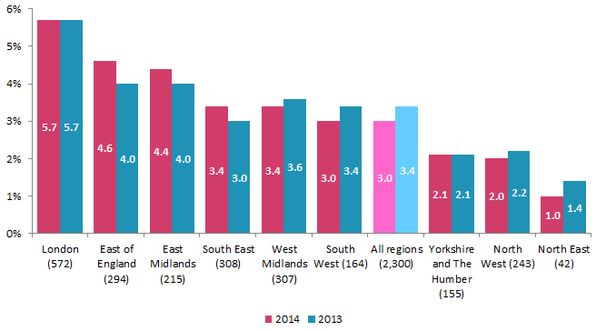

119. Thirteen local authorities had no active independent living placements as at 31 March 2014 i.e. they had no children living in the local authority in independent living. Five of these were in the London region, and three in the South East region.

120. Only one local authority had no children for whom it was responsible in independent living (Wokingham).

121. The largest number of children in independent living were the responsibility of Kent local authority (5% or 119 children).

122. Hillingdon had the highest proportion of children living within its borough in independent living arrangements (18% or 66 children).

123. Of those children in independent living for whom placement location data was available, 97% were living in an urban location, the highest percentage of any placement type (2,209 children).

124. Around half of children in independent living were placed in the areas of highest deprivation (44% or 991 children). This was substantially higher than all other placement types.

125. There has been a slight shift in the level of deprivation of independent living placements since 2013, moving from 48% in most deprived areas in 2013 to 44% in 2014.

126. Around half of children in independent living were placed in the areas of highest crime (52% or 1,186 children), unchanged from the previous year. This was substantially higher than any other placement type.

127. Two thirds of children (1,503 children) in independent living with placement location available were placed within their local authority, the highest of all placement types.

128. Three percent were placed more than 50 miles away (66 children), substantially lower than any other placement type except foster placements (4%).

Provision and quality of children’s social care
129. The East Midlands, London and South West regions placed the smallest proportion of children for adoption with a voluntary adoption agency (VAA), at around 5% each. (Map 6)

130. It was very common for local authorities to place all children via a local authority agency. For example, all but nine of the 30 LAs in the London region which placed children for adoption did so via a local authority adoption agency, as did all but two of the nine LAs in the East Midlands. (Map 6)

131. Three local authorities (Harrow, Trafford and Hackney) placed three quarters or more of their children with VAAs, and Harrow placed all children with VAAs. (Map 6)

Map 6 Proportion of children local authorities placed using Voluntary Adoption Agencies, as at 31 March 2014
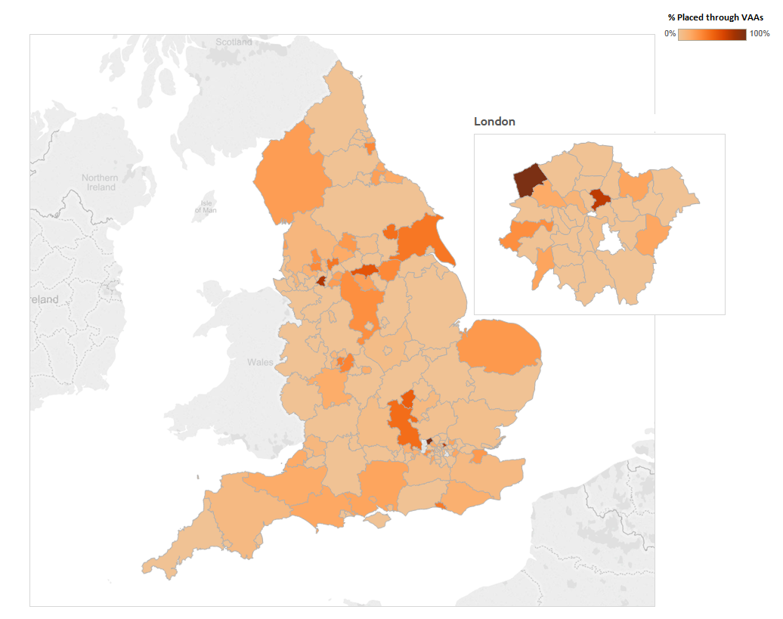

Capacity and occupancy

Children’s Homes

132. There were 1,974 children’s homes (excluding residential special schools registered as children’s homes) as at 31 March 2014, compared to 1,950 in 2013.

133. There were approximately 1,694 children’s homes with at least one child in placement as at 31 March 2014, an increase of 65 from 2013.

134. There were 205 active children’s homes with no children in placement on this date, a reduction by around one third from 2013.

135. The South West and London had half or more of their available children’s homes places unfilled on 31 March 2014. The North West had the smallest proportion, at just over one third. (Table 6)

136. The North West saw the greatest change in proportion of unfilled places, which dropped by six percentage points from the same date in 2013. (Table 6)

137. The South East saw the smallest change, of three percentage points. (Table 6)

Table 6 Places in active children’s homes, as at 31 March 2014

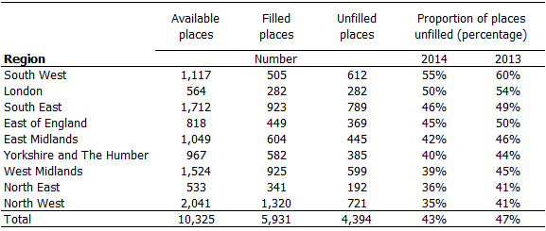

138. It is important to note that these data are for the day in question and may vary on other days. Children’s homes places may be unfilled for a variety of reasons including that some places were not available for use, or that the homes often provide very specialised care to meet particular needs, for which demand on the day in question was not required.

139. Data relating to providers and places is given in more detail in the Children’s Social Care in England Statistical First Release, due for publication on 30 July 2015.

Fostering

140. There were 462 active fostering services on 31 March 2014; eight more than in 2013.

141. One hundred and fifty-two of these were run by the local authority, and 310 were independent fostering agencies.

142. Four hundred and thirty-five fostering services had at least one child in placement as at 31 March 2014.

143. Four local authorities and 23 IFAs had no children in placement at this date.

144. The number of approved foster places in England increased by just under 5,000 from 2013, to 81,190.

145. 51,315 of these places were filled.

146. 29,875 places were unfilled:
17,275 were vacant;
5,725 were unavailable due to the needs of other children in placement;
6,875 were unavailable due to the foster carer’s circumstances.

147. Places in IFAs were more than twice as likely to be unavailable due to the needs of other children compared to local authority fostering agencies.

The quality of children’s placements

148. There were 61,369 children placed with providers inspected by Ofsted (compared to 60,395 in 2013).

149. There were 7,185 (compared to 7,311 in 2013) children in placements that were either not inspected by Ofsted, in placement with provisions that had not yet been inspected at this date, or where there was insufficient information given to verify the provider.,

150. Inspection outcomes for regulated providers of residential accommodation can tell us something about the quality of the placement. Inspection outcomes for adoption and fostering agencies, though, only tells us about the quality of the services that recruit, train and support adopters and foster carers, not about the nature of the placement itself.

Children’s homes
151. There were 6,093 children living in children’s homes at the end of March 2014. Of these children, outcome judgement data was available for the vast majority (5,735).

152. Almost one in four (24% or 1,369 children) were living in adequate homes and 1% (64) were living in inadequate homes, according to their most recent Ofsted inspection.

153. The large majority of children were living in homes judged good or better: 16% were outstanding and 59% were good.

154. For those homes judged adequate or worse as at 31 March 2014, children in those homes were the responsibility of 148 (97%) local authorities.

155. Outcome judgement data is also available on homes in which 5,126 children were living, for the point in time when the children were actually placed at the homes up to 31 March 2014.

156. Of these 5,126 children, 17% (1,015) were placed in adequate homes and 2% (87) were placed in inadequate homes.

157. Local authorities reported that one in seven children were placed in homes before they were inspected.

158. One fifth of local authorities had 25% or more of their children living in outstanding children’s homes. Around one third of local authorities had 80% or more of their children living in good or better children’s homes.

159. The percentage of children who had been in placement for more than 24 months at 31 March has increased from 20% in 2013 to 22% (1,312 children) in 2014, with a corresponding decrease in shorter placement durations.

160. Boys made up almost two thirds of children in children’s homes (3,927 children).

161. Around one fifth (1,329) of children were living in children’s homes in the North West region.

Commissioning and ownership

162. As at 31 March 2014, each local authority had children within their boundary that had been placed by other local authorities. The average was from 21 other local authorities, ranging from two LAs placing in City of London to 81 LAs placing children in Kent. (Map 1)

163. Although the average number of LAs placing in each local authority has fallen slightly, the range has remained fairly static, as the highest number of authorities placing in 2013 was 85. (Map 1)

164. Around one fifth (30) of authorities had children placed there from 40 or more other local authorities, in line with 2013. (Map 1)

Private and voluntary organisations

165. There were around 730 different private and voluntary organisations looking after 21,255 children at the end of March 2014. This represents an increase in the number of organisations, from over 600 in 2013, but a reduction in the number of children being looked after by these organisations, by around 1,700 children.

166. This suggests that there may be more children being placed in smaller organisations. There is huge variation in the size and scope of these organisations, from small private organisations looking after one or two children, in very small children’s homes, to large organisations looking after several hundred children through children’s homes, adoption, and fostering agencies. As such, organisations may each have several registered provisions.

167. There were 69 larger private and voluntary organisations that owned a service in more than one provision type; an increase of 12 from 2013:
Just under two thirds (40) of these owned both children’s homes and fostering services.
Two organisations owned children’s homes, fostering and adoption services, compared to nine in 2013.

168. These 69 organisations looked after 16,594 children at the end of March, or one quarter of all children looked after.

169. This was a large increase from the position in 2013, when only one tenth of children were looked after by an organisation with multiple provision types; however, this may not be unexpected given the increase in number of organisations with multiple provision types.

170. Over three hundred private and voluntary organisations looked after children with just one type of provision: a total of 4,509 children (7%).

Children’s homes

Map 7 Proportion of children by placing local authority living in children’s homes which were private or voluntary owned, as at 31 March 2014
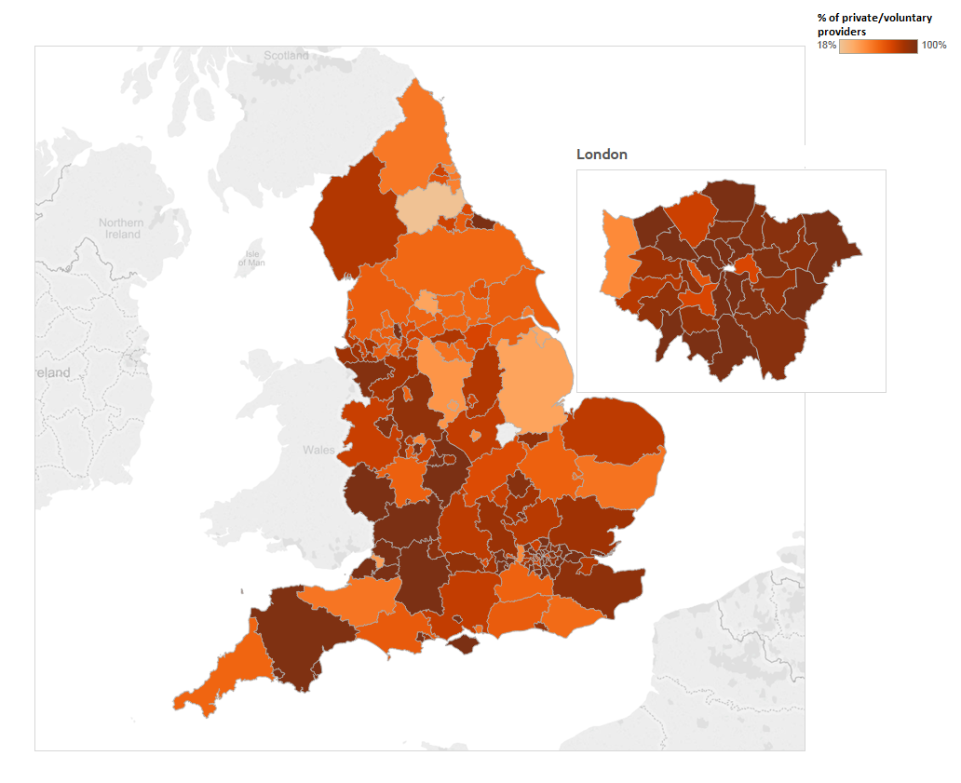

171. There were 477 separate private and voluntary-run organisations looking after a total of 4,413 children in children’s homes, representing an increase in both number of children placed (from 4,299) and number of providers (412) in 2013.

172. At 31 March 2014, 114 of these organisations looked after one or two children (just under one quarter, as in 2013), and 140 looked after between three and five children, across all their individual registrations (just under one third, as in 2013).

173. The largest 20 organisations looked after a total of over 1,300 children, (30%) of all children in private and voluntary children’s homes; this was a reduction of almost 400 children (nine percentage points) from 2013.

174. Of that group, the five largest organisations looked after just over 700 children, compared to 900 children in 2013.

175. Seventeen of the largest 20 organisations were private and three were voluntary, a slight change from 2013 when 16 were private and four voluntary.

Independent fostering agencies

176. There may be a shift away from large multiple provider organisations in the fostering sector; there was an increase of over one fifth in the number of private and voluntary organisations (from 170 to 208) between 2013 and 2014.

177. Although there was a 20% increase in the number of organisations owning more than one registered provision, the number of IFAs owned by these increased by 3%, from 281 to 290, and the number of children looked after by them increased by around 700, to 16,205.

178. Most of these children (86%) were looked after by privately-run independent fostering agencies, with 14% looked after by voluntary-run services.

Map 8 Proportion of children placed by fostering agencies which were private or voluntary owned, as at 31 March 2014
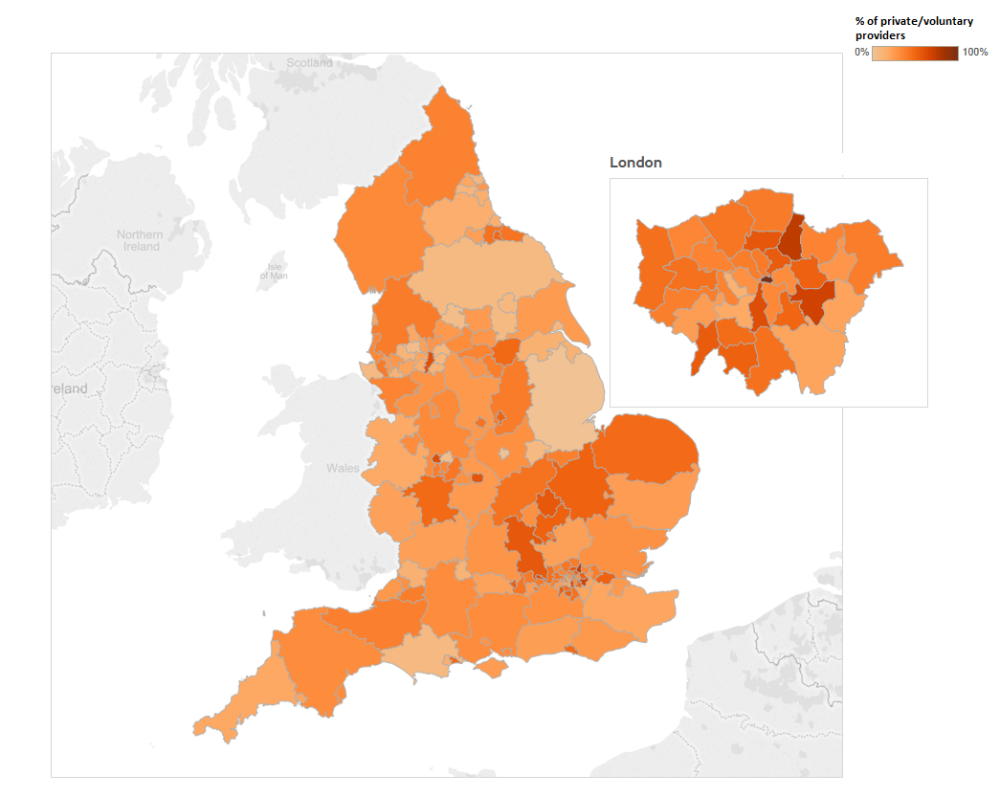

179. Half (8,172) of all children looked after by IFAs were looked after by just 16 organisations, operating through the 71 services that they owned. Of these, 12 were privately owned.

Revisions to previous release
There were no revisions to the previous release covering data at 31 March 2013.

Methodology
In both 2013 and 2014, 100% of local authorities returned data. The methodology used for data collection and cleansing is described in detail in the accompanying Quality Report, which can be found here: https://www.gov.uk/government/collections/childrens-social-care-statistics

List of tables and charts
List of Charts
Chart 1 Children looked after population in England on 31 March 2014 & 2011 Census of all children aged 0-17
Chart 2 Ethnicity of children looked after according to their age group
Chart 3 Proportion of children living in and placed by each region, as at 31 March 2014
Chart 4 Number of children living in and placed by each region in children’s homes, as at 31 March 2014
Chart 5 Proportion by placement type and distance
Chart 6 Age of children looked after and the distance they lived from their LA boundary, as at 31 March 2014
Chart 7 Ethnicity of children looked after and the distance they lived from their LA boundary, as at 31 March 2014
Chart 8 Proportion of children living in each placement type, as at 31 March 2014
Chart 9 Proportion of children by placement type and ethnicity as at 31 March 2014
Chart 10 Proportion of children looked after by length of time in placement, as at 31 March, for the years ending 2013 and 2014
Chart 11 Length of time children had lived in their most recent placement as at 31 March 2014
Chart 12 Proportion of children in rural and urban locations by placement type
Chart 13 Proportion of children looked after by placement type and level of deprivation in local areas, as at 31 March 2014
Chart 14 Proportion of children looked after by level of crime in local area, according to placement type, as at 31 March 2014
Chart 15 Proportion of children in independent living by placing region, 2014 and 2013

List of Tables
Table 1 Summary of key placement codes before and after Ofsted quality assurance 2014
Table 2 Placement by type 2013 & 2014
Table 3 Number and proportion of children looked after by their age group
Table 4 Number and proportion of children looked after by their ethnicity
Table 5 Proportion of children living in each deprivation area, by ethnicity, as at 31 March 2014
Table 6 Places in active children’s homes, as at 31 March 2014

List of maps
Map 1 Number of children placed in each local authority, as at 31 March 2014
Map 2 Proportion of children outside LA boundary, as at 31 March 2014,
Map 3 Proportion of children 20 miles or more from LA boundary, as at 31 March 2014
Map 4 Proportion of children placed in children’s homes in the most deprived areas, as at 31 March 2014
Map 5 Proportion of children placed in children’s homes in highest crime areas, as at 31 March 2014
Map 6 Proportion of children local authorities placed using Voluntary Adoption Agencies, as at 31 March 2014
Map 7 Proportion of children by placing local authority living in children’s homes which were private or voluntary owned, as at 31 March 2014
Map 8 Proportion of children placed by fostering agencies which were private or voluntary owned, as at 31 March 2014

Glossary
Adoption agencies
The focus of all adoption agencies is on placing children successfully into adoptive families who the agency recruits, assesses, prepares and supports, so they will meet the children’s needs and enable them to develop and achieve throughout their lives. The services maintained by local authorities are described in section 3(1) of the Adoption and Children Act 2002. Local authorities place children with adoptive families recruited and approved by themselves, by other local authorities or by voluntary adoption agencies who must register with Ofsted. Adoption agencies may also provide birth records, counselling and intermediary services to adoptees and birth relatives. There are three branches of voluntary adoption agencies in Wales which are inspected by Ofsted because their head offices are in England.

Adoption support agencies
Adoption support agencies are defined by section 8 of the Adoption and Children Act 2002 and provide services to anyone touched by adoption and are registered with Ofsted. This includes counselling and help for children and adults to gain information about their adoption or to trace birth relatives. Adoption support agencies can be either organisations or individuals, and may be contracted by a local authority to provide support services.

Boarding Schools
The majority of boarding schools are independent and belong to associations which are members of the Independent Schools Council. As both education and welfare in these schools are inspected by their own inspectorate, Ofsted does not inspect these schools and so they are not included in the data. The remainder are maintained boarding schools where both education and the welfare of boarders are the subject of Ofsted inspection and independent boarding schools which are members of the Bridge Schools Inspectorate or Schools Inspection Service and who receive their education inspections by these organisations and their welfare inspections by Ofsted.

Children’s homes
A children’s home is defined in section 1 of the Care Standards Act 2000, and is an establishment that provides care and accommodation wholly or mainly for children. Children’s homes vary in size and nature. They fulfil a range of purposes designed to meet the different needs of those children and young people who are assessed as needing a residential care placement. Some homes, for example, provide short breaks which are needed to help support children and their family. Some residential special schools are registered as children’s homes because boarders are resident for more than 295 days per year.

Fostering agencies
Local authority fostering agencies are defined by section 4 of the Care Standards Act 2000. Local authority fostering agencies and independent fostering agencies (IFAs) recruit, prepare, assess, train and support foster carers. Independent fostering agencies are private companies or charities, which are registered with Ofsted and provide placements to children and young people with foster carers approved by them. IFAs work closely with local authorities to deliver these placements.

Placed for adoption
A child may be placed for adoption with parental/guardian consent or with a placement order. A child placed for adoption is living with their proposed adopters, where the permanence plan for the child is adoption, but the final adoption order has not yet been completed.

Placed with parents
A child can remain looked after but be living with their parent(s), for example, as a step towards returning the child to live permanently with their parents. When a child is placed with parents, they remain the responsibility of the placing local authority. Parents in this instance are defined as a parent, a person with parental responsibility, a person who has a Child Arrangements Order in respect of the child, or any person having contact with the child by virtue of an order made under S34 Children Act 1989.

Residential accommodation in further education colleges
The care provision of further education colleges that provide, or arrange, residential accommodation for one or more students under the age of 18 years. Ofsted inspects these colleges under section 87 of the children act 1989.

Residential family centres
Residential family centres are defined in section 4(2) of the Care Standards Act 2000 as establishments at which: a) accommodation is provided for children and their parents; b) the parents’ capacity to respond to the children’s needs and to safeguard their welfare is monitored and assessed; and c) the parents are given such advice, guidance and counselling is considered necessary.

Residential special schools
Residential special schools are defined in section 59 of the Safeguarding Vulnerable Groups Act 2006. They vary in size and nature. The sector includes large non-maintained special schools which make provision for very specific needs and take children as full boarders from all over the country, to smaller more local providers catering for children with a range of different special needs and disabilities who may be resident at the school only during the week. Some residential special schools are registered as children’s homes because boarders are resident for more than 295 days per year. There are also a small number of independent residential special schools who also tend to cater for children with very specialist needs.

Secure children’s homes
Secure children’s homes are defined by section 25 of the Children Act 1989. They accommodate children and young people who are remanded or have been sentenced for committing a criminal offence. They also accommodate children and young people who are placed there by a court because their behaviour is deemed to present a significant and immediate threat to their safety or the safety of others, unless they are placed in a secure environment. Ofsted inspections are conducted in accordance with the Care Standards Act 2000 and judgements in reports are made in relation to the outcomes for children set out in the Children Act 2004. The criteria are the same as those used to inspect non-secure children’s homes.

Secure training centres/Secure units
Secure training centres are defined by section 43(1) (d) of the Prison Act 1952. Ofsted has the power to inspect under section 146 Education and Inspections Act 2006 and inspects both the care and educational provision for children in four secure training centres. They accommodate young people between the ages of 12 and 17 who have been remanded or sentenced by the courts. The centres are under contract to the Youth Justice Board, which monitors their compliance with requirements. Ofsted does not regulate secure training centres but has an agreement with the Youth Justice Board to inspect care twice a year and education once a year.

Young offenders’ institutions
Young offender institutions (YOIs) are a type of prison for offenders aged between 18 and 20, with some catering for young offenders aged 15 to 17. Generally a young offender is regarded as such until the date of their 21st or 22nd birthday, whereupon he or she will be sent to an adult prison or can remain in the YOI until they turn 22 if deemed appropriate. These were introduced under the Criminal Justice Act 1988.

Sector
Sector refers to the type of provider that owns the children’s social care provision.

Local Authority
These are public bodies responsible for the provision.

Private
These are for-profit organisations mostly with limited company status. These can also, though, be individually owned provisions and run for profit.

Voluntary
These are mostly not-for-profit organisations, mainly with charitable status. These can also be individually owned provisions and run on a not-for-profit basis.

Health Authority
These are NHS Trust-run.

SSDA903 return
This is an annual return to the Department for Education (DfE) completed by each local authority in England for every child looked after by that local authority at any time during the year ending 31 March, and all young people eligible for care leave support and whose 19th, 20th or 21st birthday falls within the collection period.

Placement codes
The children looked after placement data collection requested data on children’s placements that, for the most part, had already been validated as part of the process to submit the SSDA903 returns to the DfE. This DfE return requires local authorities to submit details of the placements where their children are, using placement codes.

The full list of placement codes and their meanings is as follows:

Placement Codes:
A3 | Placed for adoption with parental/guardian consent with current foster carer
A4 | Placed for adoption with parental/guardian consent not with current foster carer
A5 | Placed for adoption with placement order with current foster carer
A6 | Placed for adoption with placement order not with current foster carer
H5 | Residential accommodation not subject to Children’s Homes Regulations
K1 | Secure Unit
K2 | Children’s Homes
M1 | In Refuge (Section 51 of Children Act)
M2 | Whereabouts known (not in Refuge)
M3 | Whereabouts unknown
P1 | Placed with own parents or other person with parental responsibility
P2 | Independent living
P3 | Residential employment
Q1 | Foster placement with relative or friend
Q2 | Placement with other foster carer
R1 | Residential Care Home
R2 | NHS/Health Trust or other establishment providing medical or nursing care
R3 | Family Centre or Mother and Baby Unit
R5 | Young Offender Institution or prison
S1 | All Residential schools, except where dual-registered as a school and Children’s Home.
T0 | All types of temporary move
T1 | Temporary periods in hospital
T2 | Temporary absences of the child on holiday
T3 | Temporary accommodation whilst normal foster carer is on holiday
T4 | Temporary accommodation of seven days or less, for any reason, not covered by codes T1 to T3
Z1 | Other placements

Placement Provider Codes
PR0 | Parents or other person with parental responsibility
PR1 | Own provision (by the Local Authority)
PR2 | Other Local Authority provision
PR3 | Other public provision (e.g. by a PCT etc.)
PR4 | Private provision
PR5 | Voluntary/third sector provision

Placement Location Codes
IN | Inside local authority boundary
OUT | Outside local authority boundary

Aggregated placement codes

For the purposes of this release, we have aggregated some of the codes so that they are grouped with similar placements, for example all the adoption placement codes are grouped together. This helps increase the number of children in a particular type of placement and therefore the robustness of the data. The following aggregations of placement types have been used:

Foster placement Q1 - Q2
Children's Home K2
Placed for adoption A3 - A6
Placed with parents P1
Independent living and residential accommodation P2 and H5
Secure unit, Young offender institution or prison R5 and K1
Residential schools not registered as children's homes S1
Other placements M1 - M3, P3, R1 - R3, Z1

If you have any comments or feedback on this publication, please contact the Social Care Data Team on 03000 130 020 or socialcaredata@ofsted.gov.uk.

© Crown copyright
You may re-use this information (not including logos) free of charge in any format or medium, under the terms of the Open Government Licence. To view this licence, visit http://www.nationalarchives.gov.uk/doc/open-government-licence/ or write to the Information Policy Team, The National Archives, Kew, London, TW9 4DU or e-mail: psi@nationalarchives.gsi.gov.uk

For a definition of any terms used in this document, please refer to the glossary at the end of the document.
For more detailed information about the social care system in England, please refer to the Department for Education website, here (https://www.gov.uk/topic/schools-colleges-childrens-services/looked-after-children).
A related collection was carried out in 2011, but this concerned only commissioned places (excluding placements made via local authority’s own provision) and therefore the data is not comparable and has not been referenced in this release. There was no collection in 2012.
Unique Reference Numbers, the number assigned to each provider of care to children looked after, upon successful registration with Ofsted.
See Glossary for more detailed explanations of placement codes.
The Isles of Scilly had no children looked after on 31 March 2014.
This is a voluntary collection and some local authorities did not wish to disclose information about the location of potential adopters, children and young people living independently, or were placed with parents.
Percentages are rounded and may not add to 100.
The remaining ten children were as follows: four in the Channel Islands, three in Ireland, and three in the Isle of Man.
For further information on children living away from home, or outside of the local authority boundary, see: Ofsted (2013) From a Distance, available on gov.uk here (https://www.gov.uk/government/publications/looked-after-children-living-away-from-their-home-area-from-a-distance). See also: Farmer, E. and Moyers, S. (2008) Fostering effective family and friends placements, London: Jessica Kingsley Publishers. Their research shows that children who live with relatives or friends have more contact with extended family members, often on a daily basis. The fact that many of these children are placed close to where they are from facilitates this type of contact; though that is not to say that this contact is always desirable.
There were 4,243 children for whom we could not calculate distance from local authority boundary because not enough information about their location was provided. Many of these children were living with their parents, in independent living, or placed for adoption.
See: Department for Education (2014) Children’s Homes Data Pack, September 2013 p.10 for analysis of distance from boundary of placements for children in children’s homes at 31 March 2013 here (https://www.gov.uk/government/publications/childrens-homes-data-pack). The figures cited here are different to those in the DfE Data pack as DFE calculated the distance children were from their home as opposed to their local authority boundary. We did not have information about children looked after and their parents’ addresses.
No local authorities placed all of their children looked after within the local authority boundary.
Only the City of London placed all of their children looked after outside of the boundary (11 children). Nine were placed within 10 miles, and two within 20 miles of the boundary.
All LAs had at least one child living more than 20 miles outside the boundary; the highest proportion of children living more than 20 miles outside the LA boundary was 36%.
Percentages are rounded and may not add to 100.
Other placements include: children in a refuge; adult residential care homes; medical establishments; family centres or mother and baby units; residential employment and children missing.
Please refer to the glossary for a definition of these terms.
Young Offender Institutions are inspected by Her Majesty’s Inspectorate of Prisons who are the lead inspectorate for this provision, although Ofsted do provide inspectors to assist.
There were a further 523 children living in placements that had either not yet been inspected, or where we were unable to identify the setting that the children had been placed with.
See, for example, the All-Party Parliamentary Group (APPG) for Runaway and Missing Children and Adults and the APPG for Looked After Children and Care Leavers published the report of the joined enquiry into children who go missing from care in June 2012. A copy of the report can be found here (https://www.gov.uk/government/publications/report-from-the-joint-inquiry-into-children-who-go-missing-from-care).
This is linked to the change in how missing children will be recorded, so that this is no longer recorded by the local authority as a placement change. It is hoped that this will lead to more accurate recording around missing children.
See, for example, EPCAT report here (http://www.ecpat.org.uk/sites/default/files/trafficked_children_and_missing_2.pdf).
These were, starting with the largest LAs: Lancashire, Manchester, Liverpool, Staffordshire, Bradford, Nottinghamshire, Croydon, Dudley, Suffolk, and Bristol
This is likely to be partially accounted for by more intensive data quality work in 2014 than 2013 to remove short breaks/respite placements from the data returned to Ofsted by local authorities, so that there were fewer short placements included in the data.
More detail of this target is given in the Action Plan for Adoption in 2012, available here (https://www.gov.uk/government/publications/an-action-plan-for-adoption-tackling-delay).
A review by Ofsted of children in social care, using voluntarily contributed data from local authorities, discusses placement stability in Section 9.2. The full report is available here (http://www.adcs.org.uk/download/news/adcs-sg-pressures-p4-report-final.pdf).
These data excludes 4,512 children and young people for whom we do not have information about the urban/rural characteristics of where they are living.
Residential accommodation includes hostels, supported living and foyers. These are not inspected by Ofsted.
There were 4,835 children for whom we could not identify the level of local area deprivation. Areas of deprivation are analysed in quartiles as defined by the Office for National Statistics (ONS). Quartile 1 refers to the top 25% of the country in the least deprived areas, while quartile 4 refers to the bottom 25% of the country in the most deprived areas.
Areas of deprivation by crime level are analysed in quartiles as defined by the Office for National Statistics (ONS). Quartile 1 refers to the top 25% of the country in the lowest crime areas, by lower super output areas, while quartile 4 refers to the bottom 25% of the country in the highest crime areas.
This data refers to 63,729 of the 68,554 children placed as at 31 March 2014, as we do not have data on crime for 4,805 children.
Children and young people living in residential accommodation, such as hostels and foyers, have been excluded for the purposes of this section because those classed as independent living are more likely to be living on their own with less supervision. This leaves 2,283 children in independent living where placement location information was available.
This refers to children living in Hillingdon in independent living placements, not all of whom will be children for whom Hillingdon is the responsible LA.
Three local authorities had no children placed for adoption on 31 March 2014.
Residential special schools (RSS) where children reside for more than 295 days are designated as children’s homes and are regulated and inspected as such. They are often very large in size and have children living there who are looked after and who are not. Consequently comparing their capacity with their occupancy can create a distorted picture. These RSS numbers have been excluded from the discussion on capacity versus occupancy. The data have also excluded homes which only provide respite/short breaks care. Short breaks-only homes account for around 1,000 children’s home places across England, particularly concentrated in London (150 places), the South West (200 places), the North West (300 places) and Yorkshire and the Humber (140 places).
2013 figures were calculated including a small number of short break/respite only placements, which were excluded for 2014.
More information can be found in the Fostering in England data, published in January 2015 on the gov.uk website, here (https://www.gov.uk/government/statistics/fostering-in-england-1-april-2013-to-31-march-2014).
The data collected on placements was matched with Ofsted inspection outcomes, using our Unique Reference Numbers as assigned to individual providers. Information here on inspection outcomes refers to the latest full inspection outcome for each provider, as at 31 March 2014, with the exception of the data on children’s homes. The data does not take into account any subsequent inspection, either full or interim. The outcomes also refer only to the most recent stand-alone inspection of services and do not take into account any outcomes from the single inspection of children in need of help and protection, children looked after and care leavers.
3,207 (5%) were children living with parents, for example, and 3,308 (5%) were children and young people in independent accommodation; placements not inspected by Ofsted. 811 children were living in placements through settings that had not yet been inspected (%). 273 were children in all other placement types where the local authority could not readily provide the registration details of the service through which these children were placed. For example, one local authority could tell us which overall organisation they had placed children with, but could not give us the details of which individual registrations they had used. As a result, we were unable to match these placements to Ofsted judgements.
Services that had not been inspected by this date are those that were newly registered or were providers that had re-registered.
It should be noted that some of these homes may have been re-registrations, and so local authorities would have been able to reference inspection judgements against the previous URN.

