Inspections of boarding and residential provision in schools
A report on the responses to consultation
This is a report on the outcomes of the consultation about the arrangements for the inspection of boarding and residential provision in schools.
If you would like a version of this document in a different format, such as large print or Braille, please telephone 0300 123 1231 or email enquiries@ofsted.gov.uk.
Age group: 5 to 18
Published: March 2015
Reference no: 150052

Contents
Introduction 4
The proposals in the consultation 4
Overview of responses 4
Findings in full 6
Next steps 17
Annex A. Type of respondents 19

Introduction
- Ofsted recently consulted on two key proposals about the inspection of boarding and residential provision in schools. The consultation opened on 5 December 2014 and closed on 16 January 2015. We received 43 written responses and held four consultation events. We also piloted the new framework in five boarding and residential special schools and met with groups of young people as part of these inspections. We are grateful to all individuals, schools and organisations who took the time to respond to the consultation.

The proposals in the consultation
- We sought views on two specific proposals.
- The first proposal concerned the evaluation criteria for the judgements of outstanding and good in each of the judgement areas. We asked if the evaluation criteria accurately describe the characteristics of ‘good’ and ‘outstanding’ in each of the following areas:
- the overall experiences and progress of children and young people
- the quality of care and support
- how well children and young people are protected
- the effectiveness of leaders and managers.
- We also asked whether the criteria in the evaluation schedule address the diverse needs of all children who attend boarding and residential special schools.
- The second proposal was that a judgement of inadequate for ‘how well children and young people are protected’ would always limit the ‘overall experiences and progress’ judgement to inadequate. We also proposed that a judgement of inadequate for either ‘the effectiveness of leaders and managers’ or ‘the quality of care and support’ would be likely to lead to a judgement of inadequate for the ‘overall experiences and progress’ and in all instances would be limited to ‘requires improvement’.

Overview of responses
- The majority of respondents supported our proposals and said that they agreed or strongly agreed with each of the questions asked.
- We received a number of comments asking us to clarify the meaning of some of the terms used in the evaluation criteria, such as ‘progress’ and ‘outcomes’. We have added further detail to some of the evaluation criteria and provided additional guidance in the ‘Handbook for inspections of boarding and residential provision in schools’, which will accompany the inspection framework.
- Some respondents said that we are trying to cover too many settings in one framework or that the criteria appear to be directed more towards either boarding schools or residential special schools. In response, we have amended the evaluation criteria where we received comments stating that the criteria applied more to certain types of schools. In addition, an annex in the ‘Handbook for inspections of boarding and residential provision in schools’ will provide additional guidance for inspectors highlighting the different characteristics of boarding schools and residential special schools.
- There were a number of comments that there was little reference in the inspection framework to the national minimum standards for boarding schools and residential special schools. As a result, we have amended the evaluation criteria to make it clear which national minimum standards relate to each outcome area.

Findings in full

Proposal 1: the evaluation criteria
Q1. Do you agree that the evaluation criteria accurately describe good for the overall experiences and progress of children and young people?
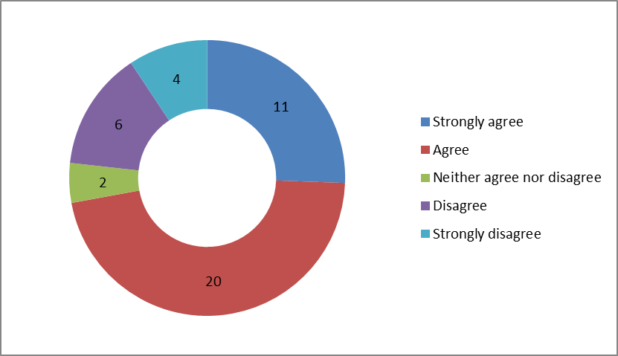

- 31 of the 43 respondents who replied to this question either agreed or strongly agreed that the evaluation criteria accurately describe good for the overall experiences and progress of children and young people.
- Although there was strong support, a number of respondents asked us to provide more detail and clarify aspects of the grade descriptors. As a result, we have made the following changes:
- removed the word ‘all’ in the first grade descriptor when referring to children and young people and added the words ‘academic and personal’ when referring to the progress that children and young people make
- added a descriptor to make it clearer that the progress individual children and young people make should be monitored to demonstrate the impact and value that the boarding/residential provision has had on children and young people’s education and personal development
- made it clearer in the grade descriptor regarding safety that the arrangements for safeguarding should be ‘robust and effective’
- added a descriptor to emphasise that the school’s healthcare arrangements are effective in promoting and maintaining young people’s physical, emotional and psychological health
- added to the descriptor regarding working in partnership with other agencies to include ‘effective and regular communication and positive feedback from them regarding the boarding/residential provision’.
Q2. Do you agree that the evaluation criteria accurately describe outstanding for the overall experiences and progress of children and young people?
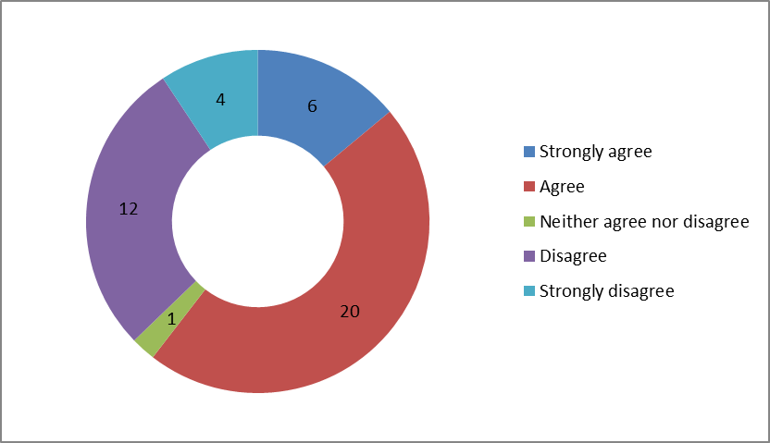

- 26 out of 43 respondents either agreed or strongly agreed that the evaluation criteria accurately describe outstanding for the quality of care and support.
- Nearly all respondents agreed or strongly agreed with the proposal. Many who disagreed did so because they were unclear about the meaning of ‘research informed practice’, so we have amended this descriptor to ‘there is evidence that practice is being improved and informed through activities such as research, the reviewing of internal practice and from good practice within the sector and this is making an outstanding difference to the lives and experiences of children and young people’.

The quality of care and support
Q3. Do you agree that the evaluation criteria accurately describe good for the quality of care and support?
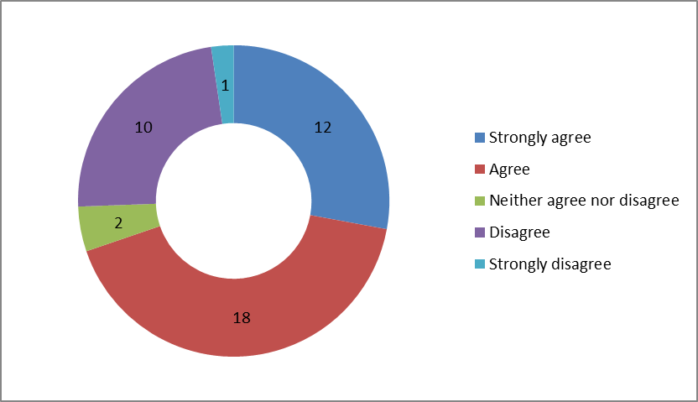

- 30 out of 43 respondents either agreed or strongly agreed that the evaluation criteria accurately describe good for the quality of care and support.
- Although there was strong support, we have made some changes following comments from respondents. We have:
- reduced the areas of duplication between the grade descriptors in this area and those in other sections
- included reference in the grade descriptors to providing support and guidance to young people new to boarding and to those preparing to leave
- included reference to providing ‘external avenues of support available which are well known to the young people’
- added a grade descriptor to ensure that children and young people are treated with dignity and respect
- included reference to keeping young people’s possessions safe in the grade descriptor regarding accommodation
- added an additional descriptor regarding contact and communication with parents/carers.
- A number of respondents asked us to make minor amendments to the wording of the grade descriptors. In response we have:
- amended the grade descriptor regarding activities to read ‘children and young people enjoy and benefit from a broad range of social and recreational activities which include activities in the wider community’
- changed the wording in the descriptor regarding health to read ‘children and young people are actively encouraged to keep themselves fit and healthy’
- removed the word ‘always’ in reference to young people being offered a choice of meals and also removed ‘which they enjoy’ – although it is important that young people generally enjoy the food provided, it is recognised that they may not always like particular meals.
Q4. Do you agree that the evaluation criteria accurately describes outstanding for the quality of care and support?
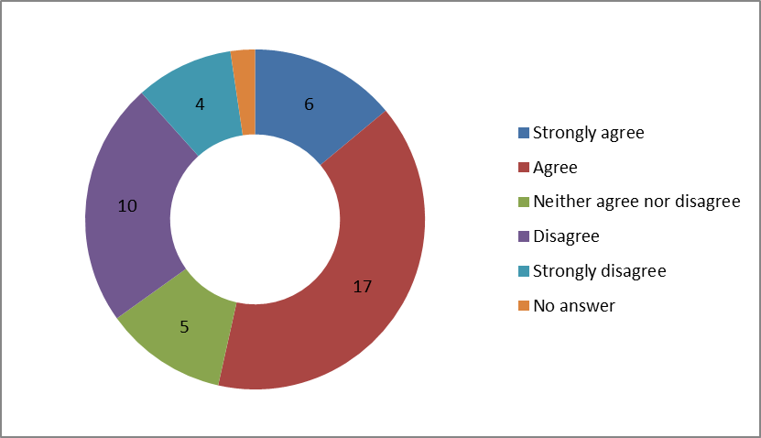

- 23 out of 42 respondents who answered this question either agreed or strongly agreed that the evaluation criteria accurately describe outstanding for the quality of care and support.
- Some respondents asked us to change the words ‘exceptional’ and ‘very positive’. We have replaced these with the word ‘outstanding’ in the descriptors.
- In response to comments from respondents, we have added ‘placing authorities’ to the descriptor regarding feedback and working in partnership with other agencies.

How well children and young people are protected
Q5. Do you agree that the evaluation criteria accurately describe good for how well children and young people are protected?
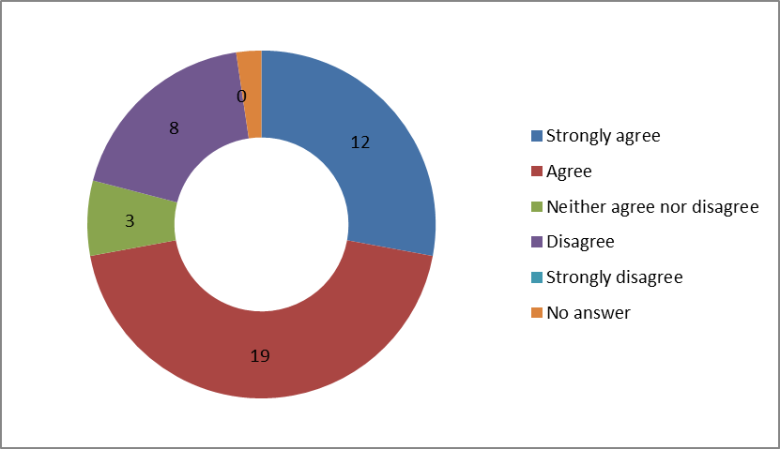
- 31 out of 42 respondents either agreed or strongly agreed that the evaluation criteria accurately describe good for how well children and young people are protected. One respondent wrote: ‘We welcome the comprehensive approach taken in this section. It is important that staff are aware of key issues and are equipped to respond in relation to child protection.’
- A number of respondents asked for greater clarity in the descriptor regarding the referral of child protection concerns to the local authority. We have changed this to ‘any child protection and/or safeguarding concerns are immediately shared with the appropriate part of the local authority in accordance with local procedures’.
- Some respondents expressed concerns that the descriptors may imply that young people report concerns only to the designated person for child protection at the school. We have amended the relevant grade descriptor to make it clear that a young person can talk to any adult regarding concerns.
- There have been other changes made to the descriptors following comments. We have:
- removed the words ‘on a regular and ongoing basis’ to the descriptor regarding the vetting of staff
- revised the descriptor regarding behaviour management to make it clear that ‘any restraint including the use of reasonable force or the restriction of liberty is only used in strict accordance with the legislative framework to protect the child or young person and those around them’
- removed the sentence ‘children and young people do not have their liberty restricted unless a relevant court order is in place’
- added a grade descriptor regarding the need for ‘strong and effective links with the local authority where it is located and there is regular communication regarding safeguarding issues’
- removed the reference to there being evidence that whistleblowing procedures have been utilised
- removed the reference to leaders and managers overseeing the safe use of electronic and social media but reinforcing that they should take action immediately if they are concerned about bullying or risky behaviours
- added a grade descriptor to ensure that ‘the school has strong and effective links with the local authority where it is located and there is regular communication regarding safeguarding issues’
- added a grade descriptor to ensure that ‘governors and/or those with responsibility for the school regularly review and monitor the school’s policy and practice regarding safeguarding’.
Q6. Do you agree that the evaluation criteria accurately describes outstanding for how well children and young people are protected?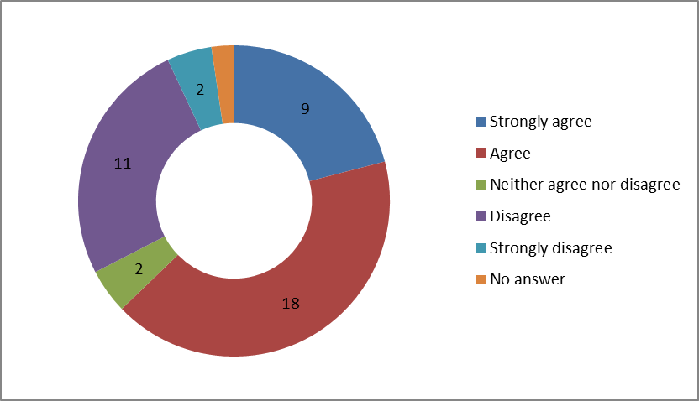
- 27 out of 42 respondents either agreed or strongly agreed that the evaluation criteria accurately describe outstanding for how well children and young people are protected.
- A number of respondents asked for greater clarity in the descriptors and as a result we have added two grade descriptors providing more detail about what is required to be outstanding. These are:
- ‘Children and young people’s safety is paramount and the school is proactive in implementing and sustaining excellent practice. Policies and procedures are robust and implemented consistently and to a high standard.’
- ‘There is excellent practice in safeguarding and child protection that makes the school stand out from others, and is worthy of wider dissemination.’
- Some respondents found the word ‘professionals’ confusing in the final grade descriptor and so it has been replaced with ‘external agencies’.

The effectiveness of leaders and managers
Q7. Do you agree that the evaluation criteria accurately describes good for the effectiveness of leaders and managers?
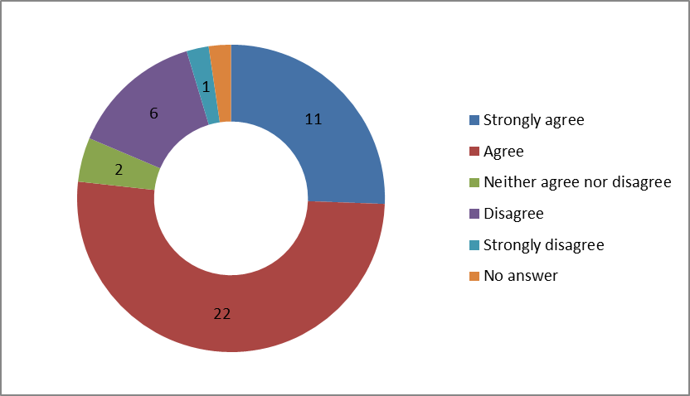
- 33 out of 42 respondents either agreed or strongly agreed that the evaluation criteria accurately describes good for the effectiveness of leaders and managers.
- Although overall support was strong, a number of respondents asked for more clarity and detail in the grade descriptors. As a result we have added the following grade descriptors regarding staffing:
- ‘The boarding/residential provision is properly staffed and resourced to meet the needs of the children and young people living there. The staff team is stable, suitably vetted, qualified and competent to deliver high-quality services to children and young people.’
- ‘Staff are deployed to meet the individual needs of children and young people so that positive relationships can be developed with staff and between peers, any conflicts can be safely managed and so that all children and young people are protected.’
- We have made further changes in response to respondents’ comments, which are as follows:
- amended the title of this section of the evaluation criteria to ‘the impact and effectiveness of leaders and managers’
- expanded the grade descriptors regarding the monitoring of the boarding/residential provision to include learning from complaints and feedback from children and young people, parents, carers and other agencies in contact with the school to improve the care of children and young people
- added a grade descriptor to ensure that ‘there is robust external scrutiny from governors and/or those with responsibility for the school who regularly review and monitor the school’s policies and practice’
- expanded the descriptor regarding the supervision of staff to include ‘leaders, managers and staff receive regular and effective supervision that is recorded. There is effective support and challenge to ensure the professional development of staff and leaders provide the right environment for good practice to thrive’
- expanded the descriptor regarding training to include keeping up to date with current practice and the induction of new staff
- added a descriptor regarding leaders and managers addressing concerns and made it clear that any unmet national minimum standards and recommendations to improve practice from the previous inspection have been fully met.
Q8. Do you agree that the evaluation criteria accurately describes outstanding for the effectiveness of leaders and managers?
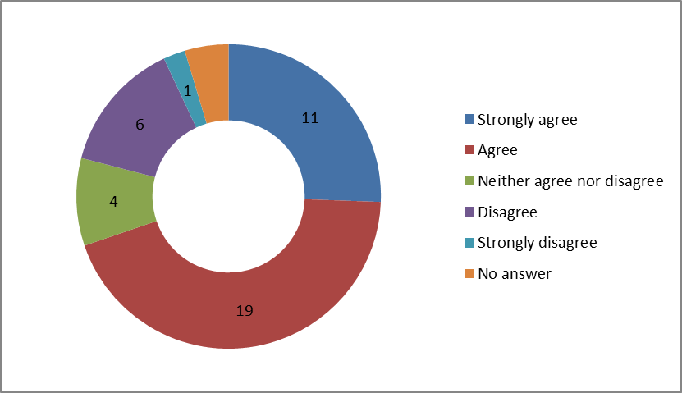
- 30 out of 41 respondents either agreed or strongly agreed that the evaluation criteria accurately describe outstanding for the effectiveness of leaders and managers.
- Some respondents wanted us to add a descriptor regarding effective monitoring and so we have added this.
- We have also added a descriptor to emphasise the importance of all areas of the school working collabobrately together to ensure the highest quality care for children and young people at the school.
Q9. Do the criteria, as they are set out in the evaluation criteria, address the diverse needs of all children who attend boarding and residential special schools?
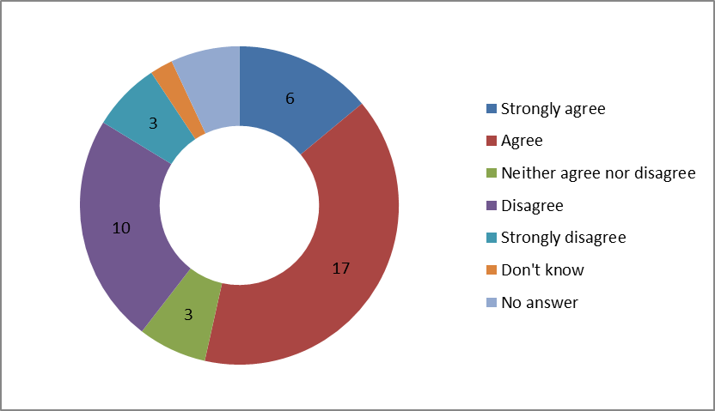
- 23 out of 40 respondents who answered this question either agreed or strongly agreed that the criteria, as set out in the evaluation criteria, address the diverse needs of all children who attend boarding and residential special schools.
- Some respondents said that we are trying to cover too many settings in one framework or that the criteria appear to be directed more towards either boarding schools or residential special schools. In response, we have amended the evaluation criteria where we received comments stating that the criteria applied more to certain types of schools. In addition, an annex in ‘The handbook for inspections of boarding and residential provision in schools’ will provide additional guidance to inspectors highlighting the different characteristics of boarding schools and residential special schools.
- Some respondents were concerned that, due to the specialist nature of their school, they would not be able to achieve a judgement of outstanding. As a result, some amendments have been made to individual grade descriptors and it will be made clear in ‘The handbook for inspections of boarding and residential provision in schools’ that the evaluation criteria can be applied to all types of schools.

Overview of Proposal 1: the evaluation criteria
- Given the overwhelmingly positive responses to the grade descriptors for good and outstanding in the evaluation criteria, we will be implementing this proposal with amendments made to the individual descriptors in response to comments received.

Proposal 2: limiting judgements
Q10. Do you agree that a judgement of inadequate for ‘how well children and young people are protected’ will always limit the judgement for the ‘overall experiences and progress of children and young people’ to inadequate?
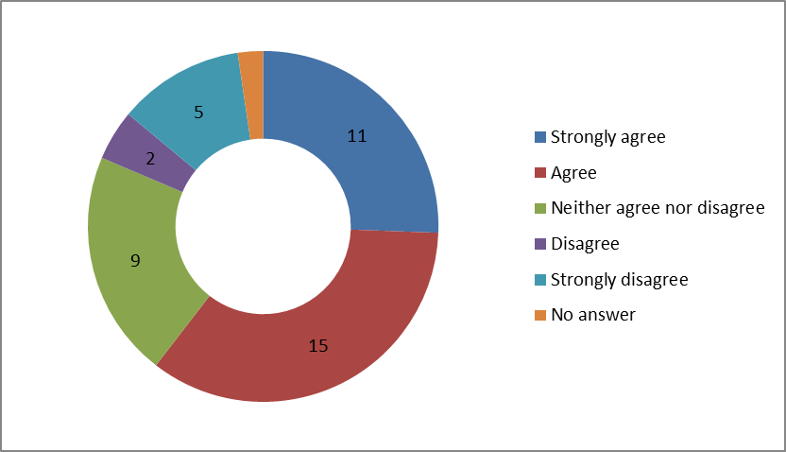
- 26 out of 42 respondents either agreed or strongly agreed that a judgement of inadequate for ‘how well children and young people are protected’ should always limit the judgement for the ‘overall experiences and progress of children and young people’ to inadequate.
- There was general agreement that a limiting judgement should apply where there were serious concerns about the welfare of children. Some respondents expressed concern that if an inadequate judgement was given for more minor failings, which did not have an impact on safety, then it was disproportionate to limit the overall inspection judgement to inadequate. Others said that a failure in protecting children did not automatically lead to inadequate outcomes regarding experiences and progress so the two judgements should not be linked.
- To address these concerns, we have made it clear in the grade descriptor for a judgement of inadequate that inspectors should make this judgement only if ‘there are serious and/or widespread failures which leave children and young people being harmed or at risk of harm or their welfare not being safeguarded’. We will also make it clearer in ‘The handbook for inspections of boarding and residential provision in schools’ that the judgement on the experiences and progress of children and young people is an overall judgment which the other three judgements feed into.
- We feel that the safety of children and young people is paramount and given the overall support for the limiting judgement, we will be implenting this proposal.
Q11. Do you agree that a judgement of inadequate for either ‘the effectiveness of leaders and managers’ or ‘the quality of care and support’ is likely to lead to a judgement of inadequate for the ‘overall experiences and progress of children and young people.’ In all instances, the judgement will be limited to ‘requires improvement’?
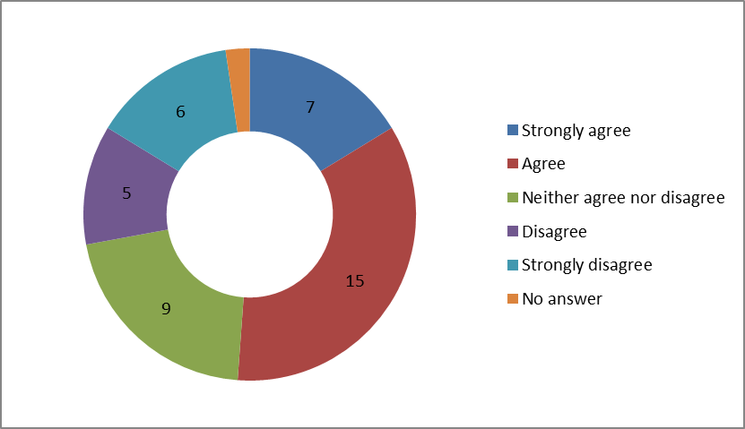
- 22 out of 42 respondents either agreed or strongly agreed that a judgement of inadequate for either ‘the effectiveness of leaders and managers’ or ‘the quality of care and support’ is likely to lead to a judgement of inadequate for the ‘overall experiences and progress of children and young people’. In all instances, the judgement will be limited to ‘requires improvement’?
- Some respondents said that they would prefer each reporting section to be discrete and not to be descriptive. We think that we have given inspectors discretion to use their professional judgement when making this judgement and that there is a connection between poor leaders and managers or poor-quality care and support and the overall judgement regarding the experiences and progress of young people.
- Given the overall support for this limiting judgement, we will be implementing this proposal.

Next steps
- We will implement the new inspection framework in April 2015. The framework will incorporate the changes that we have identified in this report. You can view the framework on our website at: www.gov.uk/government/collections/ofsted-inspections-of-boarding-and-residential-provision-in-schools.
- We will carry out a review of the new inspection framework six months after implementation.

Annex A. Type of respondents



