Further education and skills inspection outcomes

This release contains:
- final data for the most recent inspection outcomes as at 31 August 2015
- final data for inspections conducted between 1 September 2014 and 31 August 2015
- revised data for inspections conducted between 1 September 2014 and 28 February 2015

Providers were less likely to be judged good or outstanding during this reporting year | During 2014/15, 49% of further education and skills providers were judged to be good or outstanding, substantially lower than the 67% of providers judged good or outstanding in 2013/14.
Providers previously judged good or outstanding were more likely to decline this reporting year | In 2014/15, 57% of providers previously judged good or outstanding declined at their latest inspection, compared with 44% during 2013/14.
Figure 1: Most recent overall effectiveness of further education and skills providers¹
percentage
(number of providers in brackets)

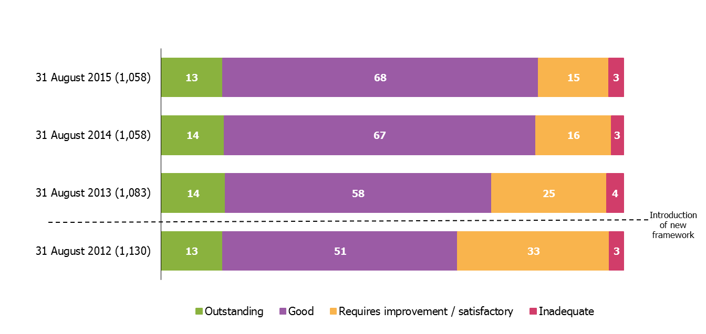

- Excludes Higher Education Institutions and National Careers Service.
- Percentages are rounded and may not add to 100.
Eighty-two percent of providers were judged good or outstanding as at 31 August 2015 | The recent trend of large year-on-year increases in the proportion of providers judged good or outstanding has slowed; however there was still a small increase from the position as at 31 August 2014.

Key findings

In 2014/15, Ofsted inspected 272 further education and skills providers. This included 77 colleges (including general further education colleges, sixth form colleges, specialist further education colleges and independent specialist colleges), 127 independent learning providers (including employers) and 60 community learning and skills providers. Ofsted also contributed to the 50 prison and young offender institution inspections, which were published by Her Majesty’s Inspectorate of Prisons between 1 September 2014 and 31 August 2015.

The percentage of further education and skills providers judged good or outstanding for overall effectiveness was 49% in 2014/15, substantially lower than for providers inspected in 2013/14 (67%). This was the case across all of the main provider types: colleges (66% of providers inspected in 2013/14 were judged good or outstanding compared with 42% in 2014/15), independent learning providers including employers (62% in 2013/14 compared with 50% in 2014/15) and community learning and skills providers (73% in 2013/14 compared with 57% in 2014/15). There are a number of factors contributing to the decline in the proportion of providers judged to be good or better and more information can be found in the report of Her Majesty’s Chief Inspector on Education and Skills for 2014/15.

Figure 2: Overall effectiveness of further education and skills providers inspected between 1 September 2014 and 31 August 2015

(number of inspections in brackets)
percentage
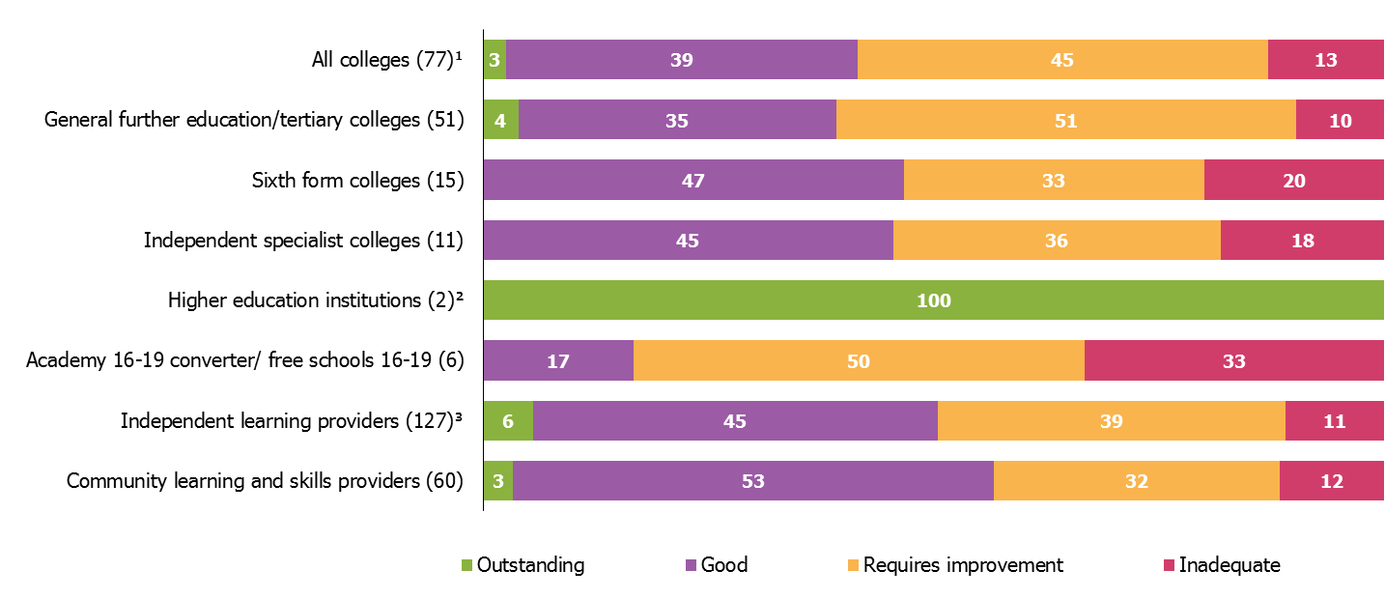

- Includes general further education/tertiary colleges, sixth form colleges, specialist further education colleges and independent specialist colleges.
- Overall effectiveness grades relate to further education provision only.
- Includes employer providers.
- Percentages are rounded and may not add to 100. Percentages should be viewed with caution where the number of providers is small.
The proportion of previously grade 3 providers being judged to require improvement or declining to inadequate has increased in 2014/15 to 46%, compared with 28% in 2013/14. Of the seven providers previously judged as inadequate, only one failed to improve in 2014/15.

Just over half of the providers previously judged as good declined in 2014/15. This was a higher proportion than in 2013/14 (see Figure 3). Additionally, four providers who had previously been outstanding were judged to require improvement and a further three outstanding providers were judged to be inadequate.

Figure 3: Proportion of previously good further education and skills providers that improved, declined or stayed the same at their next inspection (provisional)¹

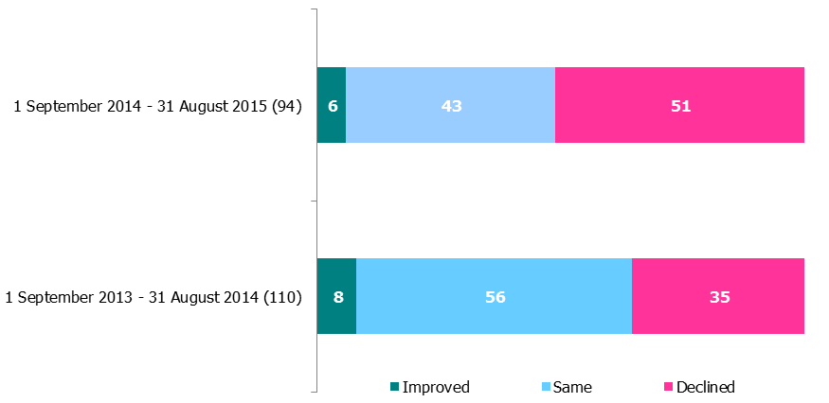
percentage
(number of providers in brackets)
- Excludes Higher Education Institutions and National Careers Service.
- Percentages are rounded and may not add to 100.

In 2014/15 Ofsted inspected an additional 59 providers who were not present in the 2013/14 cohort. Of these, just over a third (22) were judged good or outstanding, 29 were judged to require improvement and eight providers were judged to be inadequate.

Although the grade profile for inspections in 2014/15 was less positive than in previous years, the proportion of providers judged good or outstanding at their most recent inspection rose slightly, from 81% to 82% between 31 August 2014 and 31 August 2015.

The main reason behind this minimal change is that the cohort of providers included in the data are different: some providers that featured in the grade profile at 31 August 2014 lost funding or closed during 2014/15. Other providers appeared in the grade profile for the first time, as either a new provider or one that had regained funding. Taking account of the providers that moved into or out of the cohort, a slightly higher proportion of providers that opened or regained funding were judged good or outstanding than those that closed or lost funding.

This small change has resulted in a slight increase in the number and proportion of providers judged good or outstanding at their most recent inspection. This is true across all of the provider types, except for general further education colleges and independent specialist colleges, where there was a slight decline in the proportion judged good or outstanding as at 31 August 2015.

Revisions

The provisional data in the previous release related to inspections between 1 September 2014 and 28 February 2015. During this period, five inspections were carried out that were not published in time to be included in the provisional data. The inspection outcomes for these providers are included in the underlying data published alongside this report.

One of the inspections was of a general further education college and four were of independent learning providers. Of the five providers: one was judged to be good for overall effectiveness; one was judged requires improvement; and three were judged inadequate.

These revisions had the following impact:
- Overall the proportion of inadequate providers, for those inspected between 1 September 2014 and 28 February 2015, rose by two percentage points to 18%. With the proportion judged to require improvement declining by one percentage point.
- The proportion of colleges judged to be inadequate between 1 September 2014 and 28 February 2015, rose by two percentage points to 19%. Resulting in the proportion judged to be good and those requiring improvement, declining by one percentage point each.
- The proportion of independent learning providers (including employers) judged to be inadequate between 1 September 2014 and 28 February 2015, rose by three percentage points to 13%. Resulting in the proportion judged to be outstanding, those that were good and those requiring improvement declining by one percentage point each.

Notes

- The most recent inspection outcomes include: 1) providers wholly or partly funded by the Skills Funding Agency or the Education Funding Agency at that point in time, and 2) providers who were funded at the point of their inspection in 2014/15, who have subsequently lost funding or closed.

- In 2014/15 there were four main areas against which providers were assessed:
  - Overall effectiveness
  - Outcomes for learners
  - Quality of teaching, learning and assessment
  - Effectiveness of leadership and management

- There are four judgements a provider can receive against these areas: outstanding, good, requires improvement or inadequate.

- Data for the reporting year 2013/14 are available here; https://www.gov.uk/government/statistics/further-education-and-skills-inspection-outcomes-september-2013-to-august-2014

Data and information prior to June 2014 can be found here: http://webarchive.nationalarchives.gov.uk/20141124154759/http://www.ofsted.gov.uk/resources/statistics
Additional tables providing more detailed breakdowns are available here:
https://www.gov.uk/government/collections/further-education-and-skills-inspection-outcomes

If you have any comments or feedback on this publication, please contact Sarah Pearce on 03000 130 632 or Sarah.Pearce@ofsted.gov.uk

Acknowledgements
Thanks to the following for their contribution to this statistical release: Grant Kelly and Zara Yates-Vanhorne.

© Crown copyright
You may re-use this information (not including logos) free of charge in any format or medium, under the terms of the Open Government Licence. To view this licence, visit http://www.nationalarchives.gov.uk/doc/open-government-licence/ or write to the Information Policy Team, The National Archives, Kew, London, TW9 4DU or e-mail: psi@nationalarchives.gsi.gov.uk

Excludes Higher Education Institutions and National Careers Services.
Excluding Higher Education Institutions, National Careers Services, 16-19 academy converters and free schools.

