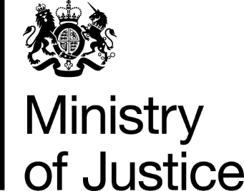
 | Our Reference: 570-16 FOI 108180 |  | November 2016

Freedom of Information Request

You asked for the following information from the Ministry of Justice (MoJ):

I am researching the exposure fraud offenders receive in the local press.

Could you please provide the number of people convicted of fraud in 2015 in Gloucestershire and in the West Midlands?

Your request has been handled under the Freedom of Information Act 2000 (FOIA).

I can confirm that the Ministry of Justice holds the information that you have asked for and I am pleased to provide this to you.

The number of offenders found guilty of fraud offences, in the requested police force areas, in 2015, can be viewed in the table attached.

