Equality in Ofsted
This eighth annual employment report focuses on equal opportunities in employment and covers the period April 2014 to March 2015.

The 2014−15 employment report will be published on Gov.uk. Please direct any questions or comments, in the first instance, to Ofsted’s HR Director.
Published: March 2016
Reference no: 160015

Contents
Introduction and overview 4
Overview of the workforce equality profile 5
Recruitment throughout 2014−15 12
Retention and turnover throughout 2014-15 14
Profile of disciplinary and grievance cases 15
Pay and reward throughout 2014−15 15
Performance management throughout 2014−15 15
Learning and development throughout 2014−15 16
Actions identified for 2014−15 17
Progress against the 2014−15 actions 17
Actions for 2015−16 18
Annex A. Ofsted grade structure 20

Introduction and overview
Ofsted aims to be an exemplary employer with a diverse and effective workforce. We ensure that the promotion of equality and human rights and the elimination of discrimination and harassment are embedded in every area of our practice, including employment.
This is our eighth annual employment report. Since our first report, we have implemented a number of changes to our structures and processes, more recently through the Promoting Improvement programme in January 2013 in which regional inspection teams were introduced. These changes have been prompted by efficiency gains, to respond to the changing landscape and our continuous efforts to find better ways of working.
At the end of 2014−15:
- we employed 1366 individuals (1,313.1 full-time equivalent) – an increase of 92 or 7% on the previous year
- 642 employees (47.0% of the total workforce) were directly engaged in front-line inspection
- 826 employees (60.5% of the total workforce) were female (from 59.2% at 31 March 2014)
- 138 employees (10.6%) were of a known BAME background (from 10.3% at 31 March 2014)
- 94 employees (6.9% of the total workforce) identified themselves as disabled (from 6.6% at 31 March 2014)
- 54 employees (4.0% of the total workforce) identified themselves as lesbian, gay, or bisexual (from 3.5% at 31 March 2014).
The information contained in this report is taken as at 31 March 2015, unless otherwise stated. All employee numbers throughout the report are shown as a headcount unless otherwise stated. We define employees as those on a permanent or fixed-term contract, and those who are seconded in or on loan to us on a full-time basis.
Please note that percentages in all following sections have been rounded and may not add up to 100.
Unless otherwise stated, all wider Civil Service comparisons have been sourced from the Annual Civil Service Employment Survey, 31 March 2014, produced by the Office for National Statistics.

Overview of the workforce equality profile

Grade profile
Figure 1: Grade breakdown

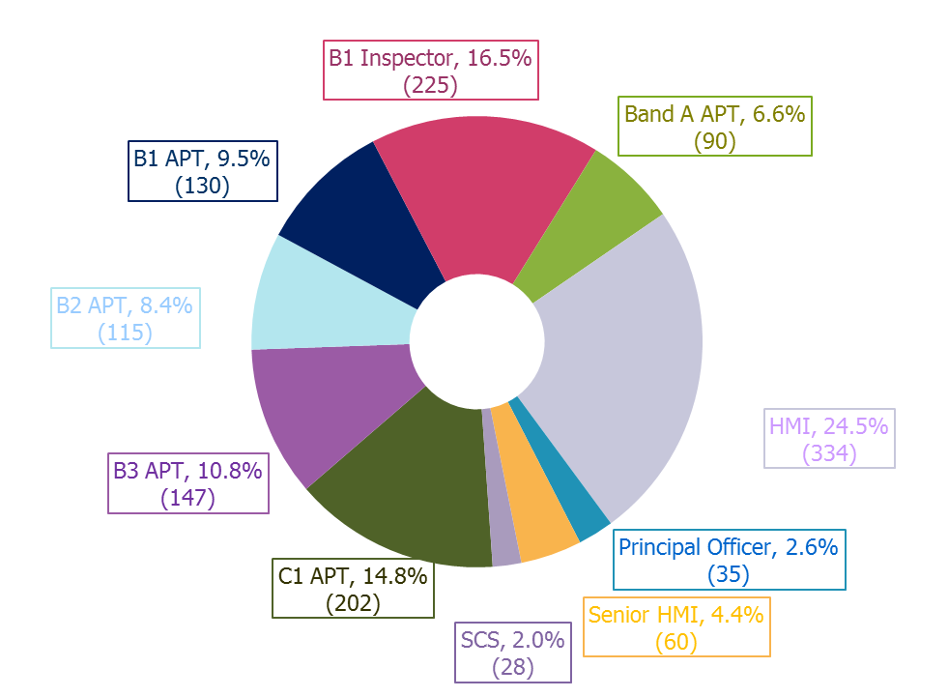
In line with our aim to focus more resources on the front line of inspection, the numbers of B1 Inspectors (+34), HMI (+16) and Senior HMI (+6) employees increased from the previous year.

Ethnicity profile
Table 1: Ethnicity categories of employees since March 2010

Ethnicity category | Mar-10  % | Mar-11  % | Mar-12  % | Mar-13  % | Mar-14  % | Mar-15  %
BAME | 11 | 11 | 11 | 11 | 10 | 10
White | 82 | 82 | 84 | 83 | 83 | 85
Ethnicity not known / not declared | 6 | 6 | 5 | 6 | 7 | 5
- BAME includes Black, Asian, Mixed and other ethnic backgrounds
- White includes White and Other White

Figure 2: Ofsted compared with Civil Service – BAME breakdown (where declared)
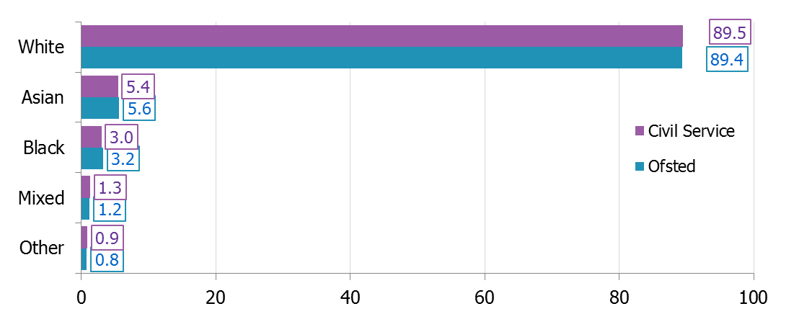
%

Figure 3: Ofsted compared with Civil Service – BAME % by Grade (where declared)

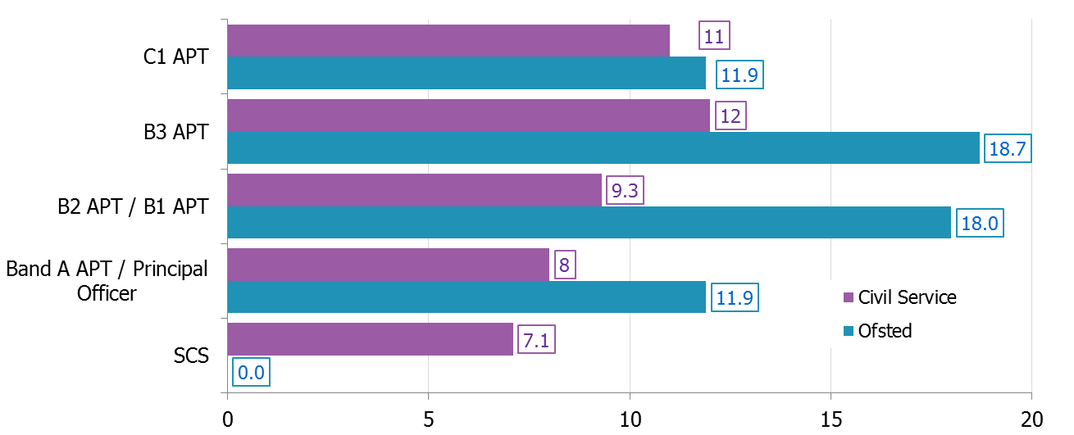
%

B1 Inspector / HMI / Senior HMI are specialist grades, therefore no relevant data is available from the wider Civil Service to allow comparison.
Our overall percentage of known BAME employees, including all inspector grades, (10.6%) is on par with Civil Service figures (10.6%).
Ofsted continues to compare favourably with the Civil Service average in relation to the ethnicity of staff across most grades except that at the SCS grades. Following work undertaken to increase diversity at our senior and inspector grades, which will ultimately feed into the talent pipeline for future SCS posts, the BAME proportion for these grades have changed as follows from the previous year.
Table 2: BAME representation at senior grades – comparison to last year

Grade | BAME %  2013-14 | BAME %  2014-15 | Difference  (+/-)
B1 Inspector | 8.2 | 9.7 | +1.5
Band A | 12.2 | 14.3 | +2.1
HMI | 6.8 | 5.2 | -1.6
Senior HMI | 3.8 | 5.2 | +1.4

Further interventions are planned for the coming year to increase the proportion of BAME staff at all senior grades, including the HMI grade.

Gender profile
Figure 4: Gender split by grade

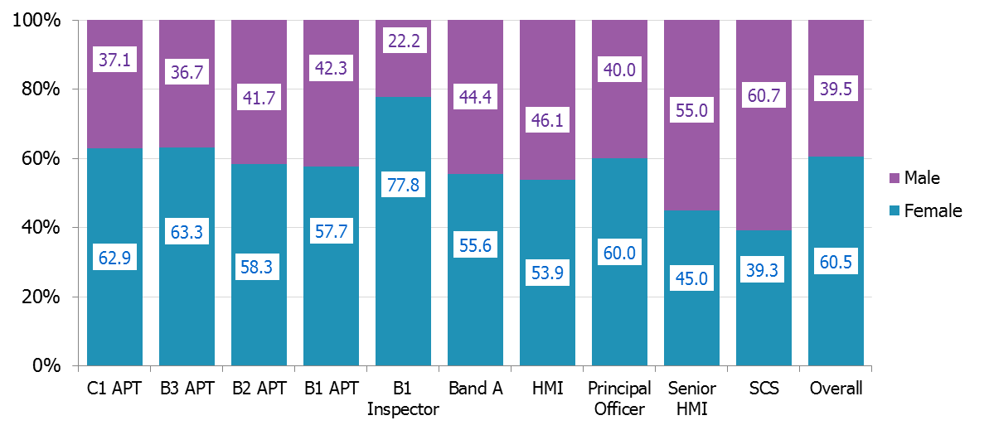
Grade

Our proportion of female to male employees remained stable from the previous year, increasing by just 1.3% in favour of the female population. At 39.3%, the proportion of female employees within the SCS grades remains slightly above the Civil Service percentage of female SCS of 38.7%.
Following the establishment of the Senior HMI grade, and with further recruitment having taken place to these roles, the proportion of females at this grade has increased by 8% to 45%.
The B1 Inspector grade has the highest proportion of female employees, at 77.8%. This is unusual compared with the wider Civil Service, where the lower grades (C1 and B3) have a higher proportion of females, and reflects the demographic of the sectors from which we would recruit to posts at this grade.

Disability profile
Figure 5: Disability breakdown by grade
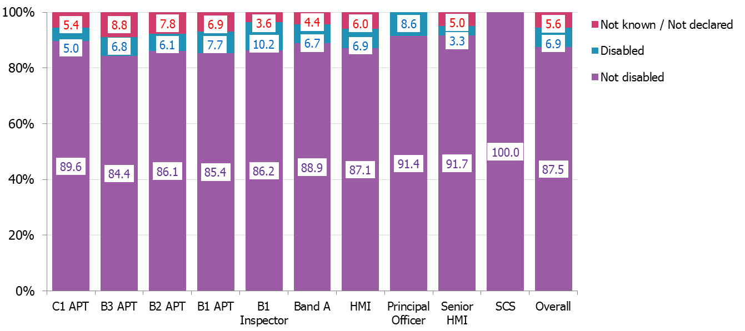
Grade

Almost 7% of the total workforce declared themselves as disabled, which is a small increase from the figure of 6.4% reported last year. Our overall proportion of disabled staff increases to 7.3% when non-declaration figures are excluded, which compares favourably to the equivalent Civil Service figure of 4.5%. Following continuing efforts to improve non-declaration rates, these have decreased across all grades. This improved information will help to inform our strategies to further increase the diversity of our workforce.

Age distribution
Figure 6: Ofsted compared with Civil Service − Age distribution
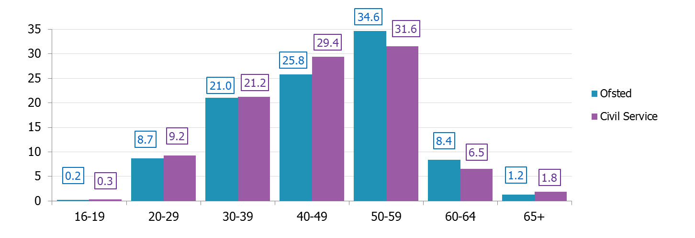
%
Age group
Our workforce age profile continues to show that we have an older workforce compared with the wider Civil Service. As reported in previous years, this overall age distribution is influenced by the requirement for significant experience at a senior level before individuals are able to work in an HMI role.
Figure 7: Age distribution by gender − %s derived from gender population

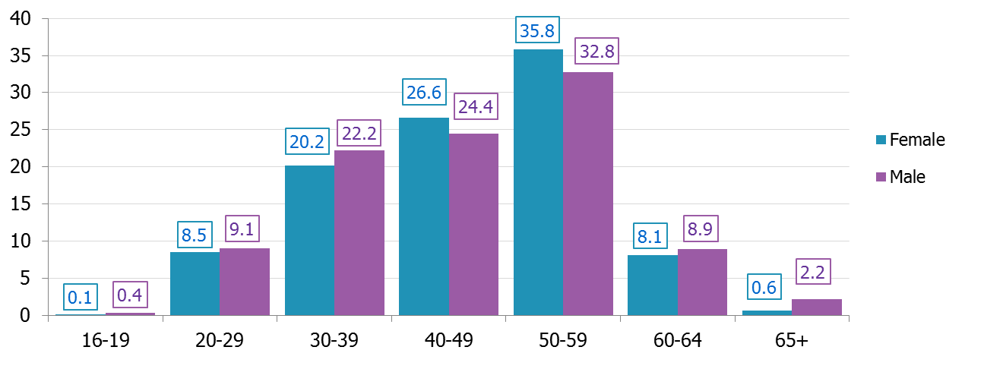
Age group
%

In line with the profile shown in Figure 6, the 50−59 age category has the largest proportion of males and females across the organisation, with the proportion of females in this category being particularly high in comparison with other categories. This reflects the gender patterns shown in Figure 4, which shows that our inspection grades, which are more heavily populated with employees in the 50−59 age category, have a larger proportion of females.

Sexual orientation profile
Figure 9: Sexual orientation breakdown of whole workforce

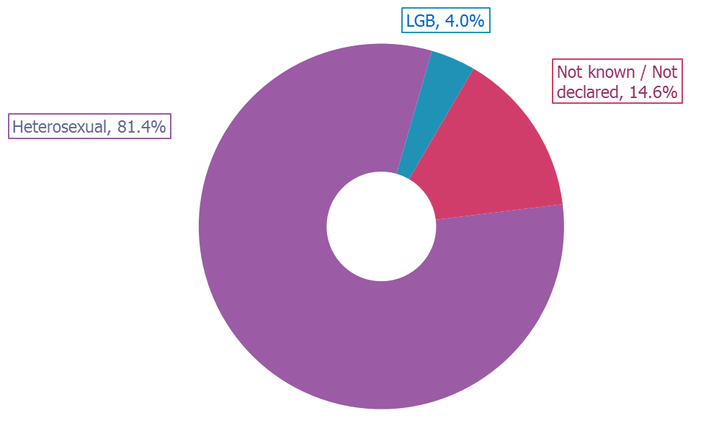

Figure 10: Sexual orientation breakdown by grade
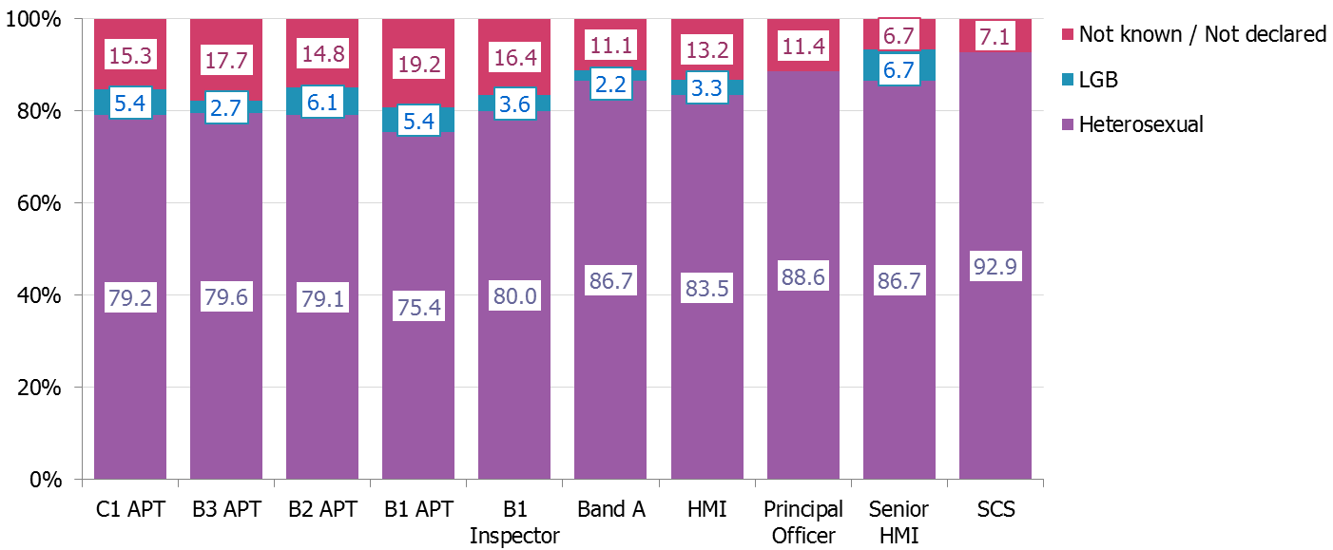
Grade

Lesbian, gay or bisexual (LGB) employees have some representation in most grades in the organisation.
Sexual orientation remains a category where we support the wider Civil Service view that individuals have a right to refuse to reveal this data. Despite this, we continue to see a trend of increasing disclosure levels among our LGB employees. 85% of the workforce disclosed their sexuality this year compared with 81% the previous year, and 59% three years ago.

Religion/Belief profile
Figure 11: Religion of employees

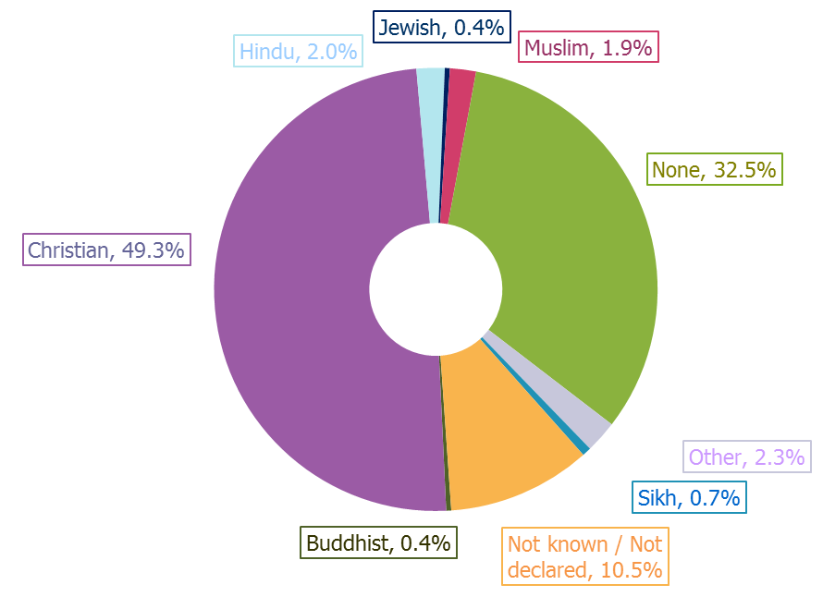
Ninety percent of employees declared their religion or belief, an increase of 2% on last year and 6% on the previous year. The most common religion/belief remains Christian, followed by ‘no religion’, as has historically been the case.
Comparison data for the Civil Service is not available.

Working patterns/flexible working profile
Eighty nine per cent of our employees work full time. This high percentage reflects the nature of our work and the need for continuity of expertise during inspections. With only 11% of employees working part time, it is impossible to draw conclusions from a diversity breakdown of all part-time employees.
During 2014−15, 56% of our employees worked from home for two or more days per week, helping reduce the cost of the estate and giving the workforce greater flexibility. The profile of working arrangements is illustrated in the table below. For reference, we define frequent remote working as an agreed, regular pattern of more than one day and up to four days (up to 80% of work time) per week, on average, working at home.
Figure 12: Breakdown of working arrangements

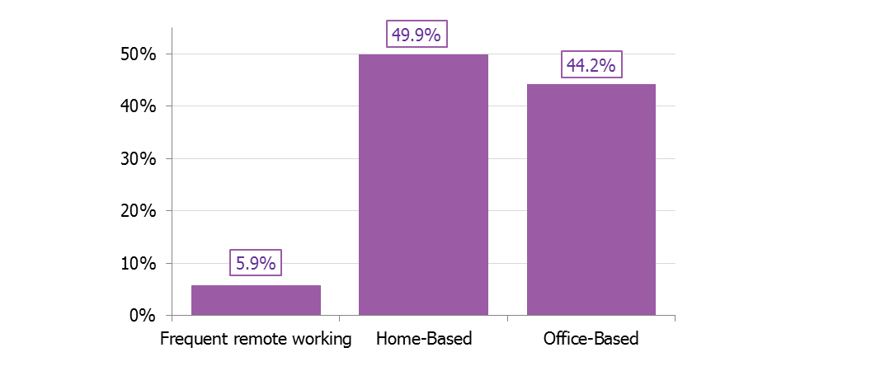

Recruitment throughout 2014−15
Figure 13: Recruitment stages reached by applicant type for SCS and inspection posts
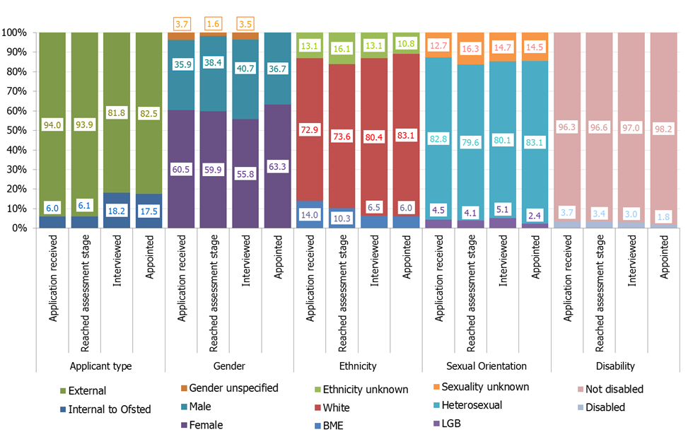

For our SCS and inspection posts, we continue to fill most vacancies with external candidates due to the skills and experience required for the roles. During the past year, the proportion of internal candidates applying to SCS and inspection posts has increased. These internal candidates remain proportionately more successful than external candidates. The increased number of internal promotions may be because of an increased focus on talent management and succession planning.
Female candidates continue to make up the majority of successful applicants. The percentage of successful female candidates increased in the past year, reflecting our workforce profile and the professional populations from where we generally recruit.
A greater proportion of BAME candidates have applied to and ultimately been successful in securing inspection posts. During the year, we rolled out a variety of training opportunities, including mandatory unconscious bias training to all managers. We are also continuing work with our recruitment advertising partners to attract BAME candidates. Additionally, we continue to use online media with a view to reaching a wider and more diverse population of job seekers than we did through print media, which was used previously.
Whereas the proportion of both LGB and disabled applicants increased slightly, the proportions that are ultimately appointed have dropped for both this year. We will work together with our revitalised LGB and disability fora to gain their insight and to agree short- and long-term actions to address this.
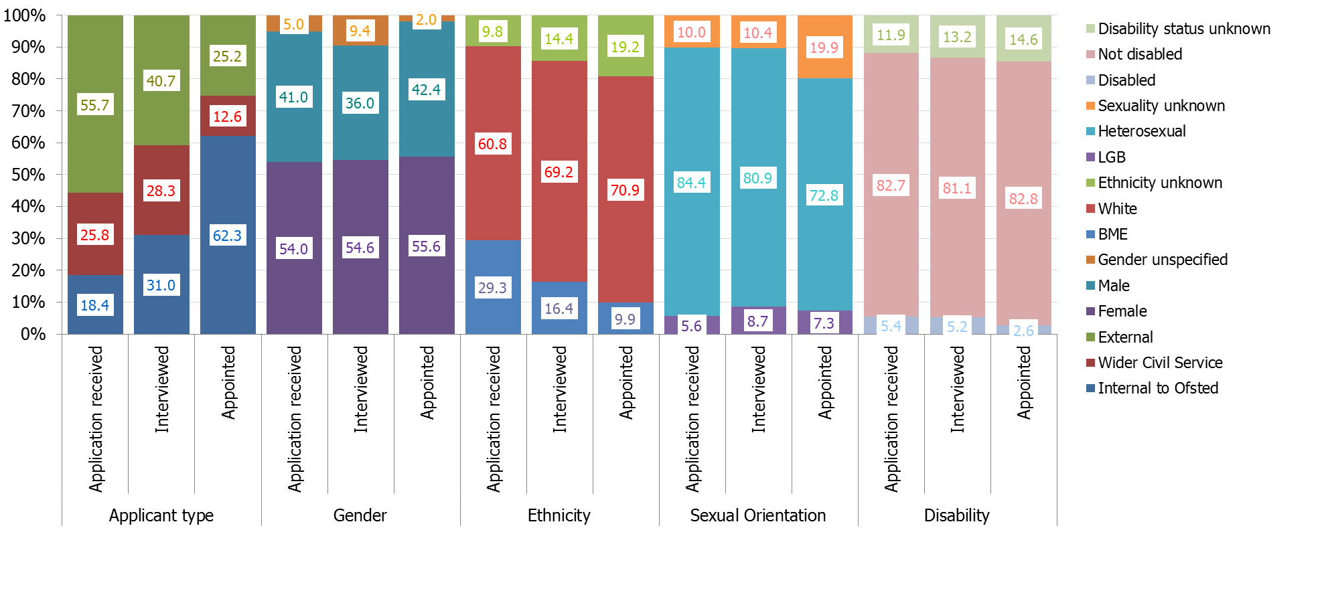
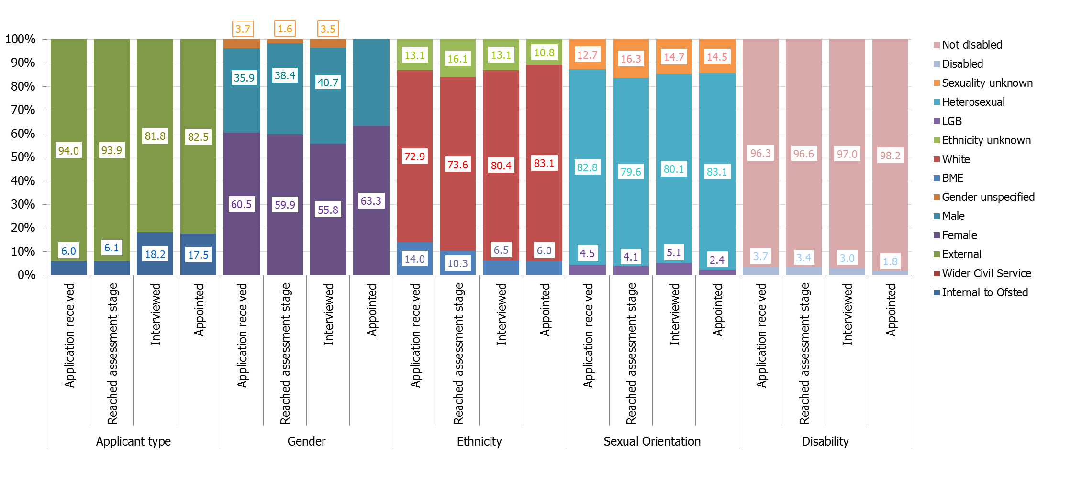
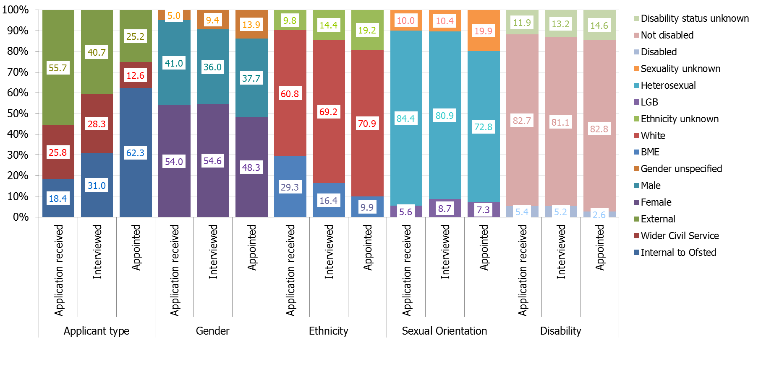
Figure 14: Recruitment stages reached by applicant type non-SCS, non-inspection posts

While Ofsted has managed to attract a high percentage of BAME applicants to our non-SCS, non-inspection posts, the percentage of BAME appointments has remained similar to last year with one in ten appointments having a Black, Asian or minority ethnic background – this is largely in line with the working age population.
Encouragingly, the percentage of appointments from lesbian, gay and bisexual applicants has increased significantly from 2.5% last year to 7.3% this year.
Overall, the success rate of candidates with a disability has fallen this year from 4.4% to 2.6% with the greatest drop occurring at interview stage. We hope that the recent roll out of unconscious bias training to all managers will further reduce any unintended bias in recruitment decisions. We will continue to monitor the diversity of candidates at each stage of the recruitment process and discuss this with our equality fora, particularly our disability forum, to identify appropriate actions that can be taken to improve outcomes for disabled applicants.
There is still a large proportion of applicants that does not provide all equality monitoring data. Ofsted will continue to review its documentation and processes to provide greater assurance to encourage greater levels of disclosure. Cabinet Office undertakes an annual monitoring of recruitment processes, and this review identified no bias within the recruitment processes.

Retention and turnover throughout 2014-15
Table 3: Numbers of joiners and leavers breakdown by gender, disability and ethnicity

Diversity category | Joiners |  | Leavers
Diversity category | No. | % | No. | %
Male | 96 | 35.6 | 77 | 41.8
Female | 174 | 64.4 | 107 | 58.2
Not disabled | 220 | 81.5 | 137 | 74.5
Disabled | 12 | 4.4 | 11 | 6.0
Disability not known / not declared | 38 | 14.1 | 36 | 19.6
White | 202 | 74.8 | 130 | 70.7
BAME | 25 | 9.3 | 17 | 9.2
Ethnicity not known / not declared | 43 | 15.9 | 37 | 20.1

The table above illustrates the diversity breakdown of employee turnover.
Two hundred seventy employees joined Ofsted between 1 April 2014 and 31 March 2015, and 184 left during the same period. Reflecting the information shown in the ‘Recruitment throughout 2014−15’ section, this year saw a higher proportion of females joining the organisation.
Our proportion of joiners who have declared themselves as BAME (9.3%) is higher than the Civil Service proportion of 8.4%. In terms of BAME leavers, we have this year closed the gap with Civil Service proportions from a 7% difference reported last year to a 2.8% difference, with the Civil Service proportion of BAME leavers reported to be 6.4%.

Profile of disciplinary and grievance cases
Table 4: Summary of disciplinary and grievance numbers by ethnicity, gender and disability from 1 April 2014 to 31 March 2015

Diversity category | Disciplinary | Grievance
BAME | 8 | 3
White | 23 | 13
Ethnicity not known / not declared | 2 | 2
Female | 17 | 12
Male | 16 | 6
Disabled | 5 | 4
Not disabled | 27 | 13
Disability not known / not declared | 1 | 1

With the continuing low number of disciplinary and grievance cases (a total of 51) despite the increased workforce of 1,366 from 1,274, we should be careful in drawing any diversity-related conclusions from this data.

Pay and reward throughout 2014−15
The 2014−15 pay award commenced on 1 April 2014. While this maintained the core principles of the established pay strategy, the award also aimed to effectively underpin the delivery of HMCI’s ambitious agenda to improve education, further education and skills and the services provided to children and young people.
Ofsted’s pay arrangements are based on a single salary model – one of the purest forms of equal pay for equal work. We aim to continue to recruit and retain a skilled and motivated workforce within a pay framework that is attractive, affordable, equitable, transparent and simple to understand.

Performance management throughout 2014−15
We operate both performance management and performance related pay (PRP) schemes for all of our employees. Performance is measured and assessed against the objectives achieved, grade competencies and our core values. Overall, performance is rated at the mid-point and at the end of each performance year in three bands, Band 1 being the highest.
- The proportion of BAME employees rated Band 1 has decreased from 16.4% in 2013−14 to 14.1% in 2014−15. This compares with 26% of employees, overall, being rated in this top performance band.
- The differential between male and female staff in Band 1 decreased from 5.3% in favour of women in 2013−14 to 0.4% in favour of women in 2014−15, meaning both groups were proportionately represented in 2014−15.
- The proportion of disabled employees rated as Band 3 has increased from 1.4% in 2013−14 to 5.4% in 2014−15, and these employees continue to receive a lower proportion of Band 1 ratings (15.2%) compared to the overall picture.
- LGBT colleagues again received the highest proportion of Band 1 ratings (35.3%) and this is a further increase from 2013−14 (27.8%).
We continue to work with Ofsted’s senior leaders and equality fora to consider any measures we could introduce to address the concerns around performance ratings for BAME and disabled colleagues. We are also working with managers to better promote use of the reasonable adjustment passport, to ensure that disabled colleagues are able to access the support they need to reach or exceed their objectives, and we plan to re-launch the passport to reinforce the importance of its use.
We will continue to raise awareness and fund opportunities for talented BAME and disabled colleagues to join the Civil Service’s Positive Action Pathways, as well as ensuring that all staff have completed unconscious bias training. We will also examine options with our internal talent panel to provide additional developmental opportunities for staff from under-represented groups.

Learning and development throughout 2014−15
Equality and human rights are integral to all our learning and development activity. Employees are required and encouraged to take part in a wide range of learning and development opportunities.
During 2014−15, the following interventions took place to support employees and ensure that we promote equality, value diversity and challenge unfair treatment:
- corporate induction courses and specialist technical induction training for inspectors and managers included interactive presentations from the LGBT staff forum
- new induction programmes for managers launched to ensure that all new managers gain the knowledge, skills and understanding of equalities and are able to uphold the organisation’s values in their management role.
- a bespoke online learning package in equalities continued to be mandatory for all new inspectors, with APT employees completing the Civil Service Learning equality and diversity e-learning package.
- our continued support to the inspector shadowing scheme for aspiring college and school senior leaders, for Black and Asian people, accessed through the Network for Black Professionals.
Table 5: Course take-up by ethnicity, disability, gender and sexuality from 1 April 2014 to 31 March 2015

Course take-up by diversity category | %
Female | 60.1
Male | 39.9
Disabled | 6.5
Non-disabled | 80.7
Disability status unknown | 12.8
BAME | 9.8
White | 78.3
Ethnicity unknown | 11.9
LGBT | 3.8
Heterosexual | 75.7
Sexuality unknown | 20.5

Equality and Diversity actions

Actions identified for 2014−15
- We will develop specific learning resources for inspectors focusing on LGB issues.
- We will support the wider Civil Service Talent Action plan for underrepresented groups.
- We will research and develop unconscious bias training, with plans to launch this training in 2015.
- We will undertake a review of the People Champions group to ensure that employees continue to have a channel to express their views and share their stories of both good practice and areas for improvement.
- We will extend the occupational health contract to cover provision of specialist advice on dyslexia.
- We will continue our commitment to the Black Leadership Initiative, and offer inspection shadowing opportunities through the Network of Black Professionals.
- We will develop talent management proposals for those BAME staff who have been recognised as high performers.

Progress against the 2014−15 actions
- LGB features in all equalities and diversity-related training for inspectors, and the workforce receives regular updates on related issues both in inspection and in employment.
- We continued our involvement with the Civil Service Summer Diversity Internship programme, which aims to provide work experience to undergraduates from BAME backgrounds, from disadvantaged backgrounds and/or with disabilities.
- We continued our commitment to the Black Leadership Initiative to offer shadowing (of schools inspection) opportunities via the Network of Black Professionals and agreed additional funding to allow this programme to continue.
- Our Executive Board has agreed an action plan to improve the diversity profile of our inspector and SCS workforce. This includes, but is not limited to, actions such as the roll out of unconscious bias training, blind sifting and improved use of diverse imagery and language in all recruitment advertising.
- We have introduced a talent panel to examine and drive talent management within Ofsted. This includes a specific focus on staff from groups that are under-represented at the more senior grades that are recognised as having the potential to progress within the organisation. These internal development opportunities will be supplemented via the agreed funding to support these groups of staff to join the Civil Service’s positive action pathway development schemes.
- The occupational health contract is now in place and has been used to inform our support to dyslexic employees on several occasions throughout the year. This service is quicker and more cost effective than our previous adviser. Improvements to this service continue to be a feature of future actions.
- The review of the People Champions took place as part of the wider review of all our employee fora in 2015. Since the People Champions group was established at the start of 2014, we have made significant improvements to the ways we engage, communicate with and involve staff e.g. through dial-ins, webinars, Yammer, discussion boards, survey monkey. Following the implementation of these initiatives, the People Champions group has been disbanded, with a view to continue focusing on introducing engagement channels for all employees rather than a select few.
- The unconscious bias training was delivered to all people managers with a recommendation to all staff that they also complete the training.

Actions for 2015−16
- The review of all our employee fora will take place in 2016, which will include an assessment of the levels of accountability each forum has. Longer term, as part of the wider work to mainstream equalities, a new equality, diversity and inclusion group will be established in 2016, which will be responsible for ensuring that we comply with requirements outlined in the Equality Duty and that we publish and monitor performance against our equalities objectives. The three equalities fora will be renamed to better reflect their purpose.
- Specific sessions will be developed for inspectors around equalities and how it should be applied to inspections. The duty of providers and the role of the inspector in relation to the Equality Act 2010 will be covered in these sessions.
- Our online equalities and human rights training will continue to be made mandatory for all new and existing inspection staff. The training covers content relating to the Equality Act; disability; conduct and behaviour; ethnicity, race and cultural awareness; and parenthood, caring and dependency responsibilities.
- We will continue our existing commitment to the Civil Service Summer Diversity Internship programme, which aims to provide work experience to undergraduates from BAME backgrounds, from disadvantaged backgrounds and/or with disabilities; and our commitment to the Black Leadership Initiative to offer shadowing (of schools inspection) opportunities via the Network of Black Professionals.
- With the Ofsted talent panel now in place, we will ensure that the panel specifically focuses on activity and opportunity for staff in under-represented groups.
- We will continue to promote The Civil Service’s Positive Action Pathway (developmental schemes) and to provide the required funding for staff to join these.
- All recruitment imagery and documentation will be reviewed to ensure that communications feature positive and senior BAME imagery and language and to move towards a blind sifting process.
- We will continue to monitor our workforce profile through our regular reports, highlighting areas of concern to Ofsted’s Executive Board.
- We will complete an Equal Pay Audit to assess whether there are any significant differences in pay depending on gender, ethnicity, and sexual orientation.
- We will re-launch the reasonable adjustments passport to reinforce the importance of its use, to ensure disabled colleagues are able to access the support they need.

Annex A. Ofsted grade structure
Ofsted’s current grade structure broadly compares to the wider Civil Service grades, as outlined in the table below.
Ofsted grading structure and Civil Service equivalent
Senior Civil Service (SCS)
Inspector job family | APT job family
Senior HMI  CS equivalent – Grade 6 | Principal Officer  CS equivalent – Grade 6
HMI  CS equivalent – Grade 7 | Band A APT  CS equivalent – Grade 7
B1 Inspector  CS equivalent - Senior Executive Officer | B1 APT  CS equivalent - Senior Executive Officer
B2 APT
CS equivalent – Higher Executive Officer
B3 APT
CS equivalent – Executive Officer
C1 APT
CS equivalent – Administrative Officer

