This document has been archived in February 2016 because it is no longer current.

Work-related learning and enterprise education: King James’s School

URN: 107754
Local authority: Kirklees
Date published: 22 September 2011
Reference: 120406
Brief description

Students at this 11-16 school develop exceptionally strong work-related and enterprise skills, together with very good personal financial awareness and basic economic and business understanding.
Overview – the school’s message


‘In the recent past, work-related learning and enterprise education were delivered mainly through one-off activities that didn’t necessarily have relevance to our curriculum and the future career needs of our students. As a consequence, the students often didn’t see the relevance of many of the activities. As we felt this aspect of our work was key to all our students’ future career prospects, we made a conscious decision to identify key employability skills and embed them across all subjects. We overcame the initial challenge of getting all staff on board by making this a major development priority for the school. We dedicated training days to train our staff on the delivery of these key employability skills in their subject areas. The impact has been rapidly rising examination results, a significant increase in the number of students progressing to further education, training and employment, and a much more exciting curriculum for our students.
We would encourage any school to make work-related and enterprise activities a high priority in their own curriculum, especially in these days of budget constraints. You’ll soon see the benefit throughout your school in areas that you least expect.’
Robert Lamb, Headteacher
The good practice in detail

The exceptionally well-planned provision for enterprise education involves all subjects in the curriculum and suspended timetable days and form tutor periods. This is in addition to discrete personal, social, health, citizenship and economics education (PSHCEE) lessons. The nub of the good practice is the school’s use of an accreditation scheme to ensure that all students receive exceptional work-related preparation in readiness for their transition to further education and employment.
Enterprise education across the curriculum
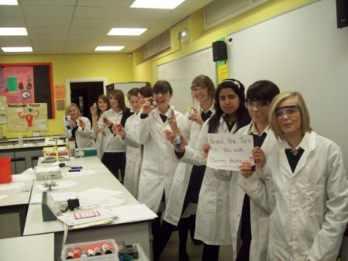
Work-related learning and enterprise education are well coordinated across the school, resulting in a coherent programme for all students. The school’s work-related learning and enterprise education policy initially developed around the former Qualifications and Curriculum Authority (QCA) guidance for work-related learning is at the heart of the process.
Women into Science and Engineering activities
The summary work-related curriculum is used to map important elements of work-related learning across Key Stage 3 and Key Stage 4.
The same framework is used for an enterprise audit in each subject area:
Stage 1: Tackling a problem or need - involves generating ideas through discussion to reach a common understanding of what is required to solve the problem or meet the need.
Stage 2: Planning the project or activity - involves breaking down tasks, organising resources, deploying team members and allocating responsibilities.
Stage 3: Implementing the plan - involves solving problems and monitoring progress.
Stage 4: Evaluating the processes - involves reviewing activities and final outcomes, reflecting on lessons learnt, and assessing the skills, attitudes, qualities and understanding acquired.
Each curriculum team identifies cross-curricular activities within its subject and produces an audit for each year, using this framework. Some examples are:
Our students get very involved in the practical activities and enjoy working in the different contexts. As a result, more students continue with science and mathematics at the age of 16. - Angela Melling, Assistant Headteacher

- Design and technology
- Mathematics
- Modern foreign languages
- Science
Career Planning
Work-related learning and enterprise activities are mapped clearly to career planning. This ensures that the students gain information and experiences that help increase their knowledge of careers and work opportunities as well as develop employability skills. The Library Challenge helps students to research relevant information, and it also helps them develop skills in finding further information independently. ‘About 18 months ago, we started the Careers and Vocational Forum that meets every half term,’ says assistant headteacher, Sean Kelly. ‘The focus of this group of staff is to ensure that careers and enterprise education permeate our work throughout the school to gear the students for the next stage.’
A health and enterprise day for Year 10, which the inspector observed, involved short sessions with local organisations including the fire service, the police force, St John’s Ambulance, a local charity supporting young people with cancer and the youth offender team.
Engaging and challenging students
The school uses assemblies, pastoral time, extra-curricular activities and suspended time-table days very effectively to arrange an excellent programme of stimulating work-related activities. Many of these activities are linked directly to curriculum areas and some operate across subjects. In the recent examples listed below, students had to work with people new to them and in different and often challenging circumstances. They developed excellent employability skills by taking part in tasks, presentations and discussions that were planned as part of each activity.
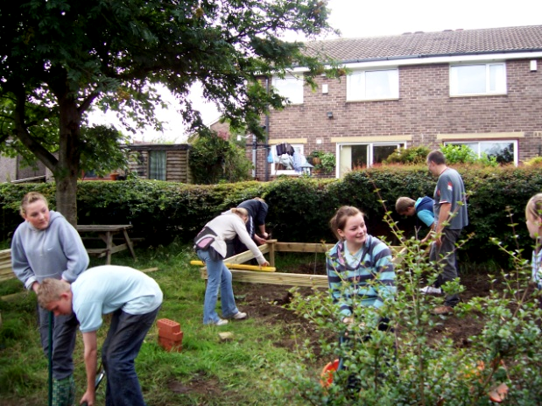
- Online safety – a whole-school design project.
Allotment and Green Group
- Chemistry @ work – Year 10 students attended an event at Huddersfield University to understand the role chemistry plays in business.
- Visit to a local Iron Foundry – Year 11.
- World foods and healthy eating – a cross-curricular day for Year 7.
- Humanities Green Day – a project for all Year 9 students to study how their actions were affecting the environment.
- Sports leaders – a programme which develops students’ sports coaching skills and arranges for them to work with pupils from primary schools.
- KJS Allotment – a project initiated by a group of Year 10 students in 2008 whose motto ‘changing the world, one plot at a time’ through developing allotments in schools led to current Year 10 students setting up an allotment at King James’s School.
- Felting – a project which enabled Year 9 students to work with a textile designer on a felting project at a local university to develop their understanding of textile technology.
The school started using the BTEC ‘Work Skills’ award at level 2 in 2009 when it realised that students had no formal record of their achievement in developing their employability skills. The students start in Year 10 and take up to two years to produce their individual assessment portfolio. The portfolio also provides a summary of their achievements and evidence of the work-related and employability skills that they have developed. The staff use a presentation at parents’ evenings to explain the award to parents and carers.
Setting up the programme involved identifying a member of staff to complete the awarding body training and, in turn, to train other staff and form tutors. The coordinator also had responsibility for internally verifying the assessments and liaising with the external verifier.
The programme is taught across the curriculum, including the core departments:
- Mathematics - managing your own money
- English - summarising documents and completing a job application letter
- PSHCEE - work experience and team working
- Pastoral time - curriculum vitae, job applications and mock interviews.
Developing expertise in the teaching and support staff
Implementing work-related learning and enterprise skills across the curriculum and introducing the BTEC ‘Work Skills’ meant re-designing the pastoral system to accommodate the accreditation scheme. And staff needed to be prepared to try out new approaches to teaching their specialist subjects.
The benefit of using a national accreditation scheme is that it ensures that all students are motivated to work to consistently high standards. - Kim Clarke, BTEC award coordinator
Successful strategies to support staff development include: giving work-related learning and enterprise education a high profile at meetings and on staff development days; providing frameworks and templates to help staff think of ideas and map activities to their specialist curricular areas; and providing opportunities for staff to share ideas and discuss challenges.
Form tutors are split into two separate sections:
- a team for Key Stage 3, with expertise in supporting new students through transition; developing initial employability skills to support their academic work as well as work-related learning; and supporting students to make choices for their next stage
- a team for Key Stage 4, with expertise in building on the employability skills already developed; delivering the BTEC ‘Work Skills’ award; and supporting students to decide on their next steps post-16.

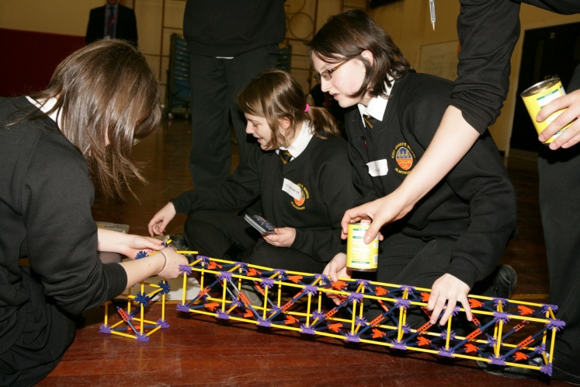
Monitoring and evaluation
Enterprise activities

The monitoring and the evaluation of work-related learning and enterprise education are effective, systematic and involve staff, partners and students. To check that employability skills are embedded across the curriculum, staff complete a questionnaire covering how students develop financial awareness and capability, what activities students do that are enterprise-related and work-related, and opportunities that are provided for students to work in a team and work independently. An example for ICT can be seen here. The school also monitors the effectiveness of enrichment activities.
Lesson observations include a record of links to enterprise and community participation. The observer also records students’ development of personal, learning and thinking skills. ‘Learning walks’ are used to monitor the implementation of specific aspects of the curriculum, including the BTEC ‘Work Skills’ award.
Students complete feedback forms after enrichment and enterprise activities. Those interviewed said that they were happy to give ‘honest answers to honest questions’ as they felt that the teachers valued their views and acted on them.
Developing links with employers and external organisations
Many staff have developed useful links through their subject specialisms and informal contacts, and the school contracts with a local business education service to enhance their work-related activities by involving local businesses and other relevant organisations and agencies. The objectives for this work are reviewed annually. A flexible contract allows the school to build on work from previous years and introduce new work to ensure that curriculum areas with fewer external links are prioritised.
In particular, employers and other partners have contributed by taking part in:
- mock interviews
- enterprise days
- business challenges
- guest speaker visits
- visits to businesses and organisations
- bespoke subject-related projects.
The impact on students’ future adult and working lives
Students speak enthusiastically about their learning and those interviewed expressed support for how the school raises their awareness of businesses, develops their employability skills and prepares them for their next steps. Their comments included:
The advantage of working with other local schools is that the projects reach a wider audience - you can share costs and resources and the students meet and work with people from different cultures and backgrounds. - Jacqueline Armitage, Community Cohesion Coordinator
‘I’m much more confident when having to make a presentation or talk to new people.’
‘The training course in sports leadership was so good. I had to read the instructions, learn how to play the game and then teach other students.’
‘I feel much more capable of becoming financially independent. I know about budgeting and about loans. It means I’ll be making informed and realistic choices if I decide to apply for a university place.’
“Before the Tenner Challenge, I didn’t know what ‘negotiate’ meant, but now I can do it.”
‘The teachers here see your potential in a way that you may not, and then they help you achieve it.’
The school’s background


King James’s School is an average-sized school serving an area on the eastern outskirts of Huddersfield. The proportion of students eligible for free school meals is below average. Most students come from White British backgrounds, with one in eight coming from a wide range of other groups. Almost all students speak English as their first language. The proportion of students with special educational needs and/or disabilities is well below average. The school has specialist status in science and in mathematics.
King James’s School, established by Royal Charter, 1608
Are you thinking of putting these ideas into practice; or already doing something similar that could help other providers; or just interested? We'd welcome your views and ideas. Get in touch here.
To view other good practice examples, go to: www.ofsted.gov.uk/resources/goodpractice

